Chainage Wise Gap Analysis

# Chainage: All

## PIU Data:

|  |  |
| --- | --- |
| **Furniture Assets** | **LHS + RHS** |
| Chevron | 32.0 |
| Cautionary Warning Signs | 202.0 |
| Hazard | 172.0 |
| Prohibitory Mandatory Signs | 4.0 |
| Informatory Signs | 225.0 |

## RA Data:

|  |  |
| --- | --- |
| **Furniture Assets** | **LHS + RHS** |
| Chevron | 59.0 |
| Cautionary Warning Signs | 282.0 |
| Hazard | 146.0 |
| Prohibitory Mandatory Signs | 173.0 |
| Informatory Signs | 376.0 |

## Gap Analysis:

|  |  |
| --- | --- |
| **Furniture Assets** | **LHS + RHS** |
| Chevron | -27.0 |
| Cautionary Warning Signs | -80.0 |
| Hazard | 26.0 |
| Prohibitory Mandatory Signs | -169.0 |
| Informatory Signs | -151.0 |

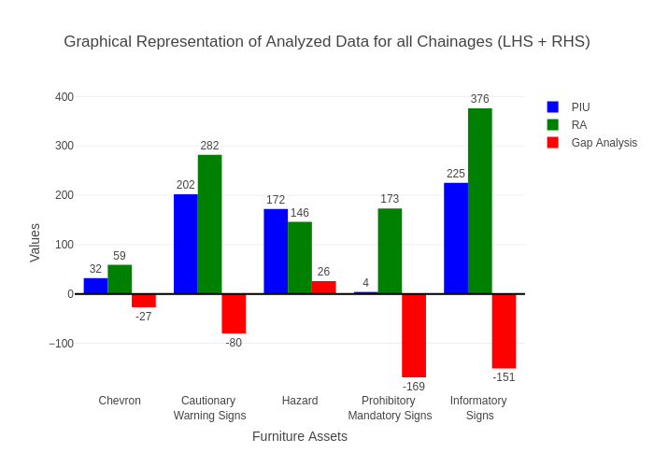

# Chainage: 4200-4500

## PIU Data:

|  |  |  |  |
| --- | --- | --- | --- |
| **Furniture Assets** | **4200-4500** | **4500-4200** | **LHS+RHS** |
| Chevron | 0.0 | 0.0 | 0.0 |
| Cautionary Warning Signs | 3.0 | 1.0 | 4.0 |
| Hazard | 1.0 | 1.0 | 2.0 |
| Prohibitory Mandatory Signs | 1.0 | 0.0 | 1.0 |
| Informatory Signs | 2.0 | 0.0 | 2.0 |

## RA Data:

|  |  |  |  |
| --- | --- | --- | --- |
| **Furniture Assets** | **4200-4500** | **4500-4200** | **LHS+RHS** |
| Chevron | 0.0 | 0.0 | 0.0 |
| Cautionary Warning Signs | 4.0 | 1.0 | 5.0 |
| Hazard | 1.0 | 0.0 | 1.0 |
| Prohibitory Mandatory Signs | 3.0 | 0.0 | 3.0 |
| Informatory Signs | 2.0 | 0.0 | 2.0 |

## Gap Analysis:

|  |  |  |  |
| --- | --- | --- | --- |
| **Furniture Assets** | **4200-4500** | **4500-4200** | **LHS+RHS** |
| Chevron | 0.0 | 0.0 | 0.0 |
| Cautionary Warning Signs | -1.0 | 0.0 | -1.0 |
| Hazard | 0.0 | 1.0 | 1.0 |
| Prohibitory Mandatory Signs | -2.0 | 0.0 | -2.0 |
| Informatory Signs | 0.0 | 0.0 | 0.0 |

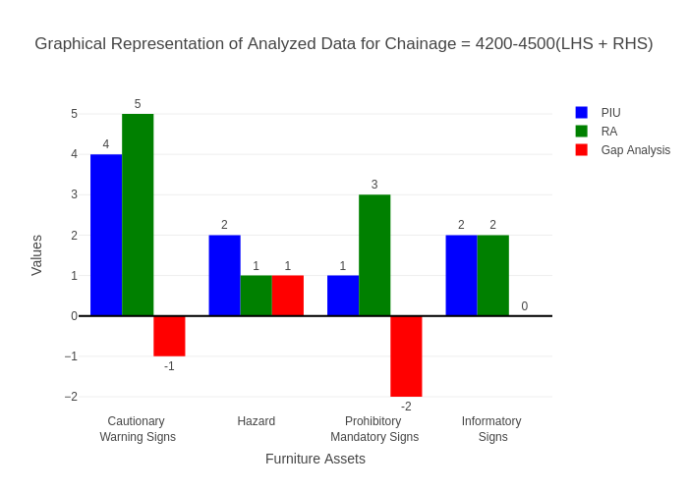

# Chainage: 4500-5000

## PIU Data:

|  |  |  |  |
| --- | --- | --- | --- |
| **Furniture Assets** | **4500-5000** | **5000-4500** | **LHS+RHS** |
| Chevron | 0.0 | 0.0 | 0.0 |
| Cautionary Warning Signs | 0.0 | 0.0 | 0.0 |
| Hazard | 0.0 | 0.0 | 0.0 |
| Prohibitory Mandatory Signs | 0.0 | 0.0 | 0.0 |
| Informatory Signs | 0.0 | 0.0 | 0.0 |

## RA Data:

|  |  |  |  |
| --- | --- | --- | --- |
| **Furniture Assets** | **4500-5000** | **5000-4500** | **LHS+RHS** |
| Chevron | 0.0 | 0.0 | 0.0 |
| Cautionary Warning Signs | 0.0 | 2.0 | 2.0 |
| Hazard | 0.0 | 0.0 | 0.0 |
| Prohibitory Mandatory Signs | 3.0 | 2.0 | 5.0 |
| Informatory Signs | 0.0 | 0.0 | 0.0 |

## Gap Analysis:

|  |  |  |  |
| --- | --- | --- | --- |
| **Furniture Assets** | **4500-5000** | **5000-4500** | **LHS+RHS** |
| Chevron | 0.0 | 0.0 | 0.0 |
| Cautionary Warning Signs | 0.0 | -2.0 | -2.0 |
| Hazard | 0.0 | 0.0 | 0.0 |
| Prohibitory Mandatory Signs | -3.0 | -2.0 | -5.0 |
| Informatory Signs | 0.0 | 0.0 | 0.0 |

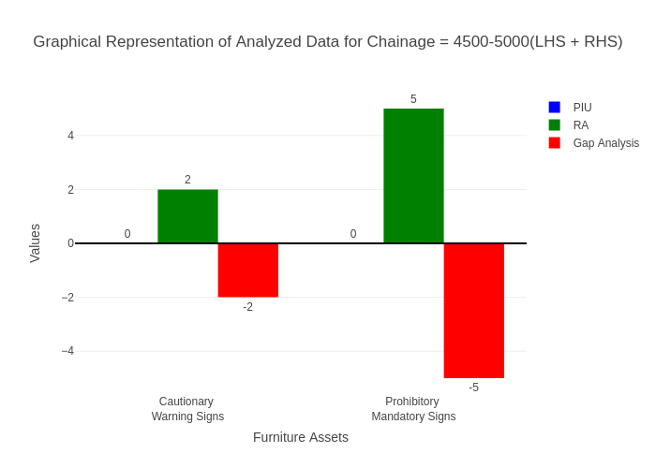

# Chainage: 5000-5500

## PIU Data:

|  |  |  |  |
| --- | --- | --- | --- |
| **Furniture Assets** | **5000-5500** | **5500-5000** | **LHS+RHS** |
| Chevron | 0.0 | 0.0 | 0.0 |
| Cautionary Warning Signs | 6.0 | 0.0 | 6.0 |
| Hazard | 1.0 | 0.0 | 1.0 |
| Prohibitory Mandatory Signs | 0.0 | 0.0 | 0.0 |
| Informatory Signs | 2.0 | 0.0 | 2.0 |

## RA Data:

|  |  |  |  |
| --- | --- | --- | --- |
| **Furniture Assets** | **5000-5500** | **5500-5000** | **LHS+RHS** |
| Chevron | 0.0 | 0.0 | 0.0 |
| Cautionary Warning Signs | 1.0 | 0.0 | 1.0 |
| Hazard | 1.0 | 0.0 | 1.0 |
| Prohibitory Mandatory Signs | 3.0 | 0.0 | 3.0 |
| Informatory Signs | 1.0 | 0.0 | 1.0 |

## Gap Analysis:

|  |  |  |  |
| --- | --- | --- | --- |
| **Furniture Assets** | **5000-5500** | **5500-5000** | **LHS+RHS** |
| Chevron | 0.0 | 0.0 | 0.0 |
| Cautionary Warning Signs | 5.0 | 0.0 | 5.0 |
| Hazard | 0.0 | 0.0 | 0.0 |
| Prohibitory Mandatory Signs | -3.0 | 0.0 | -3.0 |
| Informatory Signs | 1.0 | 0.0 | 1.0 |

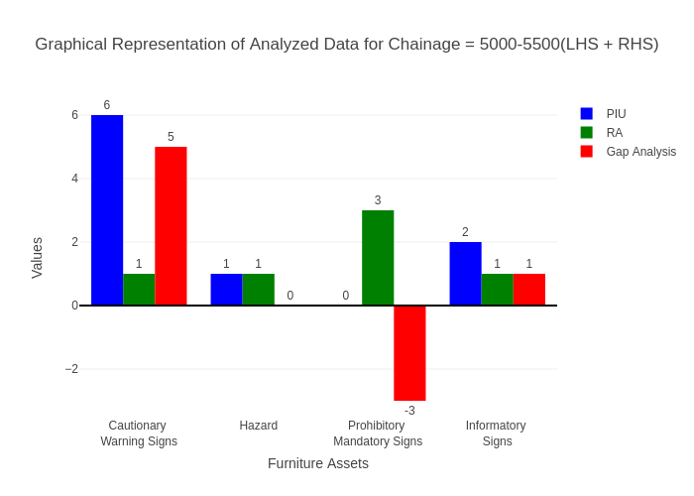

# Chainage: 5500-6000

## PIU Data:

|  |  |  |  |
| --- | --- | --- | --- |
| **Furniture Assets** | **5500-6000** | **6000-5500** | **LHS+RHS** |
| Chevron | 0.0 | 0.0 | 0.0 |
| Cautionary Warning Signs | 3.0 | 0.0 | 3.0 |
| Hazard | 0.0 | 0.0 | 0.0 |
| Prohibitory Mandatory Signs | 0.0 | 0.0 | 0.0 |
| Informatory Signs | 0.0 | 0.0 | 0.0 |

## RA Data:

|  |  |  |  |
| --- | --- | --- | --- |
| **Furniture Assets** | **5500-6000** | **6000-5500** | **LHS+RHS** |
| Chevron | 0.0 | 0.0 | 0.0 |
| Cautionary Warning Signs | 1.0 | 1.0 | 2.0 |
| Hazard | 0.0 | 0.0 | 0.0 |
| Prohibitory Mandatory Signs | 0.0 | 2.0 | 2.0 |
| Informatory Signs | 0.0 | 0.0 | 0.0 |

## Gap Analysis:

|  |  |  |  |
| --- | --- | --- | --- |
| **Furniture Assets** | **5500-6000** | **6000-5500** | **LHS+RHS** |
| Chevron | 0.0 | 0.0 | 0.0 |
| Cautionary Warning Signs | 2.0 | -1.0 | 1.0 |
| Hazard | 0.0 | 0.0 | 0.0 |
| Prohibitory Mandatory Signs | 0.0 | -2.0 | -2.0 |
| Informatory Signs | 0.0 | 0.0 | 0.0 |

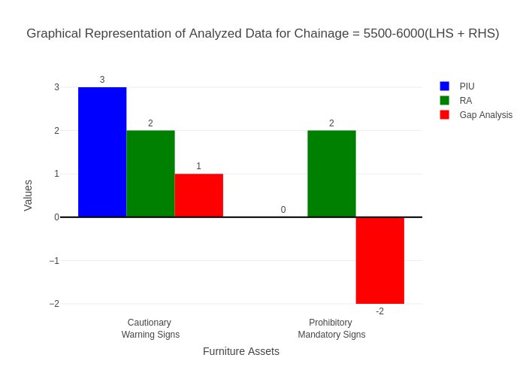

# Chainage: 6000-6500

## PIU Data:

|  |  |  |  |
| --- | --- | --- | --- |
| **Furniture Assets** | **6000-6500** | **6500-6000** | **LHS+RHS** |
| Chevron | 0.0 | 0.0 | 0.0 |
| Cautionary Warning Signs | 2.0 | 1.0 | 3.0 |
| Hazard | 0.0 | 0.0 | 0.0 |
| Prohibitory Mandatory Signs | 0.0 | 0.0 | 0.0 |
| Informatory Signs | 1.0 | 0.0 | 1.0 |

## RA Data:

|  |  |  |  |
| --- | --- | --- | --- |
| **Furniture Assets** | **6000-6500** | **6500-6000** | **LHS+RHS** |
| Chevron | 0.0 | 0.0 | 0.0 |
| Cautionary Warning Signs | 2.0 | 3.0 | 5.0 |
| Hazard | 0.0 | 1.0 | 1.0 |
| Prohibitory Mandatory Signs | 1.0 | 0.0 | 1.0 |
| Informatory Signs | 0.0 | 0.0 | 0.0 |

## Gap Analysis:

|  |  |  |  |
| --- | --- | --- | --- |
| **Furniture Assets** | **6000-6500** | **6500-6000** | **LHS+RHS** |
| Chevron | 0.0 | 0.0 | 0.0 |
| Cautionary Warning Signs | 0.0 | -2.0 | -2.0 |
| Hazard | 0.0 | -1.0 | -1.0 |
| Prohibitory Mandatory Signs | -1.0 | 0.0 | -1.0 |
| Informatory Signs | 1.0 | 0.0 | 1.0 |

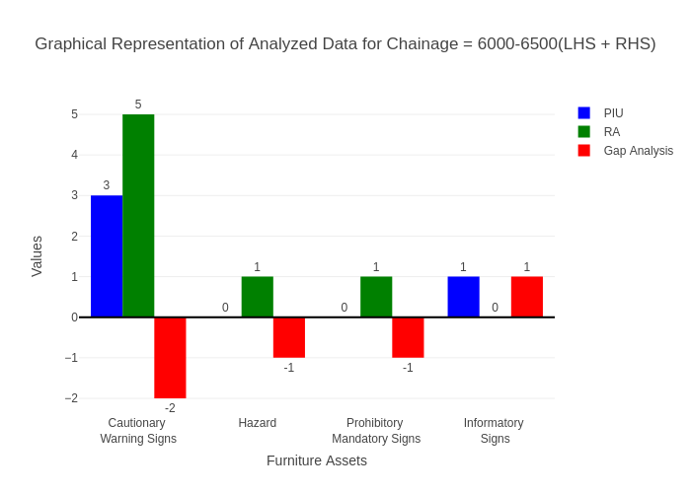

# Chainage: 6500-7000

## PIU Data:

|  |  |  |  |
| --- | --- | --- | --- |
| **Furniture Assets** | **6500-7000** | **7000-6500** | **LHS+RHS** |
| Chevron | 0.0 | 0.0 | 0.0 |
| Cautionary Warning Signs | 2.0 | 0.0 | 2.0 |
| Hazard | 0.0 | 0.0 | 0.0 |
| Prohibitory Mandatory Signs | 0.0 | 0.0 | 0.0 |
| Informatory Signs | 0.0 | 0.0 | 0.0 |

## RA Data:

|  |  |  |  |
| --- | --- | --- | --- |
| **Furniture Assets** | **6500-7000** | **7000-6500** | **LHS+RHS** |
| Chevron | 0.0 | 0.0 | 0.0 |
| Cautionary Warning Signs | 1.0 | 0.0 | 1.0 |
| Hazard | 0.0 | 0.0 | 0.0 |
| Prohibitory Mandatory Signs | 0.0 | 1.0 | 1.0 |
| Informatory Signs | 0.0 | 0.0 | 0.0 |

## Gap Analysis:

|  |  |  |  |
| --- | --- | --- | --- |
| **Furniture Assets** | **6500-7000** | **7000-6500** | **LHS+RHS** |
| Chevron | 0.0 | 0.0 | 0.0 |
| Cautionary Warning Signs | 1.0 | 0.0 | 1.0 |
| Hazard | 0.0 | 0.0 | 0.0 |
| Prohibitory Mandatory Signs | 0.0 | -1.0 | -1.0 |
| Informatory Signs | 0.0 | 0.0 | 0.0 |

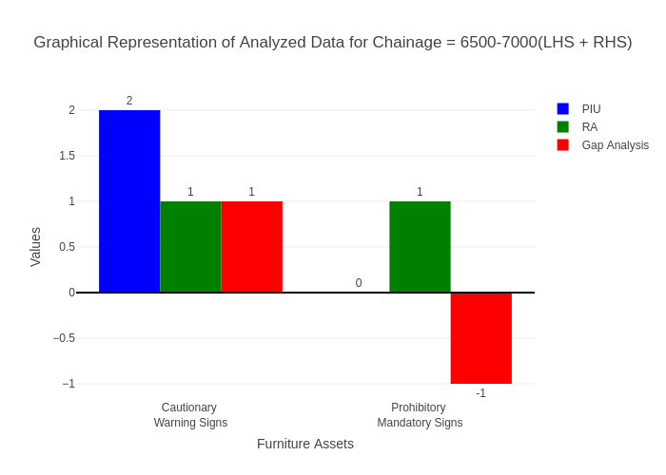

# Chainage: 7000-7500

## PIU Data:

|  |  |  |  |
| --- | --- | --- | --- |
| **Furniture Assets** | **7000-7500** | **7500-7000** | **LHS+RHS** |
| Chevron | 0.0 | 0.0 | 0.0 |
| Cautionary Warning Signs | 3.0 | 0.0 | 3.0 |
| Hazard | 1.0 | 0.0 | 1.0 |
| Prohibitory Mandatory Signs | 0.0 | 0.0 | 0.0 |
| Informatory Signs | 1.0 | 0.0 | 1.0 |

## RA Data:

|  |  |  |  |
| --- | --- | --- | --- |
| **Furniture Assets** | **7000-7500** | **7500-7000** | **LHS+RHS** |
| Chevron | 0.0 | 0.0 | 0.0 |
| Cautionary Warning Signs | 3.0 | 0.0 | 3.0 |
| Hazard | 1.0 | 1.0 | 2.0 |
| Prohibitory Mandatory Signs | 0.0 | 0.0 | 0.0 |
| Informatory Signs | 2.0 | 0.0 | 2.0 |

## Gap Analysis:

|  |  |  |  |
| --- | --- | --- | --- |
| **Furniture Assets** | **7000-7500** | **7500-7000** | **LHS+RHS** |
| Chevron | 0.0 | 0.0 | 0.0 |
| Cautionary Warning Signs | 0.0 | 0.0 | 0.0 |
| Hazard | 0.0 | -1.0 | -1.0 |
| Prohibitory Mandatory Signs | 0.0 | 0.0 | 0.0 |
| Informatory Signs | -1.0 | 0.0 | -1.0 |

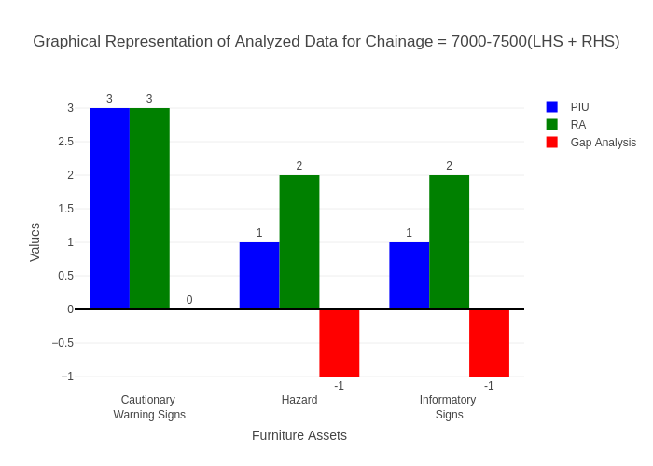

# Chainage: 7500-8000

## PIU Data:

|  |  |  |  |
| --- | --- | --- | --- |
| **Furniture Assets** | **7500-8000** | **8000-7500** | **LHS+RHS** |
| Chevron | 0.0 | 0.0 | 0.0 |
| Cautionary Warning Signs | 0.0 | 0.0 | 0.0 |
| Hazard | 1.0 | 0.0 | 1.0 |
| Prohibitory Mandatory Signs | 0.0 | 0.0 | 0.0 |
| Informatory Signs | 0.0 | 0.0 | 0.0 |

## RA Data:

|  |  |  |  |
| --- | --- | --- | --- |
| **Furniture Assets** | **7500-8000** | **8000-7500** | **LHS+RHS** |
| Chevron | 0.0 | 0.0 | 0.0 |
| Cautionary Warning Signs | 1.0 | 2.0 | 3.0 |
| Hazard | 0.0 | 1.0 | 1.0 |
| Prohibitory Mandatory Signs | 0.0 | 0.0 | 0.0 |
| Informatory Signs | 0.0 | 0.0 | 0.0 |

## Gap Analysis:

|  |  |  |  |
| --- | --- | --- | --- |
| **Furniture Assets** | **7500-8000** | **8000-7500** | **LHS+RHS** |
| Chevron | 0.0 | 0.0 | 0.0 |
| Cautionary Warning Signs | -1.0 | -2.0 | -3.0 |
| Hazard | 1.0 | -1.0 | 0.0 |
| Prohibitory Mandatory Signs | 0.0 | 0.0 | 0.0 |
| Informatory Signs | 0.0 | 0.0 | 0.0 |

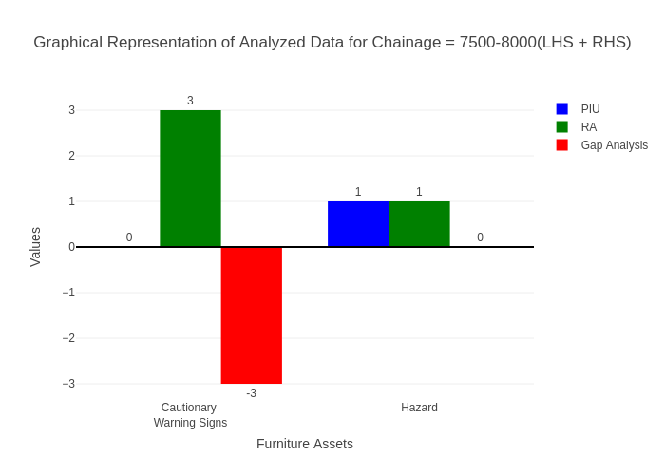

# Chainage: 8000-8500

## PIU Data:

|  |  |  |  |
| --- | --- | --- | --- |
| **Furniture Assets** | **8000-8500** | **8500-8000** | **LHS+RHS** |
| Chevron | 0.0 | 0.0 | 0.0 |
| Cautionary Warning Signs | 2.0 | 0.0 | 2.0 |
| Hazard | 0.0 | 0.0 | 0.0 |
| Prohibitory Mandatory Signs | 0.0 | 0.0 | 0.0 |
| Informatory Signs | 1.0 | 0.0 | 1.0 |

## RA Data:

|  |  |  |  |
| --- | --- | --- | --- |
| **Furniture Assets** | **8000-8500** | **8500-8000** | **LHS+RHS** |
| Chevron | 0.0 | 0.0 | 0.0 |
| Cautionary Warning Signs | 1.0 | 0.0 | 1.0 |
| Hazard | 0.0 | 0.0 | 0.0 |
| Prohibitory Mandatory Signs | 0.0 | 0.0 | 0.0 |
| Informatory Signs | 1.0 | 0.0 | 1.0 |

## Gap Analysis:

|  |  |  |  |
| --- | --- | --- | --- |
| **Furniture Assets** | **8000-8500** | **8500-8000** | **LHS+RHS** |
| Chevron | 0.0 | 0.0 | 0.0 |
| Cautionary Warning Signs | 1.0 | 0.0 | 1.0 |
| Hazard | 0.0 | 0.0 | 0.0 |
| Prohibitory Mandatory Signs | 0.0 | 0.0 | 0.0 |
| Informatory Signs | 0.0 | 0.0 | 0.0 |

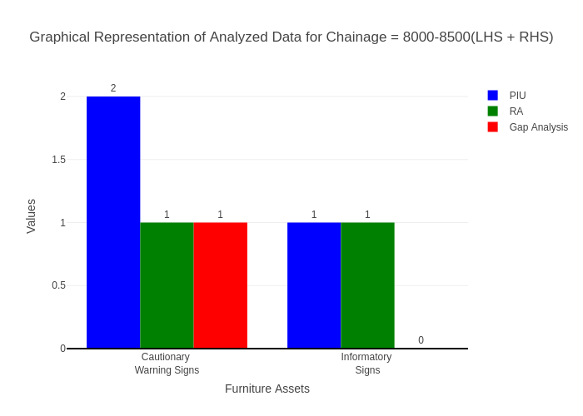

# Chainage: 8500-9000

## PIU Data:

|  |  |  |  |
| --- | --- | --- | --- |
| **Furniture Assets** | **8500-9000** | **9000-8500** | **LHS+RHS** |
| Chevron | 0.0 | 0.0 | 0.0 |
| Cautionary Warning Signs | 3.0 | 0.0 | 3.0 |
| Hazard | 0.0 | 0.0 | 0.0 |
| Prohibitory Mandatory Signs | 0.0 | 0.0 | 0.0 |
| Informatory Signs | 1.0 | 0.0 | 1.0 |

## RA Data:

|  |  |  |  |
| --- | --- | --- | --- |
| **Furniture Assets** | **8500-9000** | **9000-8500** | **LHS+RHS** |
| Chevron | 0.0 | 0.0 | 0.0 |
| Cautionary Warning Signs | 2.0 | 1.0 | 3.0 |
| Hazard | 0.0 | 0.0 | 0.0 |
| Prohibitory Mandatory Signs | 0.0 | 1.0 | 1.0 |
| Informatory Signs | 2.0 | 1.0 | 3.0 |

## Gap Analysis:

|  |  |  |  |
| --- | --- | --- | --- |
| **Furniture Assets** | **8500-9000** | **9000-8500** | **LHS+RHS** |
| Chevron | 0.0 | 0.0 | 0.0 |
| Cautionary Warning Signs | 1.0 | -1.0 | 0.0 |
| Hazard | 0.0 | 0.0 | 0.0 |
| Prohibitory Mandatory Signs | 0.0 | -1.0 | -1.0 |
| Informatory Signs | -1.0 | -1.0 | -2.0 |

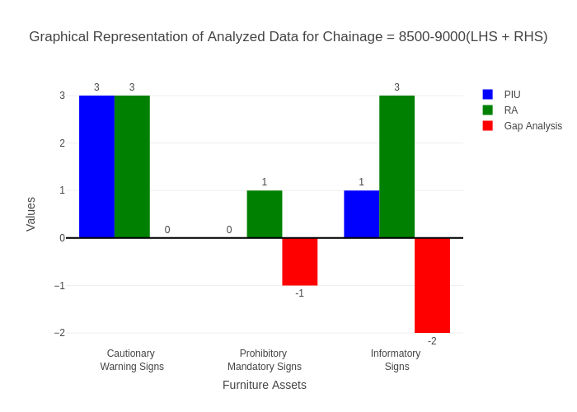

# Chainage: 9000-9500

## PIU Data:

|  |  |  |  |
| --- | --- | --- | --- |
| **Furniture Assets** | **9000-9500** | **9500-9000** | **LHS+RHS** |
| Chevron | 0.0 | 0.0 | 0.0 |
| Cautionary Warning Signs | 0.0 | 0.0 | 0.0 |
| Hazard | 0.0 | 0.0 | 0.0 |
| Prohibitory Mandatory Signs | 0.0 | 0.0 | 0.0 |
| Informatory Signs | 1.0 | 0.0 | 1.0 |

## RA Data:

|  |  |  |  |
| --- | --- | --- | --- |
| **Furniture Assets** | **9000-9500** | **9500-9000** | **LHS+RHS** |
| Chevron | 0.0 | 0.0 | 0.0 |
| Cautionary Warning Signs | 0.0 | 1.0 | 1.0 |
| Hazard | 1.0 | 0.0 | 1.0 |
| Prohibitory Mandatory Signs | 0.0 | 1.0 | 1.0 |
| Informatory Signs | 1.0 | 0.0 | 1.0 |

## Gap Analysis:

|  |  |  |  |
| --- | --- | --- | --- |
| **Furniture Assets** | **9000-9500** | **9500-9000** | **LHS+RHS** |
| Chevron | 0.0 | 0.0 | 0.0 |
| Cautionary Warning Signs | 0.0 | -1.0 | -1.0 |
| Hazard | -1.0 | 0.0 | -1.0 |
| Prohibitory Mandatory Signs | 0.0 | -1.0 | -1.0 |
| Informatory Signs | 0.0 | 0.0 | 0.0 |

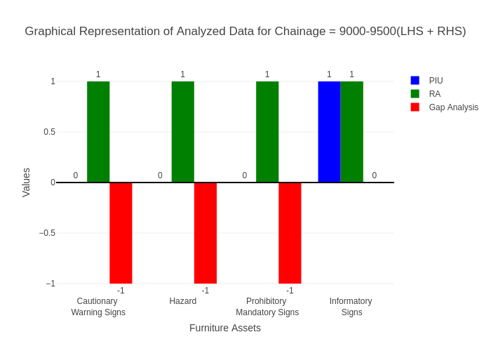

# Chainage: 10000-9500

## PIU Data:

|  |  |  |  |
| --- | --- | --- | --- |
| **Furniture Assets** | **10000-9500** | **9500-10000** | **LHS+RHS** |
| Chevron | 0.0 | 0.0 | 0.0 |
| Cautionary Warning Signs | 0.0 | 0.0 | 0.0 |
| Hazard | 0.0 | 2.0 | 2.0 |
| Prohibitory Mandatory Signs | 0.0 | 0.0 | 0.0 |
| Informatory Signs | 0.0 | 3.0 | 3.0 |

## RA Data:

|  |  |  |  |
| --- | --- | --- | --- |
| **Furniture Assets** | **10000-9500** | **9500-10000** | **LHS+RHS** |
| Chevron | 0.0 | 0.0 | 0.0 |
| Cautionary Warning Signs | 0.0 | 0.0 | 0.0 |
| Hazard | 1.0 | 0.0 | 1.0 |
| Prohibitory Mandatory Signs | 0.0 | 0.0 | 0.0 |
| Informatory Signs | 2.0 | 3.0 | 5.0 |

## Gap Analysis:

|  |  |  |  |
| --- | --- | --- | --- |
| **Furniture Assets** | **10000-9500** | **9500-10000** | **LHS+RHS** |
| Chevron | 0.0 | 0.0 | 0.0 |
| Cautionary Warning Signs | 0.0 | 0.0 | 0.0 |
| Hazard | -1.0 | 2.0 | 1.0 |
| Prohibitory Mandatory Signs | 0.0 | 0.0 | 0.0 |
| Informatory Signs | -2.0 | 0.0 | -2.0 |

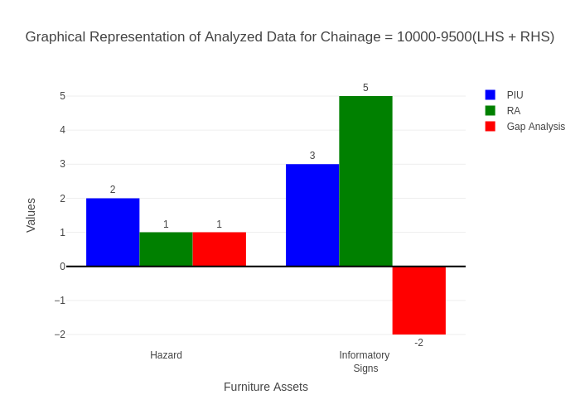

# Chainage: 10000-10500

## PIU Data:

|  |  |  |  |
| --- | --- | --- | --- |
| **Furniture Assets** | **10000-10500** | **10500-10000** | **LHS+RHS** |
| Chevron | 3.0 | 0.0 | 3.0 |
| Cautionary Warning Signs | 1.0 | 0.0 | 1.0 |
| Hazard | 0.0 | 1.0 | 1.0 |
| Prohibitory Mandatory Signs | 0.0 | 0.0 | 0.0 |
| Informatory Signs | 1.0 | 0.0 | 1.0 |

## RA Data:

|  |  |  |  |
| --- | --- | --- | --- |
| **Furniture Assets** | **10000-10500** | **10500-10000** | **LHS+RHS** |
| Chevron | 3.0 | 2.0 | 5.0 |
| Cautionary Warning Signs | 0.0 | 0.0 | 0.0 |
| Hazard | 0.0 | 1.0 | 1.0 |
| Prohibitory Mandatory Signs | 0.0 | 0.0 | 0.0 |
| Informatory Signs | 0.0 | 0.0 | 0.0 |

## Gap Analysis:

|  |  |  |  |
| --- | --- | --- | --- |
| **Furniture Assets** | **10000-10500** | **10500-10000** | **LHS+RHS** |
| Chevron | 0.0 | -2.0 | -2.0 |
| Cautionary Warning Signs | 1.0 | 0.0 | 1.0 |
| Hazard | 0.0 | 0.0 | 0.0 |
| Prohibitory Mandatory Signs | 0.0 | 0.0 | 0.0 |
| Informatory Signs | 1.0 | 0.0 | 1.0 |

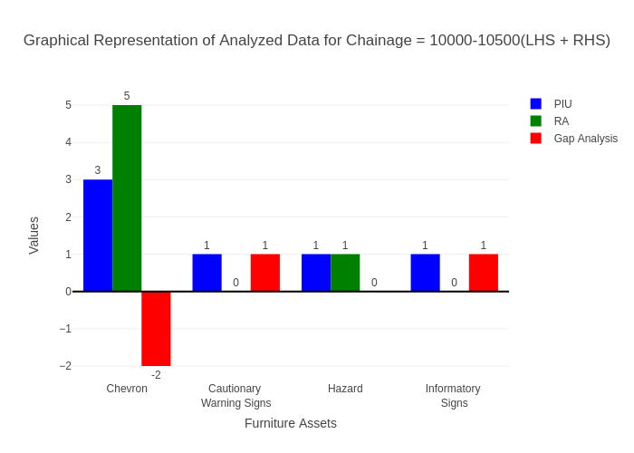

# Chainage: 10500-11000

## PIU Data:

|  |  |  |  |
| --- | --- | --- | --- |
| **Furniture Assets** | **10500-11000** | **11000-10500** | **LHS+RHS** |
| Chevron | 0.0 | 0.0 | 0.0 |
| Cautionary Warning Signs | 3.0 | 0.0 | 3.0 |
| Hazard | 0.0 | 0.0 | 0.0 |
| Prohibitory Mandatory Signs | 1.0 | 0.0 | 1.0 |
| Informatory Signs | 1.0 | 0.0 | 1.0 |

## RA Data:

|  |  |  |  |
| --- | --- | --- | --- |
| **Furniture Assets** | **10500-11000** | **11000-10500** | **LHS+RHS** |
| Chevron | 0.0 | 1.0 | 1.0 |
| Cautionary Warning Signs | 2.0 | 1.0 | 3.0 |
| Hazard | 1.0 | 0.0 | 1.0 |
| Prohibitory Mandatory Signs | 1.0 | 0.0 | 1.0 |
| Informatory Signs | 0.0 | 0.0 | 0.0 |

## Gap Analysis:

|  |  |  |  |
| --- | --- | --- | --- |
| **Furniture Assets** | **10500-11000** | **11000-10500** | **LHS+RHS** |
| Chevron | 0.0 | -1.0 | -1.0 |
| Cautionary Warning Signs | 1.0 | -1.0 | 0.0 |
| Hazard | -1.0 | 0.0 | -1.0 |
| Prohibitory Mandatory Signs | 0.0 | 0.0 | 0.0 |
| Informatory Signs | 1.0 | 0.0 | 1.0 |

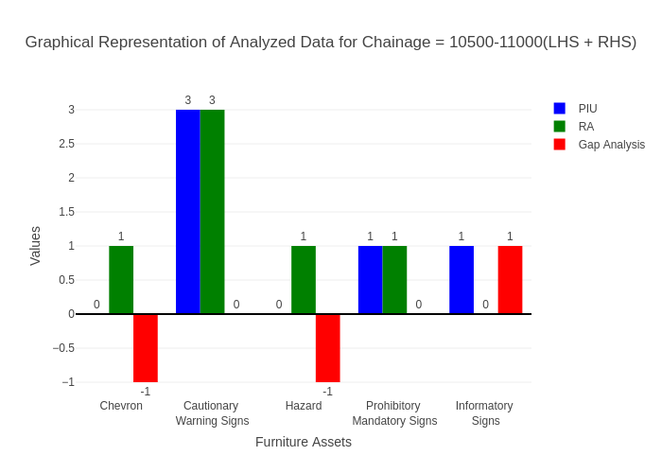

# Chainage: 11000-11500

## PIU Data:

|  |  |  |  |
| --- | --- | --- | --- |
| **Furniture Assets** | **11000-11500** | **11500-11000** | **LHS+RHS** |
| Chevron | 4.0 | 0.0 | 4.0 |
| Cautionary Warning Signs | 1.0 | 0.0 | 1.0 |
| Hazard | 4.0 | 1.0 | 5.0 |
| Prohibitory Mandatory Signs | 0.0 | 0.0 | 0.0 |
| Informatory Signs | 2.0 | 0.0 | 2.0 |

## RA Data:

|  |  |  |  |
| --- | --- | --- | --- |
| **Furniture Assets** | **11000-11500** | **11500-11000** | **LHS+RHS** |
| Chevron | 1.0 | 2.0 | 3.0 |
| Cautionary Warning Signs | 0.0 | 2.0 | 2.0 |
| Hazard | 0.0 | 2.0 | 2.0 |
| Prohibitory Mandatory Signs | 0.0 | 2.0 | 2.0 |
| Informatory Signs | 0.0 | 4.0 | 4.0 |

## Gap Analysis:

|  |  |  |  |
| --- | --- | --- | --- |
| **Furniture Assets** | **11000-11500** | **11500-11000** | **LHS+RHS** |
| Chevron | 3.0 | -2.0 | 1.0 |
| Cautionary Warning Signs | 1.0 | -2.0 | -1.0 |
| Hazard | 4.0 | -1.0 | 3.0 |
| Prohibitory Mandatory Signs | 0.0 | -2.0 | -2.0 |
| Informatory Signs | 2.0 | -4.0 | -2.0 |

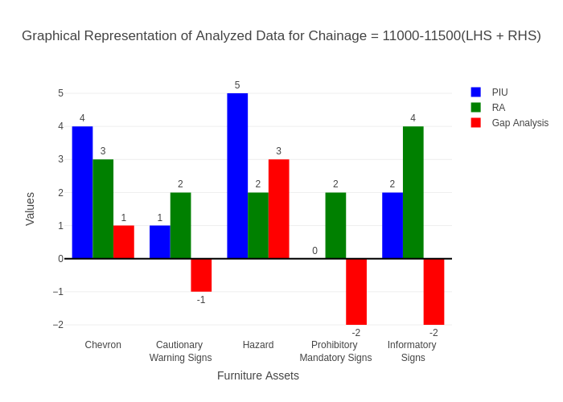

# Chainage: 11500-12000

## PIU Data:

|  |  |  |  |
| --- | --- | --- | --- |
| **Furniture Assets** | **11500-12000** | **12000-11500** | **LHS+RHS** |
| Chevron | 0.0 | 0.0 | 0.0 |
| Cautionary Warning Signs | 2.0 | 0.0 | 2.0 |
| Hazard | 1.0 | 0.0 | 1.0 |
| Prohibitory Mandatory Signs | 0.0 | 0.0 | 0.0 |
| Informatory Signs | 0.0 | 1.0 | 1.0 |

## RA Data:

|  |  |  |  |
| --- | --- | --- | --- |
| **Furniture Assets** | **11500-12000** | **12000-11500** | **LHS+RHS** |
| Chevron | 0.0 | 0.0 | 0.0 |
| Cautionary Warning Signs | 1.0 | 1.0 | 2.0 |
| Hazard | 0.0 | 1.0 | 1.0 |
| Prohibitory Mandatory Signs | 1.0 | 1.0 | 2.0 |
| Informatory Signs | 0.0 | 1.0 | 1.0 |

## Gap Analysis:

|  |  |  |  |
| --- | --- | --- | --- |
| **Furniture Assets** | **11500-12000** | **12000-11500** | **LHS+RHS** |
| Chevron | 0.0 | 0.0 | 0.0 |
| Cautionary Warning Signs | 1.0 | -1.0 | 0.0 |
| Hazard | 1.0 | -1.0 | 0.0 |
| Prohibitory Mandatory Signs | -1.0 | -1.0 | -2.0 |
| Informatory Signs | 0.0 | 0.0 | 0.0 |

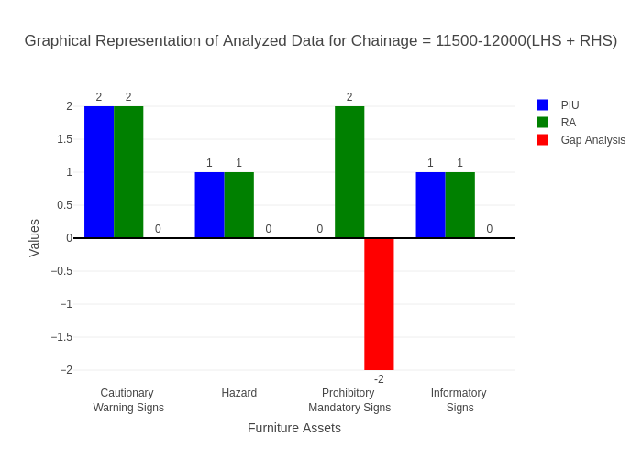

# Chainage: 12000-12500

## PIU Data:

|  |  |  |  |
| --- | --- | --- | --- |
| **Furniture Assets** | **12000-12500** | **12500-12000** | **LHS+RHS** |
| Chevron | 0.0 | 0.0 | 0.0 |
| Cautionary Warning Signs | 2.0 | 0.0 | 2.0 |
| Hazard | 1.0 | 1.0 | 2.0 |
| Prohibitory Mandatory Signs | 0.0 | 0.0 | 0.0 |
| Informatory Signs | 1.0 | 0.0 | 1.0 |

## RA Data:

|  |  |  |  |
| --- | --- | --- | --- |
| **Furniture Assets** | **12000-12500** | **12500-12000** | **LHS+RHS** |
| Chevron | 0.0 | 0.0 | 0.0 |
| Cautionary Warning Signs | 3.0 | 2.0 | 5.0 |
| Hazard | 2.0 | 0.0 | 2.0 |
| Prohibitory Mandatory Signs | 3.0 | 0.0 | 3.0 |
| Informatory Signs | 3.0 | 1.0 | 4.0 |

## Gap Analysis:

|  |  |  |  |
| --- | --- | --- | --- |
| **Furniture Assets** | **12000-12500** | **12500-12000** | **LHS+RHS** |
| Chevron | 0.0 | 0.0 | 0.0 |
| Cautionary Warning Signs | -1.0 | -2.0 | -3.0 |
| Hazard | -1.0 | 1.0 | 0.0 |
| Prohibitory Mandatory Signs | -3.0 | 0.0 | -3.0 |
| Informatory Signs | -2.0 | -1.0 | -3.0 |

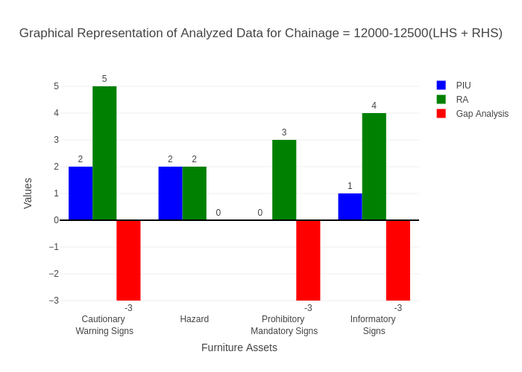

# Chainage: 12500-13000

## PIU Data:

|  |  |  |  |
| --- | --- | --- | --- |
| **Furniture Assets** | **12500-13000** | **13000-12500** | **LHS+RHS** |
| Chevron | 0.0 | 0.0 | 0.0 |
| Cautionary Warning Signs | 2.0 | 0.0 | 2.0 |
| Hazard | 1.0 | 0.0 | 1.0 |
| Prohibitory Mandatory Signs | 0.0 | 0.0 | 0.0 |
| Informatory Signs | 1.0 | 0.0 | 1.0 |

## RA Data:

|  |  |  |  |
| --- | --- | --- | --- |
| **Furniture Assets** | **12500-13000** | **13000-12500** | **LHS+RHS** |
| Chevron | 0.0 | 0.0 | 0.0 |
| Cautionary Warning Signs | 0.0 | 1.0 | 1.0 |
| Hazard | 0.0 | 1.0 | 1.0 |
| Prohibitory Mandatory Signs | 0.0 | 0.0 | 0.0 |
| Informatory Signs | 1.0 | 1.0 | 2.0 |

## Gap Analysis:

|  |  |  |  |
| --- | --- | --- | --- |
| **Furniture Assets** | **12500-13000** | **13000-12500** | **LHS+RHS** |
| Chevron | 0.0 | 0.0 | 0.0 |
| Cautionary Warning Signs | 2.0 | -1.0 | 1.0 |
| Hazard | 1.0 | -1.0 | 0.0 |
| Prohibitory Mandatory Signs | 0.0 | 0.0 | 0.0 |
| Informatory Signs | 0.0 | -1.0 | -1.0 |

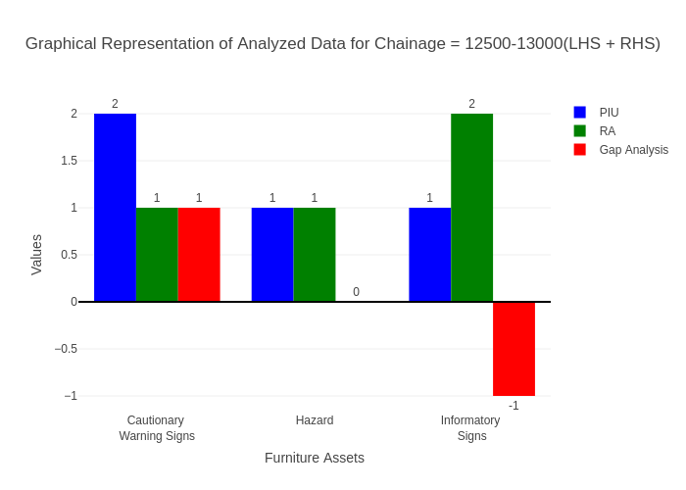

# Chainage: 13000-13500

## PIU Data:

|  |  |  |  |
| --- | --- | --- | --- |
| **Furniture Assets** | **13000-13500** | **13500-13000** | **LHS+RHS** |
| Chevron | 0.0 | 0.0 | 0.0 |
| Cautionary Warning Signs | 2.0 | 0.0 | 2.0 |
| Hazard | 0.0 | 0.0 | 0.0 |
| Prohibitory Mandatory Signs | 0.0 | 0.0 | 0.0 |
| Informatory Signs | 0.0 | 0.0 | 0.0 |

## RA Data:

|  |  |  |  |
| --- | --- | --- | --- |
| **Furniture Assets** | **13000-13500** | **13500-13000** | **LHS+RHS** |
| Chevron | 0.0 | 0.0 | 0.0 |
| Cautionary Warning Signs | 1.0 | 0.0 | 1.0 |
| Hazard | 0.0 | 0.0 | 0.0 |
| Prohibitory Mandatory Signs | 0.0 | 0.0 | 0.0 |
| Informatory Signs | 0.0 | 0.0 | 0.0 |

## Gap Analysis:

|  |  |  |  |
| --- | --- | --- | --- |
| **Furniture Assets** | **13000-13500** | **13500-13000** | **LHS+RHS** |
| Chevron | 0.0 | 0.0 | 0.0 |
| Cautionary Warning Signs | 1.0 | 0.0 | 1.0 |
| Hazard | 0.0 | 0.0 | 0.0 |
| Prohibitory Mandatory Signs | 0.0 | 0.0 | 0.0 |
| Informatory Signs | 0.0 | 0.0 | 0.0 |

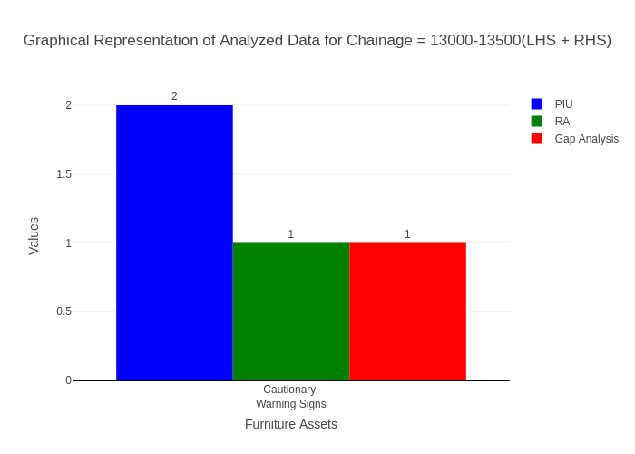

# Chainage: 13500-14000

## PIU Data:

|  |  |  |  |
| --- | --- | --- | --- |
| **Furniture Assets** | **13500-14000** | **14000-13500** | **LHS+RHS** |
| Chevron | 0.0 | 0.0 | 0.0 |
| Cautionary Warning Signs | 1.0 | 0.0 | 1.0 |
| Hazard | 1.0 | 0.0 | 1.0 |
| Prohibitory Mandatory Signs | 0.0 | 0.0 | 0.0 |
| Informatory Signs | 1.0 | 0.0 | 1.0 |

## RA Data:

|  |  |  |  |
| --- | --- | --- | --- |
| **Furniture Assets** | **13500-14000** | **14000-13500** | **LHS+RHS** |
| Chevron | 0.0 | 0.0 | 0.0 |
| Cautionary Warning Signs | 3.0 | 1.0 | 4.0 |
| Hazard | 0.0 | 1.0 | 1.0 |
| Prohibitory Mandatory Signs | 1.0 | 0.0 | 1.0 |
| Informatory Signs | 0.0 | 0.0 | 0.0 |

## Gap Analysis:

|  |  |  |  |
| --- | --- | --- | --- |
| **Furniture Assets** | **13500-14000** | **14000-13500** | **LHS+RHS** |
| Chevron | 0.0 | 0.0 | 0.0 |
| Cautionary Warning Signs | -2.0 | -1.0 | -3.0 |
| Hazard | 1.0 | -1.0 | 0.0 |
| Prohibitory Mandatory Signs | -1.0 | 0.0 | -1.0 |
| Informatory Signs | 1.0 | 0.0 | 1.0 |

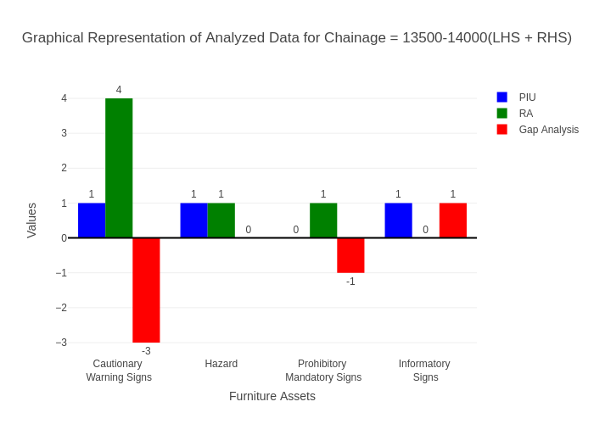

# Chainage: 14000-14500

## PIU Data:

|  |  |  |  |
| --- | --- | --- | --- |
| **Furniture Assets** | **14000-14500** | **14500-14000** | **LHS+RHS** |
| Chevron | 0.0 | 0.0 | 0.0 |
| Cautionary Warning Signs | 0.0 | 0.0 | 0.0 |
| Hazard | 1.0 | 0.0 | 1.0 |
| Prohibitory Mandatory Signs | 0.0 | 0.0 | 0.0 |
| Informatory Signs | 0.0 | 1.0 | 1.0 |

## RA Data:

|  |  |  |  |
| --- | --- | --- | --- |
| **Furniture Assets** | **14000-14500** | **14500-14000** | **LHS+RHS** |
| Chevron | 0.0 | 0.0 | 0.0 |
| Cautionary Warning Signs | 0.0 | 3.0 | 3.0 |
| Hazard | 1.0 | 0.0 | 1.0 |
| Prohibitory Mandatory Signs | 0.0 | 1.0 | 1.0 |
| Informatory Signs | 0.0 | 0.0 | 0.0 |

## Gap Analysis:

|  |  |  |  |
| --- | --- | --- | --- |
| **Furniture Assets** | **14000-14500** | **14500-14000** | **LHS+RHS** |
| Chevron | 0.0 | 0.0 | 0.0 |
| Cautionary Warning Signs | 0.0 | -3.0 | -3.0 |
| Hazard | 0.0 | 0.0 | 0.0 |
| Prohibitory Mandatory Signs | 0.0 | -1.0 | -1.0 |
| Informatory Signs | 0.0 | 1.0 | 1.0 |

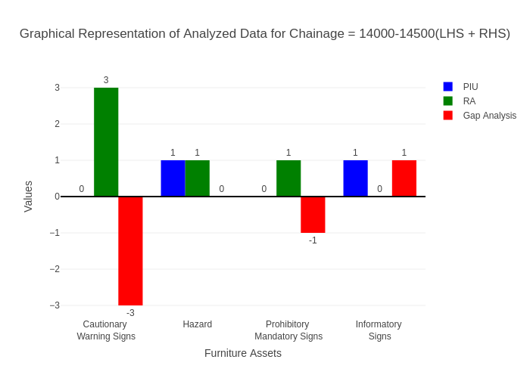

# Chainage: 14500-15000

## PIU Data:

|  |  |  |  |
| --- | --- | --- | --- |
| **Furniture Assets** | **14500-15000** | **15000-14500** | **LHS+RHS** |
| Chevron | 0.0 | 0.0 | 0.0 |
| Cautionary Warning Signs | 2.0 | 0.0 | 2.0 |
| Hazard | 2.0 | 0.0 | 2.0 |
| Prohibitory Mandatory Signs | 0.0 | 0.0 | 0.0 |
| Informatory Signs | 1.0 | 1.0 | 2.0 |

## RA Data:

|  |  |  |  |
| --- | --- | --- | --- |
| **Furniture Assets** | **14500-15000** | **15000-14500** | **LHS+RHS** |
| Chevron | 0.0 | 0.0 | 0.0 |
| Cautionary Warning Signs | 1.0 | 0.0 | 1.0 |
| Hazard | 0.0 | 0.0 | 0.0 |
| Prohibitory Mandatory Signs | 0.0 | 0.0 | 0.0 |
| Informatory Signs | 1.0 | 1.0 | 2.0 |

## Gap Analysis:

|  |  |  |  |
| --- | --- | --- | --- |
| **Furniture Assets** | **14500-15000** | **15000-14500** | **LHS+RHS** |
| Chevron | 0.0 | 0.0 | 0.0 |
| Cautionary Warning Signs | 1.0 | 0.0 | 1.0 |
| Hazard | 2.0 | 0.0 | 2.0 |
| Prohibitory Mandatory Signs | 0.0 | 0.0 | 0.0 |
| Informatory Signs | 0.0 | 0.0 | 0.0 |

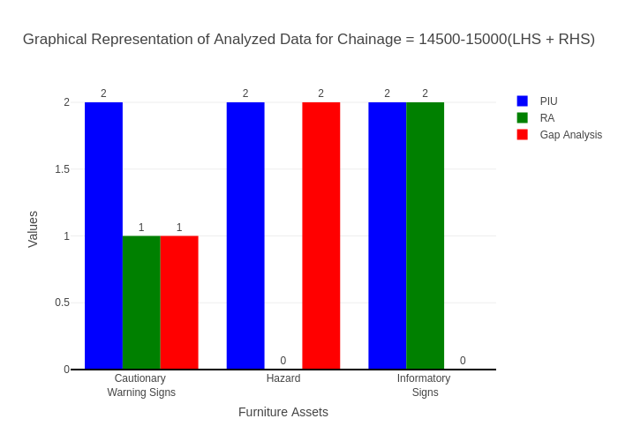

# Chainage: 15000-15500

## PIU Data:

|  |  |  |  |
| --- | --- | --- | --- |
| **Furniture Assets** | **15000-15500** | **15500-15000** | **LHS+RHS** |
| Chevron | 2.0 | 0.0 | 2.0 |
| Cautionary Warning Signs | 2.0 | 1.0 | 3.0 |
| Hazard | 1.0 | 0.0 | 1.0 |
| Prohibitory Mandatory Signs | 0.0 | 0.0 | 0.0 |
| Informatory Signs | 2.0 | 0.0 | 2.0 |

## RA Data:

|  |  |  |  |
| --- | --- | --- | --- |
| **Furniture Assets** | **15000-15500** | **15500-15000** | **LHS+RHS** |
| Chevron | 2.0 | 6.0 | 8.0 |
| Cautionary Warning Signs | 1.0 | 1.0 | 2.0 |
| Hazard | 1.0 | 0.0 | 1.0 |
| Prohibitory Mandatory Signs | 0.0 | 1.0 | 1.0 |
| Informatory Signs | 1.0 | 3.0 | 4.0 |

## Gap Analysis:

|  |  |  |  |
| --- | --- | --- | --- |
| **Furniture Assets** | **15000-15500** | **15500-15000** | **LHS+RHS** |
| Chevron | 0.0 | -6.0 | -6.0 |
| Cautionary Warning Signs | 1.0 | 0.0 | 1.0 |
| Hazard | 0.0 | 0.0 | 0.0 |
| Prohibitory Mandatory Signs | 0.0 | -1.0 | -1.0 |
| Informatory Signs | 1.0 | -3.0 | -2.0 |

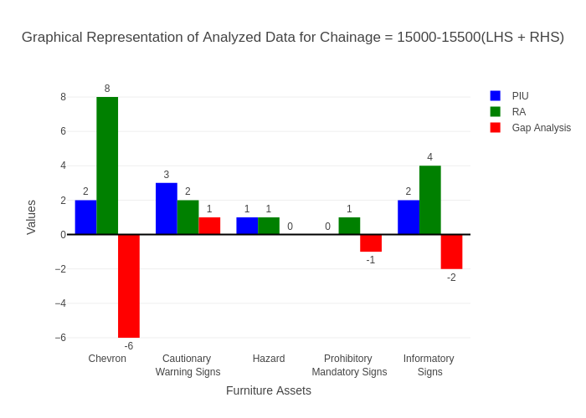

# Chainage: 15500-16000

## PIU Data:

|  |  |  |  |
| --- | --- | --- | --- |
| **Furniture Assets** | **15500-16000** | **16000-15500** | **LHS+RHS** |
| Chevron | 0.0 | 0.0 | 0.0 |
| Cautionary Warning Signs | 0.0 | 0.0 | 0.0 |
| Hazard | 0.0 | 1.0 | 1.0 |
| Prohibitory Mandatory Signs | 0.0 | 0.0 | 0.0 |
| Informatory Signs | 0.0 | 0.0 | 0.0 |

## RA Data:

|  |  |  |  |
| --- | --- | --- | --- |
| **Furniture Assets** | **15500-16000** | **16000-15500** | **LHS+RHS** |
| Chevron | 0.0 | 0.0 | 0.0 |
| Cautionary Warning Signs | 0.0 | 1.0 | 1.0 |
| Hazard | 0.0 | 0.0 | 0.0 |
| Prohibitory Mandatory Signs | 0.0 | 0.0 | 0.0 |
| Informatory Signs | 0.0 | 0.0 | 0.0 |

## Gap Analysis:

|  |  |  |  |
| --- | --- | --- | --- |
| **Furniture Assets** | **15500-16000** | **16000-15500** | **LHS+RHS** |
| Chevron | 0.0 | 0.0 | 0.0 |
| Cautionary Warning Signs | 0.0 | -1.0 | -1.0 |
| Hazard | 0.0 | 1.0 | 1.0 |
| Prohibitory Mandatory Signs | 0.0 | 0.0 | 0.0 |
| Informatory Signs | 0.0 | 0.0 | 0.0 |

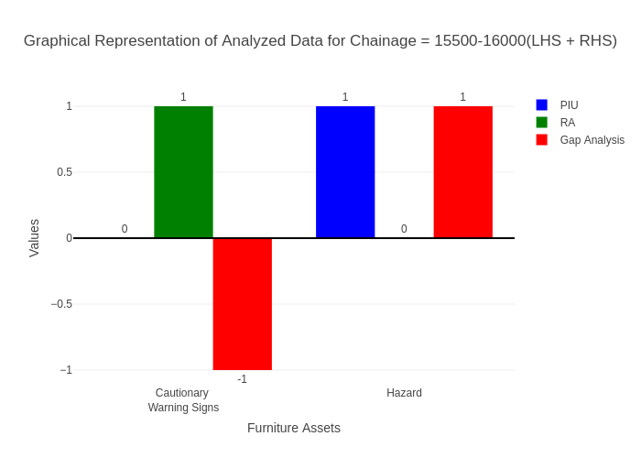

# Chainage: 16000-16500

## PIU Data:

|  |  |  |  |
| --- | --- | --- | --- |
| **Furniture Assets** | **16000-16500** | **16500-16000** | **LHS+RHS** |
| Chevron | 0.0 | 0.0 | 0.0 |
| Cautionary Warning Signs | 0.0 | 0.0 | 0.0 |
| Hazard | 0.0 | 0.0 | 0.0 |
| Prohibitory Mandatory Signs | 0.0 | 0.0 | 0.0 |
| Informatory Signs | 0.0 | 0.0 | 0.0 |

## RA Data:

|  |  |  |  |
| --- | --- | --- | --- |
| **Furniture Assets** | **16000-16500** | **16500-16000** | **LHS+RHS** |
| Chevron | 0.0 | 0.0 | 0.0 |
| Cautionary Warning Signs | 0.0 | 0.0 | 0.0 |
| Hazard | 1.0 | 0.0 | 1.0 |
| Prohibitory Mandatory Signs | 0.0 | 0.0 | 0.0 |
| Informatory Signs | 0.0 | 0.0 | 0.0 |

## Gap Analysis:

|  |  |  |  |
| --- | --- | --- | --- |
| **Furniture Assets** | **16000-16500** | **16500-16000** | **LHS+RHS** |
| Chevron | 0.0 | 0.0 | 0.0 |
| Cautionary Warning Signs | 0.0 | 0.0 | 0.0 |
| Hazard | -1.0 | 0.0 | -1.0 |
| Prohibitory Mandatory Signs | 0.0 | 0.0 | 0.0 |
| Informatory Signs | 0.0 | 0.0 | 0.0 |

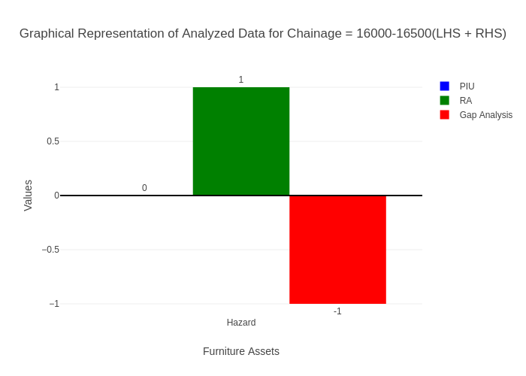

# Chainage: 16500-17000

## PIU Data:

|  |  |  |  |
| --- | --- | --- | --- |
| **Furniture Assets** | **16500-17000** | **17000-16500** | **LHS+RHS** |
| Chevron | 0.0 | 0.0 | 0.0 |
| Cautionary Warning Signs | 3.0 | 0.0 | 3.0 |
| Hazard | 1.0 | 0.0 | 1.0 |
| Prohibitory Mandatory Signs | 0.0 | 0.0 | 0.0 |
| Informatory Signs | 5.0 | 1.0 | 6.0 |

## RA Data:

|  |  |  |  |
| --- | --- | --- | --- |
| **Furniture Assets** | **16500-17000** | **17000-16500** | **LHS+RHS** |
| Chevron | 0.0 | 0.0 | 0.0 |
| Cautionary Warning Signs | 0.0 | 0.0 | 0.0 |
| Hazard | 0.0 | 0.0 | 0.0 |
| Prohibitory Mandatory Signs | 3.0 | 0.0 | 3.0 |
| Informatory Signs | 1.0 | 0.0 | 1.0 |

## Gap Analysis:

|  |  |  |  |
| --- | --- | --- | --- |
| **Furniture Assets** | **16500-17000** | **17000-16500** | **LHS+RHS** |
| Chevron | 0.0 | 0.0 | 0.0 |
| Cautionary Warning Signs | 3.0 | 0.0 | 3.0 |
| Hazard | 1.0 | 0.0 | 1.0 |
| Prohibitory Mandatory Signs | -3.0 | 0.0 | -3.0 |
| Informatory Signs | 4.0 | 1.0 | 5.0 |

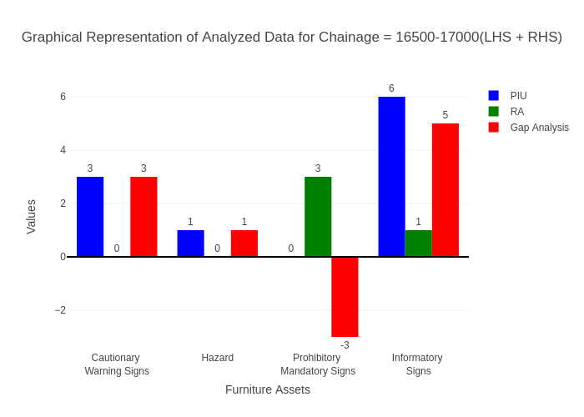

# Chainage: 17000-17500

## PIU Data:

|  |  |  |  |
| --- | --- | --- | --- |
| **Furniture Assets** | **17000-17500** | **17500-17000** | **LHS+RHS** |
| Chevron | 1.0 | 0.0 | 1.0 |
| Cautionary Warning Signs | 2.0 | 0.0 | 2.0 |
| Hazard | 2.0 | 0.0 | 2.0 |
| Prohibitory Mandatory Signs | 0.0 | 0.0 | 0.0 |
| Informatory Signs | 1.0 | 0.0 | 1.0 |

## RA Data:

|  |  |  |  |
| --- | --- | --- | --- |
| **Furniture Assets** | **17000-17500** | **17500-17000** | **LHS+RHS** |
| Chevron | 0.0 | 0.0 | 0.0 |
| Cautionary Warning Signs | 1.0 | 2.0 | 3.0 |
| Hazard | 2.0 | 1.0 | 3.0 |
| Prohibitory Mandatory Signs | 1.0 | 2.0 | 3.0 |
| Informatory Signs | 0.0 | 1.0 | 1.0 |

## Gap Analysis:

|  |  |  |  |
| --- | --- | --- | --- |
| **Furniture Assets** | **17000-17500** | **17500-17000** | **LHS+RHS** |
| Chevron | 1.0 | 0.0 | 1.0 |
| Cautionary Warning Signs | 1.0 | -2.0 | -1.0 |
| Hazard | 0.0 | -1.0 | -1.0 |
| Prohibitory Mandatory Signs | -1.0 | -2.0 | -3.0 |
| Informatory Signs | 1.0 | -1.0 | 0.0 |

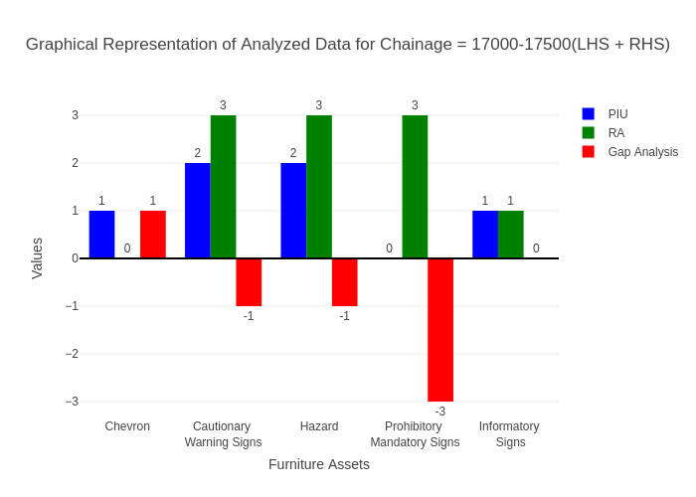

# Chainage: 17500-18000

## PIU Data:

|  |  |  |  |
| --- | --- | --- | --- |
| **Furniture Assets** | **17500-18000** | **18000-17500** | **LHS+RHS** |
| Chevron | 0.0 | 0.0 | 0.0 |
| Cautionary Warning Signs | 1.0 | 0.0 | 1.0 |
| Hazard | 0.0 | 0.0 | 0.0 |
| Prohibitory Mandatory Signs | 0.0 | 0.0 | 0.0 |
| Informatory Signs | 0.0 | 0.0 | 0.0 |

## RA Data:

|  |  |  |  |
| --- | --- | --- | --- |
| **Furniture Assets** | **17500-18000** | **18000-17500** | **LHS+RHS** |
| Chevron | 0.0 | 0.0 | 0.0 |
| Cautionary Warning Signs | 1.0 | 0.0 | 1.0 |
| Hazard | 0.0 | 1.0 | 1.0 |
| Prohibitory Mandatory Signs | 1.0 | 1.0 | 2.0 |
| Informatory Signs | 0.0 | 1.0 | 1.0 |

## Gap Analysis:

|  |  |  |  |
| --- | --- | --- | --- |
| **Furniture Assets** | **17500-18000** | **18000-17500** | **LHS+RHS** |
| Chevron | 0.0 | 0.0 | 0.0 |
| Cautionary Warning Signs | 0.0 | 0.0 | 0.0 |
| Hazard | 0.0 | -1.0 | -1.0 |
| Prohibitory Mandatory Signs | -1.0 | -1.0 | -2.0 |
| Informatory Signs | 0.0 | -1.0 | -1.0 |

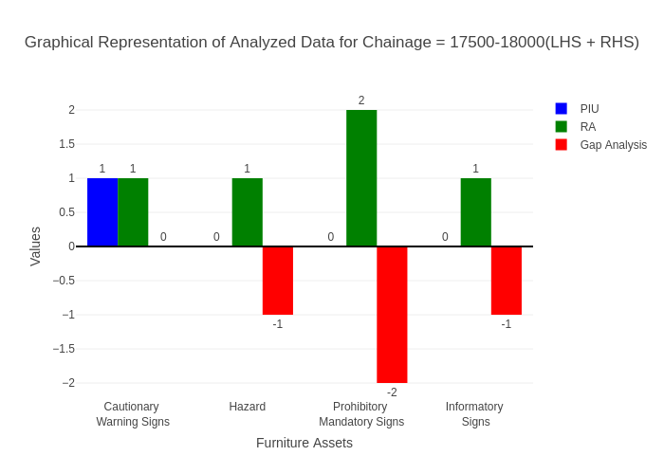

# Chainage: 18000-18500

## PIU Data:

|  |  |  |  |
| --- | --- | --- | --- |
| **Furniture Assets** | **18000-18500** | **18500-18000** | **LHS+RHS** |
| Chevron | 0.0 | 0.0 | 0.0 |
| Cautionary Warning Signs | 0.0 | 0.0 | 0.0 |
| Hazard | 0.0 | 0.0 | 0.0 |
| Prohibitory Mandatory Signs | 0.0 | 0.0 | 0.0 |
| Informatory Signs | 0.0 | 0.0 | 0.0 |

## RA Data:

|  |  |  |  |
| --- | --- | --- | --- |
| **Furniture Assets** | **18000-18500** | **18500-18000** | **LHS+RHS** |
| Chevron | 0.0 | 0.0 | 0.0 |
| Cautionary Warning Signs | 0.0 | 0.0 | 0.0 |
| Hazard | 0.0 | 0.0 | 0.0 |
| Prohibitory Mandatory Signs | 0.0 | 0.0 | 0.0 |
| Informatory Signs | 0.0 | 0.0 | 0.0 |

## Gap Analysis:

|  |  |  |  |
| --- | --- | --- | --- |
| **Furniture Assets** | **18000-18500** | **18500-18000** | **LHS+RHS** |
| Chevron | 0.0 | 0.0 | 0.0 |
| Cautionary Warning Signs | 0.0 | 0.0 | 0.0 |
| Hazard | 0.0 | 0.0 | 0.0 |
| Prohibitory Mandatory Signs | 0.0 | 0.0 | 0.0 |
| Informatory Signs | 0.0 | 0.0 | 0.0 |

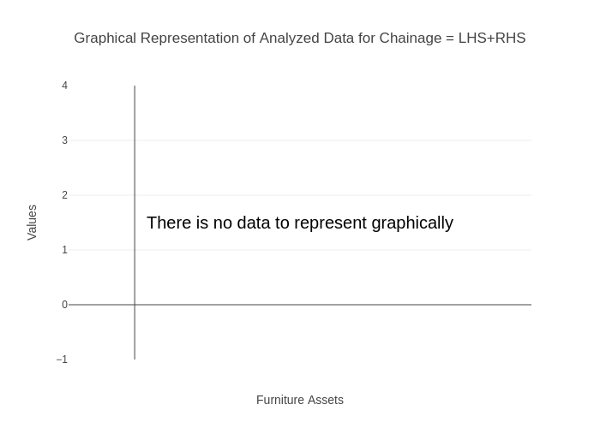

# Chainage: 18500-19000

## PIU Data:

|  |  |  |  |
| --- | --- | --- | --- |
| **Furniture Assets** | **18500-19000** | **19000-18500** | **LHS+RHS** |
| Chevron | 0.0 | 0.0 | 0.0 |
| Cautionary Warning Signs | 1.0 | 0.0 | 1.0 |
| Hazard | 1.0 | 0.0 | 1.0 |
| Prohibitory Mandatory Signs | 0.0 | 0.0 | 0.0 |
| Informatory Signs | 0.0 | 0.0 | 0.0 |

## RA Data:

|  |  |  |  |
| --- | --- | --- | --- |
| **Furniture Assets** | **18500-19000** | **19000-18500** | **LHS+RHS** |
| Chevron | 0.0 | 0.0 | 0.0 |
| Cautionary Warning Signs | 1.0 | 0.0 | 1.0 |
| Hazard | 2.0 | 0.0 | 2.0 |
| Prohibitory Mandatory Signs | 1.0 | 0.0 | 1.0 |
| Informatory Signs | 1.0 | 0.0 | 1.0 |

## Gap Analysis:

|  |  |  |  |
| --- | --- | --- | --- |
| **Furniture Assets** | **18500-19000** | **19000-18500** | **LHS+RHS** |
| Chevron | 0.0 | 0.0 | 0.0 |
| Cautionary Warning Signs | 0.0 | 0.0 | 0.0 |
| Hazard | -1.0 | 0.0 | -1.0 |
| Prohibitory Mandatory Signs | -1.0 | 0.0 | -1.0 |
| Informatory Signs | -1.0 | 0.0 | -1.0 |

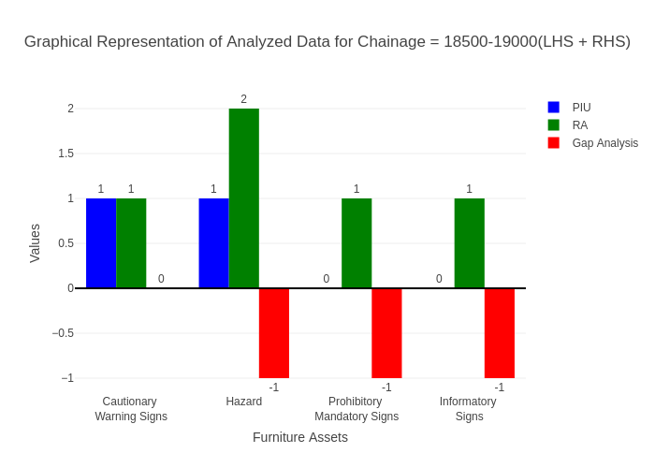

# Chainage: 19000-19500

## PIU Data:

|  |  |  |  |
| --- | --- | --- | --- |
| **Furniture Assets** | **19000-19500** | **19500-19000** | **LHS+RHS** |
| Chevron | 1.0 | 0.0 | 1.0 |
| Cautionary Warning Signs | 1.0 | 0.0 | 1.0 |
| Hazard | 2.0 | 0.0 | 2.0 |
| Prohibitory Mandatory Signs | 0.0 | 0.0 | 0.0 |
| Informatory Signs | 0.0 | 0.0 | 0.0 |

## RA Data:

|  |  |  |  |
| --- | --- | --- | --- |
| **Furniture Assets** | **19000-19500** | **19500-19000** | **LHS+RHS** |
| Chevron | 0.0 | 0.0 | 0.0 |
| Cautionary Warning Signs | 0.0 | 1.0 | 1.0 |
| Hazard | 0.0 | 0.0 | 0.0 |
| Prohibitory Mandatory Signs | 0.0 | 1.0 | 1.0 |
| Informatory Signs | 0.0 | 1.0 | 1.0 |

## Gap Analysis:

|  |  |  |  |
| --- | --- | --- | --- |
| **Furniture Assets** | **19000-19500** | **19500-19000** | **LHS+RHS** |
| Chevron | 1.0 | 0.0 | 1.0 |
| Cautionary Warning Signs | 1.0 | -1.0 | 0.0 |
| Hazard | 2.0 | 0.0 | 2.0 |
| Prohibitory Mandatory Signs | 0.0 | -1.0 | -1.0 |
| Informatory Signs | 0.0 | -1.0 | -1.0 |

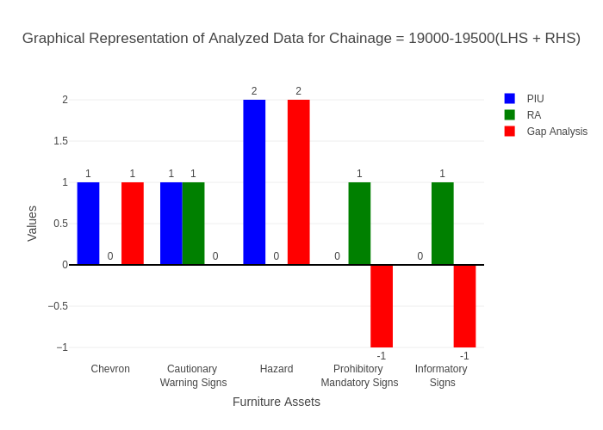

# Chainage: 19500-20000

## PIU Data:

|  |  |  |  |
| --- | --- | --- | --- |
| **Furniture Assets** | **19500-20000** | **20000-19500** | **LHS+RHS** |
| Chevron | 0.0 | 0.0 | 0.0 |
| Cautionary Warning Signs | 1.0 | 0.0 | 1.0 |
| Hazard | 0.0 | 0.0 | 0.0 |
| Prohibitory Mandatory Signs | 1.0 | 0.0 | 1.0 |
| Informatory Signs | 0.0 | 1.0 | 1.0 |

## RA Data:

|  |  |  |  |
| --- | --- | --- | --- |
| **Furniture Assets** | **19500-20000** | **20000-19500** | **LHS+RHS** |
| Chevron | 0.0 | 0.0 | 0.0 |
| Cautionary Warning Signs | 1.0 | 1.0 | 2.0 |
| Hazard | 0.0 | 0.0 | 0.0 |
| Prohibitory Mandatory Signs | 1.0 | 1.0 | 2.0 |
| Informatory Signs | 0.0 | 0.0 | 0.0 |

## Gap Analysis:

|  |  |  |  |
| --- | --- | --- | --- |
| **Furniture Assets** | **19500-20000** | **20000-19500** | **LHS+RHS** |
| Chevron | 0.0 | 0.0 | 0.0 |
| Cautionary Warning Signs | 0.0 | -1.0 | -1.0 |
| Hazard | 0.0 | 0.0 | 0.0 |
| Prohibitory Mandatory Signs | 0.0 | -1.0 | -1.0 |
| Informatory Signs | 0.0 | 1.0 | 1.0 |

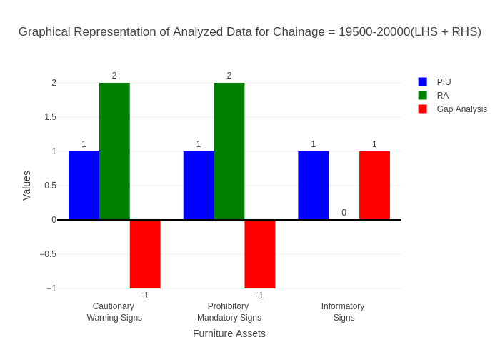

# Chainage: 20000-20500

## PIU Data:

|  |  |  |  |
| --- | --- | --- | --- |
| **Furniture Assets** | **20000-20500** | **20500-20000** | **LHS+RHS** |
| Chevron | 0.0 | 0.0 | 0.0 |
| Cautionary Warning Signs | 1.0 | 0.0 | 1.0 |
| Hazard | 2.0 | 0.0 | 2.0 |
| Prohibitory Mandatory Signs | 0.0 | 0.0 | 0.0 |
| Informatory Signs | 1.0 | 0.0 | 1.0 |

## RA Data:

|  |  |  |  |
| --- | --- | --- | --- |
| **Furniture Assets** | **20000-20500** | **20500-20000** | **LHS+RHS** |
| Chevron | 0.0 | 0.0 | 0.0 |
| Cautionary Warning Signs | 0.0 | 1.0 | 1.0 |
| Hazard | 0.0 | 0.0 | 0.0 |
| Prohibitory Mandatory Signs | 1.0 | 0.0 | 1.0 |
| Informatory Signs | 1.0 | 1.0 | 2.0 |

## Gap Analysis:

|  |  |  |  |
| --- | --- | --- | --- |
| **Furniture Assets** | **20000-20500** | **20500-20000** | **LHS+RHS** |
| Chevron | 0.0 | 0.0 | 0.0 |
| Cautionary Warning Signs | 1.0 | -1.0 | 0.0 |
| Hazard | 2.0 | 0.0 | 2.0 |
| Prohibitory Mandatory Signs | -1.0 | 0.0 | -1.0 |
| Informatory Signs | 0.0 | -1.0 | -1.0 |

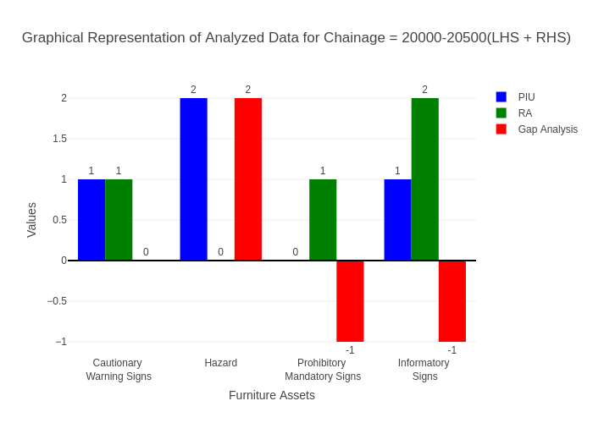

# Chainage: 20500-21000

## PIU Data:

|  |  |  |  |
| --- | --- | --- | --- |
| **Furniture Assets** | **20500-21000** | **21000-20500** | **LHS+RHS** |
| Chevron | 0.0 | 0.0 | 0.0 |
| Cautionary Warning Signs | 0.0 | 0.0 | 0.0 |
| Hazard | 1.0 | 0.0 | 1.0 |
| Prohibitory Mandatory Signs | 0.0 | 0.0 | 0.0 |
| Informatory Signs | 0.0 | 0.0 | 0.0 |

## RA Data:

|  |  |  |  |
| --- | --- | --- | --- |
| **Furniture Assets** | **20500-21000** | **21000-20500** | **LHS+RHS** |
| Chevron | 0.0 | 0.0 | 0.0 |
| Cautionary Warning Signs | 0.0 | 0.0 | 0.0 |
| Hazard | 1.0 | 0.0 | 1.0 |
| Prohibitory Mandatory Signs | 0.0 | 0.0 | 0.0 |
| Informatory Signs | 0.0 | 0.0 | 0.0 |

## Gap Analysis:

|  |  |  |  |
| --- | --- | --- | --- |
| **Furniture Assets** | **20500-21000** | **21000-20500** | **LHS+RHS** |
| Chevron | 0.0 | 0.0 | 0.0 |
| Cautionary Warning Signs | 0.0 | 0.0 | 0.0 |
| Hazard | 0.0 | 0.0 | 0.0 |
| Prohibitory Mandatory Signs | 0.0 | 0.0 | 0.0 |
| Informatory Signs | 0.0 | 0.0 | 0.0 |

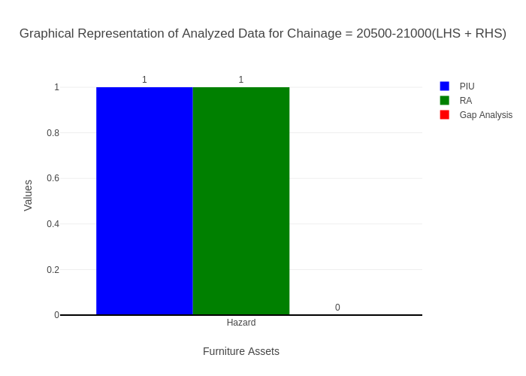

# Chainage: 21000-21500

## PIU Data:

|  |  |  |  |
| --- | --- | --- | --- |
| **Furniture Assets** | **21000-21500** | **21500-21000** | **LHS+RHS** |
| Chevron | 0.0 | 0.0 | 0.0 |
| Cautionary Warning Signs | 0.0 | 0.0 | 0.0 |
| Hazard | 1.0 | 1.0 | 2.0 |
| Prohibitory Mandatory Signs | 0.0 | 0.0 | 0.0 |
| Informatory Signs | 0.0 | 0.0 | 0.0 |

## RA Data:

|  |  |  |  |
| --- | --- | --- | --- |
| **Furniture Assets** | **21000-21500** | **21500-21000** | **LHS+RHS** |
| Chevron | 0.0 | 0.0 | 0.0 |
| Cautionary Warning Signs | 0.0 | 0.0 | 0.0 |
| Hazard | 0.0 | 0.0 | 0.0 |
| Prohibitory Mandatory Signs | 0.0 | 0.0 | 0.0 |
| Informatory Signs | 0.0 | 0.0 | 0.0 |

## Gap Analysis:

|  |  |  |  |
| --- | --- | --- | --- |
| **Furniture Assets** | **21000-21500** | **21500-21000** | **LHS+RHS** |
| Chevron | 0.0 | 0.0 | 0.0 |
| Cautionary Warning Signs | 0.0 | 0.0 | 0.0 |
| Hazard | 1.0 | 1.0 | 2.0 |
| Prohibitory Mandatory Signs | 0.0 | 0.0 | 0.0 |
| Informatory Signs | 0.0 | 0.0 | 0.0 |

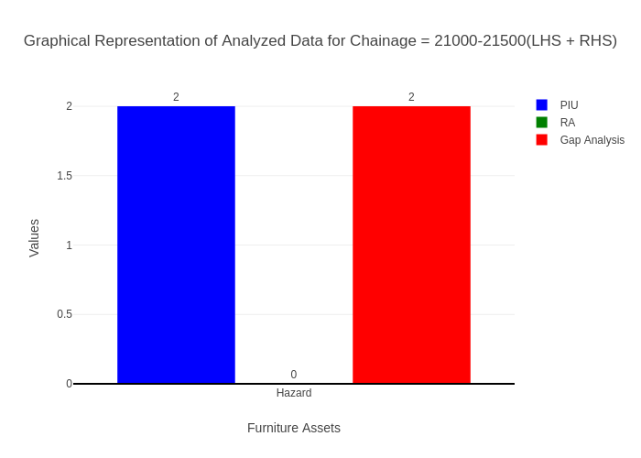

# Chainage: 21500-22000

## PIU Data:

|  |  |  |  |
| --- | --- | --- | --- |
| **Furniture Assets** | **21500-22000** | **22000-21500** | **LHS+RHS** |
| Chevron | 0.0 | 0.0 | 0.0 |
| Cautionary Warning Signs | 0.0 | 0.0 | 0.0 |
| Hazard | 0.0 | 0.0 | 0.0 |
| Prohibitory Mandatory Signs | 0.0 | 0.0 | 0.0 |
| Informatory Signs | 0.0 | 0.0 | 0.0 |

## RA Data:

|  |  |  |  |
| --- | --- | --- | --- |
| **Furniture Assets** | **21500-22000** | **22000-21500** | **LHS+RHS** |
| Chevron | 0.0 | 0.0 | 0.0 |
| Cautionary Warning Signs | 0.0 | 0.0 | 0.0 |
| Hazard | 0.0 | 1.0 | 1.0 |
| Prohibitory Mandatory Signs | 0.0 | 0.0 | 0.0 |
| Informatory Signs | 0.0 | 0.0 | 0.0 |

## Gap Analysis:

|  |  |  |  |
| --- | --- | --- | --- |
| **Furniture Assets** | **21500-22000** | **22000-21500** | **LHS+RHS** |
| Chevron | 0.0 | 0.0 | 0.0 |
| Cautionary Warning Signs | 0.0 | 0.0 | 0.0 |
| Hazard | 0.0 | -1.0 | -1.0 |
| Prohibitory Mandatory Signs | 0.0 | 0.0 | 0.0 |
| Informatory Signs | 0.0 | 0.0 | 0.0 |

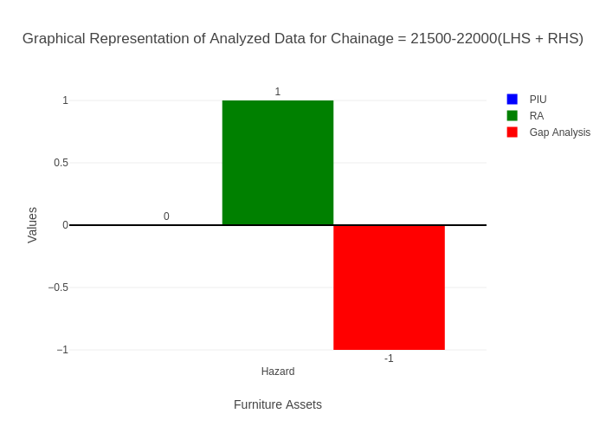

# Chainage: 22000-22500

## PIU Data:

|  |  |  |  |
| --- | --- | --- | --- |
| **Furniture Assets** | **22000-22500** | **22500-22000** | **LHS+RHS** |
| Chevron | 0.0 | 0.0 | 0.0 |
| Cautionary Warning Signs | 2.0 | 0.0 | 2.0 |
| Hazard | 1.0 | 1.0 | 2.0 |
| Prohibitory Mandatory Signs | 0.0 | 0.0 | 0.0 |
| Informatory Signs | 1.0 | 0.0 | 1.0 |

## RA Data:

|  |  |  |  |
| --- | --- | --- | --- |
| **Furniture Assets** | **22000-22500** | **22500-22000** | **LHS+RHS** |
| Chevron | 0.0 | 0.0 | 0.0 |
| Cautionary Warning Signs | 0.0 | 0.0 | 0.0 |
| Hazard | 0.0 | 0.0 | 0.0 |
| Prohibitory Mandatory Signs | 0.0 | 0.0 | 0.0 |
| Informatory Signs | 0.0 | 0.0 | 0.0 |

## Gap Analysis:

|  |  |  |  |
| --- | --- | --- | --- |
| **Furniture Assets** | **22000-22500** | **22500-22000** | **LHS+RHS** |
| Chevron | 0.0 | 0.0 | 0.0 |
| Cautionary Warning Signs | 2.0 | 0.0 | 2.0 |
| Hazard | 1.0 | 1.0 | 2.0 |
| Prohibitory Mandatory Signs | 0.0 | 0.0 | 0.0 |
| Informatory Signs | 1.0 | 0.0 | 1.0 |

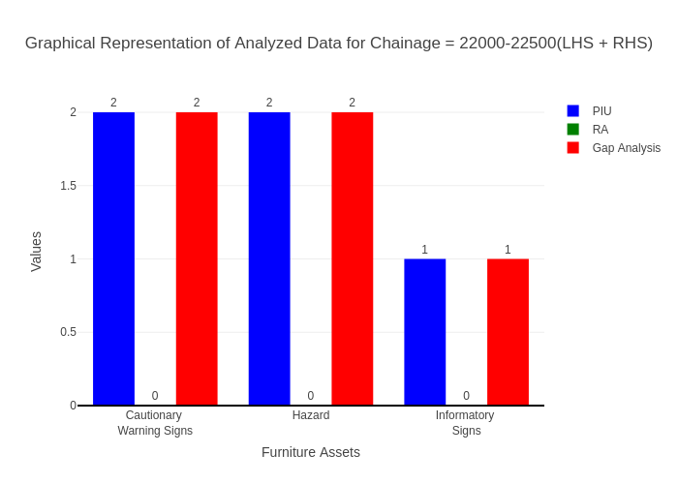

# Chainage: 22500-23000

## PIU Data:

|  |  |  |  |
| --- | --- | --- | --- |
| **Furniture Assets** | **22500-23000** | **23000-22500** | **LHS+RHS** |
| Chevron | 0.0 | 0.0 | 0.0 |
| Cautionary Warning Signs | 0.0 | 0.0 | 0.0 |
| Hazard | 2.0 | 0.0 | 2.0 |
| Prohibitory Mandatory Signs | 0.0 | 0.0 | 0.0 |
| Informatory Signs | 2.0 | 0.0 | 2.0 |

## RA Data:

|  |  |  |  |
| --- | --- | --- | --- |
| **Furniture Assets** | **22500-23000** | **23000-22500** | **LHS+RHS** |
| Chevron | 0.0 | 0.0 | 0.0 |
| Cautionary Warning Signs | 1.0 | 0.0 | 1.0 |
| Hazard | 1.0 | 0.0 | 1.0 |
| Prohibitory Mandatory Signs | 1.0 | 1.0 | 2.0 |
| Informatory Signs | 2.0 | 0.0 | 2.0 |

## Gap Analysis:

|  |  |  |  |
| --- | --- | --- | --- |
| **Furniture Assets** | **22500-23000** | **23000-22500** | **LHS+RHS** |
| Chevron | 0.0 | 0.0 | 0.0 |
| Cautionary Warning Signs | -1.0 | 0.0 | -1.0 |
| Hazard | 1.0 | 0.0 | 1.0 |
| Prohibitory Mandatory Signs | -1.0 | -1.0 | -2.0 |
| Informatory Signs | 0.0 | 0.0 | 0.0 |

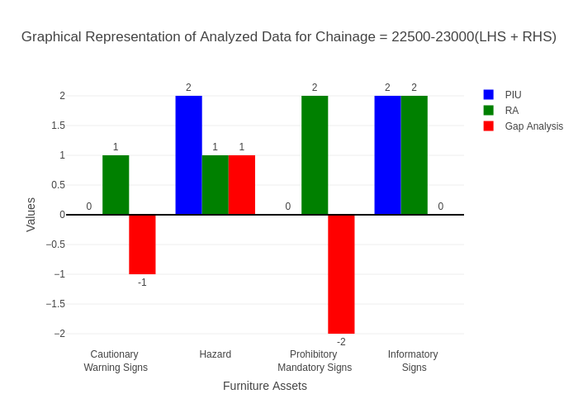

# Chainage: 23000-23500

## PIU Data:

|  |  |  |  |
| --- | --- | --- | --- |
| **Furniture Assets** | **23000-23500** | **23500-23000** | **LHS+RHS** |
| Chevron | 0.0 | 0.0 | 0.0 |
| Cautionary Warning Signs | 0.0 | 0.0 | 0.0 |
| Hazard | 0.0 | 0.0 | 0.0 |
| Prohibitory Mandatory Signs | 0.0 | 0.0 | 0.0 |
| Informatory Signs | 0.0 | 0.0 | 0.0 |

## RA Data:

|  |  |  |  |
| --- | --- | --- | --- |
| **Furniture Assets** | **23000-23500** | **23500-23000** | **LHS+RHS** |
| Chevron | 0.0 | 0.0 | 0.0 |
| Cautionary Warning Signs | 0.0 | 1.0 | 1.0 |
| Hazard | 0.0 | 0.0 | 0.0 |
| Prohibitory Mandatory Signs | 0.0 | 0.0 | 0.0 |
| Informatory Signs | 0.0 | 2.0 | 2.0 |

## Gap Analysis:

|  |  |  |  |
| --- | --- | --- | --- |
| **Furniture Assets** | **23000-23500** | **23500-23000** | **LHS+RHS** |
| Chevron | 0.0 | 0.0 | 0.0 |
| Cautionary Warning Signs | 0.0 | -1.0 | -1.0 |
| Hazard | 0.0 | 0.0 | 0.0 |
| Prohibitory Mandatory Signs | 0.0 | 0.0 | 0.0 |
| Informatory Signs | 0.0 | -2.0 | -2.0 |

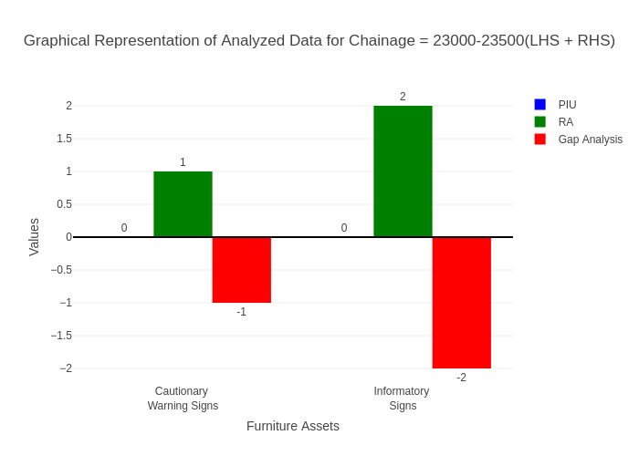

# Chainage: 23500-24000

## PIU Data:

|  |  |  |  |
| --- | --- | --- | --- |
| **Furniture Assets** | **23500-24000** | **24000-23500** | **LHS+RHS** |
| Chevron | 0.0 | 0.0 | 0.0 |
| Cautionary Warning Signs | 0.0 | 0.0 | 0.0 |
| Hazard | 1.0 | 0.0 | 1.0 |
| Prohibitory Mandatory Signs | 0.0 | 0.0 | 0.0 |
| Informatory Signs | 0.0 | 0.0 | 0.0 |

## RA Data:

|  |  |  |  |
| --- | --- | --- | --- |
| **Furniture Assets** | **23500-24000** | **24000-23500** | **LHS+RHS** |
| Chevron | 0.0 | 0.0 | 0.0 |
| Cautionary Warning Signs | 0.0 | 0.0 | 0.0 |
| Hazard | 0.0 | 0.0 | 0.0 |
| Prohibitory Mandatory Signs | 0.0 | 0.0 | 0.0 |
| Informatory Signs | 0.0 | 0.0 | 0.0 |

## Gap Analysis:

|  |  |  |  |
| --- | --- | --- | --- |
| **Furniture Assets** | **23500-24000** | **24000-23500** | **LHS+RHS** |
| Chevron | 0.0 | 0.0 | 0.0 |
| Cautionary Warning Signs | 0.0 | 0.0 | 0.0 |
| Hazard | 1.0 | 0.0 | 1.0 |
| Prohibitory Mandatory Signs | 0.0 | 0.0 | 0.0 |
| Informatory Signs | 0.0 | 0.0 | 0.0 |

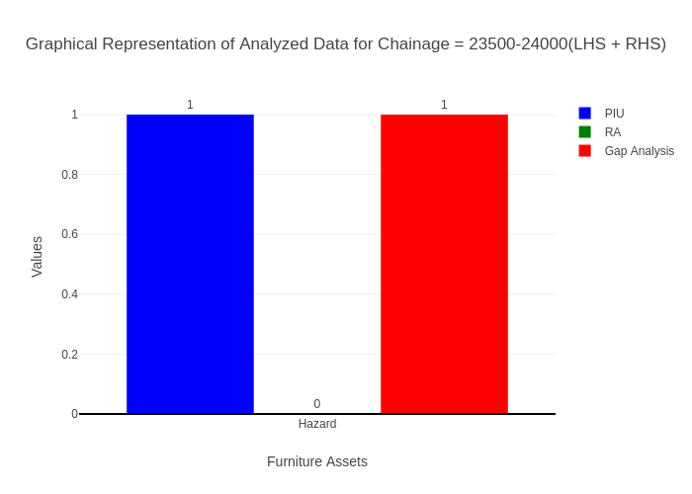

# Chainage: 24000-24500

## PIU Data:

|  |  |  |  |
| --- | --- | --- | --- |
| **Furniture Assets** | **24000-24500** | **24500-24000** | **LHS+RHS** |
| Chevron | 0.0 | 0.0 | 0.0 |
| Cautionary Warning Signs | 1.0 | 3.0 | 4.0 |
| Hazard | 1.0 | 0.0 | 1.0 |
| Prohibitory Mandatory Signs | 0.0 | 0.0 | 0.0 |
| Informatory Signs | 1.0 | 0.0 | 1.0 |

## RA Data:

|  |  |  |  |
| --- | --- | --- | --- |
| **Furniture Assets** | **24000-24500** | **24500-24000** | **LHS+RHS** |
| Chevron | 0.0 | 0.0 | 0.0 |
| Cautionary Warning Signs | 2.0 | 0.0 | 2.0 |
| Hazard | 0.0 | 1.0 | 1.0 |
| Prohibitory Mandatory Signs | 2.0 | 0.0 | 2.0 |
| Informatory Signs | 2.0 | 0.0 | 2.0 |

## Gap Analysis:

|  |  |  |  |
| --- | --- | --- | --- |
| **Furniture Assets** | **24000-24500** | **24500-24000** | **LHS+RHS** |
| Chevron | 0.0 | 0.0 | 0.0 |
| Cautionary Warning Signs | -1.0 | 3.0 | 2.0 |
| Hazard | 1.0 | -1.0 | 0.0 |
| Prohibitory Mandatory Signs | -2.0 | 0.0 | -2.0 |
| Informatory Signs | -1.0 | 0.0 | -1.0 |

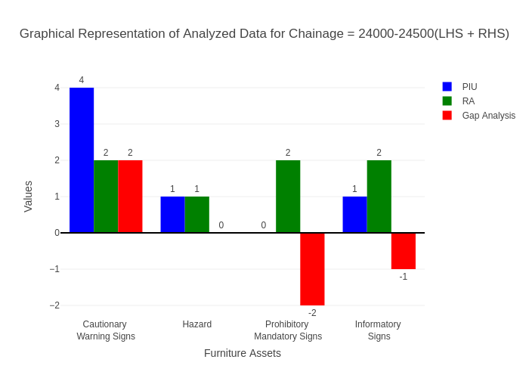

# Chainage: 24500-25000

## PIU Data:

|  |  |  |  |
| --- | --- | --- | --- |
| **Furniture Assets** | **24500-25000** | **25000-24500** | **LHS+RHS** |
| Chevron | 0.0 | 0.0 | 0.0 |
| Cautionary Warning Signs | 1.0 | 0.0 | 1.0 |
| Hazard | 1.0 | 0.0 | 1.0 |
| Prohibitory Mandatory Signs | 0.0 | 0.0 | 0.0 |
| Informatory Signs | 1.0 | 0.0 | 1.0 |

## RA Data:

|  |  |  |  |
| --- | --- | --- | --- |
| **Furniture Assets** | **24500-25000** | **25000-24500** | **LHS+RHS** |
| Chevron | 0.0 | 0.0 | 0.0 |
| Cautionary Warning Signs | 1.0 | 3.0 | 4.0 |
| Hazard | 0.0 | 0.0 | 0.0 |
| Prohibitory Mandatory Signs | 1.0 | 1.0 | 2.0 |
| Informatory Signs | 1.0 | 1.0 | 2.0 |

## Gap Analysis:

|  |  |  |  |
| --- | --- | --- | --- |
| **Furniture Assets** | **24500-25000** | **25000-24500** | **LHS+RHS** |
| Chevron | 0.0 | 0.0 | 0.0 |
| Cautionary Warning Signs | 0.0 | -3.0 | -3.0 |
| Hazard | 1.0 | 0.0 | 1.0 |
| Prohibitory Mandatory Signs | -1.0 | -1.0 | -2.0 |
| Informatory Signs | 0.0 | -1.0 | -1.0 |

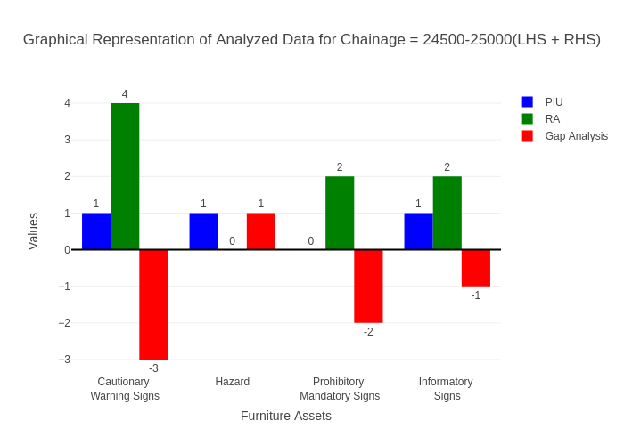

# Chainage: 25000-25500

## PIU Data:

|  |  |  |  |
| --- | --- | --- | --- |
| **Furniture Assets** | **25000-25500** | **25500-25000** | **LHS+RHS** |
| Chevron | 0.0 | 0.0 | 0.0 |
| Cautionary Warning Signs | 1.0 | 0.0 | 1.0 |
| Hazard | 0.0 | 0.0 | 0.0 |
| Prohibitory Mandatory Signs | 0.0 | 0.0 | 0.0 |
| Informatory Signs | 1.0 | 1.0 | 2.0 |

## RA Data:

|  |  |  |  |
| --- | --- | --- | --- |
| **Furniture Assets** | **25000-25500** | **25500-25000** | **LHS+RHS** |
| Chevron | 0.0 | 0.0 | 0.0 |
| Cautionary Warning Signs | 1.0 | 1.0 | 2.0 |
| Hazard | 0.0 | 1.0 | 1.0 |
| Prohibitory Mandatory Signs | 1.0 | 7.0 | 8.0 |
| Informatory Signs | 1.0 | 6.0 | 7.0 |

## Gap Analysis:

|  |  |  |  |
| --- | --- | --- | --- |
| **Furniture Assets** | **25000-25500** | **25500-25000** | **LHS+RHS** |
| Chevron | 0.0 | 0.0 | 0.0 |
| Cautionary Warning Signs | 0.0 | -1.0 | -1.0 |
| Hazard | 0.0 | -1.0 | -1.0 |
| Prohibitory Mandatory Signs | -1.0 | -7.0 | -8.0 |
| Informatory Signs | 0.0 | -5.0 | -5.0 |

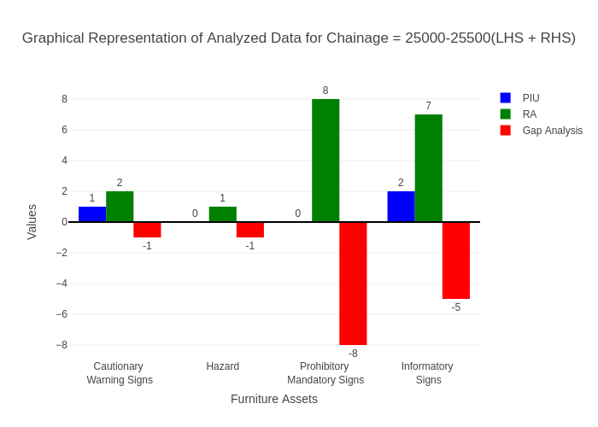

# Chainage: 25500-26000

## PIU Data:

|  |  |  |  |
| --- | --- | --- | --- |
| **Furniture Assets** | **25500-26000** | **26000-25500** | **LHS+RHS** |
| Chevron | 0.0 | 0.0 | 0.0 |
| Cautionary Warning Signs | 0.0 | 0.0 | 0.0 |
| Hazard | 1.0 | 0.0 | 1.0 |
| Prohibitory Mandatory Signs | 0.0 | 0.0 | 0.0 |
| Informatory Signs | 0.0 | 0.0 | 0.0 |

## RA Data:

|  |  |  |  |
| --- | --- | --- | --- |
| **Furniture Assets** | **25500-26000** | **26000-25500** | **LHS+RHS** |
| Chevron | 0.0 | 0.0 | 0.0 |
| Cautionary Warning Signs | 0.0 | 2.0 | 2.0 |
| Hazard | 1.0 | 0.0 | 1.0 |
| Prohibitory Mandatory Signs | 0.0 | 1.0 | 1.0 |
| Informatory Signs | 0.0 | 1.0 | 1.0 |

## Gap Analysis:

|  |  |  |  |
| --- | --- | --- | --- |
| **Furniture Assets** | **25500-26000** | **26000-25500** | **LHS+RHS** |
| Chevron | 0.0 | 0.0 | 0.0 |
| Cautionary Warning Signs | 0.0 | -2.0 | -2.0 |
| Hazard | 0.0 | 0.0 | 0.0 |
| Prohibitory Mandatory Signs | 0.0 | -1.0 | -1.0 |
| Informatory Signs | 0.0 | -1.0 | -1.0 |

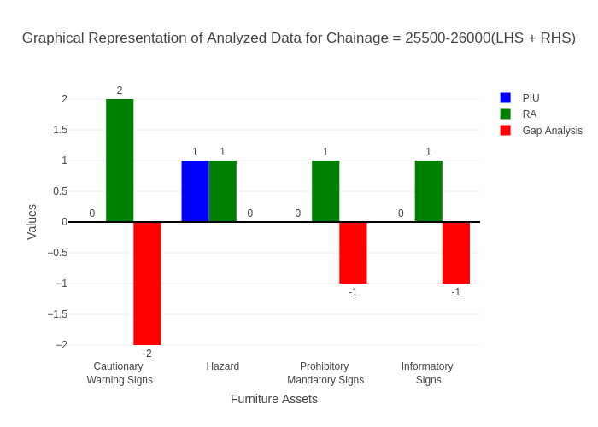

# Chainage: 26000-26500

## PIU Data:

|  |  |  |  |
| --- | --- | --- | --- |
| **Furniture Assets** | **26000-26500** | **26500-26000** | **LHS+RHS** |
| Chevron | 0.0 | 0.0 | 0.0 |
| Cautionary Warning Signs | 0.0 | 0.0 | 0.0 |
| Hazard | 1.0 | 0.0 | 1.0 |
| Prohibitory Mandatory Signs | 0.0 | 0.0 | 0.0 |
| Informatory Signs | 1.0 | 1.0 | 2.0 |

## RA Data:

|  |  |  |  |
| --- | --- | --- | --- |
| **Furniture Assets** | **26000-26500** | **26500-26000** | **LHS+RHS** |
| Chevron | 0.0 | 0.0 | 0.0 |
| Cautionary Warning Signs | 0.0 | 0.0 | 0.0 |
| Hazard | 0.0 | 1.0 | 1.0 |
| Prohibitory Mandatory Signs | 0.0 | 0.0 | 0.0 |
| Informatory Signs | 1.0 | 0.0 | 1.0 |

## Gap Analysis:

|  |  |  |  |
| --- | --- | --- | --- |
| **Furniture Assets** | **26000-26500** | **26500-26000** | **LHS+RHS** |
| Chevron | 0.0 | 0.0 | 0.0 |
| Cautionary Warning Signs | 0.0 | 0.0 | 0.0 |
| Hazard | 1.0 | -1.0 | 0.0 |
| Prohibitory Mandatory Signs | 0.0 | 0.0 | 0.0 |
| Informatory Signs | 0.0 | 1.0 | 1.0 |

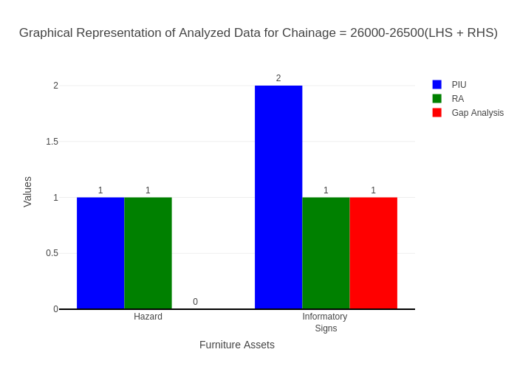

# Chainage: 26500-27000

## PIU Data:

|  |  |  |  |
| --- | --- | --- | --- |
| **Furniture Assets** | **26500-27000** | **27000-26500** | **LHS+RHS** |
| Chevron | 0.0 | 0.0 | 0.0 |
| Cautionary Warning Signs | 0.0 | 0.0 | 0.0 |
| Hazard | 0.0 | 0.0 | 0.0 |
| Prohibitory Mandatory Signs | 0.0 | 0.0 | 0.0 |
| Informatory Signs | 0.0 | 0.0 | 0.0 |

## RA Data:

|  |  |  |  |
| --- | --- | --- | --- |
| **Furniture Assets** | **26500-27000** | **27000-26500** | **LHS+RHS** |
| Chevron | 0.0 | 0.0 | 0.0 |
| Cautionary Warning Signs | 0.0 | 0.0 | 0.0 |
| Hazard | 0.0 | 0.0 | 0.0 |
| Prohibitory Mandatory Signs | 0.0 | 0.0 | 0.0 |
| Informatory Signs | 0.0 | 1.0 | 1.0 |

## Gap Analysis:

|  |  |  |  |
| --- | --- | --- | --- |
| **Furniture Assets** | **26500-27000** | **27000-26500** | **LHS+RHS** |
| Chevron | 0.0 | 0.0 | 0.0 |
| Cautionary Warning Signs | 0.0 | 0.0 | 0.0 |
| Hazard | 0.0 | 0.0 | 0.0 |
| Prohibitory Mandatory Signs | 0.0 | 0.0 | 0.0 |
| Informatory Signs | 0.0 | -1.0 | -1.0 |

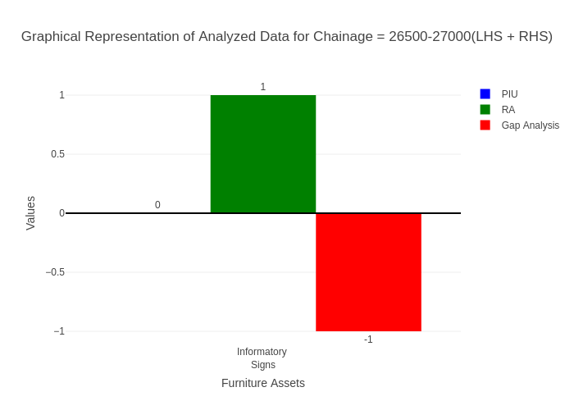

# Chainage: 27000-27500

## PIU Data:

|  |  |  |  |
| --- | --- | --- | --- |
| **Furniture Assets** | **27000-27500** | **27500-27000** | **LHS+RHS** |
| Chevron | 0.0 | 0.0 | 0.0 |
| Cautionary Warning Signs | 2.0 | 0.0 | 2.0 |
| Hazard | 1.0 | 0.0 | 1.0 |
| Prohibitory Mandatory Signs | 0.0 | 0.0 | 0.0 |
| Informatory Signs | 3.0 | 1.0 | 4.0 |

## RA Data:

|  |  |  |  |
| --- | --- | --- | --- |
| **Furniture Assets** | **27000-27500** | **27500-27000** | **LHS+RHS** |
| Chevron | 0.0 | 0.0 | 0.0 |
| Cautionary Warning Signs | 1.0 | 0.0 | 1.0 |
| Hazard | 1.0 | 0.0 | 1.0 |
| Prohibitory Mandatory Signs | 0.0 | 0.0 | 0.0 |
| Informatory Signs | 1.0 | 0.0 | 1.0 |

## Gap Analysis:

|  |  |  |  |
| --- | --- | --- | --- |
| **Furniture Assets** | **27000-27500** | **27500-27000** | **LHS+RHS** |
| Chevron | 0.0 | 0.0 | 0.0 |
| Cautionary Warning Signs | 1.0 | 0.0 | 1.0 |
| Hazard | 0.0 | 0.0 | 0.0 |
| Prohibitory Mandatory Signs | 0.0 | 0.0 | 0.0 |
| Informatory Signs | 2.0 | 1.0 | 3.0 |

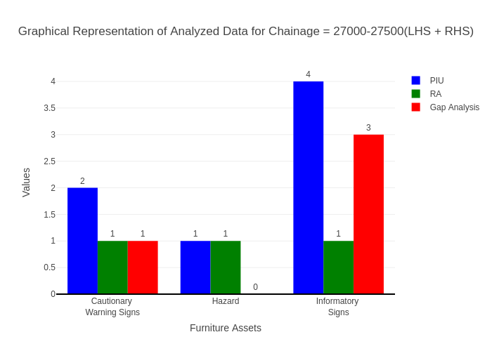

# Chainage: 27500-28000

## PIU Data:

|  |  |  |  |
| --- | --- | --- | --- |
| **Furniture Assets** | **27500-28000** | **28000-27500** | **LHS+RHS** |
| Chevron | 0.0 | 0.0 | 0.0 |
| Cautionary Warning Signs | 0.0 | 1.0 | 1.0 |
| Hazard | 0.0 | 0.0 | 0.0 |
| Prohibitory Mandatory Signs | 0.0 | 0.0 | 0.0 |
| Informatory Signs | 0.0 | 1.0 | 1.0 |

## RA Data:

|  |  |  |  |
| --- | --- | --- | --- |
| **Furniture Assets** | **27500-28000** | **28000-27500** | **LHS+RHS** |
| Chevron | 0.0 | 0.0 | 0.0 |
| Cautionary Warning Signs | 0.0 | 4.0 | 4.0 |
| Hazard | 0.0 | 0.0 | 0.0 |
| Prohibitory Mandatory Signs | 0.0 | 1.0 | 1.0 |
| Informatory Signs | 2.0 | 3.0 | 5.0 |

## Gap Analysis:

|  |  |  |  |
| --- | --- | --- | --- |
| **Furniture Assets** | **27500-28000** | **28000-27500** | **LHS+RHS** |
| Chevron | 0.0 | 0.0 | 0.0 |
| Cautionary Warning Signs | 0.0 | -3.0 | -3.0 |
| Hazard | 0.0 | 0.0 | 0.0 |
| Prohibitory Mandatory Signs | 0.0 | -1.0 | -1.0 |
| Informatory Signs | -2.0 | -2.0 | -4.0 |

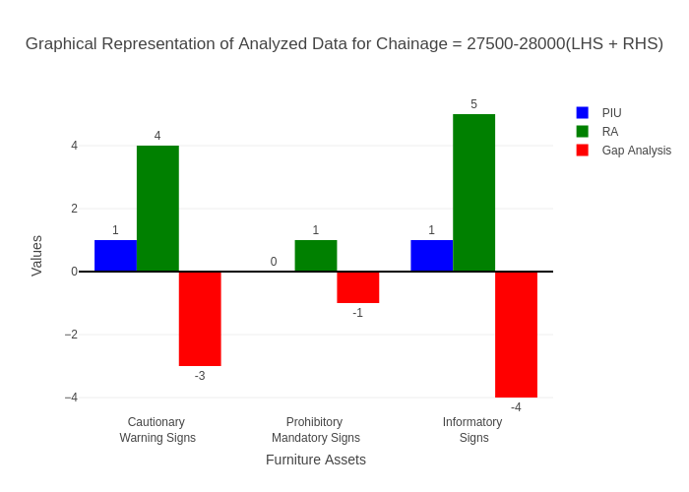

# Chainage: 28000-28500

## PIU Data:

|  |  |  |  |
| --- | --- | --- | --- |
| **Furniture Assets** | **28000-28500** | **28500-28000** | **LHS+RHS** |
| Chevron | 1.0 | 0.0 | 1.0 |
| Cautionary Warning Signs | 1.0 | 0.0 | 1.0 |
| Hazard | 1.0 | 0.0 | 1.0 |
| Prohibitory Mandatory Signs | 0.0 | 0.0 | 0.0 |
| Informatory Signs | 2.0 | 0.0 | 2.0 |

## RA Data:

|  |  |  |  |
| --- | --- | --- | --- |
| **Furniture Assets** | **28000-28500** | **28500-28000** | **LHS+RHS** |
| Chevron | 0.0 | 0.0 | 0.0 |
| Cautionary Warning Signs | 0.0 | 0.0 | 0.0 |
| Hazard | 0.0 | 0.0 | 0.0 |
| Prohibitory Mandatory Signs | 0.0 | 0.0 | 0.0 |
| Informatory Signs | 0.0 | 2.0 | 2.0 |

## Gap Analysis:

|  |  |  |  |
| --- | --- | --- | --- |
| **Furniture Assets** | **28000-28500** | **28500-28000** | **LHS+RHS** |
| Chevron | 1.0 | 0.0 | 1.0 |
| Cautionary Warning Signs | 1.0 | 0.0 | 1.0 |
| Hazard | 1.0 | 0.0 | 1.0 |
| Prohibitory Mandatory Signs | 0.0 | 0.0 | 0.0 |
| Informatory Signs | 2.0 | -2.0 | 0.0 |

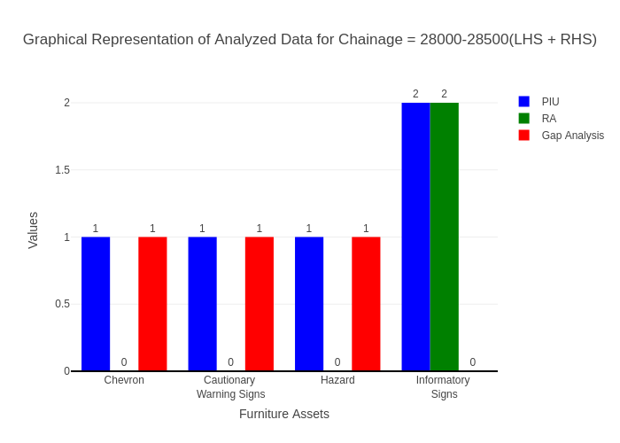

# Chainage: 28500-29000

## PIU Data:

|  |  |  |  |
| --- | --- | --- | --- |
| **Furniture Assets** | **28500-29000** | **29000-28500** | **LHS+RHS** |
| Chevron | 0.0 | 0.0 | 0.0 |
| Cautionary Warning Signs | 0.0 | 0.0 | 0.0 |
| Hazard | 1.0 | 0.0 | 1.0 |
| Prohibitory Mandatory Signs | 0.0 | 0.0 | 0.0 |
| Informatory Signs | 2.0 | 0.0 | 2.0 |

## RA Data:

|  |  |  |  |
| --- | --- | --- | --- |
| **Furniture Assets** | **28500-29000** | **29000-28500** | **LHS+RHS** |
| Chevron | 0.0 | 0.0 | 0.0 |
| Cautionary Warning Signs | 0.0 | 1.0 | 1.0 |
| Hazard | 1.0 | 1.0 | 2.0 |
| Prohibitory Mandatory Signs | 1.0 | 0.0 | 1.0 |
| Informatory Signs | 2.0 | 1.0 | 3.0 |

## Gap Analysis:

|  |  |  |  |
| --- | --- | --- | --- |
| **Furniture Assets** | **28500-29000** | **29000-28500** | **LHS+RHS** |
| Chevron | 0.0 | 0.0 | 0.0 |
| Cautionary Warning Signs | 0.0 | -1.0 | -1.0 |
| Hazard | 0.0 | -1.0 | -1.0 |
| Prohibitory Mandatory Signs | -1.0 | 0.0 | -1.0 |
| Informatory Signs | 0.0 | -1.0 | -1.0 |

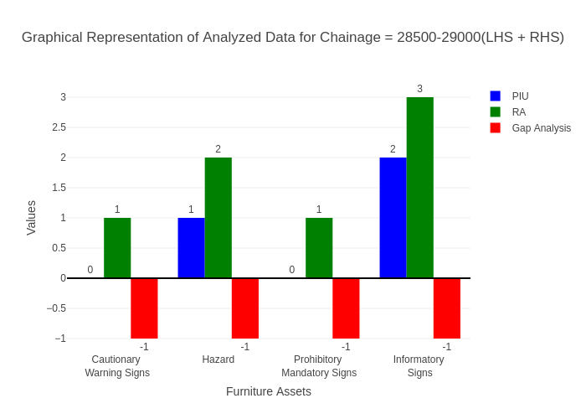

# Chainage: 29000-29500

## PIU Data:

|  |  |  |  |
| --- | --- | --- | --- |
| **Furniture Assets** | **29000-29500** | **29500-29000** | **LHS+RHS** |
| Chevron | 0.0 | 0.0 | 0.0 |
| Cautionary Warning Signs | 1.0 | 1.0 | 2.0 |
| Hazard | 1.0 | 0.0 | 1.0 |
| Prohibitory Mandatory Signs | 0.0 | 0.0 | 0.0 |
| Informatory Signs | 1.0 | 0.0 | 1.0 |

## RA Data:

|  |  |  |  |
| --- | --- | --- | --- |
| **Furniture Assets** | **29000-29500** | **29500-29000** | **LHS+RHS** |
| Chevron | 0.0 | 0.0 | 0.0 |
| Cautionary Warning Signs | 1.0 | 0.0 | 1.0 |
| Hazard | 1.0 | 0.0 | 1.0 |
| Prohibitory Mandatory Signs | 0.0 | 1.0 | 1.0 |
| Informatory Signs | 2.0 | 1.0 | 3.0 |

## Gap Analysis:

|  |  |  |  |
| --- | --- | --- | --- |
| **Furniture Assets** | **29000-29500** | **29500-29000** | **LHS+RHS** |
| Chevron | 0.0 | 0.0 | 0.0 |
| Cautionary Warning Signs | 0.0 | 1.0 | 1.0 |
| Hazard | 0.0 | 0.0 | 0.0 |
| Prohibitory Mandatory Signs | 0.0 | -1.0 | -1.0 |
| Informatory Signs | -1.0 | -1.0 | -2.0 |

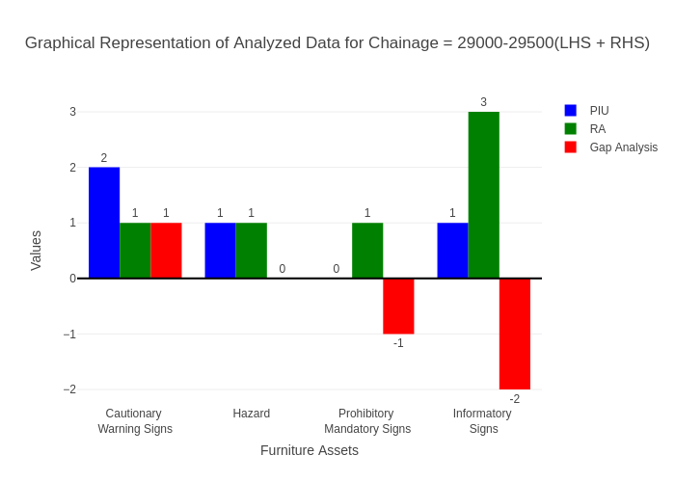

# Chainage: 29500-30000

## PIU Data:

|  |  |  |  |
| --- | --- | --- | --- |
| **Furniture Assets** | **29500-30000** | **30000-29500** | **LHS+RHS** |
| Chevron | 0.0 | 0.0 | 0.0 |
| Cautionary Warning Signs | 0.0 | 0.0 | 0.0 |
| Hazard | 0.0 | 0.0 | 0.0 |
| Prohibitory Mandatory Signs | 0.0 | 0.0 | 0.0 |
| Informatory Signs | 0.0 | 0.0 | 0.0 |

## RA Data:

|  |  |  |  |
| --- | --- | --- | --- |
| **Furniture Assets** | **29500-30000** | **30000-29500** | **LHS+RHS** |
| Chevron | 0.0 | 0.0 | 0.0 |
| Cautionary Warning Signs | 0.0 | 2.0 | 2.0 |
| Hazard | 0.0 | 1.0 | 1.0 |
| Prohibitory Mandatory Signs | 0.0 | 0.0 | 0.0 |
| Informatory Signs | 0.0 | 2.0 | 2.0 |

## Gap Analysis:

|  |  |  |  |
| --- | --- | --- | --- |
| **Furniture Assets** | **29500-30000** | **30000-29500** | **LHS+RHS** |
| Chevron | 0.0 | 0.0 | 0.0 |
| Cautionary Warning Signs | 0.0 | -2.0 | -2.0 |
| Hazard | 0.0 | -1.0 | -1.0 |
| Prohibitory Mandatory Signs | 0.0 | 0.0 | 0.0 |
| Informatory Signs | 0.0 | -2.0 | -2.0 |

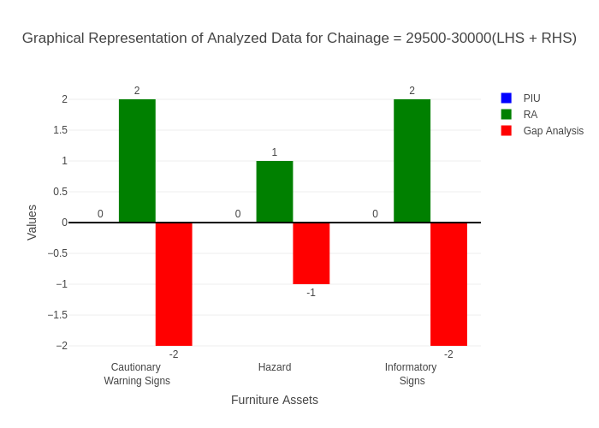

# Chainage: 30000-30500

## PIU Data:

|  |  |  |  |
| --- | --- | --- | --- |
| **Furniture Assets** | **30000-30500** | **30500-30000** | **LHS+RHS** |
| Chevron | 0.0 | 0.0 | 0.0 |
| Cautionary Warning Signs | 0.0 | 0.0 | 0.0 |
| Hazard | 1.0 | 0.0 | 1.0 |
| Prohibitory Mandatory Signs | 0.0 | 0.0 | 0.0 |
| Informatory Signs | 1.0 | 0.0 | 1.0 |

## RA Data:

|  |  |  |  |
| --- | --- | --- | --- |
| **Furniture Assets** | **30000-30500** | **30500-30000** | **LHS+RHS** |
| Chevron | 0.0 | 0.0 | 0.0 |
| Cautionary Warning Signs | 0.0 | 0.0 | 0.0 |
| Hazard | 1.0 | 1.0 | 2.0 |
| Prohibitory Mandatory Signs | 0.0 | 1.0 | 1.0 |
| Informatory Signs | 1.0 | 1.0 | 2.0 |

## Gap Analysis:

|  |  |  |  |
| --- | --- | --- | --- |
| **Furniture Assets** | **30000-30500** | **30500-30000** | **LHS+RHS** |
| Chevron | 0.0 | 0.0 | 0.0 |
| Cautionary Warning Signs | 0.0 | 0.0 | 0.0 |
| Hazard | 0.0 | -1.0 | -1.0 |
| Prohibitory Mandatory Signs | 0.0 | -1.0 | -1.0 |
| Informatory Signs | 0.0 | -1.0 | -1.0 |

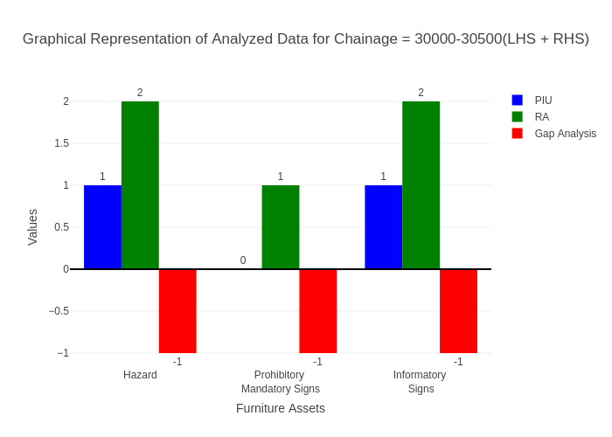

# Chainage: 30500-31000

## PIU Data:

|  |  |  |  |
| --- | --- | --- | --- |
| **Furniture Assets** | **30500-31000** | **31000-30500** | **LHS+RHS** |
| Chevron | 0.0 | 0.0 | 0.0 |
| Cautionary Warning Signs | 3.0 | 1.0 | 4.0 |
| Hazard | 2.0 | 0.0 | 2.0 |
| Prohibitory Mandatory Signs | 0.0 | 0.0 | 0.0 |
| Informatory Signs | 3.0 | 1.0 | 4.0 |

## RA Data:

|  |  |  |  |
| --- | --- | --- | --- |
| **Furniture Assets** | **30500-31000** | **31000-30500** | **LHS+RHS** |
| Chevron | 0.0 | 0.0 | 0.0 |
| Cautionary Warning Signs | 3.0 | 0.0 | 3.0 |
| Hazard | 1.0 | 0.0 | 1.0 |
| Prohibitory Mandatory Signs | 1.0 | 0.0 | 1.0 |
| Informatory Signs | 1.0 | 0.0 | 1.0 |

## Gap Analysis:

|  |  |  |  |
| --- | --- | --- | --- |
| **Furniture Assets** | **30500-31000** | **31000-30500** | **LHS+RHS** |
| Chevron | 0.0 | 0.0 | 0.0 |
| Cautionary Warning Signs | 0.0 | 1.0 | 1.0 |
| Hazard | 1.0 | 0.0 | 1.0 |
| Prohibitory Mandatory Signs | -1.0 | 0.0 | -1.0 |
| Informatory Signs | 2.0 | 1.0 | 3.0 |

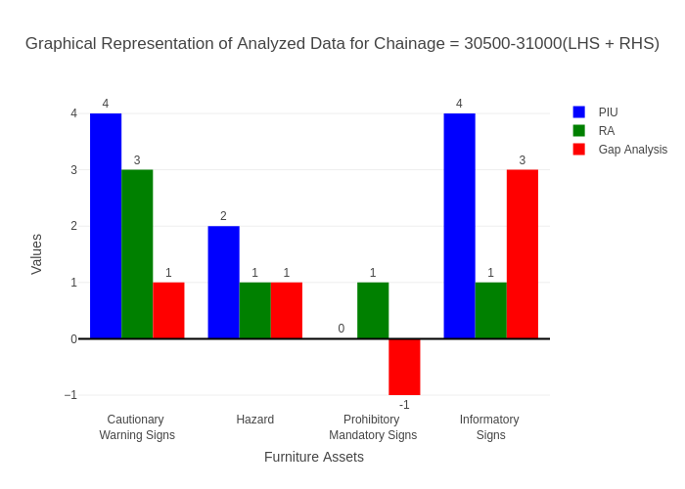

# Chainage: 31000-31500

## PIU Data:

|  |  |  |  |
| --- | --- | --- | --- |
| **Furniture Assets** | **31000-31500** | **31500-31000** | **LHS+RHS** |
| Chevron | 0.0 | 0.0 | 0.0 |
| Cautionary Warning Signs | 2.0 | 0.0 | 2.0 |
| Hazard | 0.0 | 0.0 | 0.0 |
| Prohibitory Mandatory Signs | 0.0 | 0.0 | 0.0 |
| Informatory Signs | 0.0 | 1.0 | 1.0 |

## RA Data:

|  |  |  |  |
| --- | --- | --- | --- |
| **Furniture Assets** | **31000-31500** | **31500-31000** | **LHS+RHS** |
| Chevron | 0.0 | 0.0 | 0.0 |
| Cautionary Warning Signs | 0.0 | 1.0 | 1.0 |
| Hazard | 1.0 | 0.0 | 1.0 |
| Prohibitory Mandatory Signs | 0.0 | 2.0 | 2.0 |
| Informatory Signs | 1.0 | 4.0 | 5.0 |

## Gap Analysis:

|  |  |  |  |
| --- | --- | --- | --- |
| **Furniture Assets** | **31000-31500** | **31500-31000** | **LHS+RHS** |
| Chevron | 0.0 | 0.0 | 0.0 |
| Cautionary Warning Signs | 2.0 | -1.0 | 1.0 |
| Hazard | -1.0 | 0.0 | -1.0 |
| Prohibitory Mandatory Signs | 0.0 | -2.0 | -2.0 |
| Informatory Signs | -1.0 | -3.0 | -4.0 |

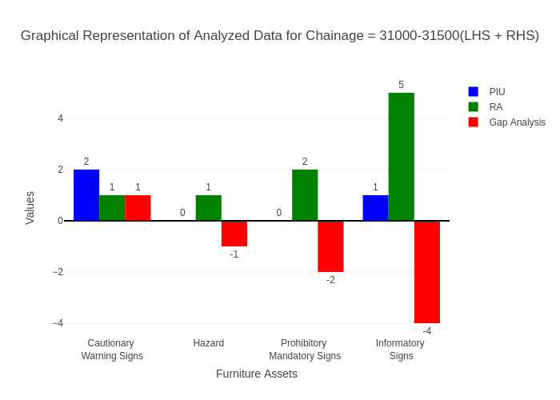

# Chainage: 31500-32000

## PIU Data:

|  |  |  |  |
| --- | --- | --- | --- |
| **Furniture Assets** | **31500-32000** | **32000-31500** | **LHS+RHS** |
| Chevron | 0.0 | 0.0 | 0.0 |
| Cautionary Warning Signs | 1.0 | 0.0 | 1.0 |
| Hazard | 1.0 | 0.0 | 1.0 |
| Prohibitory Mandatory Signs | 0.0 | 0.0 | 0.0 |
| Informatory Signs | 0.0 | 0.0 | 0.0 |

## RA Data:

|  |  |  |  |
| --- | --- | --- | --- |
| **Furniture Assets** | **31500-32000** | **32000-31500** | **LHS+RHS** |
| Chevron | 0.0 | 0.0 | 0.0 |
| Cautionary Warning Signs | 0.0 | 2.0 | 2.0 |
| Hazard | 0.0 | 1.0 | 1.0 |
| Prohibitory Mandatory Signs | 0.0 | 0.0 | 0.0 |
| Informatory Signs | 0.0 | 2.0 | 2.0 |

## Gap Analysis:

|  |  |  |  |
| --- | --- | --- | --- |
| **Furniture Assets** | **31500-32000** | **32000-31500** | **LHS+RHS** |
| Chevron | 0.0 | 0.0 | 0.0 |
| Cautionary Warning Signs | 1.0 | -2.0 | -1.0 |
| Hazard | 1.0 | -1.0 | 0.0 |
| Prohibitory Mandatory Signs | 0.0 | 0.0 | 0.0 |
| Informatory Signs | 0.0 | -2.0 | -2.0 |

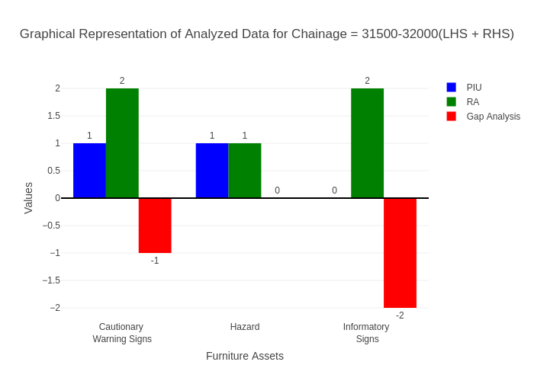

# Chainage: 32000-32500

## PIU Data:

|  |  |  |  |
| --- | --- | --- | --- |
| **Furniture Assets** | **32000-32500** | **32500-32000** | **LHS+RHS** |
| Chevron | 0.0 | 0.0 | 0.0 |
| Cautionary Warning Signs | 1.0 | 0.0 | 1.0 |
| Hazard | 2.0 | 0.0 | 2.0 |
| Prohibitory Mandatory Signs | 0.0 | 0.0 | 0.0 |
| Informatory Signs | 0.0 | 0.0 | 0.0 |

## RA Data:

|  |  |  |  |
| --- | --- | --- | --- |
| **Furniture Assets** | **32000-32500** | **32500-32000** | **LHS+RHS** |
| Chevron | 0.0 | 0.0 | 0.0 |
| Cautionary Warning Signs | 0.0 | 0.0 | 0.0 |
| Hazard | 1.0 | 1.0 | 2.0 |
| Prohibitory Mandatory Signs | 1.0 | 0.0 | 1.0 |
| Informatory Signs | 0.0 | 0.0 | 0.0 |

## Gap Analysis:

|  |  |  |  |
| --- | --- | --- | --- |
| **Furniture Assets** | **32000-32500** | **32500-32000** | **LHS+RHS** |
| Chevron | 0.0 | 0.0 | 0.0 |
| Cautionary Warning Signs | 1.0 | 0.0 | 1.0 |
| Hazard | 1.0 | -1.0 | 0.0 |
| Prohibitory Mandatory Signs | -1.0 | 0.0 | -1.0 |
| Informatory Signs | 0.0 | 0.0 | 0.0 |

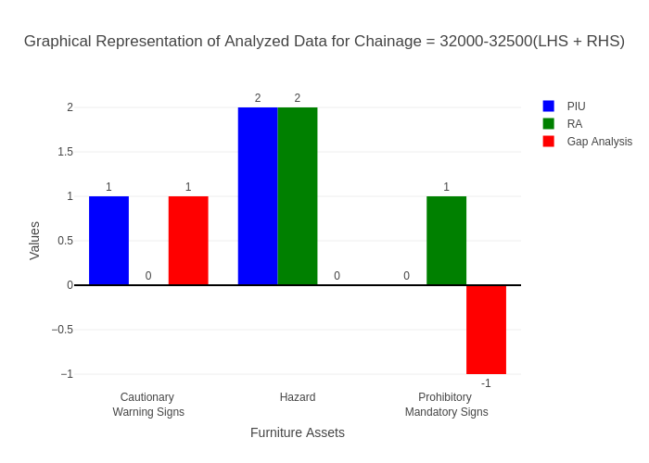

# Chainage: 32500-33000

## PIU Data:

|  |  |  |  |
| --- | --- | --- | --- |
| **Furniture Assets** | **32500-33000** | **33000-32500** | **LHS+RHS** |
| Chevron | 0.0 | 0.0 | 0.0 |
| Cautionary Warning Signs | 0.0 | 0.0 | 0.0 |
| Hazard | 0.0 | 0.0 | 0.0 |
| Prohibitory Mandatory Signs | 0.0 | 0.0 | 0.0 |
| Informatory Signs | 0.0 | 0.0 | 0.0 |

## RA Data:

|  |  |  |  |
| --- | --- | --- | --- |
| **Furniture Assets** | **32500-33000** | **33000-32500** | **LHS+RHS** |
| Chevron | 0.0 | 0.0 | 0.0 |
| Cautionary Warning Signs | 0.0 | 0.0 | 0.0 |
| Hazard | 0.0 | 0.0 | 0.0 |
| Prohibitory Mandatory Signs | 0.0 | 0.0 | 0.0 |
| Informatory Signs | 1.0 | 0.0 | 1.0 |

## Gap Analysis:

|  |  |  |  |
| --- | --- | --- | --- |
| **Furniture Assets** | **32500-33000** | **33000-32500** | **LHS+RHS** |
| Chevron | 0.0 | 0.0 | 0.0 |
| Cautionary Warning Signs | 0.0 | 0.0 | 0.0 |
| Hazard | 0.0 | 0.0 | 0.0 |
| Prohibitory Mandatory Signs | 0.0 | 0.0 | 0.0 |
| Informatory Signs | -1.0 | 0.0 | -1.0 |

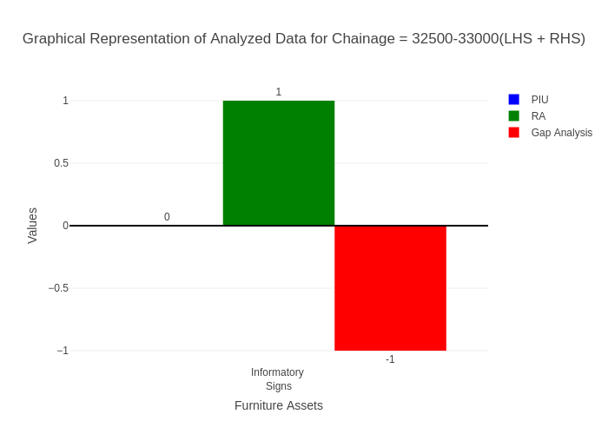

# Chainage: 33000-33500

## PIU Data:

|  |  |  |  |
| --- | --- | --- | --- |
| **Furniture Assets** | **33000-33500** | **33500-33000** | **LHS+RHS** |
| Chevron | 0.0 | 0.0 | 0.0 |
| Cautionary Warning Signs | 2.0 | 0.0 | 2.0 |
| Hazard | 0.0 | 0.0 | 0.0 |
| Prohibitory Mandatory Signs | 0.0 | 0.0 | 0.0 |
| Informatory Signs | 0.0 | 0.0 | 0.0 |

## RA Data:

|  |  |  |  |
| --- | --- | --- | --- |
| **Furniture Assets** | **33000-33500** | **33500-33000** | **LHS+RHS** |
| Chevron | 0.0 | 0.0 | 0.0 |
| Cautionary Warning Signs | 0.0 | 0.0 | 0.0 |
| Hazard | 0.0 | 0.0 | 0.0 |
| Prohibitory Mandatory Signs | 0.0 | 0.0 | 0.0 |
| Informatory Signs | 0.0 | 0.0 | 0.0 |

## Gap Analysis:

|  |  |  |  |
| --- | --- | --- | --- |
| **Furniture Assets** | **33000-33500** | **33500-33000** | **LHS+RHS** |
| Chevron | 0.0 | 0.0 | 0.0 |
| Cautionary Warning Signs | 2.0 | 0.0 | 2.0 |
| Hazard | 0.0 | 0.0 | 0.0 |
| Prohibitory Mandatory Signs | 0.0 | 0.0 | 0.0 |
| Informatory Signs | 0.0 | 0.0 | 0.0 |

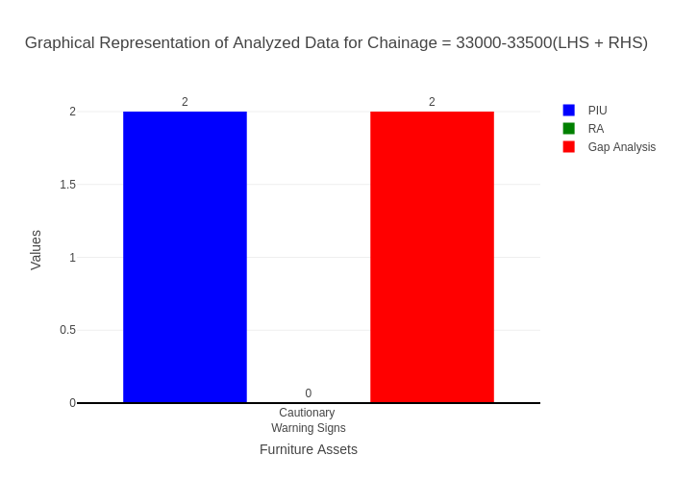

# Chainage: 33500-34000

## PIU Data:

|  |  |  |  |
| --- | --- | --- | --- |
| **Furniture Assets** | **33500-34000** | **34000-33500** | **LHS+RHS** |
| Chevron | 0.0 | 0.0 | 0.0 |
| Cautionary Warning Signs | 3.0 | 0.0 | 3.0 |
| Hazard | 1.0 | 0.0 | 1.0 |
| Prohibitory Mandatory Signs | 0.0 | 0.0 | 0.0 |
| Informatory Signs | 1.0 | 0.0 | 1.0 |

## RA Data:

|  |  |  |  |
| --- | --- | --- | --- |
| **Furniture Assets** | **33500-34000** | **34000-33500** | **LHS+RHS** |
| Chevron | 0.0 | 0.0 | 0.0 |
| Cautionary Warning Signs | 1.0 | 0.0 | 1.0 |
| Hazard | 1.0 | 0.0 | 1.0 |
| Prohibitory Mandatory Signs | 0.0 | 0.0 | 0.0 |
| Informatory Signs | 1.0 | 0.0 | 1.0 |

## Gap Analysis:

|  |  |  |  |
| --- | --- | --- | --- |
| **Furniture Assets** | **33500-34000** | **34000-33500** | **LHS+RHS** |
| Chevron | 0.0 | 0.0 | 0.0 |
| Cautionary Warning Signs | 2.0 | 0.0 | 2.0 |
| Hazard | 0.0 | 0.0 | 0.0 |
| Prohibitory Mandatory Signs | 0.0 | 0.0 | 0.0 |
| Informatory Signs | 0.0 | 0.0 | 0.0 |

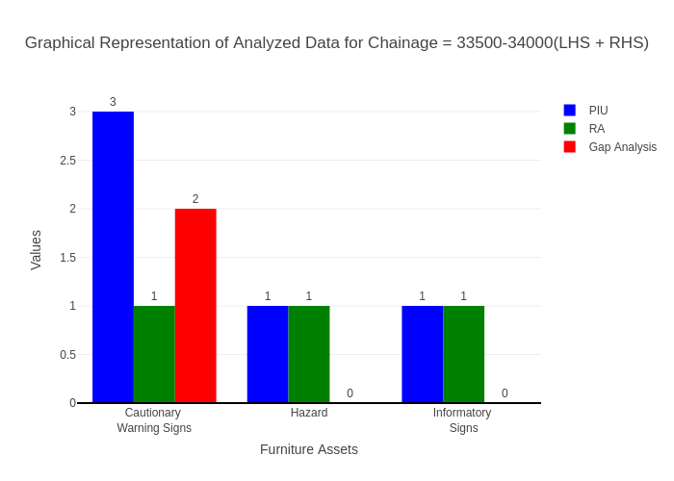

# Chainage: 34000-34500

## PIU Data:

|  |  |  |  |
| --- | --- | --- | --- |
| **Furniture Assets** | **34000-34500** | **34500-34000** | **LHS+RHS** |
| Chevron | 0.0 | 0.0 | 0.0 |
| Cautionary Warning Signs | 0.0 | 0.0 | 0.0 |
| Hazard | 1.0 | 0.0 | 1.0 |
| Prohibitory Mandatory Signs | 0.0 | 0.0 | 0.0 |
| Informatory Signs | 0.0 | 0.0 | 0.0 |

## RA Data:

|  |  |  |  |
| --- | --- | --- | --- |
| **Furniture Assets** | **34000-34500** | **34500-34000** | **LHS+RHS** |
| Chevron | 0.0 | 0.0 | 0.0 |
| Cautionary Warning Signs | 0.0 | 2.0 | 2.0 |
| Hazard | 1.0 | 2.0 | 3.0 |
| Prohibitory Mandatory Signs | 0.0 | 0.0 | 0.0 |
| Informatory Signs | 0.0 | 2.0 | 2.0 |

## Gap Analysis:

|  |  |  |  |
| --- | --- | --- | --- |
| **Furniture Assets** | **34000-34500** | **34500-34000** | **LHS+RHS** |
| Chevron | 0.0 | 0.0 | 0.0 |
| Cautionary Warning Signs | 0.0 | -2.0 | -2.0 |
| Hazard | 0.0 | -2.0 | -2.0 |
| Prohibitory Mandatory Signs | 0.0 | 0.0 | 0.0 |
| Informatory Signs | 0.0 | -2.0 | -2.0 |

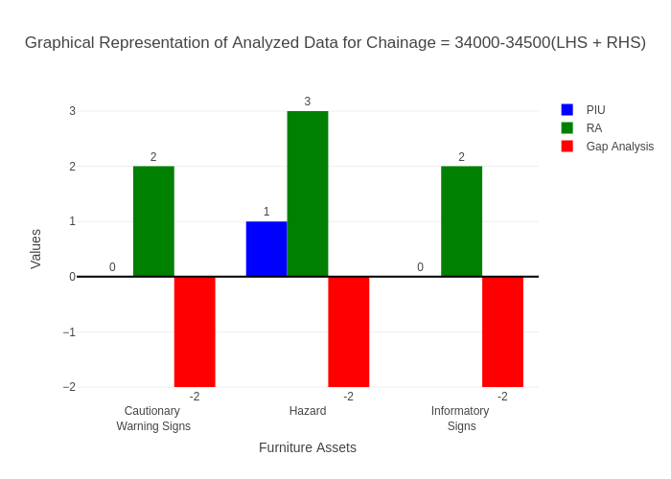

# Chainage: 34500-35000

## PIU Data:

|  |  |  |  |
| --- | --- | --- | --- |
| **Furniture Assets** | **34500-35000** | **35000-34500** | **LHS+RHS** |
| Chevron | 0.0 | 0.0 | 0.0 |
| Cautionary Warning Signs | 0.0 | 0.0 | 0.0 |
| Hazard | 1.0 | 1.0 | 2.0 |
| Prohibitory Mandatory Signs | 0.0 | 0.0 | 0.0 |
| Informatory Signs | 1.0 | 0.0 | 1.0 |

## RA Data:

|  |  |  |  |
| --- | --- | --- | --- |
| **Furniture Assets** | **34500-35000** | **35000-34500** | **LHS+RHS** |
| Chevron | 0.0 | 0.0 | 0.0 |
| Cautionary Warning Signs | 0.0 | 0.0 | 0.0 |
| Hazard | 1.0 | 0.0 | 1.0 |
| Prohibitory Mandatory Signs | 0.0 | 0.0 | 0.0 |
| Informatory Signs | 0.0 | 0.0 | 0.0 |

## Gap Analysis:

|  |  |  |  |
| --- | --- | --- | --- |
| **Furniture Assets** | **34500-35000** | **35000-34500** | **LHS+RHS** |
| Chevron | 0.0 | 0.0 | 0.0 |
| Cautionary Warning Signs | 0.0 | 0.0 | 0.0 |
| Hazard | 0.0 | 1.0 | 1.0 |
| Prohibitory Mandatory Signs | 0.0 | 0.0 | 0.0 |
| Informatory Signs | 1.0 | 0.0 | 1.0 |

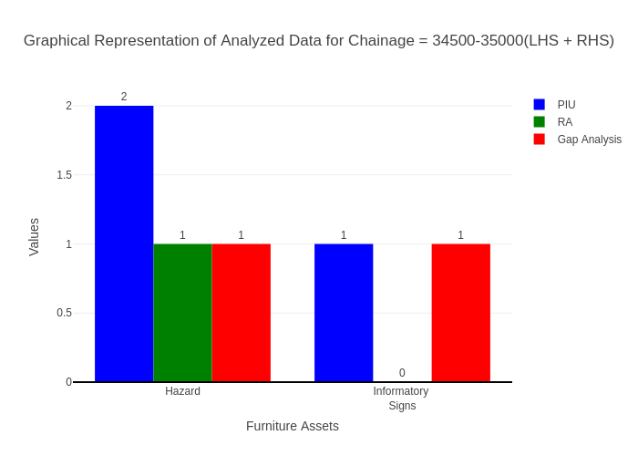

# Chainage: 35000-35500

## PIU Data:

|  |  |  |  |
| --- | --- | --- | --- |
| **Furniture Assets** | **35000-35500** | **35500-35000** | **LHS+RHS** |
| Chevron | 0.0 | 0.0 | 0.0 |
| Cautionary Warning Signs | 1.0 | 0.0 | 1.0 |
| Hazard | 1.0 | 0.0 | 1.0 |
| Prohibitory Mandatory Signs | 0.0 | 0.0 | 0.0 |
| Informatory Signs | 1.0 | 0.0 | 1.0 |

## RA Data:

|  |  |  |  |
| --- | --- | --- | --- |
| **Furniture Assets** | **35000-35500** | **35500-35000** | **LHS+RHS** |
| Chevron | 0.0 | 0.0 | 0.0 |
| Cautionary Warning Signs | 0.0 | 0.0 | 0.0 |
| Hazard | 1.0 | 0.0 | 1.0 |
| Prohibitory Mandatory Signs | 0.0 | 0.0 | 0.0 |
| Informatory Signs | 2.0 | 2.0 | 4.0 |

## Gap Analysis:

|  |  |  |  |
| --- | --- | --- | --- |
| **Furniture Assets** | **35000-35500** | **35500-35000** | **LHS+RHS** |
| Chevron | 0.0 | 0.0 | 0.0 |
| Cautionary Warning Signs | 1.0 | 0.0 | 1.0 |
| Hazard | 0.0 | 0.0 | 0.0 |
| Prohibitory Mandatory Signs | 0.0 | 0.0 | 0.0 |
| Informatory Signs | -1.0 | -2.0 | -3.0 |

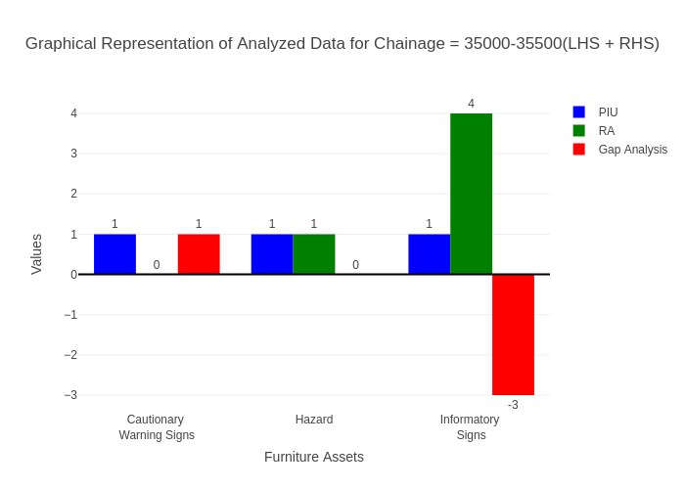

# Chainage: 35500-36000

## PIU Data:

|  |  |  |  |
| --- | --- | --- | --- |
| **Furniture Assets** | **35500-36000** | **36000-35500** | **LHS+RHS** |
| Chevron | 0.0 | 0.0 | 0.0 |
| Cautionary Warning Signs | 1.0 | 0.0 | 1.0 |
| Hazard | 0.0 | 1.0 | 1.0 |
| Prohibitory Mandatory Signs | 0.0 | 0.0 | 0.0 |
| Informatory Signs | 0.0 | 0.0 | 0.0 |

## RA Data:

|  |  |  |  |
| --- | --- | --- | --- |
| **Furniture Assets** | **35500-36000** | **36000-35500** | **LHS+RHS** |
| Chevron | 0.0 | 0.0 | 0.0 |
| Cautionary Warning Signs | 0.0 | 0.0 | 0.0 |
| Hazard | 0.0 | 0.0 | 0.0 |
| Prohibitory Mandatory Signs | 0.0 | 0.0 | 0.0 |
| Informatory Signs | 0.0 | 0.0 | 0.0 |

## Gap Analysis:

|  |  |  |  |
| --- | --- | --- | --- |
| **Furniture Assets** | **35500-36000** | **36000-35500** | **LHS+RHS** |
| Chevron | 0.0 | 0.0 | 0.0 |
| Cautionary Warning Signs | 1.0 | 0.0 | 1.0 |
| Hazard | 0.0 | 1.0 | 1.0 |
| Prohibitory Mandatory Signs | 0.0 | 0.0 | 0.0 |
| Informatory Signs | 0.0 | 0.0 | 0.0 |

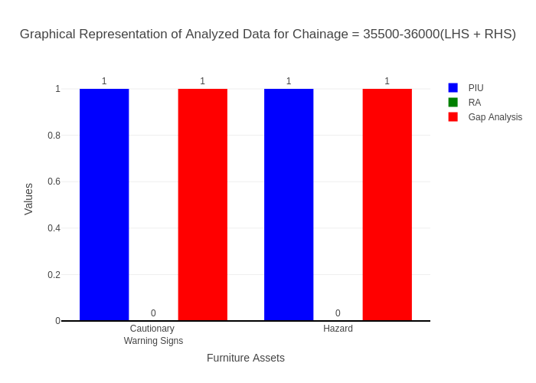

# Chainage: 36000-36500

## PIU Data:

|  |  |  |  |
| --- | --- | --- | --- |
| **Furniture Assets** | **36000-36500** | **36500-36000** | **LHS+RHS** |
| Chevron | 0.0 | 0.0 | 0.0 |
| Cautionary Warning Signs | 2.0 | 0.0 | 2.0 |
| Hazard | 1.0 | 0.0 | 1.0 |
| Prohibitory Mandatory Signs | 0.0 | 0.0 | 0.0 |
| Informatory Signs | 3.0 | 0.0 | 3.0 |

## RA Data:

|  |  |  |  |
| --- | --- | --- | --- |
| **Furniture Assets** | **36000-36500** | **36500-36000** | **LHS+RHS** |
| Chevron | 0.0 | 0.0 | 0.0 |
| Cautionary Warning Signs | 1.0 | 0.0 | 1.0 |
| Hazard | 1.0 | 1.0 | 2.0 |
| Prohibitory Mandatory Signs | 0.0 | 0.0 | 0.0 |
| Informatory Signs | 3.0 | 0.0 | 3.0 |

## Gap Analysis:

|  |  |  |  |
| --- | --- | --- | --- |
| **Furniture Assets** | **36000-36500** | **36500-36000** | **LHS+RHS** |
| Chevron | 0.0 | 0.0 | 0.0 |
| Cautionary Warning Signs | 1.0 | 0.0 | 1.0 |
| Hazard | 0.0 | -1.0 | -1.0 |
| Prohibitory Mandatory Signs | 0.0 | 0.0 | 0.0 |
| Informatory Signs | 0.0 | 0.0 | 0.0 |

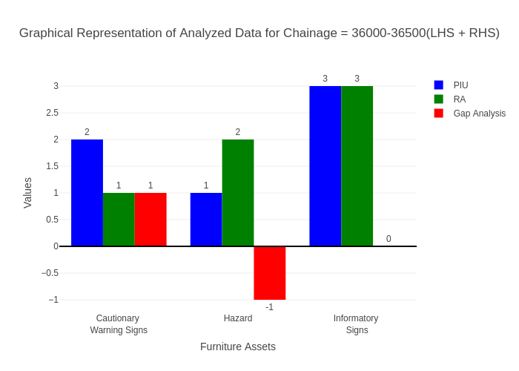

# Chainage: 36500-37000

## PIU Data:

|  |  |  |  |
| --- | --- | --- | --- |
| **Furniture Assets** | **36500-37000** | **37000-36500** | **LHS+RHS** |
| Chevron | 0.0 | 0.0 | 0.0 |
| Cautionary Warning Signs | 0.0 | 0.0 | 0.0 |
| Hazard | 0.0 | 0.0 | 0.0 |
| Prohibitory Mandatory Signs | 0.0 | 0.0 | 0.0 |
| Informatory Signs | 6.0 | 0.0 | 6.0 |

## RA Data:

|  |  |  |  |
| --- | --- | --- | --- |
| **Furniture Assets** | **36500-37000** | **37000-36500** | **LHS+RHS** |
| Chevron | 0.0 | 0.0 | 0.0 |
| Cautionary Warning Signs | 0.0 | 2.0 | 2.0 |
| Hazard | 0.0 | 0.0 | 0.0 |
| Prohibitory Mandatory Signs | 0.0 | 0.0 | 0.0 |
| Informatory Signs | 4.0 | 2.0 | 6.0 |

## Gap Analysis:

|  |  |  |  |
| --- | --- | --- | --- |
| **Furniture Assets** | **36500-37000** | **37000-36500** | **LHS+RHS** |
| Chevron | 0.0 | 0.0 | 0.0 |
| Cautionary Warning Signs | 0.0 | -2.0 | -2.0 |
| Hazard | 0.0 | 0.0 | 0.0 |
| Prohibitory Mandatory Signs | 0.0 | 0.0 | 0.0 |
| Informatory Signs | 2.0 | -2.0 | 0.0 |

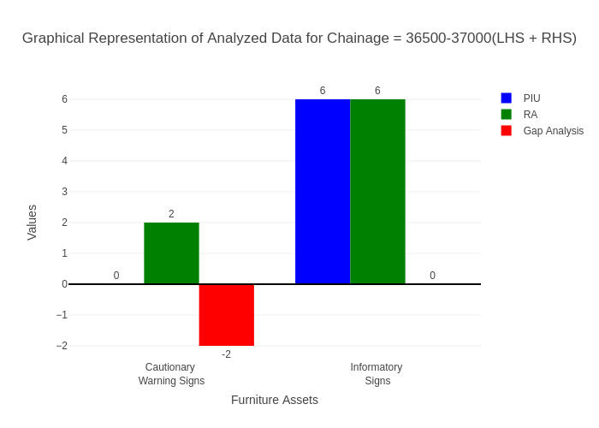

# Chainage: 37000-37500

## PIU Data:

|  |  |  |  |
| --- | --- | --- | --- |
| **Furniture Assets** | **37000-37500** | **37500-37000** | **LHS+RHS** |
| Chevron | 0.0 | 0.0 | 0.0 |
| Cautionary Warning Signs | 0.0 | 0.0 | 0.0 |
| Hazard | 0.0 | 0.0 | 0.0 |
| Prohibitory Mandatory Signs | 0.0 | 0.0 | 0.0 |
| Informatory Signs | 3.0 | 1.0 | 4.0 |

## RA Data:

|  |  |  |  |
| --- | --- | --- | --- |
| **Furniture Assets** | **37000-37500** | **37500-37000** | **LHS+RHS** |
| Chevron | 0.0 | 0.0 | 0.0 |
| Cautionary Warning Signs | 0.0 | 0.0 | 0.0 |
| Hazard | 2.0 | 1.0 | 3.0 |
| Prohibitory Mandatory Signs | 0.0 | 0.0 | 0.0 |
| Informatory Signs | 11.0 | 0.0 | 11.0 |

## Gap Analysis:

|  |  |  |  |
| --- | --- | --- | --- |
| **Furniture Assets** | **37000-37500** | **37500-37000** | **LHS+RHS** |
| Chevron | 0.0 | 0.0 | 0.0 |
| Cautionary Warning Signs | 0.0 | 0.0 | 0.0 |
| Hazard | -2.0 | -1.0 | -3.0 |
| Prohibitory Mandatory Signs | 0.0 | 0.0 | 0.0 |
| Informatory Signs | -8.0 | 1.0 | -7.0 |

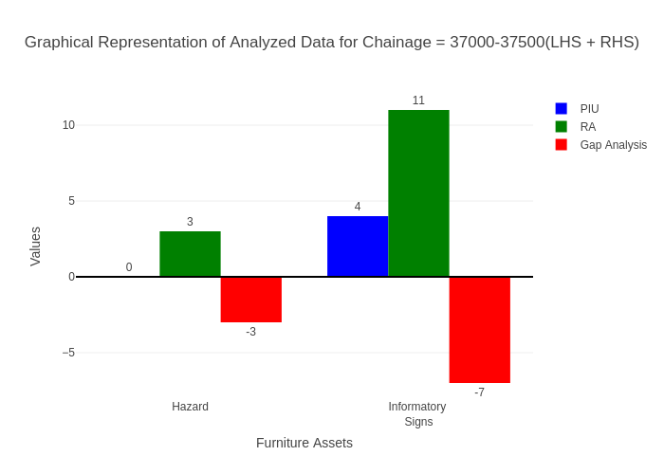

# Chainage: 37500-38000

## PIU Data:

|  |  |  |  |
| --- | --- | --- | --- |
| **Furniture Assets** | **37500-38000** | **38000-37500** | **LHS+RHS** |
| Chevron | 0.0 | 0.0 | 0.0 |
| Cautionary Warning Signs | 0.0 | 0.0 | 0.0 |
| Hazard | 0.0 | 0.0 | 0.0 |
| Prohibitory Mandatory Signs | 0.0 | 0.0 | 0.0 |
| Informatory Signs | 0.0 | 0.0 | 0.0 |

## RA Data:

|  |  |  |  |
| --- | --- | --- | --- |
| **Furniture Assets** | **37500-38000** | **38000-37500** | **LHS+RHS** |
| Chevron | 0.0 | 1.0 | 1.0 |
| Cautionary Warning Signs | 0.0 | 0.0 | 0.0 |
| Hazard | 0.0 | 0.0 | 0.0 |
| Prohibitory Mandatory Signs | 0.0 | 0.0 | 0.0 |
| Informatory Signs | 1.0 | 6.0 | 7.0 |

## Gap Analysis:

|  |  |  |  |
| --- | --- | --- | --- |
| **Furniture Assets** | **37500-38000** | **38000-37500** | **LHS+RHS** |
| Chevron | 0.0 | -1.0 | -1.0 |
| Cautionary Warning Signs | 0.0 | 0.0 | 0.0 |
| Hazard | 0.0 | 0.0 | 0.0 |
| Prohibitory Mandatory Signs | 0.0 | 0.0 | 0.0 |
| Informatory Signs | -1.0 | -6.0 | -7.0 |

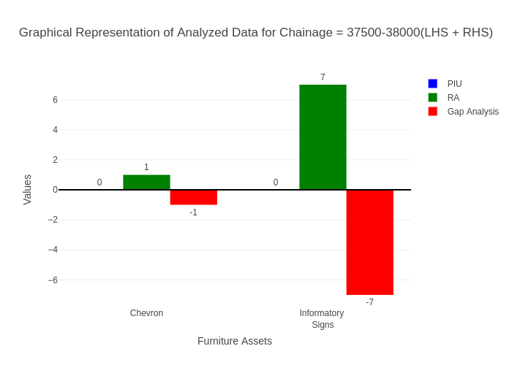

# Chainage: 38000-38500

## PIU Data:

|  |  |  |  |
| --- | --- | --- | --- |
| **Furniture Assets** | **38000-38500** | **38500-38000** | **LHS+RHS** |
| Chevron | 0.0 | 0.0 | 0.0 |
| Cautionary Warning Signs | 0.0 | 1.0 | 1.0 |
| Hazard | 3.0 | 0.0 | 3.0 |
| Prohibitory Mandatory Signs | 0.0 | 0.0 | 0.0 |
| Informatory Signs | 1.0 | 0.0 | 1.0 |

## RA Data:

|  |  |  |  |
| --- | --- | --- | --- |
| **Furniture Assets** | **38000-38500** | **38500-38000** | **LHS+RHS** |
| Chevron | 0.0 | 0.0 | 0.0 |
| Cautionary Warning Signs | 1.0 | 0.0 | 1.0 |
| Hazard | 1.0 | 1.0 | 2.0 |
| Prohibitory Mandatory Signs | 0.0 | 0.0 | 0.0 |
| Informatory Signs | 1.0 | 4.0 | 5.0 |

## Gap Analysis:

|  |  |  |  |
| --- | --- | --- | --- |
| **Furniture Assets** | **38000-38500** | **38500-38000** | **LHS+RHS** |
| Chevron | 0.0 | 0.0 | 0.0 |
| Cautionary Warning Signs | -1.0 | 1.0 | 0.0 |
| Hazard | 2.0 | -1.0 | 1.0 |
| Prohibitory Mandatory Signs | 0.0 | 0.0 | 0.0 |
| Informatory Signs | 0.0 | -4.0 | -4.0 |

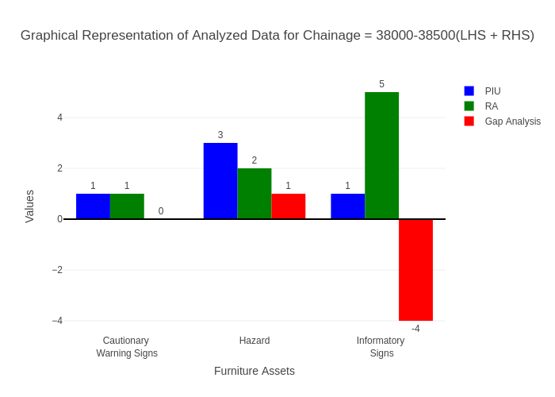

# Chainage: 38500-39000

## PIU Data:

|  |  |  |  |
| --- | --- | --- | --- |
| **Furniture Assets** | **38500-39000** | **39000-38500** | **LHS+RHS** |
| Chevron | 3.0 | 0.0 | 3.0 |
| Cautionary Warning Signs | 0.0 | 0.0 | 0.0 |
| Hazard | 0.0 | 0.0 | 0.0 |
| Prohibitory Mandatory Signs | 0.0 | 0.0 | 0.0 |
| Informatory Signs | 0.0 | 0.0 | 0.0 |

## RA Data:

|  |  |  |  |
| --- | --- | --- | --- |
| **Furniture Assets** | **38500-39000** | **39000-38500** | **LHS+RHS** |
| Chevron | 0.0 | 0.0 | 0.0 |
| Cautionary Warning Signs | 1.0 | 1.0 | 2.0 |
| Hazard | 1.0 | 0.0 | 1.0 |
| Prohibitory Mandatory Signs | 1.0 | 0.0 | 1.0 |
| Informatory Signs | 0.0 | 3.0 | 3.0 |

## Gap Analysis:

|  |  |  |  |
| --- | --- | --- | --- |
| **Furniture Assets** | **38500-39000** | **39000-38500** | **LHS+RHS** |
| Chevron | 3.0 | 0.0 | 3.0 |
| Cautionary Warning Signs | -1.0 | -1.0 | -2.0 |
| Hazard | -1.0 | 0.0 | -1.0 |
| Prohibitory Mandatory Signs | -1.0 | 0.0 | -1.0 |
| Informatory Signs | 0.0 | -3.0 | -3.0 |

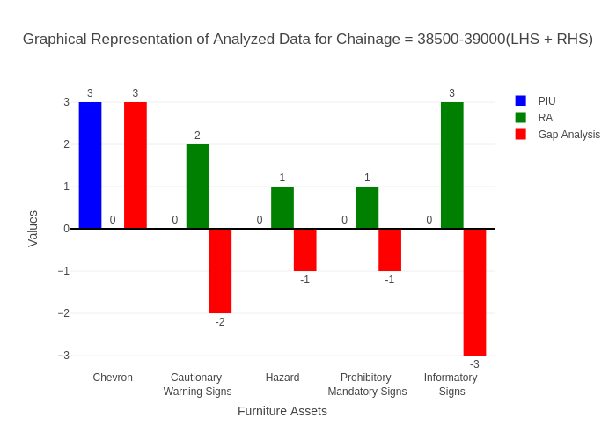

# Chainage: 39000-39500

## PIU Data:

|  |  |  |  |
| --- | --- | --- | --- |
| **Furniture Assets** | **39000-39500** | **39500-39000** | **LHS+RHS** |
| Chevron | 0.0 | 1.0 | 1.0 |
| Cautionary Warning Signs | 2.0 | 0.0 | 2.0 |
| Hazard | 1.0 | 0.0 | 1.0 |
| Prohibitory Mandatory Signs | 0.0 | 0.0 | 0.0 |
| Informatory Signs | 5.0 | 0.0 | 5.0 |

## RA Data:

|  |  |  |  |
| --- | --- | --- | --- |
| **Furniture Assets** | **39000-39500** | **39500-39000** | **LHS+RHS** |
| Chevron | 0.0 | 0.0 | 0.0 |
| Cautionary Warning Signs | 1.0 | 0.0 | 1.0 |
| Hazard | 0.0 | 0.0 | 0.0 |
| Prohibitory Mandatory Signs | 0.0 | 0.0 | 0.0 |
| Informatory Signs | 5.0 | 0.0 | 5.0 |

## Gap Analysis:

|  |  |  |  |
| --- | --- | --- | --- |
| **Furniture Assets** | **39000-39500** | **39500-39000** | **LHS+RHS** |
| Chevron | 0.0 | 1.0 | 1.0 |
| Cautionary Warning Signs | 1.0 | 0.0 | 1.0 |
| Hazard | 1.0 | 0.0 | 1.0 |
| Prohibitory Mandatory Signs | 0.0 | 0.0 | 0.0 |
| Informatory Signs | 0.0 | 0.0 | 0.0 |

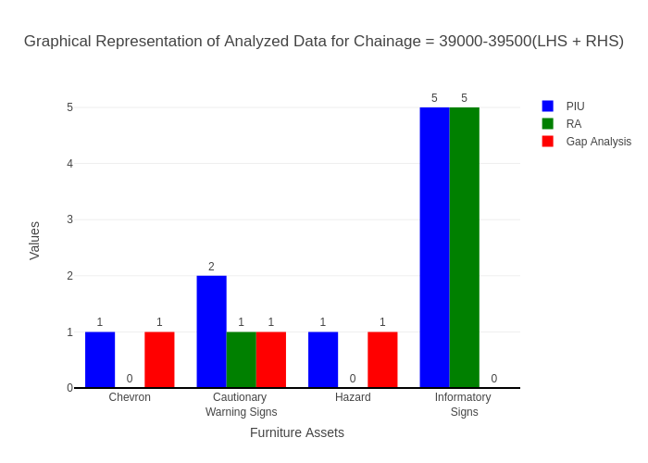

# Chainage: 39500-40000

## PIU Data:

|  |  |  |  |
| --- | --- | --- | --- |
| **Furniture Assets** | **39500-40000** | **40000-39500** | **LHS+RHS** |
| Chevron | 0.0 | 0.0 | 0.0 |
| Cautionary Warning Signs | 3.0 | 0.0 | 3.0 |
| Hazard | 2.0 | 1.0 | 3.0 |
| Prohibitory Mandatory Signs | 0.0 | 0.0 | 0.0 |
| Informatory Signs | 1.0 | 0.0 | 1.0 |

## RA Data:

|  |  |  |  |
| --- | --- | --- | --- |
| **Furniture Assets** | **39500-40000** | **40000-39500** | **LHS+RHS** |
| Chevron | 0.0 | 0.0 | 0.0 |
| Cautionary Warning Signs | 2.0 | 1.0 | 3.0 |
| Hazard | 1.0 | 1.0 | 2.0 |
| Prohibitory Mandatory Signs | 1.0 | 0.0 | 1.0 |
| Informatory Signs | 2.0 | 1.0 | 3.0 |

## Gap Analysis:

|  |  |  |  |
| --- | --- | --- | --- |
| **Furniture Assets** | **39500-40000** | **40000-39500** | **LHS+RHS** |
| Chevron | 0.0 | 0.0 | 0.0 |
| Cautionary Warning Signs | 1.0 | -1.0 | 0.0 |
| Hazard | 1.0 | 0.0 | 1.0 |
| Prohibitory Mandatory Signs | -1.0 | 0.0 | -1.0 |
| Informatory Signs | -1.0 | -1.0 | -2.0 |

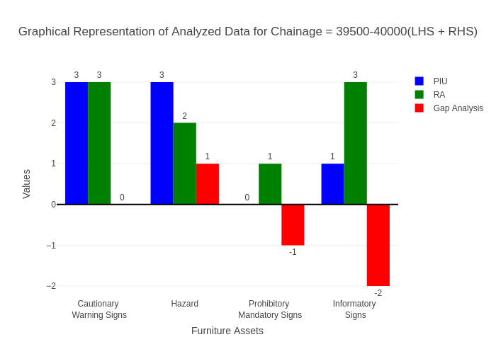

# Chainage: 40000-40500

## PIU Data:

|  |  |  |  |
| --- | --- | --- | --- |
| **Furniture Assets** | **40000-40500** | **40500-40000** | **LHS+RHS** |
| Chevron | 1.0 | 0.0 | 1.0 |
| Cautionary Warning Signs | 0.0 | 0.0 | 0.0 |
| Hazard | 0.0 | 0.0 | 0.0 |
| Prohibitory Mandatory Signs | 0.0 | 0.0 | 0.0 |
| Informatory Signs | 0.0 | 0.0 | 0.0 |

## RA Data:

|  |  |  |  |
| --- | --- | --- | --- |
| **Furniture Assets** | **40000-40500** | **40500-40000** | **LHS+RHS** |
| Chevron | 0.0 | 0.0 | 0.0 |
| Cautionary Warning Signs | 0.0 | 2.0 | 2.0 |
| Hazard | 1.0 | 0.0 | 1.0 |
| Prohibitory Mandatory Signs | 0.0 | 0.0 | 0.0 |
| Informatory Signs | 1.0 | 3.0 | 4.0 |

## Gap Analysis:

|  |  |  |  |
| --- | --- | --- | --- |
| **Furniture Assets** | **40000-40500** | **40500-40000** | **LHS+RHS** |
| Chevron | 1.0 | 0.0 | 1.0 |
| Cautionary Warning Signs | 0.0 | -2.0 | -2.0 |
| Hazard | -1.0 | 0.0 | -1.0 |
| Prohibitory Mandatory Signs | 0.0 | 0.0 | 0.0 |
| Informatory Signs | -1.0 | -3.0 | -4.0 |

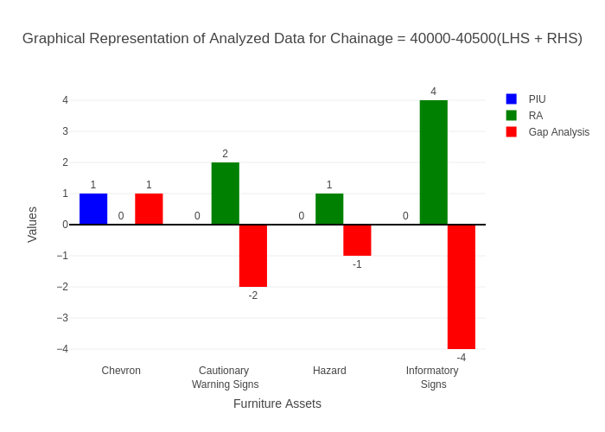

# Chainage: 40500-41000

## PIU Data:

|  |  |  |  |
| --- | --- | --- | --- |
| **Furniture Assets** | **40500-41000** | **41000-40500** | **LHS+RHS** |
| Chevron | 1.0 | 0.0 | 1.0 |
| Cautionary Warning Signs | 1.0 | 0.0 | 1.0 |
| Hazard | 0.0 | 0.0 | 0.0 |
| Prohibitory Mandatory Signs | 0.0 | 0.0 | 0.0 |
| Informatory Signs | 0.0 | 0.0 | 0.0 |

## RA Data:

|  |  |  |  |
| --- | --- | --- | --- |
| **Furniture Assets** | **40500-41000** | **41000-40500** | **LHS+RHS** |
| Chevron | 0.0 | 0.0 | 0.0 |
| Cautionary Warning Signs | 0.0 | 0.0 | 0.0 |
| Hazard | 1.0 | 0.0 | 1.0 |
| Prohibitory Mandatory Signs | 0.0 | 0.0 | 0.0 |
| Informatory Signs | 0.0 | 0.0 | 0.0 |

## Gap Analysis:

|  |  |  |  |
| --- | --- | --- | --- |
| **Furniture Assets** | **40500-41000** | **41000-40500** | **LHS+RHS** |
| Chevron | 1.0 | 0.0 | 1.0 |
| Cautionary Warning Signs | 1.0 | 0.0 | 1.0 |
| Hazard | -1.0 | 0.0 | -1.0 |
| Prohibitory Mandatory Signs | 0.0 | 0.0 | 0.0 |
| Informatory Signs | 0.0 | 0.0 | 0.0 |

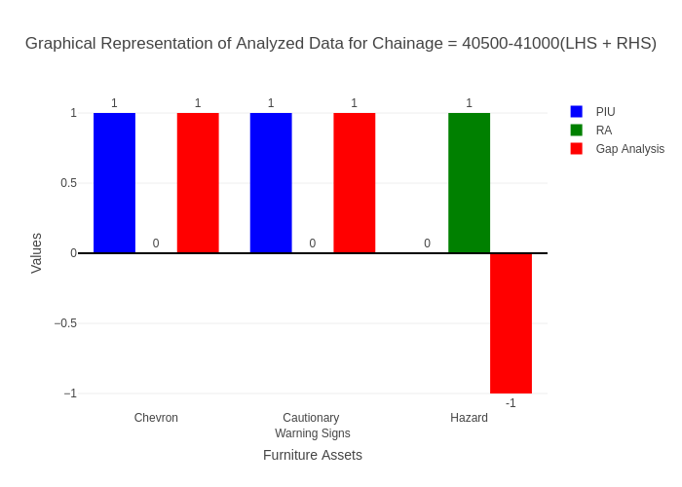

# Chainage: 41000-41500

## PIU Data:

|  |  |  |  |
| --- | --- | --- | --- |
| **Furniture Assets** | **41000-41500** | **41500-41000** | **LHS+RHS** |
| Chevron | 0.0 | 0.0 | 0.0 |
| Cautionary Warning Signs | 1.0 | 0.0 | 1.0 |
| Hazard | 0.0 | 0.0 | 0.0 |
| Prohibitory Mandatory Signs | 1.0 | 0.0 | 1.0 |
| Informatory Signs | 0.0 | 1.0 | 1.0 |

## RA Data:

|  |  |  |  |
| --- | --- | --- | --- |
| **Furniture Assets** | **41000-41500** | **41500-41000** | **LHS+RHS** |
| Chevron | 0.0 | 0.0 | 0.0 |
| Cautionary Warning Signs | 0.0 | 0.0 | 0.0 |
| Hazard | 0.0 | 0.0 | 0.0 |
| Prohibitory Mandatory Signs | 0.0 | 0.0 | 0.0 |
| Informatory Signs | 0.0 | 0.0 | 0.0 |

## Gap Analysis:

|  |  |  |  |
| --- | --- | --- | --- |
| **Furniture Assets** | **41000-41500** | **41500-41000** | **LHS+RHS** |
| Chevron | 0.0 | 0.0 | 0.0 |
| Cautionary Warning Signs | 1.0 | 0.0 | 1.0 |
| Hazard | 0.0 | 0.0 | 0.0 |
| Prohibitory Mandatory Signs | 1.0 | 0.0 | 1.0 |
| Informatory Signs | 0.0 | 1.0 | 1.0 |

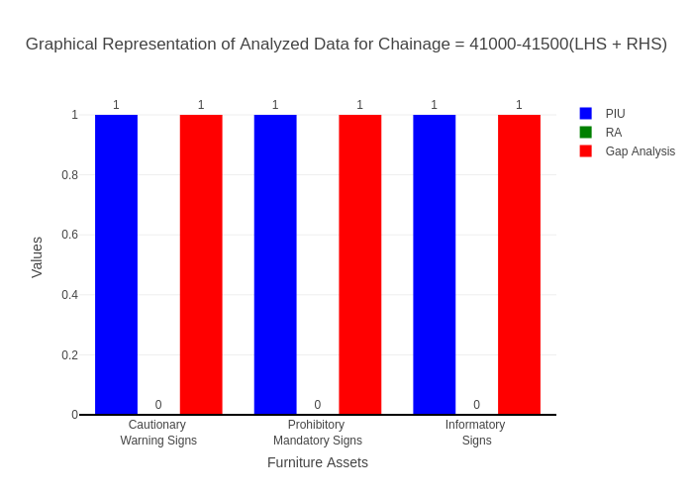

# Chainage: 41500-42000

## PIU Data:

|  |  |  |  |
| --- | --- | --- | --- |
| **Furniture Assets** | **41500-42000** | **42000-41500** | **LHS+RHS** |
| Chevron | 0.0 | 0.0 | 0.0 |
| Cautionary Warning Signs | 0.0 | 0.0 | 0.0 |
| Hazard | 0.0 | 0.0 | 0.0 |
| Prohibitory Mandatory Signs | 0.0 | 0.0 | 0.0 |
| Informatory Signs | 0.0 | 0.0 | 0.0 |

## RA Data:

|  |  |  |  |
| --- | --- | --- | --- |
| **Furniture Assets** | **41500-42000** | **42000-41500** | **LHS+RHS** |
| Chevron | 0.0 | 0.0 | 0.0 |
| Cautionary Warning Signs | 0.0 | 1.0 | 1.0 |
| Hazard | 0.0 | 2.0 | 2.0 |
| Prohibitory Mandatory Signs | 1.0 | 3.0 | 4.0 |
| Informatory Signs | 1.0 | 4.0 | 5.0 |

## Gap Analysis:

|  |  |  |  |
| --- | --- | --- | --- |
| **Furniture Assets** | **41500-42000** | **42000-41500** | **LHS+RHS** |
| Chevron | 0.0 | 0.0 | 0.0 |
| Cautionary Warning Signs | 0.0 | -1.0 | -1.0 |
| Hazard | 0.0 | -2.0 | -2.0 |
| Prohibitory Mandatory Signs | -1.0 | -3.0 | -4.0 |
| Informatory Signs | -1.0 | -4.0 | -5.0 |

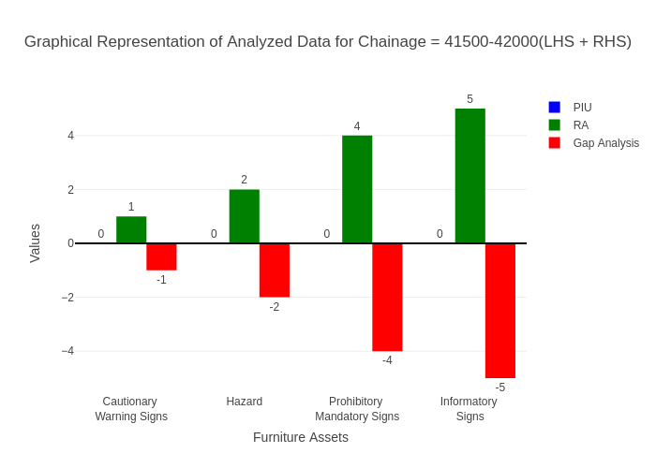

# Chainage: 42000-42500

## PIU Data:

|  |  |  |  |
| --- | --- | --- | --- |
| **Furniture Assets** | **42000-42500** | **42500-42000** | **LHS+RHS** |
| Chevron | 0.0 | 0.0 | 0.0 |
| Cautionary Warning Signs | 0.0 | 0.0 | 0.0 |
| Hazard | 2.0 | 0.0 | 2.0 |
| Prohibitory Mandatory Signs | 0.0 | 0.0 | 0.0 |
| Informatory Signs | 1.0 | 0.0 | 1.0 |

## RA Data:

|  |  |  |  |
| --- | --- | --- | --- |
| **Furniture Assets** | **42000-42500** | **42500-42000** | **LHS+RHS** |
| Chevron | 0.0 | 0.0 | 0.0 |
| Cautionary Warning Signs | 0.0 | 0.0 | 0.0 |
| Hazard | 0.0 | 0.0 | 0.0 |
| Prohibitory Mandatory Signs | 0.0 | 1.0 | 1.0 |
| Informatory Signs | 1.0 | 1.0 | 2.0 |

## Gap Analysis:

|  |  |  |  |
| --- | --- | --- | --- |
| **Furniture Assets** | **42000-42500** | **42500-42000** | **LHS+RHS** |
| Chevron | 0.0 | 0.0 | 0.0 |
| Cautionary Warning Signs | 0.0 | 0.0 | 0.0 |
| Hazard | 2.0 | 0.0 | 2.0 |
| Prohibitory Mandatory Signs | 0.0 | -1.0 | -1.0 |
| Informatory Signs | 0.0 | -1.0 | -1.0 |

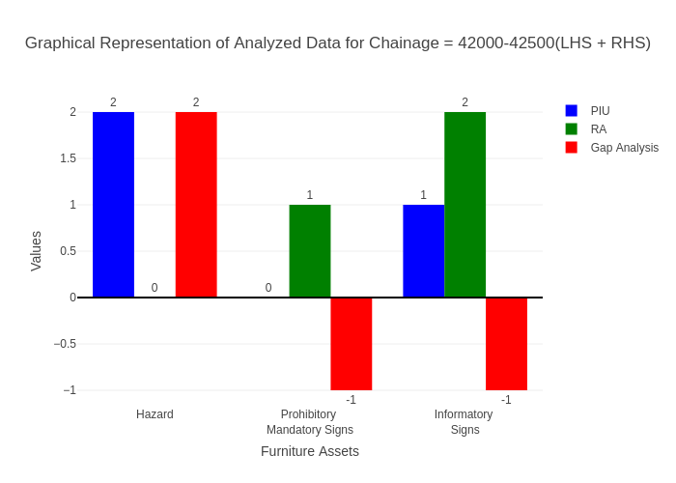

# Chainage: 42500-43000

## PIU Data:

|  |  |  |  |
| --- | --- | --- | --- |
| **Furniture Assets** | **42500-43000** | **43000-42500** | **LHS+RHS** |
| Chevron | 0.0 | 0.0 | 0.0 |
| Cautionary Warning Signs | 4.0 | 0.0 | 4.0 |
| Hazard | 2.0 | 1.0 | 3.0 |
| Prohibitory Mandatory Signs | 0.0 | 0.0 | 0.0 |
| Informatory Signs | 2.0 | 0.0 | 2.0 |

## RA Data:

|  |  |  |  |
| --- | --- | --- | --- |
| **Furniture Assets** | **42500-43000** | **43000-42500** | **LHS+RHS** |
| Chevron | 0.0 | 0.0 | 0.0 |
| Cautionary Warning Signs | 4.0 | 0.0 | 4.0 |
| Hazard | 2.0 | 0.0 | 2.0 |
| Prohibitory Mandatory Signs | 0.0 | 0.0 | 0.0 |
| Informatory Signs | 2.0 | 0.0 | 2.0 |

## Gap Analysis:

|  |  |  |  |
| --- | --- | --- | --- |
| **Furniture Assets** | **42500-43000** | **43000-42500** | **LHS+RHS** |
| Chevron | 0.0 | 0.0 | 0.0 |
| Cautionary Warning Signs | 0.0 | 0.0 | 0.0 |
| Hazard | 0.0 | 1.0 | 1.0 |
| Prohibitory Mandatory Signs | 0.0 | 0.0 | 0.0 |
| Informatory Signs | 0.0 | 0.0 | 0.0 |

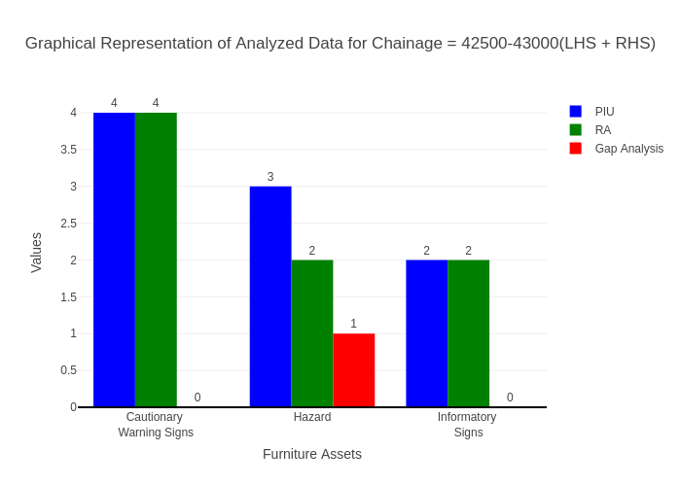

# Chainage: 43000-43500

## PIU Data:

|  |  |  |  |
| --- | --- | --- | --- |
| **Furniture Assets** | **43000-43500** | **43500-43000** | **LHS+RHS** |
| Chevron | 0.0 | 0.0 | 0.0 |
| Cautionary Warning Signs | 0.0 | 0.0 | 0.0 |
| Hazard | 0.0 | 0.0 | 0.0 |
| Prohibitory Mandatory Signs | 0.0 | 0.0 | 0.0 |
| Informatory Signs | 0.0 | 0.0 | 0.0 |

## RA Data:

|  |  |  |  |
| --- | --- | --- | --- |
| **Furniture Assets** | **43000-43500** | **43500-43000** | **LHS+RHS** |
| Chevron | 0.0 | 0.0 | 0.0 |
| Cautionary Warning Signs | 0.0 | 2.0 | 2.0 |
| Hazard | 1.0 | 2.0 | 3.0 |
| Prohibitory Mandatory Signs | 0.0 | 0.0 | 0.0 |
| Informatory Signs | 0.0 | 3.0 | 3.0 |

## Gap Analysis:

|  |  |  |  |
| --- | --- | --- | --- |
| **Furniture Assets** | **43000-43500** | **43500-43000** | **LHS+RHS** |
| Chevron | 0.0 | 0.0 | 0.0 |
| Cautionary Warning Signs | 0.0 | -2.0 | -2.0 |
| Hazard | -1.0 | -2.0 | -3.0 |
| Prohibitory Mandatory Signs | 0.0 | 0.0 | 0.0 |
| Informatory Signs | 0.0 | -3.0 | -3.0 |

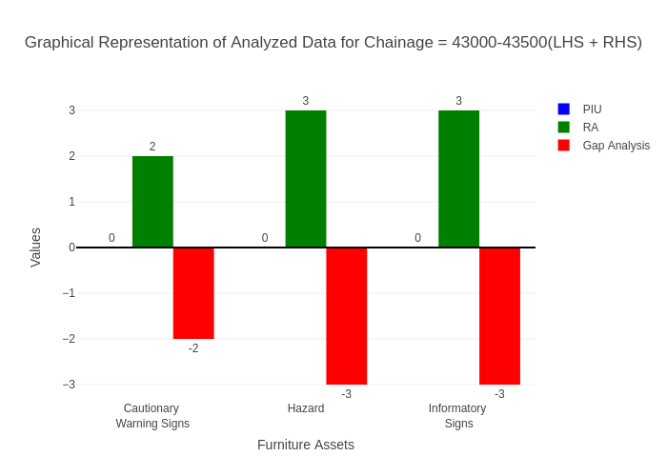

# Chainage: 43500-44000

## PIU Data:

|  |  |  |  |
| --- | --- | --- | --- |
| **Furniture Assets** | **43500-44000** | **44000-43500** | **LHS+RHS** |
| Chevron | 0.0 | 0.0 | 0.0 |
| Cautionary Warning Signs | 0.0 | 0.0 | 0.0 |
| Hazard | 0.0 | 0.0 | 0.0 |
| Prohibitory Mandatory Signs | 0.0 | 0.0 | 0.0 |
| Informatory Signs | 0.0 | 0.0 | 0.0 |

## RA Data:

|  |  |  |  |
| --- | --- | --- | --- |
| **Furniture Assets** | **43500-44000** | **44000-43500** | **LHS+RHS** |
| Chevron | 0.0 | 0.0 | 0.0 |
| Cautionary Warning Signs | 1.0 | 1.0 | 2.0 |
| Hazard | 1.0 | 0.0 | 1.0 |
| Prohibitory Mandatory Signs | 1.0 | 0.0 | 1.0 |
| Informatory Signs | 1.0 | 0.0 | 1.0 |

## Gap Analysis:

|  |  |  |  |
| --- | --- | --- | --- |
| **Furniture Assets** | **43500-44000** | **44000-43500** | **LHS+RHS** |
| Chevron | 0.0 | 0.0 | 0.0 |
| Cautionary Warning Signs | -1.0 | -1.0 | -2.0 |
| Hazard | -1.0 | 0.0 | -1.0 |
| Prohibitory Mandatory Signs | -1.0 | 0.0 | -1.0 |
| Informatory Signs | -1.0 | 0.0 | -1.0 |

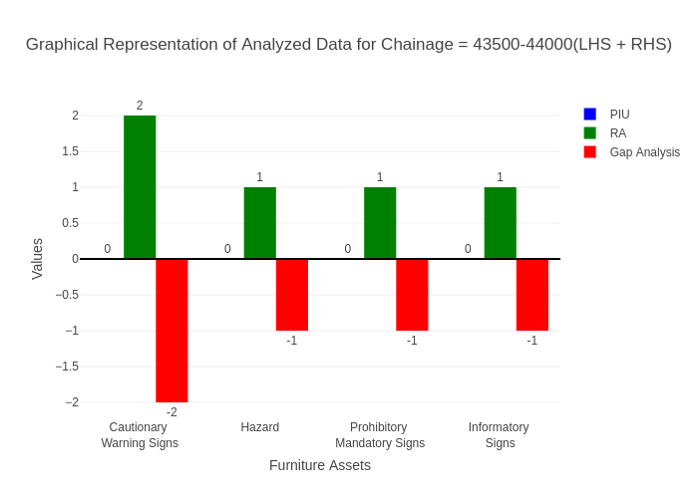

# Chainage: 44000-44500

## PIU Data:

|  |  |  |  |
| --- | --- | --- | --- |
| **Furniture Assets** | **44000-44500** | **44500-44000** | **LHS+RHS** |
| Chevron | 0.0 | 0.0 | 0.0 |
| Cautionary Warning Signs | 1.0 | 0.0 | 1.0 |
| Hazard | 0.0 | 0.0 | 0.0 |
| Prohibitory Mandatory Signs | 0.0 | 0.0 | 0.0 |
| Informatory Signs | 0.0 | 1.0 | 1.0 |

## RA Data:

|  |  |  |  |
| --- | --- | --- | --- |
| **Furniture Assets** | **44000-44500** | **44500-44000** | **LHS+RHS** |
| Chevron | 0.0 | 0.0 | 0.0 |
| Cautionary Warning Signs | 1.0 | 2.0 | 3.0 |
| Hazard | 0.0 | 0.0 | 0.0 |
| Prohibitory Mandatory Signs | 0.0 | 0.0 | 0.0 |
| Informatory Signs | 0.0 | 0.0 | 0.0 |

## Gap Analysis:

|  |  |  |  |
| --- | --- | --- | --- |
| **Furniture Assets** | **44000-44500** | **44500-44000** | **LHS+RHS** |
| Chevron | 0.0 | 0.0 | 0.0 |
| Cautionary Warning Signs | 0.0 | -2.0 | -2.0 |
| Hazard | 0.0 | 0.0 | 0.0 |
| Prohibitory Mandatory Signs | 0.0 | 0.0 | 0.0 |
| Informatory Signs | 0.0 | 1.0 | 1.0 |

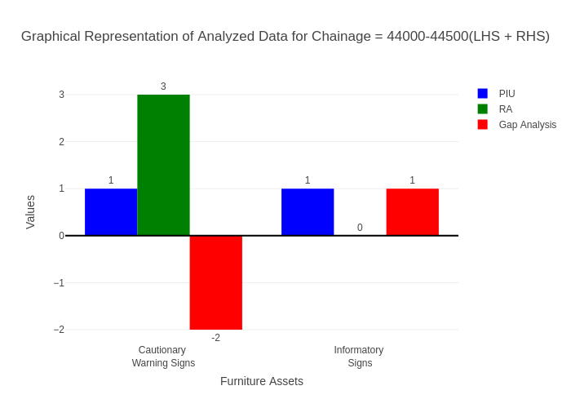

# Chainage: 44500-45000

## PIU Data:

|  |  |  |  |
| --- | --- | --- | --- |
| **Furniture Assets** | **44500-45000** | **45000-44500** | **LHS+RHS** |
| Chevron | 0.0 | 0.0 | 0.0 |
| Cautionary Warning Signs | 0.0 | 0.0 | 0.0 |
| Hazard | 0.0 | 0.0 | 0.0 |
| Prohibitory Mandatory Signs | 0.0 | 0.0 | 0.0 |
| Informatory Signs | 0.0 | 0.0 | 0.0 |

## RA Data:

|  |  |  |  |
| --- | --- | --- | --- |
| **Furniture Assets** | **44500-45000** | **45000-44500** | **LHS+RHS** |
| Chevron | 0.0 | 0.0 | 0.0 |
| Cautionary Warning Signs | 0.0 | 1.0 | 1.0 |
| Hazard | 0.0 | 0.0 | 0.0 |
| Prohibitory Mandatory Signs | 0.0 | 2.0 | 2.0 |
| Informatory Signs | 0.0 | 0.0 | 0.0 |

## Gap Analysis:

|  |  |  |  |
| --- | --- | --- | --- |
| **Furniture Assets** | **44500-45000** | **45000-44500** | **LHS+RHS** |
| Chevron | 0.0 | 0.0 | 0.0 |
| Cautionary Warning Signs | 0.0 | -1.0 | -1.0 |
| Hazard | 0.0 | 0.0 | 0.0 |
| Prohibitory Mandatory Signs | 0.0 | -2.0 | -2.0 |
| Informatory Signs | 0.0 | 0.0 | 0.0 |

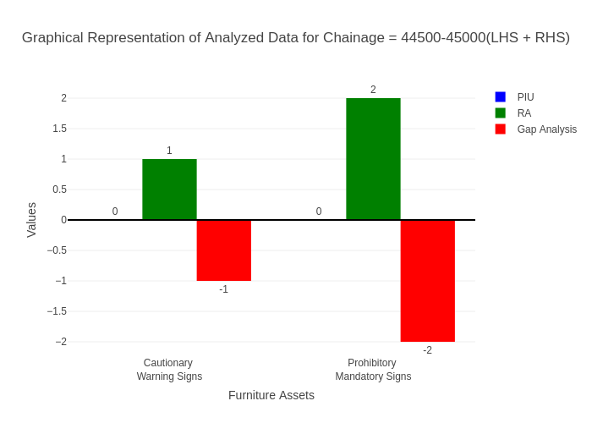

# Chainage: 45000-45500

## PIU Data:

|  |  |  |  |
| --- | --- | --- | --- |
| **Furniture Assets** | **45000-45500** | **45500-45000** | **LHS+RHS** |
| Chevron | 0.0 | 0.0 | 0.0 |
| Cautionary Warning Signs | 1.0 | 0.0 | 1.0 |
| Hazard | 1.0 | 1.0 | 2.0 |
| Prohibitory Mandatory Signs | 0.0 | 0.0 | 0.0 |
| Informatory Signs | 0.0 | 0.0 | 0.0 |

## RA Data:

|  |  |  |  |
| --- | --- | --- | --- |
| **Furniture Assets** | **45000-45500** | **45500-45000** | **LHS+RHS** |
| Chevron | 0.0 | 0.0 | 0.0 |
| Cautionary Warning Signs | 2.0 | 1.0 | 3.0 |
| Hazard | 1.0 | 0.0 | 1.0 |
| Prohibitory Mandatory Signs | 0.0 | 0.0 | 0.0 |
| Informatory Signs | 2.0 | 3.0 | 5.0 |

## Gap Analysis:

|  |  |  |  |
| --- | --- | --- | --- |
| **Furniture Assets** | **45000-45500** | **45500-45000** | **LHS+RHS** |
| Chevron | 0.0 | 0.0 | 0.0 |
| Cautionary Warning Signs | -1.0 | -1.0 | -2.0 |
| Hazard | 0.0 | 1.0 | 1.0 |
| Prohibitory Mandatory Signs | 0.0 | 0.0 | 0.0 |
| Informatory Signs | -2.0 | -3.0 | -5.0 |

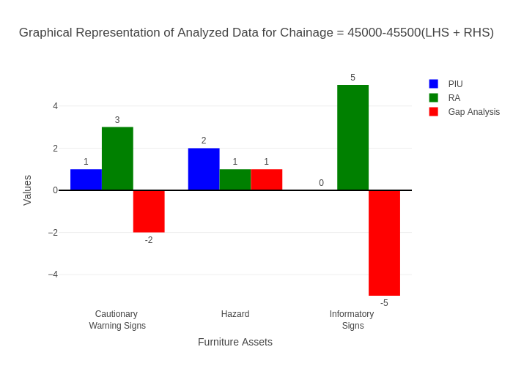

# Chainage: 45500-46000

## PIU Data:

|  |  |  |  |
| --- | --- | --- | --- |
| **Furniture Assets** | **45500-46000** | **46000-45500** | **LHS+RHS** |
| Chevron | 0.0 | 0.0 | 0.0 |
| Cautionary Warning Signs | 0.0 | 0.0 | 0.0 |
| Hazard | 0.0 | 0.0 | 0.0 |
| Prohibitory Mandatory Signs | 0.0 | 0.0 | 0.0 |
| Informatory Signs | 0.0 | 0.0 | 0.0 |

## RA Data:

|  |  |  |  |
| --- | --- | --- | --- |
| **Furniture Assets** | **45500-46000** | **46000-45500** | **LHS+RHS** |
| Chevron | 3.0 | 0.0 | 3.0 |
| Cautionary Warning Signs | 2.0 | 1.0 | 3.0 |
| Hazard | 0.0 | 1.0 | 1.0 |
| Prohibitory Mandatory Signs | 0.0 | 0.0 | 0.0 |
| Informatory Signs | 2.0 | 3.0 | 5.0 |

## Gap Analysis:

|  |  |  |  |
| --- | --- | --- | --- |
| **Furniture Assets** | **45500-46000** | **46000-45500** | **LHS+RHS** |
| Chevron | -3.0 | 0.0 | -3.0 |
| Cautionary Warning Signs | -2.0 | -1.0 | -3.0 |
| Hazard | 0.0 | -1.0 | -1.0 |
| Prohibitory Mandatory Signs | 0.0 | 0.0 | 0.0 |
| Informatory Signs | -2.0 | -3.0 | -5.0 |

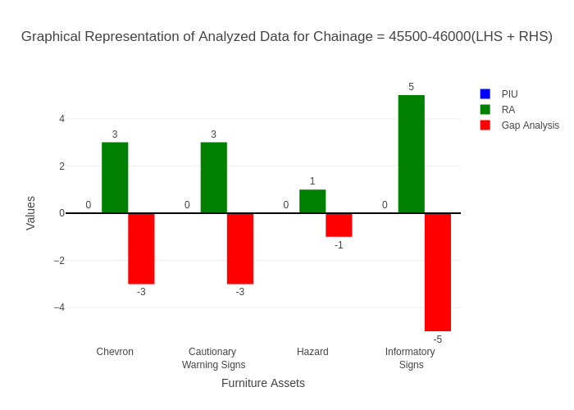

# Chainage: 46000-46500

## PIU Data:

|  |  |  |  |
| --- | --- | --- | --- |
| **Furniture Assets** | **46000-46500** | **46500-46000** | **LHS+RHS** |
| Chevron | 1.0 | 0.0 | 1.0 |
| Cautionary Warning Signs | 0.0 | 0.0 | 0.0 |
| Hazard | 2.0 | 0.0 | 2.0 |
| Prohibitory Mandatory Signs | 0.0 | 0.0 | 0.0 |
| Informatory Signs | 0.0 | 0.0 | 0.0 |

## RA Data:

|  |  |  |  |
| --- | --- | --- | --- |
| **Furniture Assets** | **46000-46500** | **46500-46000** | **LHS+RHS** |
| Chevron | 0.0 | 2.0 | 2.0 |
| Cautionary Warning Signs | 0.0 | 0.0 | 0.0 |
| Hazard | 0.0 | 0.0 | 0.0 |
| Prohibitory Mandatory Signs | 0.0 | 0.0 | 0.0 |
| Informatory Signs | 0.0 | 1.0 | 1.0 |

## Gap Analysis:

|  |  |  |  |
| --- | --- | --- | --- |
| **Furniture Assets** | **46000-46500** | **46500-46000** | **LHS+RHS** |
| Chevron | 1.0 | -2.0 | -1.0 |
| Cautionary Warning Signs | 0.0 | 0.0 | 0.0 |
| Hazard | 2.0 | 0.0 | 2.0 |
| Prohibitory Mandatory Signs | 0.0 | 0.0 | 0.0 |
| Informatory Signs | 0.0 | -1.0 | -1.0 |

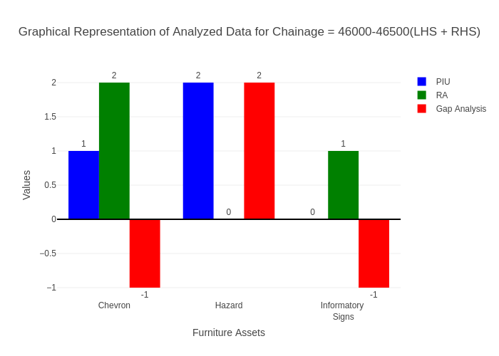

# Chainage: 46500-47000

## PIU Data:

|  |  |  |  |
| --- | --- | --- | --- |
| **Furniture Assets** | **46500-47000** | **47000-46500** | **LHS+RHS** |
| Chevron | 0.0 | 0.0 | 0.0 |
| Cautionary Warning Signs | 0.0 | 0.0 | 0.0 |
| Hazard | 0.0 | 0.0 | 0.0 |
| Prohibitory Mandatory Signs | 0.0 | 0.0 | 0.0 |
| Informatory Signs | 0.0 | 0.0 | 0.0 |

## RA Data:

|  |  |  |  |
| --- | --- | --- | --- |
| **Furniture Assets** | **46500-47000** | **47000-46500** | **LHS+RHS** |
| Chevron | 0.0 | 0.0 | 0.0 |
| Cautionary Warning Signs | 0.0 | 0.0 | 0.0 |
| Hazard | 0.0 | 0.0 | 0.0 |
| Prohibitory Mandatory Signs | 0.0 | 0.0 | 0.0 |
| Informatory Signs | 0.0 | 0.0 | 0.0 |

## Gap Analysis:

|  |  |  |  |
| --- | --- | --- | --- |
| **Furniture Assets** | **46500-47000** | **47000-46500** | **LHS+RHS** |
| Chevron | 0.0 | 0.0 | 0.0 |
| Cautionary Warning Signs | 0.0 | 0.0 | 0.0 |
| Hazard | 0.0 | 0.0 | 0.0 |
| Prohibitory Mandatory Signs | 0.0 | 0.0 | 0.0 |
| Informatory Signs | 0.0 | 0.0 | 0.0 |



# Chainage: 47000-47500

## PIU Data:

|  |  |  |  |
| --- | --- | --- | --- |
| **Furniture Assets** | **47000-47500** | **47500-47000** | **LHS+RHS** |
| Chevron | 0.0 | 0.0 | 0.0 |
| Cautionary Warning Signs | 0.0 | 0.0 | 0.0 |
| Hazard | 0.0 | 0.0 | 0.0 |
| Prohibitory Mandatory Signs | 0.0 | 0.0 | 0.0 |
| Informatory Signs | 0.0 | 0.0 | 0.0 |

## RA Data:

|  |  |  |  |
| --- | --- | --- | --- |
| **Furniture Assets** | **47000-47500** | **47500-47000** | **LHS+RHS** |
| Chevron | 0.0 | 0.0 | 0.0 |
| Cautionary Warning Signs | 1.0 | 0.0 | 1.0 |
| Hazard | 0.0 | 0.0 | 0.0 |
| Prohibitory Mandatory Signs | 2.0 | 0.0 | 2.0 |
| Informatory Signs | 0.0 | 0.0 | 0.0 |

## Gap Analysis:

|  |  |  |  |
| --- | --- | --- | --- |
| **Furniture Assets** | **47000-47500** | **47500-47000** | **LHS+RHS** |
| Chevron | 0.0 | 0.0 | 0.0 |
| Cautionary Warning Signs | -1.0 | 0.0 | -1.0 |
| Hazard | 0.0 | 0.0 | 0.0 |
| Prohibitory Mandatory Signs | -2.0 | 0.0 | -2.0 |
| Informatory Signs | 0.0 | 0.0 | 0.0 |

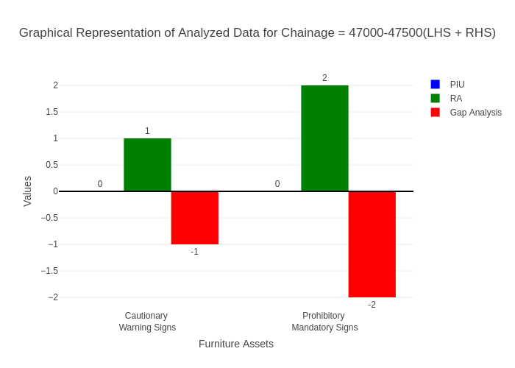

# Chainage: 47500-48000

## PIU Data:

|  |  |  |  |
| --- | --- | --- | --- |
| **Furniture Assets** | **47500-48000** | **48000-47500** | **LHS+RHS** |
| Chevron | 0.0 | 0.0 | 0.0 |
| Cautionary Warning Signs | 0.0 | 0.0 | 0.0 |
| Hazard | 0.0 | 0.0 | 0.0 |
| Prohibitory Mandatory Signs | 0.0 | 0.0 | 0.0 |
| Informatory Signs | 0.0 | 0.0 | 0.0 |

## RA Data:

|  |  |  |  |
| --- | --- | --- | --- |
| **Furniture Assets** | **47500-48000** | **48000-47500** | **LHS+RHS** |
| Chevron | 0.0 | 0.0 | 0.0 |
| Cautionary Warning Signs | 0.0 | 0.0 | 0.0 |
| Hazard | 1.0 | 0.0 | 1.0 |
| Prohibitory Mandatory Signs | 0.0 | 0.0 | 0.0 |
| Informatory Signs | 1.0 | 0.0 | 1.0 |

## Gap Analysis:

|  |  |  |  |
| --- | --- | --- | --- |
| **Furniture Assets** | **47500-48000** | **48000-47500** | **LHS+RHS** |
| Chevron | 0.0 | 0.0 | 0.0 |
| Cautionary Warning Signs | 0.0 | 0.0 | 0.0 |
| Hazard | -1.0 | 0.0 | -1.0 |
| Prohibitory Mandatory Signs | 0.0 | 0.0 | 0.0 |
| Informatory Signs | -1.0 | 0.0 | -1.0 |

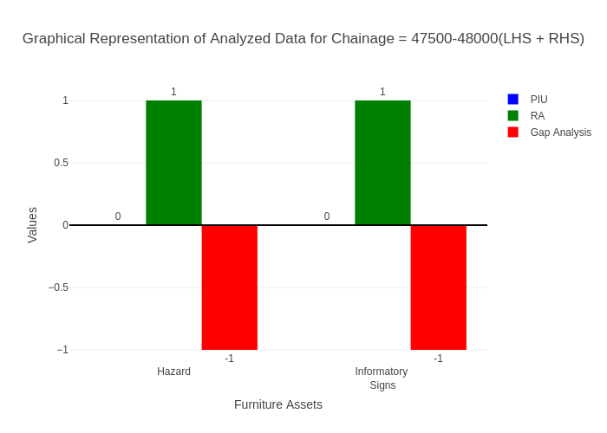

# Chainage: 48000-48500

## PIU Data:

|  |  |  |  |
| --- | --- | --- | --- |
| **Furniture Assets** | **48000-48500** | **48500-48000** | **LHS+RHS** |
| Chevron | 0.0 | 0.0 | 0.0 |
| Cautionary Warning Signs | 0.0 | 0.0 | 0.0 |
| Hazard | 1.0 | 0.0 | 1.0 |
| Prohibitory Mandatory Signs | 0.0 | 0.0 | 0.0 |
| Informatory Signs | 0.0 | 0.0 | 0.0 |

## RA Data:

|  |  |  |  |
| --- | --- | --- | --- |
| **Furniture Assets** | **48000-48500** | **48500-48000** | **LHS+RHS** |
| Chevron | 0.0 | 0.0 | 0.0 |
| Cautionary Warning Signs | 0.0 | 0.0 | 0.0 |
| Hazard | 0.0 | 1.0 | 1.0 |
| Prohibitory Mandatory Signs | 0.0 | 0.0 | 0.0 |
| Informatory Signs | 0.0 | 1.0 | 1.0 |

## Gap Analysis:

|  |  |  |  |
| --- | --- | --- | --- |
| **Furniture Assets** | **48000-48500** | **48500-48000** | **LHS+RHS** |
| Chevron | 0.0 | 0.0 | 0.0 |
| Cautionary Warning Signs | 0.0 | 0.0 | 0.0 |
| Hazard | 1.0 | -1.0 | 0.0 |
| Prohibitory Mandatory Signs | 0.0 | 0.0 | 0.0 |
| Informatory Signs | 0.0 | -1.0 | -1.0 |

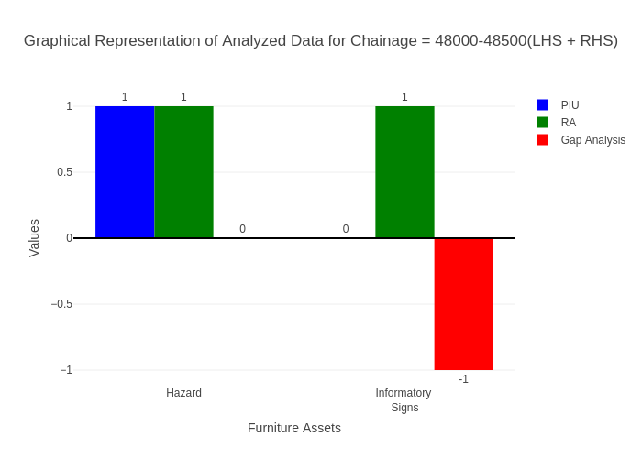

# Chainage: 48500-49000

## PIU Data:

|  |  |  |  |
| --- | --- | --- | --- |
| **Furniture Assets** | **48500-49000** | **49000-48500** | **LHS+RHS** |
| Chevron | 0.0 | 0.0 | 0.0 |
| Cautionary Warning Signs | 0.0 | 0.0 | 0.0 |
| Hazard | 0.0 | 1.0 | 1.0 |
| Prohibitory Mandatory Signs | 0.0 | 0.0 | 0.0 |
| Informatory Signs | 0.0 | 0.0 | 0.0 |

## RA Data:

|  |  |  |  |
| --- | --- | --- | --- |
| **Furniture Assets** | **48500-49000** | **49000-48500** | **LHS+RHS** |
| Chevron | 0.0 | 0.0 | 0.0 |
| Cautionary Warning Signs | 0.0 | 0.0 | 0.0 |
| Hazard | 0.0 | 0.0 | 0.0 |
| Prohibitory Mandatory Signs | 1.0 | 0.0 | 1.0 |
| Informatory Signs | 0.0 | 0.0 | 0.0 |

## Gap Analysis:

|  |  |  |  |
| --- | --- | --- | --- |
| **Furniture Assets** | **48500-49000** | **49000-48500** | **LHS+RHS** |
| Chevron | 0.0 | 0.0 | 0.0 |
| Cautionary Warning Signs | 0.0 | 0.0 | 0.0 |
| Hazard | 0.0 | 1.0 | 1.0 |
| Prohibitory Mandatory Signs | -1.0 | 0.0 | -1.0 |
| Informatory Signs | 0.0 | 0.0 | 0.0 |

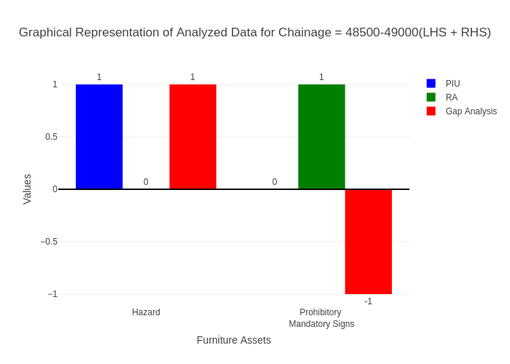

# Chainage: 49000-49500

## PIU Data:

|  |  |  |  |
| --- | --- | --- | --- |
| **Furniture Assets** | **49000-49500** | **49500-49000** | **LHS+RHS** |
| Chevron | 0.0 | 0.0 | 0.0 |
| Cautionary Warning Signs | 1.0 | 0.0 | 1.0 |
| Hazard | 0.0 | 0.0 | 0.0 |
| Prohibitory Mandatory Signs | 0.0 | 0.0 | 0.0 |
| Informatory Signs | 0.0 | 1.0 | 1.0 |

## RA Data:

|  |  |  |  |
| --- | --- | --- | --- |
| **Furniture Assets** | **49000-49500** | **49500-49000** | **LHS+RHS** |
| Chevron | 0.0 | 0.0 | 0.0 |
| Cautionary Warning Signs | 1.0 | 0.0 | 1.0 |
| Hazard | 0.0 | 0.0 | 0.0 |
| Prohibitory Mandatory Signs | 0.0 | 0.0 | 0.0 |
| Informatory Signs | 1.0 | 0.0 | 1.0 |

## Gap Analysis:

|  |  |  |  |
| --- | --- | --- | --- |
| **Furniture Assets** | **49000-49500** | **49500-49000** | **LHS+RHS** |
| Chevron | 0.0 | 0.0 | 0.0 |
| Cautionary Warning Signs | 0.0 | 0.0 | 0.0 |
| Hazard | 0.0 | 0.0 | 0.0 |
| Prohibitory Mandatory Signs | 0.0 | 0.0 | 0.0 |
| Informatory Signs | -1.0 | 1.0 | 0.0 |

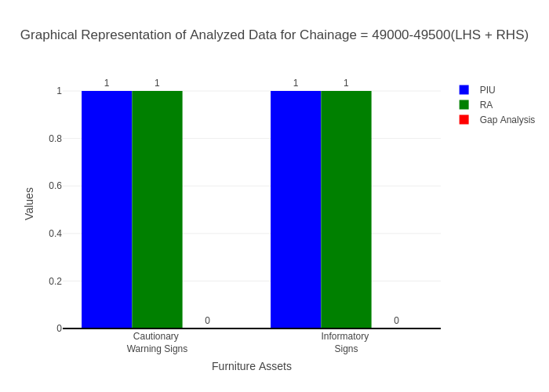

# Chainage: 49500-50000

## PIU Data:

|  |  |  |  |
| --- | --- | --- | --- |
| **Furniture Assets** | **49500-50000** | **50000-49500** | **LHS+RHS** |
| Chevron | 0.0 | 0.0 | 0.0 |
| Cautionary Warning Signs | 0.0 | 0.0 | 0.0 |
| Hazard | 2.0 | 0.0 | 2.0 |
| Prohibitory Mandatory Signs | 0.0 | 0.0 | 0.0 |
| Informatory Signs | 2.0 | 0.0 | 2.0 |

## RA Data:

|  |  |  |  |
| --- | --- | --- | --- |
| **Furniture Assets** | **49500-50000** | **50000-49500** | **LHS+RHS** |
| Chevron | 0.0 | 0.0 | 0.0 |
| Cautionary Warning Signs | 0.0 | 1.0 | 1.0 |
| Hazard | 1.0 | 1.0 | 2.0 |
| Prohibitory Mandatory Signs | 0.0 | 0.0 | 0.0 |
| Informatory Signs | 0.0 | 2.0 | 2.0 |

## Gap Analysis:

|  |  |  |  |
| --- | --- | --- | --- |
| **Furniture Assets** | **49500-50000** | **50000-49500** | **LHS+RHS** |
| Chevron | 0.0 | 0.0 | 0.0 |
| Cautionary Warning Signs | 0.0 | -1.0 | -1.0 |
| Hazard | 1.0 | -1.0 | 0.0 |
| Prohibitory Mandatory Signs | 0.0 | 0.0 | 0.0 |
| Informatory Signs | 2.0 | -2.0 | 0.0 |

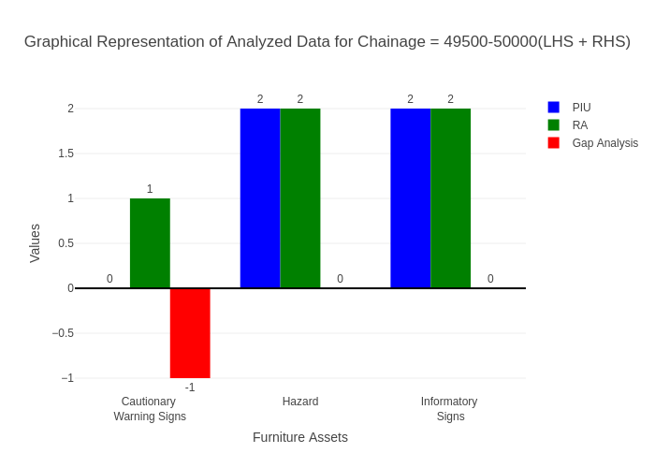

# Chainage: 50000-50500

## PIU Data:

|  |  |  |  |
| --- | --- | --- | --- |
| **Furniture Assets** | **50000-50500** | **50500-50000** | **LHS+RHS** |
| Chevron | 0.0 | 0.0 | 0.0 |
| Cautionary Warning Signs | 0.0 | 0.0 | 0.0 |
| Hazard | 0.0 | 0.0 | 0.0 |
| Prohibitory Mandatory Signs | 0.0 | 0.0 | 0.0 |
| Informatory Signs | 0.0 | 0.0 | 0.0 |

## RA Data:

|  |  |  |  |
| --- | --- | --- | --- |
| **Furniture Assets** | **50000-50500** | **50500-50000** | **LHS+RHS** |
| Chevron | 0.0 | 0.0 | 0.0 |
| Cautionary Warning Signs | 0.0 | 0.0 | 0.0 |
| Hazard | 0.0 | 0.0 | 0.0 |
| Prohibitory Mandatory Signs | 0.0 | 0.0 | 0.0 |
| Informatory Signs | 1.0 | 1.0 | 2.0 |

## Gap Analysis:

|  |  |  |  |
| --- | --- | --- | --- |
| **Furniture Assets** | **50000-50500** | **50500-50000** | **LHS+RHS** |
| Chevron | 0.0 | 0.0 | 0.0 |
| Cautionary Warning Signs | 0.0 | 0.0 | 0.0 |
| Hazard | 0.0 | 0.0 | 0.0 |
| Prohibitory Mandatory Signs | 0.0 | 0.0 | 0.0 |
| Informatory Signs | -1.0 | -1.0 | -2.0 |

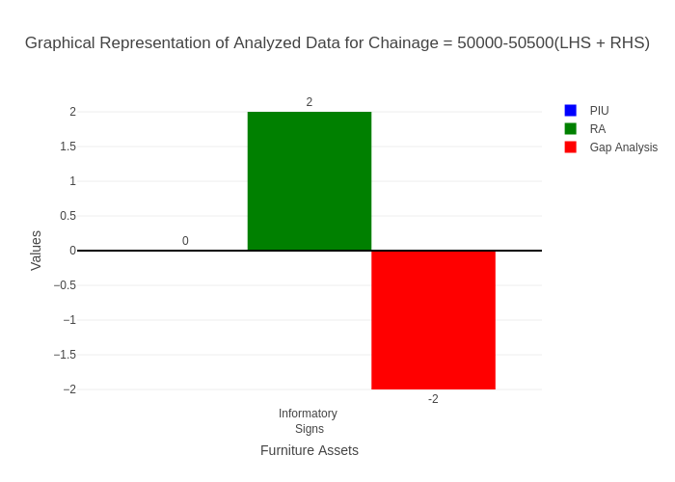

# Chainage: 50500-51000

## PIU Data:

|  |  |  |  |
| --- | --- | --- | --- |
| **Furniture Assets** | **50500-51000** | **51000-50500** | **LHS+RHS** |
| Chevron | 0.0 | 0.0 | 0.0 |
| Cautionary Warning Signs | 0.0 | 0.0 | 0.0 |
| Hazard | 0.0 | 0.0 | 0.0 |
| Prohibitory Mandatory Signs | 0.0 | 0.0 | 0.0 |
| Informatory Signs | 0.0 | 0.0 | 0.0 |

## RA Data:

|  |  |  |  |
| --- | --- | --- | --- |
| **Furniture Assets** | **50500-51000** | **51000-50500** | **LHS+RHS** |
| Chevron | 0.0 | 0.0 | 0.0 |
| Cautionary Warning Signs | 0.0 | 0.0 | 0.0 |
| Hazard | 0.0 | 0.0 | 0.0 |
| Prohibitory Mandatory Signs | 0.0 | 0.0 | 0.0 |
| Informatory Signs | 0.0 | 0.0 | 0.0 |

## Gap Analysis:

|  |  |  |  |
| --- | --- | --- | --- |
| **Furniture Assets** | **50500-51000** | **51000-50500** | **LHS+RHS** |
| Chevron | 0.0 | 0.0 | 0.0 |
| Cautionary Warning Signs | 0.0 | 0.0 | 0.0 |
| Hazard | 0.0 | 0.0 | 0.0 |
| Prohibitory Mandatory Signs | 0.0 | 0.0 | 0.0 |
| Informatory Signs | 0.0 | 0.0 | 0.0 |



# Chainage: 51000-51500

## PIU Data:

|  |  |  |  |
| --- | --- | --- | --- |
| **Furniture Assets** | **51000-51500** | **51500-51000** | **LHS+RHS** |
| Chevron | 0.0 | 0.0 | 0.0 |
| Cautionary Warning Signs | 0.0 | 0.0 | 0.0 |
| Hazard | 0.0 | 0.0 | 0.0 |
| Prohibitory Mandatory Signs | 0.0 | 0.0 | 0.0 |
| Informatory Signs | 0.0 | 0.0 | 0.0 |

## RA Data:

|  |  |  |  |
| --- | --- | --- | --- |
| **Furniture Assets** | **51000-51500** | **51500-51000** | **LHS+RHS** |
| Chevron | 0.0 | 0.0 | 0.0 |
| Cautionary Warning Signs | 0.0 | 0.0 | 0.0 |
| Hazard | 0.0 | 0.0 | 0.0 |
| Prohibitory Mandatory Signs | 0.0 | 0.0 | 0.0 |
| Informatory Signs | 0.0 | 0.0 | 0.0 |

## Gap Analysis:

|  |  |  |  |
| --- | --- | --- | --- |
| **Furniture Assets** | **51000-51500** | **51500-51000** | **LHS+RHS** |
| Chevron | 0.0 | 0.0 | 0.0 |
| Cautionary Warning Signs | 0.0 | 0.0 | 0.0 |
| Hazard | 0.0 | 0.0 | 0.0 |
| Prohibitory Mandatory Signs | 0.0 | 0.0 | 0.0 |
| Informatory Signs | 0.0 | 0.0 | 0.0 |



# Chainage: 51500-52000

## PIU Data:

|  |  |  |  |
| --- | --- | --- | --- |
| **Furniture Assets** | **51500-52000** | **52000-51500** | **LHS+RHS** |
| Chevron | 0.0 | 0.0 | 0.0 |
| Cautionary Warning Signs | 0.0 | 0.0 | 0.0 |
| Hazard | 0.0 | 0.0 | 0.0 |
| Prohibitory Mandatory Signs | 0.0 | 0.0 | 0.0 |
| Informatory Signs | 0.0 | 0.0 | 0.0 |

## RA Data:

|  |  |  |  |
| --- | --- | --- | --- |
| **Furniture Assets** | **51500-52000** | **52000-51500** | **LHS+RHS** |
| Chevron | 0.0 | 0.0 | 0.0 |
| Cautionary Warning Signs | 0.0 | 0.0 | 0.0 |
| Hazard | 0.0 | 0.0 | 0.0 |
| Prohibitory Mandatory Signs | 0.0 | 0.0 | 0.0 |
| Informatory Signs | 0.0 | 1.0 | 1.0 |

## Gap Analysis:

|  |  |  |  |
| --- | --- | --- | --- |
| **Furniture Assets** | **51500-52000** | **52000-51500** | **LHS+RHS** |
| Chevron | 0.0 | 0.0 | 0.0 |
| Cautionary Warning Signs | 0.0 | 0.0 | 0.0 |
| Hazard | 0.0 | 0.0 | 0.0 |
| Prohibitory Mandatory Signs | 0.0 | 0.0 | 0.0 |
| Informatory Signs | 0.0 | -1.0 | -1.0 |

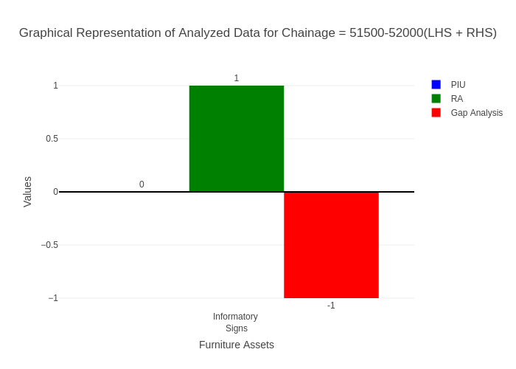

# Chainage: 52000-52500

## PIU Data:

|  |  |  |  |
| --- | --- | --- | --- |
| **Furniture Assets** | **52000-52500** | **52500-52000** | **LHS+RHS** |
| Chevron | 0.0 | 0.0 | 0.0 |
| Cautionary Warning Signs | 2.0 | 0.0 | 2.0 |
| Hazard | 2.0 | 0.0 | 2.0 |
| Prohibitory Mandatory Signs | 0.0 | 0.0 | 0.0 |
| Informatory Signs | 1.0 | 0.0 | 1.0 |

## RA Data:

|  |  |  |  |
| --- | --- | --- | --- |
| **Furniture Assets** | **52000-52500** | **52500-52000** | **LHS+RHS** |
| Chevron | 0.0 | 0.0 | 0.0 |
| Cautionary Warning Signs | 2.0 | 0.0 | 2.0 |
| Hazard | 1.0 | 0.0 | 1.0 |
| Prohibitory Mandatory Signs | 0.0 | 0.0 | 0.0 |
| Informatory Signs | 2.0 | 2.0 | 4.0 |

## Gap Analysis:

|  |  |  |  |
| --- | --- | --- | --- |
| **Furniture Assets** | **52000-52500** | **52500-52000** | **LHS+RHS** |
| Chevron | 0.0 | 0.0 | 0.0 |
| Cautionary Warning Signs | 0.0 | 0.0 | 0.0 |
| Hazard | 1.0 | 0.0 | 1.0 |
| Prohibitory Mandatory Signs | 0.0 | 0.0 | 0.0 |
| Informatory Signs | -1.0 | -2.0 | -3.0 |

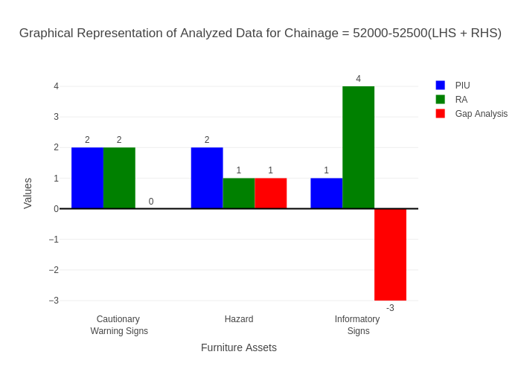

# Chainage: 52500-53000

## PIU Data:

|  |  |  |  |
| --- | --- | --- | --- |
| **Furniture Assets** | **52500-53000** | **53000-52500** | **LHS+RHS** |
| Chevron | 0.0 | 0.0 | 0.0 |
| Cautionary Warning Signs | 0.0 | 1.0 | 1.0 |
| Hazard | 0.0 | 0.0 | 0.0 |
| Prohibitory Mandatory Signs | 0.0 | 0.0 | 0.0 |
| Informatory Signs | 0.0 | 0.0 | 0.0 |

## RA Data:

|  |  |  |  |
| --- | --- | --- | --- |
| **Furniture Assets** | **52500-53000** | **53000-52500** | **LHS+RHS** |
| Chevron | 0.0 | 0.0 | 0.0 |
| Cautionary Warning Signs | 0.0 | 1.0 | 1.0 |
| Hazard | 0.0 | 1.0 | 1.0 |
| Prohibitory Mandatory Signs | 0.0 | 2.0 | 2.0 |
| Informatory Signs | 0.0 | 0.0 | 0.0 |

## Gap Analysis:

|  |  |  |  |
| --- | --- | --- | --- |
| **Furniture Assets** | **52500-53000** | **53000-52500** | **LHS+RHS** |
| Chevron | 0.0 | 0.0 | 0.0 |
| Cautionary Warning Signs | 0.0 | 0.0 | 0.0 |
| Hazard | 0.0 | -1.0 | -1.0 |
| Prohibitory Mandatory Signs | 0.0 | -2.0 | -2.0 |
| Informatory Signs | 0.0 | 0.0 | 0.0 |

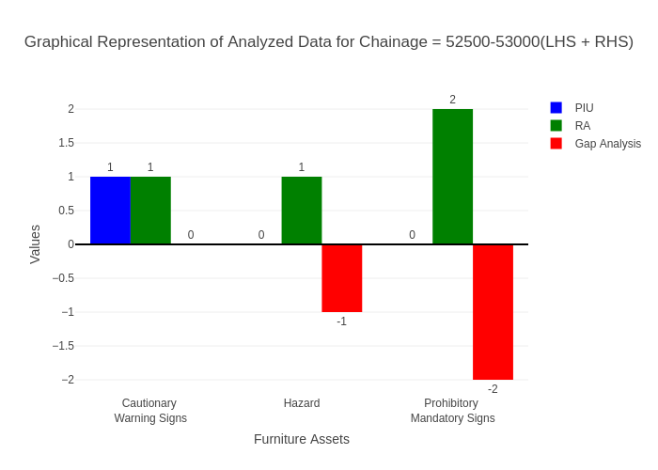

# Chainage: 53000-53500

## PIU Data:

|  |  |  |  |
| --- | --- | --- | --- |
| **Furniture Assets** | **53000-53500** | **53500-53000** | **LHS+RHS** |
| Chevron | 0.0 | 0.0 | 0.0 |
| Cautionary Warning Signs | 0.0 | 0.0 | 0.0 |
| Hazard | 0.0 | 0.0 | 0.0 |
| Prohibitory Mandatory Signs | 0.0 | 0.0 | 0.0 |
| Informatory Signs | 0.0 | 0.0 | 0.0 |

## RA Data:

|  |  |  |  |
| --- | --- | --- | --- |
| **Furniture Assets** | **53000-53500** | **53500-53000** | **LHS+RHS** |
| Chevron | 0.0 | 0.0 | 0.0 |
| Cautionary Warning Signs | 0.0 | 2.0 | 2.0 |
| Hazard | 0.0 | 0.0 | 0.0 |
| Prohibitory Mandatory Signs | 0.0 | 1.0 | 1.0 |
| Informatory Signs | 0.0 | 4.0 | 4.0 |

## Gap Analysis:

|  |  |  |  |
| --- | --- | --- | --- |
| **Furniture Assets** | **53000-53500** | **53500-53000** | **LHS+RHS** |
| Chevron | 0.0 | 0.0 | 0.0 |
| Cautionary Warning Signs | 0.0 | -2.0 | -2.0 |
| Hazard | 0.0 | 0.0 | 0.0 |
| Prohibitory Mandatory Signs | 0.0 | -1.0 | -1.0 |
| Informatory Signs | 0.0 | -4.0 | -4.0 |

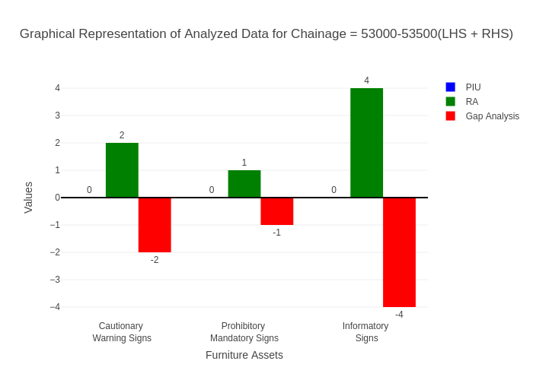

# Chainage: 53500-54000

## PIU Data:

|  |  |  |  |
| --- | --- | --- | --- |
| **Furniture Assets** | **53500-54000** | **54000-53500** | **LHS+RHS** |
| Chevron | 0.0 | 0.0 | 0.0 |
| Cautionary Warning Signs | 0.0 | 0.0 | 0.0 |
| Hazard | 0.0 | 0.0 | 0.0 |
| Prohibitory Mandatory Signs | 0.0 | 0.0 | 0.0 |
| Informatory Signs | 0.0 | 0.0 | 0.0 |

## RA Data:

|  |  |  |  |
| --- | --- | --- | --- |
| **Furniture Assets** | **53500-54000** | **54000-53500** | **LHS+RHS** |
| Chevron | 0.0 | 0.0 | 0.0 |
| Cautionary Warning Signs | 0.0 | 0.0 | 0.0 |
| Hazard | 0.0 | 0.0 | 0.0 |
| Prohibitory Mandatory Signs | 0.0 | 0.0 | 0.0 |
| Informatory Signs | 0.0 | 0.0 | 0.0 |

## Gap Analysis:

|  |  |  |  |
| --- | --- | --- | --- |
| **Furniture Assets** | **53500-54000** | **54000-53500** | **LHS+RHS** |
| Chevron | 0.0 | 0.0 | 0.0 |
| Cautionary Warning Signs | 0.0 | 0.0 | 0.0 |
| Hazard | 0.0 | 0.0 | 0.0 |
| Prohibitory Mandatory Signs | 0.0 | 0.0 | 0.0 |
| Informatory Signs | 0.0 | 0.0 | 0.0 |



# Chainage: 54000-54500

## PIU Data:

|  |  |  |  |
| --- | --- | --- | --- |
| **Furniture Assets** | **54000-54500** | **54500-54000** | **LHS+RHS** |
| Chevron | 0.0 | 0.0 | 0.0 |
| Cautionary Warning Signs | 0.0 | 0.0 | 0.0 |
| Hazard | 1.0 | 0.0 | 1.0 |
| Prohibitory Mandatory Signs | 0.0 | 0.0 | 0.0 |
| Informatory Signs | 0.0 | 0.0 | 0.0 |

## RA Data:

|  |  |  |  |
| --- | --- | --- | --- |
| **Furniture Assets** | **54000-54500** | **54500-54000** | **LHS+RHS** |
| Chevron | 0.0 | 0.0 | 0.0 |
| Cautionary Warning Signs | 0.0 | 0.0 | 0.0 |
| Hazard | 0.0 | 0.0 | 0.0 |
| Prohibitory Mandatory Signs | 0.0 | 0.0 | 0.0 |
| Informatory Signs | 0.0 | 0.0 | 0.0 |

## Gap Analysis:

|  |  |  |  |
| --- | --- | --- | --- |
| **Furniture Assets** | **54000-54500** | **54500-54000** | **LHS+RHS** |
| Chevron | 0.0 | 0.0 | 0.0 |
| Cautionary Warning Signs | 0.0 | 0.0 | 0.0 |
| Hazard | 1.0 | 0.0 | 1.0 |
| Prohibitory Mandatory Signs | 0.0 | 0.0 | 0.0 |
| Informatory Signs | 0.0 | 0.0 | 0.0 |

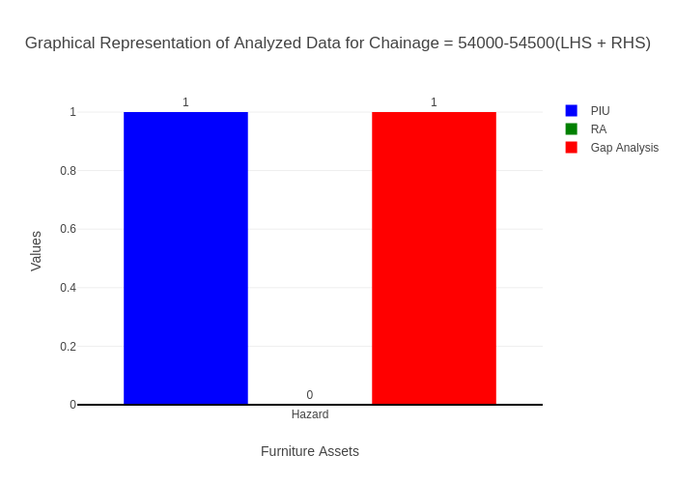

# Chainage: 54500-55000

## PIU Data:

|  |  |  |  |
| --- | --- | --- | --- |
| **Furniture Assets** | **54500-55000** | **55000-54500** | **LHS+RHS** |
| Chevron | 0.0 | 0.0 | 0.0 |
| Cautionary Warning Signs | 0.0 | 0.0 | 0.0 |
| Hazard | 2.0 | 1.0 | 3.0 |
| Prohibitory Mandatory Signs | 0.0 | 0.0 | 0.0 |
| Informatory Signs | 0.0 | 0.0 | 0.0 |

## RA Data:

|  |  |  |  |
| --- | --- | --- | --- |
| **Furniture Assets** | **54500-55000** | **55000-54500** | **LHS+RHS** |
| Chevron | 0.0 | 0.0 | 0.0 |
| Cautionary Warning Signs | 0.0 | 0.0 | 0.0 |
| Hazard | 1.0 | 0.0 | 1.0 |
| Prohibitory Mandatory Signs | 0.0 | 0.0 | 0.0 |
| Informatory Signs | 0.0 | 0.0 | 0.0 |

## Gap Analysis:

|  |  |  |  |
| --- | --- | --- | --- |
| **Furniture Assets** | **54500-55000** | **55000-54500** | **LHS+RHS** |
| Chevron | 0.0 | 0.0 | 0.0 |
| Cautionary Warning Signs | 0.0 | 0.0 | 0.0 |
| Hazard | 1.0 | 1.0 | 2.0 |
| Prohibitory Mandatory Signs | 0.0 | 0.0 | 0.0 |
| Informatory Signs | 0.0 | 0.0 | 0.0 |

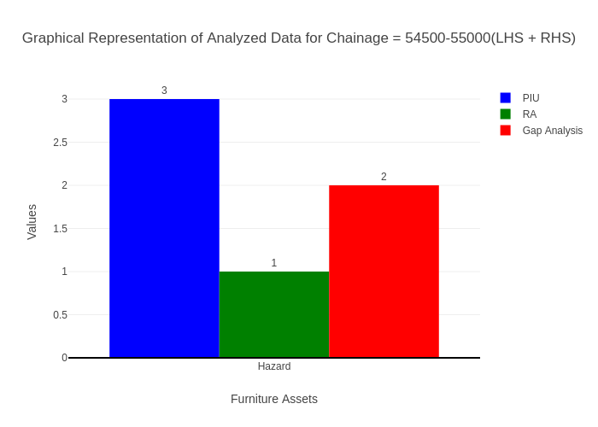

# Chainage: 55000-55500

## PIU Data:

|  |  |  |  |
| --- | --- | --- | --- |
| **Furniture Assets** | **55000-55500** | **55500-55000** | **LHS+RHS** |
| Chevron | 1.0 | 0.0 | 1.0 |
| Cautionary Warning Signs | 1.0 | 0.0 | 1.0 |
| Hazard | 1.0 | 0.0 | 1.0 |
| Prohibitory Mandatory Signs | 0.0 | 0.0 | 0.0 |
| Informatory Signs | 3.0 | 0.0 | 3.0 |

## RA Data:

|  |  |  |  |
| --- | --- | --- | --- |
| **Furniture Assets** | **55000-55500** | **55500-55000** | **LHS+RHS** |
| Chevron | 0.0 | 0.0 | 0.0 |
| Cautionary Warning Signs | 1.0 | 0.0 | 1.0 |
| Hazard | 1.0 | 0.0 | 1.0 |
| Prohibitory Mandatory Signs | 0.0 | 0.0 | 0.0 |
| Informatory Signs | 7.0 | 2.0 | 9.0 |

## Gap Analysis:

|  |  |  |  |
| --- | --- | --- | --- |
| **Furniture Assets** | **55000-55500** | **55500-55000** | **LHS+RHS** |
| Chevron | 1.0 | 0.0 | 1.0 |
| Cautionary Warning Signs | 0.0 | 0.0 | 0.0 |
| Hazard | 0.0 | 0.0 | 0.0 |
| Prohibitory Mandatory Signs | 0.0 | 0.0 | 0.0 |
| Informatory Signs | -4.0 | -2.0 | -6.0 |

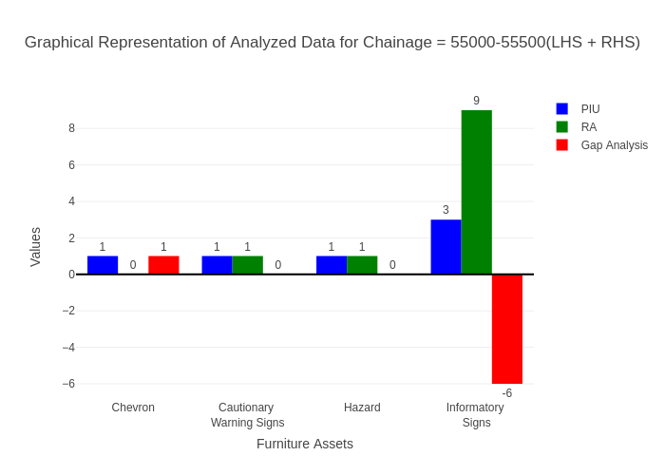

# Chainage: 55500-56000

## PIU Data:

|  |  |  |  |
| --- | --- | --- | --- |
| **Furniture Assets** | **55500-56000** | **56000-55500** | **LHS+RHS** |
| Chevron | 0.0 | 0.0 | 0.0 |
| Cautionary Warning Signs | 0.0 | 0.0 | 0.0 |
| Hazard | 0.0 | 0.0 | 0.0 |
| Prohibitory Mandatory Signs | 0.0 | 0.0 | 0.0 |
| Informatory Signs | 0.0 | 0.0 | 0.0 |

## RA Data:

|  |  |  |  |
| --- | --- | --- | --- |
| **Furniture Assets** | **55500-56000** | **56000-55500** | **LHS+RHS** |
| Chevron | 0.0 | 0.0 | 0.0 |
| Cautionary Warning Signs | 1.0 | 1.0 | 2.0 |
| Hazard | 0.0 | 1.0 | 1.0 |
| Prohibitory Mandatory Signs | 0.0 | 0.0 | 0.0 |
| Informatory Signs | 2.0 | 0.0 | 2.0 |

## Gap Analysis:

|  |  |  |  |
| --- | --- | --- | --- |
| **Furniture Assets** | **55500-56000** | **56000-55500** | **LHS+RHS** |
| Chevron | 0.0 | 0.0 | 0.0 |
| Cautionary Warning Signs | -1.0 | -1.0 | -2.0 |
| Hazard | 0.0 | -1.0 | -1.0 |
| Prohibitory Mandatory Signs | 0.0 | 0.0 | 0.0 |
| Informatory Signs | -2.0 | 0.0 | -2.0 |

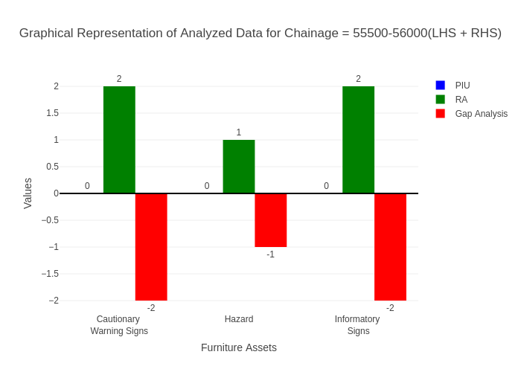

# Chainage: 56000-56500

## PIU Data:

|  |  |  |  |
| --- | --- | --- | --- |
| **Furniture Assets** | **56000-56500** | **56500-56000** | **LHS+RHS** |
| Chevron | 0.0 | 0.0 | 0.0 |
| Cautionary Warning Signs | 0.0 | 0.0 | 0.0 |
| Hazard | 1.0 | 0.0 | 1.0 |
| Prohibitory Mandatory Signs | 0.0 | 0.0 | 0.0 |
| Informatory Signs | 3.0 | 0.0 | 3.0 |

## RA Data:

|  |  |  |  |
| --- | --- | --- | --- |
| **Furniture Assets** | **56000-56500** | **56500-56000** | **LHS+RHS** |
| Chevron | 0.0 | 0.0 | 0.0 |
| Cautionary Warning Signs | 0.0 | 0.0 | 0.0 |
| Hazard | 0.0 | 0.0 | 0.0 |
| Prohibitory Mandatory Signs | 0.0 | 0.0 | 0.0 |
| Informatory Signs | 4.0 | 2.0 | 6.0 |

## Gap Analysis:

|  |  |  |  |
| --- | --- | --- | --- |
| **Furniture Assets** | **56000-56500** | **56500-56000** | **LHS+RHS** |
| Chevron | 0.0 | 0.0 | 0.0 |
| Cautionary Warning Signs | 0.0 | 0.0 | 0.0 |
| Hazard | 1.0 | 0.0 | 1.0 |
| Prohibitory Mandatory Signs | 0.0 | 0.0 | 0.0 |
| Informatory Signs | -1.0 | -2.0 | -3.0 |

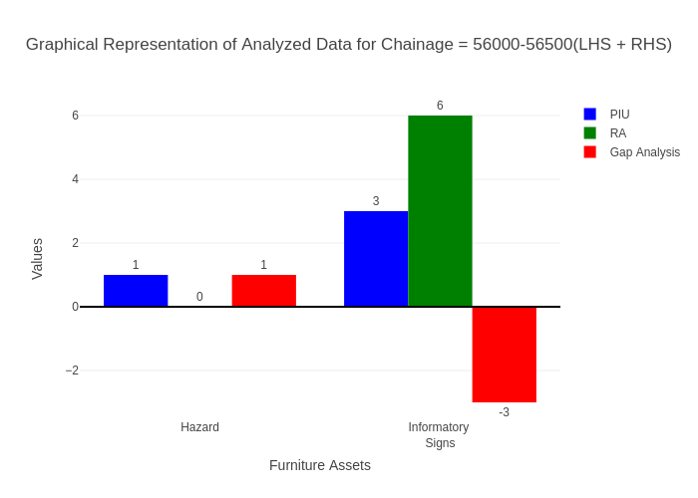

# Chainage: 56500-57000

## PIU Data:

|  |  |  |  |
| --- | --- | --- | --- |
| **Furniture Assets** | **56500-57000** | **57000-56500** | **LHS+RHS** |
| Chevron | 0.0 | 0.0 | 0.0 |
| Cautionary Warning Signs | 1.0 | 1.0 | 2.0 |
| Hazard | 3.0 | 0.0 | 3.0 |
| Prohibitory Mandatory Signs | 0.0 | 0.0 | 0.0 |
| Informatory Signs | 2.0 | 0.0 | 2.0 |

## RA Data:

|  |  |  |  |
| --- | --- | --- | --- |
| **Furniture Assets** | **56500-57000** | **57000-56500** | **LHS+RHS** |
| Chevron | 0.0 | 0.0 | 0.0 |
| Cautionary Warning Signs | 2.0 | 1.0 | 3.0 |
| Hazard | 1.0 | 1.0 | 2.0 |
| Prohibitory Mandatory Signs | 1.0 | 0.0 | 1.0 |
| Informatory Signs | 2.0 | 0.0 | 2.0 |

## Gap Analysis:

|  |  |  |  |
| --- | --- | --- | --- |
| **Furniture Assets** | **56500-57000** | **57000-56500** | **LHS+RHS** |
| Chevron | 0.0 | 0.0 | 0.0 |
| Cautionary Warning Signs | -1.0 | 0.0 | -1.0 |
| Hazard | 2.0 | -1.0 | 1.0 |
| Prohibitory Mandatory Signs | -1.0 | 0.0 | -1.0 |
| Informatory Signs | 0.0 | 0.0 | 0.0 |

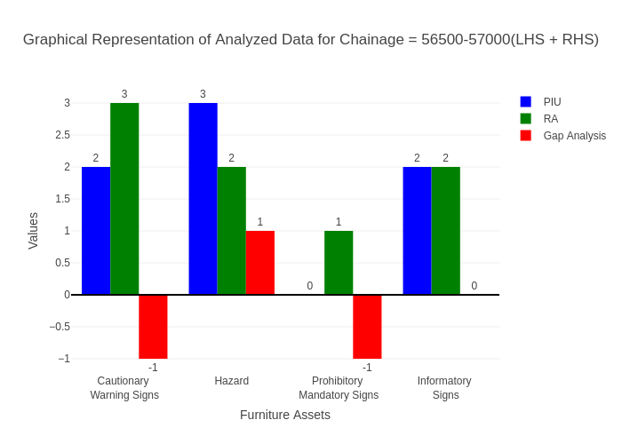

# Chainage: 57000-57500

## PIU Data:

|  |  |  |  |
| --- | --- | --- | --- |
| **Furniture Assets** | **57000-57500** | **57500-57000** | **LHS+RHS** |
| Chevron | 0.0 | 0.0 | 0.0 |
| Cautionary Warning Signs | 0.0 | 0.0 | 0.0 |
| Hazard | 0.0 | 0.0 | 0.0 |
| Prohibitory Mandatory Signs | 0.0 | 0.0 | 0.0 |
| Informatory Signs | 0.0 | 0.0 | 0.0 |

## RA Data:

|  |  |  |  |
| --- | --- | --- | --- |
| **Furniture Assets** | **57000-57500** | **57500-57000** | **LHS+RHS** |
| Chevron | 0.0 | 0.0 | 0.0 |
| Cautionary Warning Signs | 0.0 | 3.0 | 3.0 |
| Hazard | 3.0 | 1.0 | 4.0 |
| Prohibitory Mandatory Signs | 0.0 | 2.0 | 2.0 |
| Informatory Signs | 0.0 | 1.0 | 1.0 |

## Gap Analysis:

|  |  |  |  |
| --- | --- | --- | --- |
| **Furniture Assets** | **57000-57500** | **57500-57000** | **LHS+RHS** |
| Chevron | 0.0 | 0.0 | 0.0 |
| Cautionary Warning Signs | 0.0 | -3.0 | -3.0 |
| Hazard | -3.0 | -1.0 | -4.0 |
| Prohibitory Mandatory Signs | 0.0 | -2.0 | -2.0 |
| Informatory Signs | 0.0 | -1.0 | -1.0 |

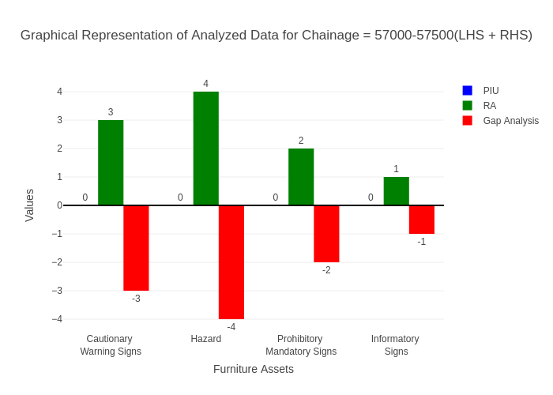

# Chainage: 57500-58000

## PIU Data:

|  |  |  |  |
| --- | --- | --- | --- |
| **Furniture Assets** | **57500-58000** | **58000-57500** | **LHS+RHS** |
| Chevron | 0.0 | 0.0 | 0.0 |
| Cautionary Warning Signs | 0.0 | 0.0 | 0.0 |
| Hazard | 0.0 | 0.0 | 0.0 |
| Prohibitory Mandatory Signs | 0.0 | 0.0 | 0.0 |
| Informatory Signs | 0.0 | 0.0 | 0.0 |

## RA Data:

|  |  |  |  |
| --- | --- | --- | --- |
| **Furniture Assets** | **57500-58000** | **58000-57500** | **LHS+RHS** |
| Chevron | 0.0 | 0.0 | 0.0 |
| Cautionary Warning Signs | 0.0 | 0.0 | 0.0 |
| Hazard | 1.0 | 1.0 | 2.0 |
| Prohibitory Mandatory Signs | 0.0 | 0.0 | 0.0 |
| Informatory Signs | 0.0 | 1.0 | 1.0 |

## Gap Analysis:

|  |  |  |  |
| --- | --- | --- | --- |
| **Furniture Assets** | **57500-58000** | **58000-57500** | **LHS+RHS** |
| Chevron | 0.0 | 0.0 | 0.0 |
| Cautionary Warning Signs | 0.0 | 0.0 | 0.0 |
| Hazard | -1.0 | -1.0 | -2.0 |
| Prohibitory Mandatory Signs | 0.0 | 0.0 | 0.0 |
| Informatory Signs | 0.0 | -1.0 | -1.0 |

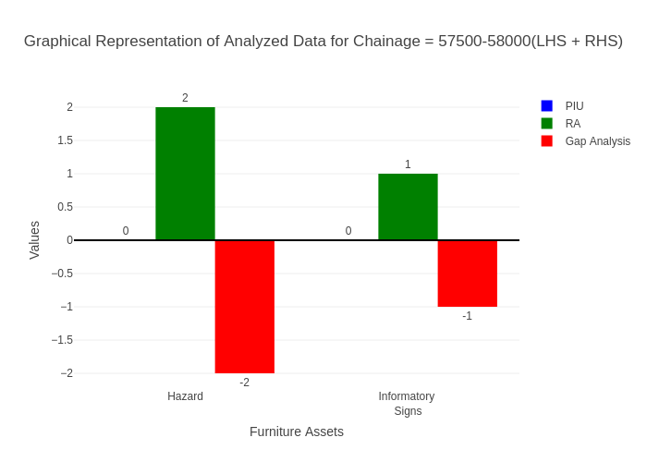

# Chainage: 58000-58500

## PIU Data:

|  |  |  |  |
| --- | --- | --- | --- |
| **Furniture Assets** | **58000-58500** | **58500-58000** | **LHS+RHS** |
| Chevron | 1.0 | 0.0 | 1.0 |
| Cautionary Warning Signs | 1.0 | 0.0 | 1.0 |
| Hazard | 5.0 | 0.0 | 5.0 |
| Prohibitory Mandatory Signs | 0.0 | 0.0 | 0.0 |
| Informatory Signs | 1.0 | 0.0 | 1.0 |

## RA Data:

|  |  |  |  |
| --- | --- | --- | --- |
| **Furniture Assets** | **58000-58500** | **58500-58000** | **LHS+RHS** |
| Chevron | 2.0 | 0.0 | 2.0 |
| Cautionary Warning Signs | 0.0 | 0.0 | 0.0 |
| Hazard | 0.0 | 0.0 | 0.0 |
| Prohibitory Mandatory Signs | 0.0 | 0.0 | 0.0 |
| Informatory Signs | 0.0 | 0.0 | 0.0 |

## Gap Analysis:

|  |  |  |  |
| --- | --- | --- | --- |
| **Furniture Assets** | **58000-58500** | **58500-58000** | **LHS+RHS** |
| Chevron | -1.0 | 0.0 | -1.0 |
| Cautionary Warning Signs | 1.0 | 0.0 | 1.0 |
| Hazard | 5.0 | 0.0 | 5.0 |
| Prohibitory Mandatory Signs | 0.0 | 0.0 | 0.0 |
| Informatory Signs | 1.0 | 0.0 | 1.0 |

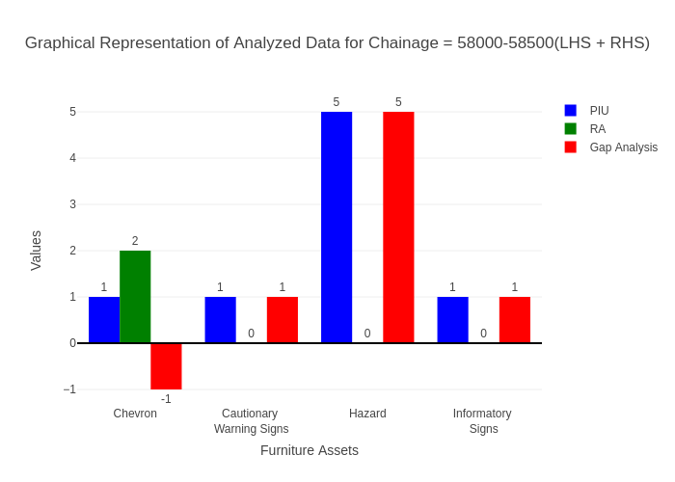

# Chainage: 58500-59000

## PIU Data:

|  |  |  |  |
| --- | --- | --- | --- |
| **Furniture Assets** | **58500-59000** | **59000-58500** | **LHS+RHS** |
| Chevron | 1.0 | 0.0 | 1.0 |
| Cautionary Warning Signs | 0.0 | 2.0 | 2.0 |
| Hazard | 2.0 | 0.0 | 2.0 |
| Prohibitory Mandatory Signs | 0.0 | 0.0 | 0.0 |
| Informatory Signs | 0.0 | 0.0 | 0.0 |

## RA Data:

|  |  |  |  |
| --- | --- | --- | --- |
| **Furniture Assets** | **58500-59000** | **59000-58500** | **LHS+RHS** |
| Chevron | 1.0 | 2.0 | 3.0 |
| Cautionary Warning Signs | 0.0 | 0.0 | 0.0 |
| Hazard | 1.0 | 0.0 | 1.0 |
| Prohibitory Mandatory Signs | 0.0 | 0.0 | 0.0 |
| Informatory Signs | 1.0 | 0.0 | 1.0 |

## Gap Analysis:

|  |  |  |  |
| --- | --- | --- | --- |
| **Furniture Assets** | **58500-59000** | **59000-58500** | **LHS+RHS** |
| Chevron | 0.0 | -2.0 | -2.0 |
| Cautionary Warning Signs | 0.0 | 2.0 | 2.0 |
| Hazard | 1.0 | 0.0 | 1.0 |
| Prohibitory Mandatory Signs | 0.0 | 0.0 | 0.0 |
| Informatory Signs | -1.0 | 0.0 | -1.0 |

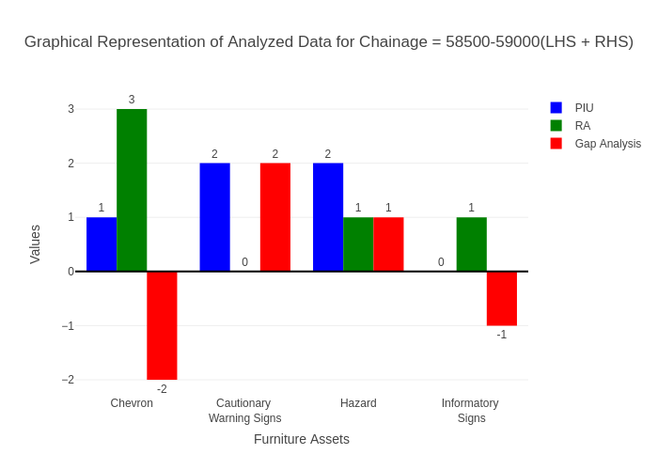

# Chainage: 59000-59500

## PIU Data:

|  |  |  |  |
| --- | --- | --- | --- |
| **Furniture Assets** | **59000-59500** | **59500-59000** | **LHS+RHS** |
| Chevron | 0.0 | 0.0 | 0.0 |
| Cautionary Warning Signs | 0.0 | 1.0 | 1.0 |
| Hazard | 0.0 | 0.0 | 0.0 |
| Prohibitory Mandatory Signs | 0.0 | 0.0 | 0.0 |
| Informatory Signs | 0.0 | 0.0 | 0.0 |

## RA Data:

|  |  |  |  |
| --- | --- | --- | --- |
| **Furniture Assets** | **59000-59500** | **59500-59000** | **LHS+RHS** |
| Chevron | 0.0 | 0.0 | 0.0 |
| Cautionary Warning Signs | 0.0 | 3.0 | 3.0 |
| Hazard | 0.0 | 1.0 | 1.0 |
| Prohibitory Mandatory Signs | 0.0 | 2.0 | 2.0 |
| Informatory Signs | 1.0 | 0.0 | 1.0 |

## Gap Analysis:

|  |  |  |  |
| --- | --- | --- | --- |
| **Furniture Assets** | **59000-59500** | **59500-59000** | **LHS+RHS** |
| Chevron | 0.0 | 0.0 | 0.0 |
| Cautionary Warning Signs | 0.0 | -2.0 | -2.0 |
| Hazard | 0.0 | -1.0 | -1.0 |
| Prohibitory Mandatory Signs | 0.0 | -2.0 | -2.0 |
| Informatory Signs | -1.0 | 0.0 | -1.0 |

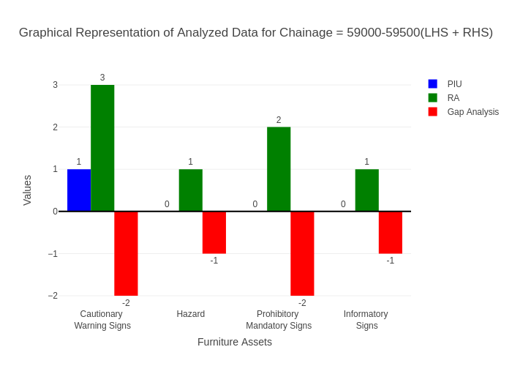

# Chainage: 59500-60000

## PIU Data:

|  |  |  |  |
| --- | --- | --- | --- |
| **Furniture Assets** | **59500-60000** | **60000-59500** | **LHS+RHS** |
| Chevron | 0.0 | 0.0 | 0.0 |
| Cautionary Warning Signs | 0.0 | 0.0 | 0.0 |
| Hazard | 0.0 | 0.0 | 0.0 |
| Prohibitory Mandatory Signs | 0.0 | 0.0 | 0.0 |
| Informatory Signs | 0.0 | 1.0 | 1.0 |

## RA Data:

|  |  |  |  |
| --- | --- | --- | --- |
| **Furniture Assets** | **59500-60000** | **60000-59500** | **LHS+RHS** |
| Chevron | 0.0 | 0.0 | 0.0 |
| Cautionary Warning Signs | 0.0 | 0.0 | 0.0 |
| Hazard | 0.0 | 0.0 | 0.0 |
| Prohibitory Mandatory Signs | 0.0 | 0.0 | 0.0 |
| Informatory Signs | 1.0 | 1.0 | 2.0 |

## Gap Analysis:

|  |  |  |  |
| --- | --- | --- | --- |
| **Furniture Assets** | **59500-60000** | **60000-59500** | **LHS+RHS** |
| Chevron | 0.0 | 0.0 | 0.0 |
| Cautionary Warning Signs | 0.0 | 0.0 | 0.0 |
| Hazard | 0.0 | 0.0 | 0.0 |
| Prohibitory Mandatory Signs | 0.0 | 0.0 | 0.0 |
| Informatory Signs | -1.0 | 0.0 | -1.0 |

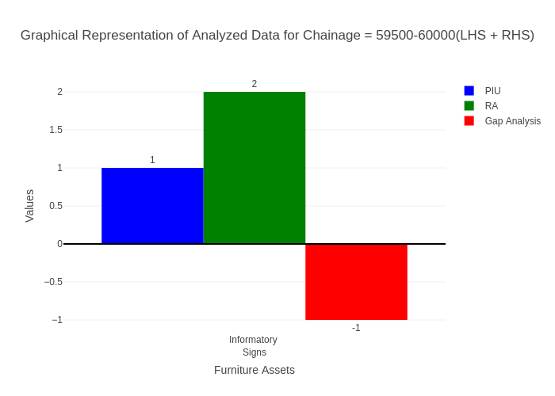

# Chainage: 60000-60500

## PIU Data:

|  |  |  |  |
| --- | --- | --- | --- |
| **Furniture Assets** | **60000-60500** | **60500-60000** | **LHS+RHS** |
| Chevron | 0.0 | 0.0 | 0.0 |
| Cautionary Warning Signs | 0.0 | 0.0 | 0.0 |
| Hazard | 1.0 | 0.0 | 1.0 |
| Prohibitory Mandatory Signs | 0.0 | 0.0 | 0.0 |
| Informatory Signs | 0.0 | 0.0 | 0.0 |

## RA Data:

|  |  |  |  |
| --- | --- | --- | --- |
| **Furniture Assets** | **60000-60500** | **60500-60000** | **LHS+RHS** |
| Chevron | 0.0 | 0.0 | 0.0 |
| Cautionary Warning Signs | 0.0 | 1.0 | 1.0 |
| Hazard | 1.0 | 0.0 | 1.0 |
| Prohibitory Mandatory Signs | 0.0 | 0.0 | 0.0 |
| Informatory Signs | 1.0 | 2.0 | 3.0 |

## Gap Analysis:

|  |  |  |  |
| --- | --- | --- | --- |
| **Furniture Assets** | **60000-60500** | **60500-60000** | **LHS+RHS** |
| Chevron | 0.0 | 0.0 | 0.0 |
| Cautionary Warning Signs | 0.0 | -1.0 | -1.0 |
| Hazard | 0.0 | 0.0 | 0.0 |
| Prohibitory Mandatory Signs | 0.0 | 0.0 | 0.0 |
| Informatory Signs | -1.0 | -2.0 | -3.0 |

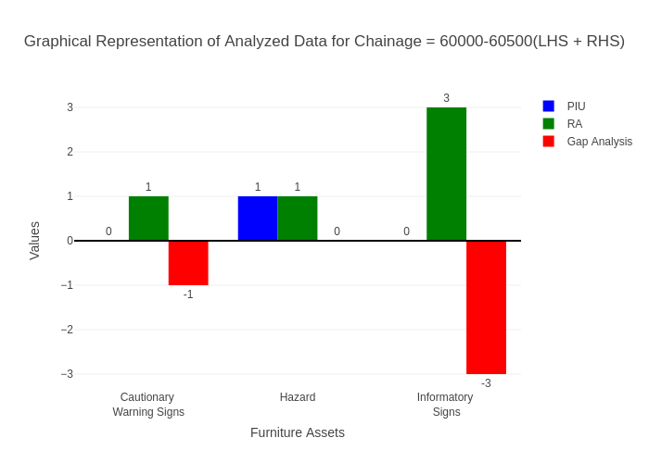

# Chainage: 60500-61000

## PIU Data:

|  |  |  |  |
| --- | --- | --- | --- |
| **Furniture Assets** | **60500-61000** | **61000-60500** | **LHS+RHS** |
| Chevron | 0.0 | 0.0 | 0.0 |
| Cautionary Warning Signs | 0.0 | 0.0 | 0.0 |
| Hazard | 0.0 | 0.0 | 0.0 |
| Prohibitory Mandatory Signs | 0.0 | 0.0 | 0.0 |
| Informatory Signs | 0.0 | 0.0 | 0.0 |

## RA Data:

|  |  |  |  |
| --- | --- | --- | --- |
| **Furniture Assets** | **60500-61000** | **61000-60500** | **LHS+RHS** |
| Chevron | 0.0 | 0.0 | 0.0 |
| Cautionary Warning Signs | 1.0 | 0.0 | 1.0 |
| Hazard | 0.0 | 0.0 | 0.0 |
| Prohibitory Mandatory Signs | 4.0 | 0.0 | 4.0 |
| Informatory Signs | 0.0 | 0.0 | 0.0 |

## Gap Analysis:

|  |  |  |  |
| --- | --- | --- | --- |
| **Furniture Assets** | **60500-61000** | **61000-60500** | **LHS+RHS** |
| Chevron | 0.0 | 0.0 | 0.0 |
| Cautionary Warning Signs | -1.0 | 0.0 | -1.0 |
| Hazard | 0.0 | 0.0 | 0.0 |
| Prohibitory Mandatory Signs | -4.0 | 0.0 | -4.0 |
| Informatory Signs | 0.0 | 0.0 | 0.0 |

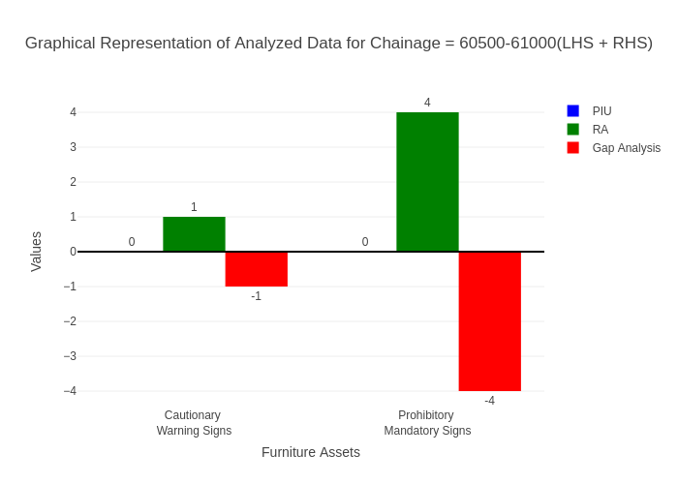

# Chainage: 61000-61500

## PIU Data:

|  |  |  |  |
| --- | --- | --- | --- |
| **Furniture Assets** | **61000-61500** | **61500-61000** | **LHS+RHS** |
| Chevron | 0.0 | 0.0 | 0.0 |
| Cautionary Warning Signs | 0.0 | 0.0 | 0.0 |
| Hazard | 0.0 | 0.0 | 0.0 |
| Prohibitory Mandatory Signs | 0.0 | 0.0 | 0.0 |
| Informatory Signs | 0.0 | 0.0 | 0.0 |

## RA Data:

|  |  |  |  |
| --- | --- | --- | --- |
| **Furniture Assets** | **61000-61500** | **61500-61000** | **LHS+RHS** |
| Chevron | 0.0 | 0.0 | 0.0 |
| Cautionary Warning Signs | 0.0 | 0.0 | 0.0 |
| Hazard | 0.0 | 0.0 | 0.0 |
| Prohibitory Mandatory Signs | 0.0 | 0.0 | 0.0 |
| Informatory Signs | 0.0 | 0.0 | 0.0 |

## Gap Analysis:

|  |  |  |  |
| --- | --- | --- | --- |
| **Furniture Assets** | **61000-61500** | **61500-61000** | **LHS+RHS** |
| Chevron | 0.0 | 0.0 | 0.0 |
| Cautionary Warning Signs | 0.0 | 0.0 | 0.0 |
| Hazard | 0.0 | 0.0 | 0.0 |
| Prohibitory Mandatory Signs | 0.0 | 0.0 | 0.0 |
| Informatory Signs | 0.0 | 0.0 | 0.0 |



# Chainage: 61500-62000

## PIU Data:

|  |  |  |  |
| --- | --- | --- | --- |
| **Furniture Assets** | **61500-62000** | **62000-61500** | **LHS+RHS** |
| Chevron | 0.0 | 0.0 | 0.0 |
| Cautionary Warning Signs | 0.0 | 0.0 | 0.0 |
| Hazard | 0.0 | 0.0 | 0.0 |
| Prohibitory Mandatory Signs | 0.0 | 0.0 | 0.0 |
| Informatory Signs | 0.0 | 0.0 | 0.0 |

## RA Data:

|  |  |  |  |
| --- | --- | --- | --- |
| **Furniture Assets** | **61500-62000** | **62000-61500** | **LHS+RHS** |
| Chevron | 0.0 | 0.0 | 0.0 |
| Cautionary Warning Signs | 2.0 | 0.0 | 2.0 |
| Hazard | 0.0 | 0.0 | 0.0 |
| Prohibitory Mandatory Signs | 1.0 | 0.0 | 1.0 |
| Informatory Signs | 0.0 | 0.0 | 0.0 |

## Gap Analysis:

|  |  |  |  |
| --- | --- | --- | --- |
| **Furniture Assets** | **61500-62000** | **62000-61500** | **LHS+RHS** |
| Chevron | 0.0 | 0.0 | 0.0 |
| Cautionary Warning Signs | -2.0 | 0.0 | -2.0 |
| Hazard | 0.0 | 0.0 | 0.0 |
| Prohibitory Mandatory Signs | -1.0 | 0.0 | -1.0 |
| Informatory Signs | 0.0 | 0.0 | 0.0 |

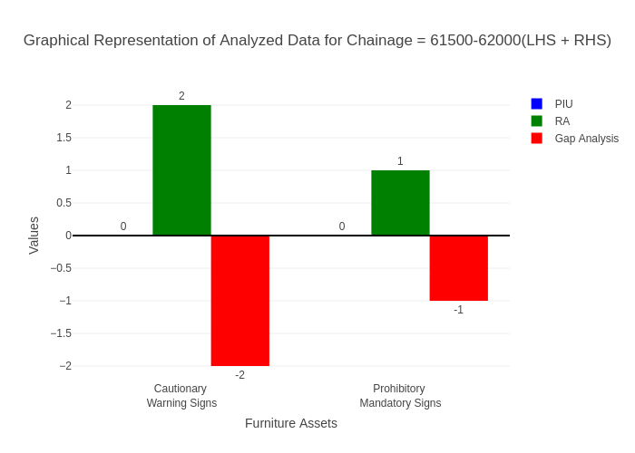

# Chainage: 62000-62500

## PIU Data:

|  |  |  |  |
| --- | --- | --- | --- |
| **Furniture Assets** | **62000-62500** | **62500-62000** | **LHS+RHS** |
| Chevron | 0.0 | 0.0 | 0.0 |
| Cautionary Warning Signs | 1.0 | 0.0 | 1.0 |
| Hazard | 0.0 | 0.0 | 0.0 |
| Prohibitory Mandatory Signs | 0.0 | 0.0 | 0.0 |
| Informatory Signs | 1.0 | 1.0 | 2.0 |

## RA Data:

|  |  |  |  |
| --- | --- | --- | --- |
| **Furniture Assets** | **62000-62500** | **62500-62000** | **LHS+RHS** |
| Chevron | 0.0 | 0.0 | 0.0 |
| Cautionary Warning Signs | 2.0 | 0.0 | 2.0 |
| Hazard | 1.0 | 0.0 | 1.0 |
| Prohibitory Mandatory Signs | 0.0 | 1.0 | 1.0 |
| Informatory Signs | 1.0 | 0.0 | 1.0 |

## Gap Analysis:

|  |  |  |  |
| --- | --- | --- | --- |
| **Furniture Assets** | **62000-62500** | **62500-62000** | **LHS+RHS** |
| Chevron | 0.0 | 0.0 | 0.0 |
| Cautionary Warning Signs | -1.0 | 0.0 | -1.0 |
| Hazard | -1.0 | 0.0 | -1.0 |
| Prohibitory Mandatory Signs | 0.0 | -1.0 | -1.0 |
| Informatory Signs | 0.0 | 1.0 | 1.0 |

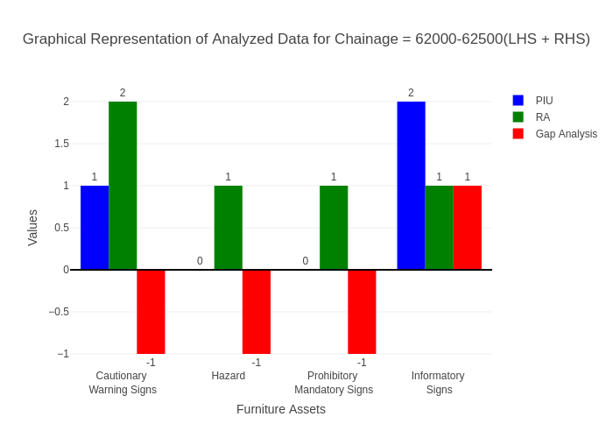

# Chainage: 62500-63000

## PIU Data:

|  |  |  |  |
| --- | --- | --- | --- |
| **Furniture Assets** | **62500-63000** | **63000-62500** | **LHS+RHS** |
| Chevron | 0.0 | 0.0 | 0.0 |
| Cautionary Warning Signs | 0.0 | 0.0 | 0.0 |
| Hazard | 1.0 | 0.0 | 1.0 |
| Prohibitory Mandatory Signs | 0.0 | 0.0 | 0.0 |
| Informatory Signs | 0.0 | 0.0 | 0.0 |

## RA Data:

|  |  |  |  |
| --- | --- | --- | --- |
| **Furniture Assets** | **62500-63000** | **63000-62500** | **LHS+RHS** |
| Chevron | 0.0 | 0.0 | 0.0 |
| Cautionary Warning Signs | 0.0 | 1.0 | 1.0 |
| Hazard | 0.0 | 0.0 | 0.0 |
| Prohibitory Mandatory Signs | 0.0 | 1.0 | 1.0 |
| Informatory Signs | 0.0 | 1.0 | 1.0 |

## Gap Analysis:

|  |  |  |  |
| --- | --- | --- | --- |
| **Furniture Assets** | **62500-63000** | **63000-62500** | **LHS+RHS** |
| Chevron | 0.0 | 0.0 | 0.0 |
| Cautionary Warning Signs | 0.0 | -1.0 | -1.0 |
| Hazard | 1.0 | 0.0 | 1.0 |
| Prohibitory Mandatory Signs | 0.0 | -1.0 | -1.0 |
| Informatory Signs | 0.0 | -1.0 | -1.0 |

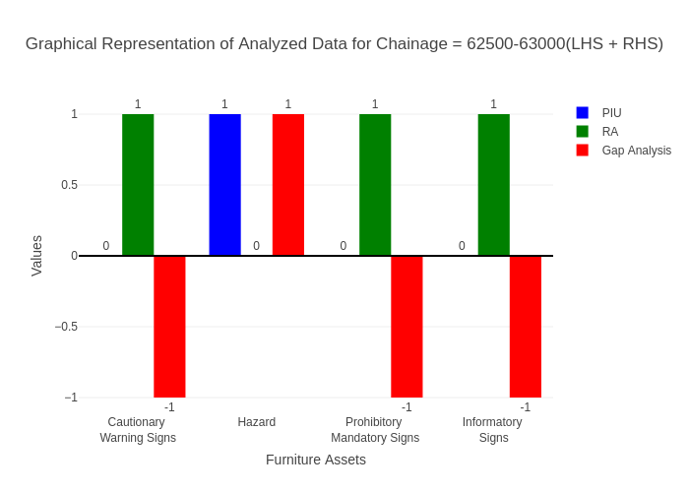

# Chainage: 63000-63500

## PIU Data:

|  |  |  |  |
| --- | --- | --- | --- |
| **Furniture Assets** | **63000-63500** | **63500-63000** | **LHS+RHS** |
| Chevron | 0.0 | 0.0 | 0.0 |
| Cautionary Warning Signs | 0.0 | 0.0 | 0.0 |
| Hazard | 0.0 | 0.0 | 0.0 |
| Prohibitory Mandatory Signs | 0.0 | 0.0 | 0.0 |
| Informatory Signs | 0.0 | 0.0 | 0.0 |

## RA Data:

|  |  |  |  |
| --- | --- | --- | --- |
| **Furniture Assets** | **63000-63500** | **63500-63000** | **LHS+RHS** |
| Chevron | 0.0 | 0.0 | 0.0 |
| Cautionary Warning Signs | 0.0 | 0.0 | 0.0 |
| Hazard | 0.0 | 0.0 | 0.0 |
| Prohibitory Mandatory Signs | 0.0 | 0.0 | 0.0 |
| Informatory Signs | 0.0 | 0.0 | 0.0 |

## Gap Analysis:

|  |  |  |  |
| --- | --- | --- | --- |
| **Furniture Assets** | **63000-63500** | **63500-63000** | **LHS+RHS** |
| Chevron | 0.0 | 0.0 | 0.0 |
| Cautionary Warning Signs | 0.0 | 0.0 | 0.0 |
| Hazard | 0.0 | 0.0 | 0.0 |
| Prohibitory Mandatory Signs | 0.0 | 0.0 | 0.0 |
| Informatory Signs | 0.0 | 0.0 | 0.0 |



# Chainage: 63500-64000

## PIU Data:

|  |  |  |  |
| --- | --- | --- | --- |
| **Furniture Assets** | **63500-64000** | **64000-63500** | **LHS+RHS** |
| Chevron | 0.0 | 0.0 | 0.0 |
| Cautionary Warning Signs | 0.0 | 0.0 | 0.0 |
| Hazard | 1.0 | 0.0 | 1.0 |
| Prohibitory Mandatory Signs | 0.0 | 0.0 | 0.0 |
| Informatory Signs | 0.0 | 0.0 | 0.0 |

## RA Data:

|  |  |  |  |
| --- | --- | --- | --- |
| **Furniture Assets** | **63500-64000** | **64000-63500** | **LHS+RHS** |
| Chevron | 0.0 | 0.0 | 0.0 |
| Cautionary Warning Signs | 0.0 | 0.0 | 0.0 |
| Hazard | 0.0 | 0.0 | 0.0 |
| Prohibitory Mandatory Signs | 0.0 | 0.0 | 0.0 |
| Informatory Signs | 0.0 | 0.0 | 0.0 |

## Gap Analysis:

|  |  |  |  |
| --- | --- | --- | --- |
| **Furniture Assets** | **63500-64000** | **64000-63500** | **LHS+RHS** |
| Chevron | 0.0 | 0.0 | 0.0 |
| Cautionary Warning Signs | 0.0 | 0.0 | 0.0 |
| Hazard | 1.0 | 0.0 | 1.0 |
| Prohibitory Mandatory Signs | 0.0 | 0.0 | 0.0 |
| Informatory Signs | 0.0 | 0.0 | 0.0 |

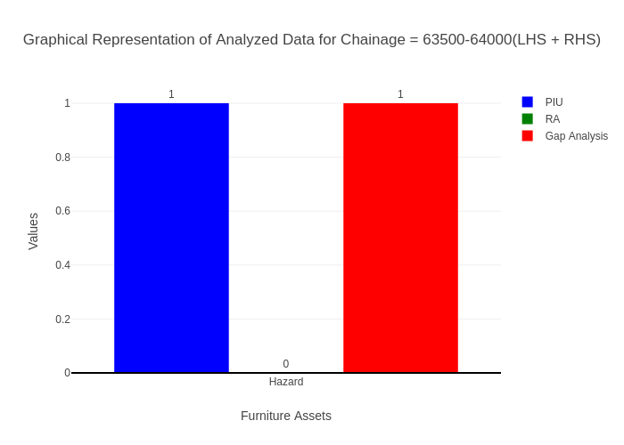

# Chainage: 64000-64500

## PIU Data:

|  |  |  |  |
| --- | --- | --- | --- |
| **Furniture Assets** | **64000-64500** | **64500-64000** | **LHS+RHS** |
| Chevron | 0.0 | 0.0 | 0.0 |
| Cautionary Warning Signs | 0.0 | 0.0 | 0.0 |
| Hazard | 1.0 | 0.0 | 1.0 |
| Prohibitory Mandatory Signs | 0.0 | 0.0 | 0.0 |
| Informatory Signs | 1.0 | 0.0 | 1.0 |

## RA Data:

|  |  |  |  |
| --- | --- | --- | --- |
| **Furniture Assets** | **64000-64500** | **64500-64000** | **LHS+RHS** |
| Chevron | 0.0 | 0.0 | 0.0 |
| Cautionary Warning Signs | 2.0 | 0.0 | 2.0 |
| Hazard | 1.0 | 0.0 | 1.0 |
| Prohibitory Mandatory Signs | 0.0 | 0.0 | 0.0 |
| Informatory Signs | 0.0 | 0.0 | 0.0 |

## Gap Analysis:

|  |  |  |  |
| --- | --- | --- | --- |
| **Furniture Assets** | **64000-64500** | **64500-64000** | **LHS+RHS** |
| Chevron | 0.0 | 0.0 | 0.0 |
| Cautionary Warning Signs | -2.0 | 0.0 | -2.0 |
| Hazard | 0.0 | 0.0 | 0.0 |
| Prohibitory Mandatory Signs | 0.0 | 0.0 | 0.0 |
| Informatory Signs | 1.0 | 0.0 | 1.0 |

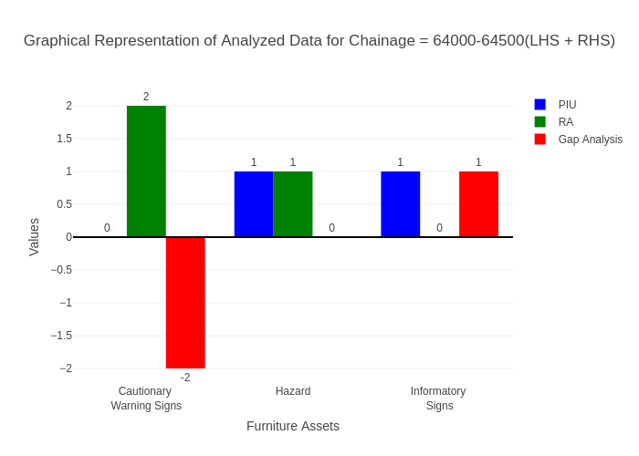

# Chainage: 64500-65000

## PIU Data:

|  |  |  |  |
| --- | --- | --- | --- |
| **Furniture Assets** | **64500-65000** | **65000-64500** | **LHS+RHS** |
| Chevron | 0.0 | 0.0 | 0.0 |
| Cautionary Warning Signs | 0.0 | 0.0 | 0.0 |
| Hazard | 0.0 | 0.0 | 0.0 |
| Prohibitory Mandatory Signs | 0.0 | 0.0 | 0.0 |
| Informatory Signs | 0.0 | 0.0 | 0.0 |

## RA Data:

|  |  |  |  |
| --- | --- | --- | --- |
| **Furniture Assets** | **64500-65000** | **65000-64500** | **LHS+RHS** |
| Chevron | 0.0 | 0.0 | 0.0 |
| Cautionary Warning Signs | 0.0 | 0.0 | 0.0 |
| Hazard | 0.0 | 0.0 | 0.0 |
| Prohibitory Mandatory Signs | 0.0 | 0.0 | 0.0 |
| Informatory Signs | 0.0 | 2.0 | 2.0 |

## Gap Analysis:

|  |  |  |  |
| --- | --- | --- | --- |
| **Furniture Assets** | **64500-65000** | **65000-64500** | **LHS+RHS** |
| Chevron | 0.0 | 0.0 | 0.0 |
| Cautionary Warning Signs | 0.0 | 0.0 | 0.0 |
| Hazard | 0.0 | 0.0 | 0.0 |
| Prohibitory Mandatory Signs | 0.0 | 0.0 | 0.0 |
| Informatory Signs | 0.0 | -2.0 | -2.0 |

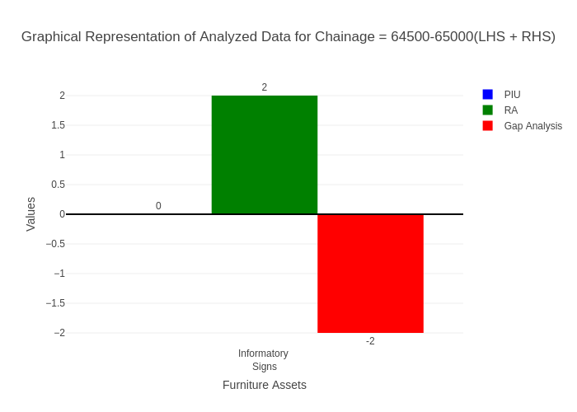

# Chainage: 65000-65500

## PIU Data:

|  |  |  |  |
| --- | --- | --- | --- |
| **Furniture Assets** | **65000-65500** | **65500-65000** | **LHS+RHS** |
| Chevron | 0.0 | 0.0 | 0.0 |
| Cautionary Warning Signs | 0.0 | 0.0 | 0.0 |
| Hazard | 0.0 | 0.0 | 0.0 |
| Prohibitory Mandatory Signs | 0.0 | 0.0 | 0.0 |
| Informatory Signs | 0.0 | 0.0 | 0.0 |

## RA Data:

|  |  |  |  |
| --- | --- | --- | --- |
| **Furniture Assets** | **65000-65500** | **65500-65000** | **LHS+RHS** |
| Chevron | 0.0 | 0.0 | 0.0 |
| Cautionary Warning Signs | 0.0 | 2.0 | 2.0 |
| Hazard | 0.0 | 0.0 | 0.0 |
| Prohibitory Mandatory Signs | 0.0 | 1.0 | 1.0 |
| Informatory Signs | 1.0 | 0.0 | 1.0 |

## Gap Analysis:

|  |  |  |  |
| --- | --- | --- | --- |
| **Furniture Assets** | **65000-65500** | **65500-65000** | **LHS+RHS** |
| Chevron | 0.0 | 0.0 | 0.0 |
| Cautionary Warning Signs | 0.0 | -2.0 | -2.0 |
| Hazard | 0.0 | 0.0 | 0.0 |
| Prohibitory Mandatory Signs | 0.0 | -1.0 | -1.0 |
| Informatory Signs | -1.0 | 0.0 | -1.0 |

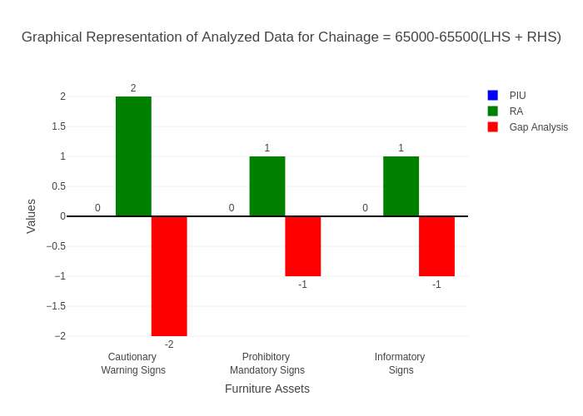

# Chainage: 65500-66000

## PIU Data:

|  |  |  |  |
| --- | --- | --- | --- |
| **Furniture Assets** | **65500-66000** | **66000-65500** | **LHS+RHS** |
| Chevron | 0.0 | 0.0 | 0.0 |
| Cautionary Warning Signs | 2.0 | 0.0 | 2.0 |
| Hazard | 0.0 | 0.0 | 0.0 |
| Prohibitory Mandatory Signs | 0.0 | 0.0 | 0.0 |
| Informatory Signs | 0.0 | 0.0 | 0.0 |

## RA Data:

|  |  |  |  |
| --- | --- | --- | --- |
| **Furniture Assets** | **65500-66000** | **66000-65500** | **LHS+RHS** |
| Chevron | 0.0 | 0.0 | 0.0 |
| Cautionary Warning Signs | 1.0 | 0.0 | 1.0 |
| Hazard | 0.0 | 0.0 | 0.0 |
| Prohibitory Mandatory Signs | 1.0 | 0.0 | 1.0 |
| Informatory Signs | 0.0 | 1.0 | 1.0 |

## Gap Analysis:

|  |  |  |  |
| --- | --- | --- | --- |
| **Furniture Assets** | **65500-66000** | **66000-65500** | **LHS+RHS** |
| Chevron | 0.0 | 0.0 | 0.0 |
| Cautionary Warning Signs | 1.0 | 0.0 | 1.0 |
| Hazard | 0.0 | 0.0 | 0.0 |
| Prohibitory Mandatory Signs | -1.0 | 0.0 | -1.0 |
| Informatory Signs | 0.0 | -1.0 | -1.0 |

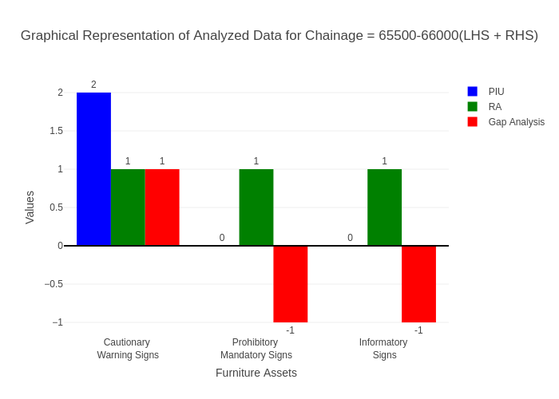

# Chainage: 66000-66500

## PIU Data:

|  |  |  |  |
| --- | --- | --- | --- |
| **Furniture Assets** | **66000-66500** | **66500-66000** | **LHS+RHS** |
| Chevron | 0.0 | 0.0 | 0.0 |
| Cautionary Warning Signs | 0.0 | 0.0 | 0.0 |
| Hazard | 2.0 | 0.0 | 2.0 |
| Prohibitory Mandatory Signs | 0.0 | 0.0 | 0.0 |
| Informatory Signs | 0.0 | 0.0 | 0.0 |

## RA Data:

|  |  |  |  |
| --- | --- | --- | --- |
| **Furniture Assets** | **66000-66500** | **66500-66000** | **LHS+RHS** |
| Chevron | 0.0 | 0.0 | 0.0 |
| Cautionary Warning Signs | 0.0 | 0.0 | 0.0 |
| Hazard | 1.0 | 0.0 | 1.0 |
| Prohibitory Mandatory Signs | 0.0 | 0.0 | 0.0 |
| Informatory Signs | 0.0 | 0.0 | 0.0 |

## Gap Analysis:

|  |  |  |  |
| --- | --- | --- | --- |
| **Furniture Assets** | **66000-66500** | **66500-66000** | **LHS+RHS** |
| Chevron | 0.0 | 0.0 | 0.0 |
| Cautionary Warning Signs | 0.0 | 0.0 | 0.0 |
| Hazard | 1.0 | 0.0 | 1.0 |
| Prohibitory Mandatory Signs | 0.0 | 0.0 | 0.0 |
| Informatory Signs | 0.0 | 0.0 | 0.0 |

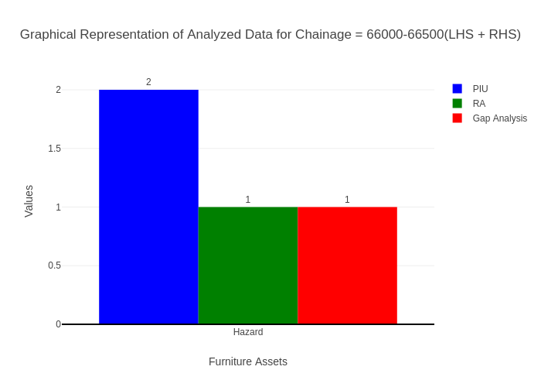

# Chainage: 66500-67000

## PIU Data:

|  |  |  |  |
| --- | --- | --- | --- |
| **Furniture Assets** | **66500-67000** | **67000-66500** | **LHS+RHS** |
| Chevron | 0.0 | 0.0 | 0.0 |
| Cautionary Warning Signs | 0.0 | 0.0 | 0.0 |
| Hazard | 0.0 | 0.0 | 0.0 |
| Prohibitory Mandatory Signs | 0.0 | 0.0 | 0.0 |
| Informatory Signs | 0.0 | 0.0 | 0.0 |

## RA Data:

|  |  |  |  |
| --- | --- | --- | --- |
| **Furniture Assets** | **66500-67000** | **67000-66500** | **LHS+RHS** |
| Chevron | 0.0 | 0.0 | 0.0 |
| Cautionary Warning Signs | 0.0 | 0.0 | 0.0 |
| Hazard | 0.0 | 0.0 | 0.0 |
| Prohibitory Mandatory Signs | 0.0 | 0.0 | 0.0 |
| Informatory Signs | 0.0 | 0.0 | 0.0 |

## Gap Analysis:

|  |  |  |  |
| --- | --- | --- | --- |
| **Furniture Assets** | **66500-67000** | **67000-66500** | **LHS+RHS** |
| Chevron | 0.0 | 0.0 | 0.0 |
| Cautionary Warning Signs | 0.0 | 0.0 | 0.0 |
| Hazard | 0.0 | 0.0 | 0.0 |
| Prohibitory Mandatory Signs | 0.0 | 0.0 | 0.0 |
| Informatory Signs | 0.0 | 0.0 | 0.0 |



# Chainage: 67000-67500

## PIU Data:

|  |  |  |  |
| --- | --- | --- | --- |
| **Furniture Assets** | **67000-67500** | **67500-67000** | **LHS+RHS** |
| Chevron | 0.0 | 0.0 | 0.0 |
| Cautionary Warning Signs | 2.0 | 0.0 | 2.0 |
| Hazard | 1.0 | 0.0 | 1.0 |
| Prohibitory Mandatory Signs | 0.0 | 0.0 | 0.0 |
| Informatory Signs | 0.0 | 0.0 | 0.0 |

## RA Data:

|  |  |  |  |
| --- | --- | --- | --- |
| **Furniture Assets** | **67000-67500** | **67500-67000** | **LHS+RHS** |
| Chevron | 0.0 | 0.0 | 0.0 |
| Cautionary Warning Signs | 0.0 | 0.0 | 0.0 |
| Hazard | 0.0 | 0.0 | 0.0 |
| Prohibitory Mandatory Signs | 0.0 | 0.0 | 0.0 |
| Informatory Signs | 0.0 | 0.0 | 0.0 |

## Gap Analysis:

|  |  |  |  |
| --- | --- | --- | --- |
| **Furniture Assets** | **67000-67500** | **67500-67000** | **LHS+RHS** |
| Chevron | 0.0 | 0.0 | 0.0 |
| Cautionary Warning Signs | 2.0 | 0.0 | 2.0 |
| Hazard | 1.0 | 0.0 | 1.0 |
| Prohibitory Mandatory Signs | 0.0 | 0.0 | 0.0 |
| Informatory Signs | 0.0 | 0.0 | 0.0 |

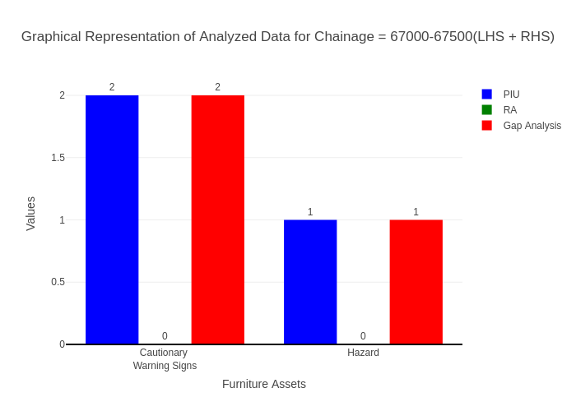

# Chainage: 67500-68000

## PIU Data:

|  |  |  |  |
| --- | --- | --- | --- |
| **Furniture Assets** | **67500-68000** | **68000-67500** | **LHS+RHS** |
| Chevron | 0.0 | 0.0 | 0.0 |
| Cautionary Warning Signs | 1.0 | 0.0 | 1.0 |
| Hazard | 1.0 | 0.0 | 1.0 |
| Prohibitory Mandatory Signs | 0.0 | 0.0 | 0.0 |
| Informatory Signs | 3.0 | 0.0 | 3.0 |

## RA Data:

|  |  |  |  |
| --- | --- | --- | --- |
| **Furniture Assets** | **67500-68000** | **68000-67500** | **LHS+RHS** |
| Chevron | 0.0 | 0.0 | 0.0 |
| Cautionary Warning Signs | 0.0 | 0.0 | 0.0 |
| Hazard | 0.0 | 0.0 | 0.0 |
| Prohibitory Mandatory Signs | 0.0 | 0.0 | 0.0 |
| Informatory Signs | 4.0 | 1.0 | 5.0 |

## Gap Analysis:

|  |  |  |  |
| --- | --- | --- | --- |
| **Furniture Assets** | **67500-68000** | **68000-67500** | **LHS+RHS** |
| Chevron | 0.0 | 0.0 | 0.0 |
| Cautionary Warning Signs | 1.0 | 0.0 | 1.0 |
| Hazard | 1.0 | 0.0 | 1.0 |
| Prohibitory Mandatory Signs | 0.0 | 0.0 | 0.0 |
| Informatory Signs | -1.0 | -1.0 | -2.0 |

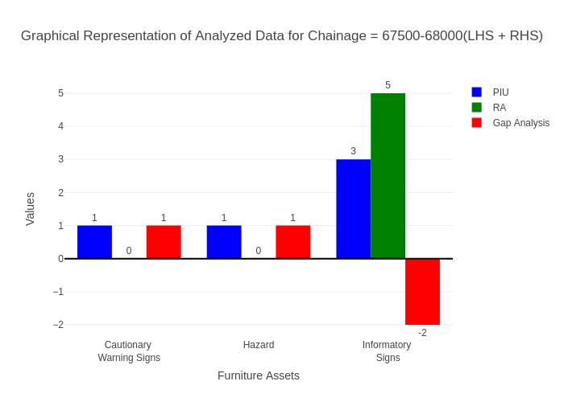

# Chainage: 68000-68500

## PIU Data:

|  |  |  |  |
| --- | --- | --- | --- |
| **Furniture Assets** | **68000-68500** | **68500-68000** | **LHS+RHS** |
| Chevron | 0.0 | 0.0 | 0.0 |
| Cautionary Warning Signs | 0.0 | 0.0 | 0.0 |
| Hazard | 1.0 | 0.0 | 1.0 |
| Prohibitory Mandatory Signs | 0.0 | 0.0 | 0.0 |
| Informatory Signs | 0.0 | 0.0 | 0.0 |

## RA Data:

|  |  |  |  |
| --- | --- | --- | --- |
| **Furniture Assets** | **68000-68500** | **68500-68000** | **LHS+RHS** |
| Chevron | 0.0 | 0.0 | 0.0 |
| Cautionary Warning Signs | 1.0 | 1.0 | 2.0 |
| Hazard | 0.0 | 0.0 | 0.0 |
| Prohibitory Mandatory Signs | 0.0 | 1.0 | 1.0 |
| Informatory Signs | 0.0 | 0.0 | 0.0 |

## Gap Analysis:

|  |  |  |  |
| --- | --- | --- | --- |
| **Furniture Assets** | **68000-68500** | **68500-68000** | **LHS+RHS** |
| Chevron | 0.0 | 0.0 | 0.0 |
| Cautionary Warning Signs | -1.0 | -1.0 | -2.0 |
| Hazard | 1.0 | 0.0 | 1.0 |
| Prohibitory Mandatory Signs | 0.0 | -1.0 | -1.0 |
| Informatory Signs | 0.0 | 0.0 | 0.0 |

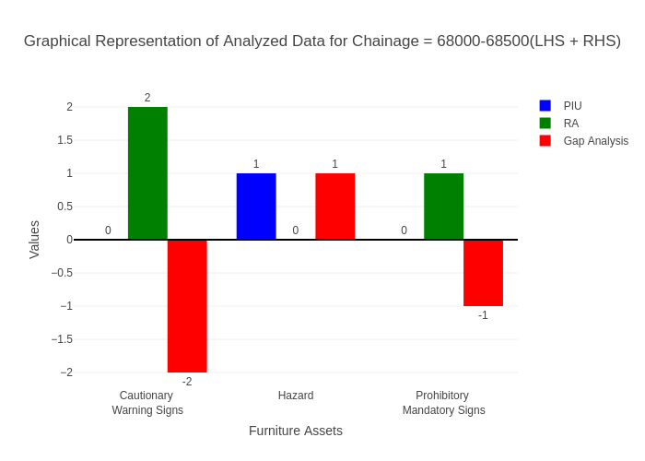

# Chainage: 68500-69000

## PIU Data:

|  |  |  |  |
| --- | --- | --- | --- |
| **Furniture Assets** | **68500-69000** | **69000-68500** | **LHS+RHS** |
| Chevron | 0.0 | 0.0 | 0.0 |
| Cautionary Warning Signs | 0.0 | 0.0 | 0.0 |
| Hazard | 0.0 | 0.0 | 0.0 |
| Prohibitory Mandatory Signs | 0.0 | 0.0 | 0.0 |
| Informatory Signs | 0.0 | 0.0 | 0.0 |

## RA Data:

|  |  |  |  |
| --- | --- | --- | --- |
| **Furniture Assets** | **68500-69000** | **69000-68500** | **LHS+RHS** |
| Chevron | 0.0 | 0.0 | 0.0 |
| Cautionary Warning Signs | 1.0 | 0.0 | 1.0 |
| Hazard | 0.0 | 0.0 | 0.0 |
| Prohibitory Mandatory Signs | 0.0 | 0.0 | 0.0 |
| Informatory Signs | 0.0 | 0.0 | 0.0 |

## Gap Analysis:

|  |  |  |  |
| --- | --- | --- | --- |
| **Furniture Assets** | **68500-69000** | **69000-68500** | **LHS+RHS** |
| Chevron | 0.0 | 0.0 | 0.0 |
| Cautionary Warning Signs | -1.0 | 0.0 | -1.0 |
| Hazard | 0.0 | 0.0 | 0.0 |
| Prohibitory Mandatory Signs | 0.0 | 0.0 | 0.0 |
| Informatory Signs | 0.0 | 0.0 | 0.0 |

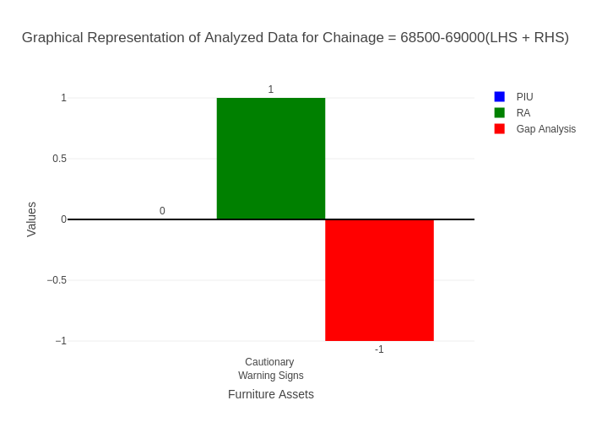

# Chainage: 69000-69500

## PIU Data:

|  |  |  |  |
| --- | --- | --- | --- |
| **Furniture Assets** | **69000-69500** | **69500-69000** | **LHS+RHS** |
| Chevron | 0.0 | 0.0 | 0.0 |
| Cautionary Warning Signs | 3.0 | 0.0 | 3.0 |
| Hazard | 1.0 | 0.0 | 1.0 |
| Prohibitory Mandatory Signs | 0.0 | 0.0 | 0.0 |
| Informatory Signs | 1.0 | 0.0 | 1.0 |

## RA Data:

|  |  |  |  |
| --- | --- | --- | --- |
| **Furniture Assets** | **69000-69500** | **69500-69000** | **LHS+RHS** |
| Chevron | 0.0 | 0.0 | 0.0 |
| Cautionary Warning Signs | 0.0 | 0.0 | 0.0 |
| Hazard | 0.0 | 0.0 | 0.0 |
| Prohibitory Mandatory Signs | 0.0 | 0.0 | 0.0 |
| Informatory Signs | 0.0 | 0.0 | 0.0 |

## Gap Analysis:

|  |  |  |  |
| --- | --- | --- | --- |
| **Furniture Assets** | **69000-69500** | **69500-69000** | **LHS+RHS** |
| Chevron | 0.0 | 0.0 | 0.0 |
| Cautionary Warning Signs | 3.0 | 0.0 | 3.0 |
| Hazard | 1.0 | 0.0 | 1.0 |
| Prohibitory Mandatory Signs | 0.0 | 0.0 | 0.0 |
| Informatory Signs | 1.0 | 0.0 | 1.0 |

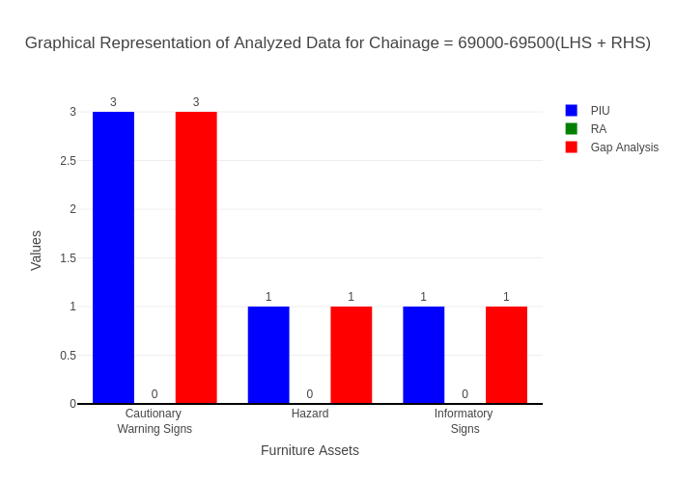

# Chainage: 69500-70000

## PIU Data:

|  |  |  |  |
| --- | --- | --- | --- |
| **Furniture Assets** | **69500-70000** | **70000-69500** | **LHS+RHS** |
| Chevron | 1.0 | 0.0 | 1.0 |
| Cautionary Warning Signs | 1.0 | 0.0 | 1.0 |
| Hazard | 3.0 | 0.0 | 3.0 |
| Prohibitory Mandatory Signs | 0.0 | 0.0 | 0.0 |
| Informatory Signs | 0.0 | 0.0 | 0.0 |

## RA Data:

|  |  |  |  |
| --- | --- | --- | --- |
| **Furniture Assets** | **69500-70000** | **70000-69500** | **LHS+RHS** |
| Chevron | 3.0 | 0.0 | 3.0 |
| Cautionary Warning Signs | 1.0 | 0.0 | 1.0 |
| Hazard | 0.0 | 0.0 | 0.0 |
| Prohibitory Mandatory Signs | 0.0 | 0.0 | 0.0 |
| Informatory Signs | 2.0 | 0.0 | 2.0 |

## Gap Analysis:

|  |  |  |  |
| --- | --- | --- | --- |
| **Furniture Assets** | **69500-70000** | **70000-69500** | **LHS+RHS** |
| Chevron | -2.0 | 0.0 | -2.0 |
| Cautionary Warning Signs | 0.0 | 0.0 | 0.0 |
| Hazard | 3.0 | 0.0 | 3.0 |
| Prohibitory Mandatory Signs | 0.0 | 0.0 | 0.0 |
| Informatory Signs | -2.0 | 0.0 | -2.0 |

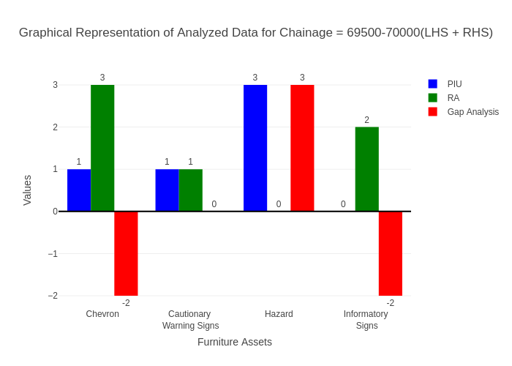

# Chainage: 70000-70500

## PIU Data:

|  |  |  |  |
| --- | --- | --- | --- |
| **Furniture Assets** | **70000-70500** | **70500-70000** | **LHS+RHS** |
| Chevron | 0.0 | 0.0 | 0.0 |
| Cautionary Warning Signs | 0.0 | 0.0 | 0.0 |
| Hazard | 0.0 | 0.0 | 0.0 |
| Prohibitory Mandatory Signs | 0.0 | 0.0 | 0.0 |
| Informatory Signs | 0.0 | 0.0 | 0.0 |

## RA Data:

|  |  |  |  |
| --- | --- | --- | --- |
| **Furniture Assets** | **70000-70500** | **70500-70000** | **LHS+RHS** |
| Chevron | 0.0 | 1.0 | 1.0 |
| Cautionary Warning Signs | 0.0 | 3.0 | 3.0 |
| Hazard | 0.0 | 0.0 | 0.0 |
| Prohibitory Mandatory Signs | 0.0 | 1.0 | 1.0 |
| Informatory Signs | 1.0 | 1.0 | 2.0 |

## Gap Analysis:

|  |  |  |  |
| --- | --- | --- | --- |
| **Furniture Assets** | **70000-70500** | **70500-70000** | **LHS+RHS** |
| Chevron | 0.0 | -1.0 | -1.0 |
| Cautionary Warning Signs | 0.0 | -3.0 | -3.0 |
| Hazard | 0.0 | 0.0 | 0.0 |
| Prohibitory Mandatory Signs | 0.0 | -1.0 | -1.0 |
| Informatory Signs | -1.0 | -1.0 | -2.0 |

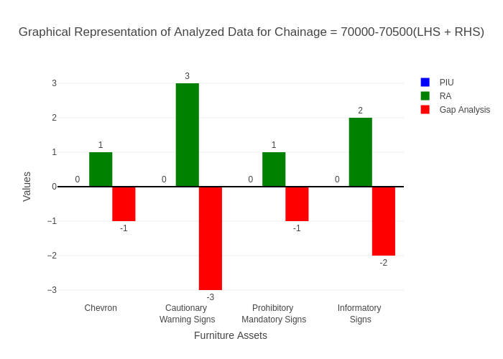

# Chainage: 70500-71000

## PIU Data:

|  |  |  |  |
| --- | --- | --- | --- |
| **Furniture Assets** | **70500-71000** | **71000-70500** | **LHS+RHS** |
| Chevron | 0.0 | 0.0 | 0.0 |
| Cautionary Warning Signs | 0.0 | 0.0 | 0.0 |
| Hazard | 0.0 | 0.0 | 0.0 |
| Prohibitory Mandatory Signs | 0.0 | 0.0 | 0.0 |
| Informatory Signs | 0.0 | 0.0 | 0.0 |

## RA Data:

|  |  |  |  |
| --- | --- | --- | --- |
| **Furniture Assets** | **70500-71000** | **71000-70500** | **LHS+RHS** |
| Chevron | 0.0 | 0.0 | 0.0 |
| Cautionary Warning Signs | 0.0 | 1.0 | 1.0 |
| Hazard | 0.0 | 0.0 | 0.0 |
| Prohibitory Mandatory Signs | 0.0 | 0.0 | 0.0 |
| Informatory Signs | 0.0 | 0.0 | 0.0 |

## Gap Analysis:

|  |  |  |  |
| --- | --- | --- | --- |
| **Furniture Assets** | **70500-71000** | **71000-70500** | **LHS+RHS** |
| Chevron | 0.0 | 0.0 | 0.0 |
| Cautionary Warning Signs | 0.0 | -1.0 | -1.0 |
| Hazard | 0.0 | 0.0 | 0.0 |
| Prohibitory Mandatory Signs | 0.0 | 0.0 | 0.0 |
| Informatory Signs | 0.0 | 0.0 | 0.0 |

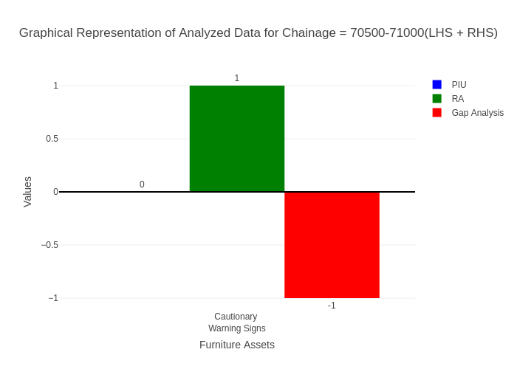

# Chainage: 71000-71500

## PIU Data:

|  |  |  |  |
| --- | --- | --- | --- |
| **Furniture Assets** | **71000-71500** | **71500-71000** | **LHS+RHS** |
| Chevron | 0.0 | 0.0 | 0.0 |
| Cautionary Warning Signs | 3.0 | 0.0 | 3.0 |
| Hazard | 0.0 | 0.0 | 0.0 |
| Prohibitory Mandatory Signs | 0.0 | 0.0 | 0.0 |
| Informatory Signs | 1.0 | 0.0 | 1.0 |

## RA Data:

|  |  |  |  |
| --- | --- | --- | --- |
| **Furniture Assets** | **71000-71500** | **71500-71000** | **LHS+RHS** |
| Chevron | 0.0 | 0.0 | 0.0 |
| Cautionary Warning Signs | 1.0 | 0.0 | 1.0 |
| Hazard | 0.0 | 0.0 | 0.0 |
| Prohibitory Mandatory Signs | 0.0 | 0.0 | 0.0 |
| Informatory Signs | 0.0 | 0.0 | 0.0 |

## Gap Analysis:

|  |  |  |  |
| --- | --- | --- | --- |
| **Furniture Assets** | **71000-71500** | **71500-71000** | **LHS+RHS** |
| Chevron | 0.0 | 0.0 | 0.0 |
| Cautionary Warning Signs | 2.0 | 0.0 | 2.0 |
| Hazard | 0.0 | 0.0 | 0.0 |
| Prohibitory Mandatory Signs | 0.0 | 0.0 | 0.0 |
| Informatory Signs | 1.0 | 0.0 | 1.0 |

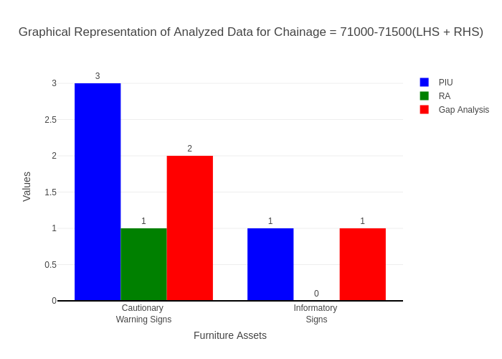

# Chainage: 71500-72000

## PIU Data:

|  |  |  |  |
| --- | --- | --- | --- |
| **Furniture Assets** | **71500-72000** | **72000-71500** | **LHS+RHS** |
| Chevron | 0.0 | 0.0 | 0.0 |
| Cautionary Warning Signs | 0.0 | 0.0 | 0.0 |
| Hazard | 1.0 | 0.0 | 1.0 |
| Prohibitory Mandatory Signs | 0.0 | 0.0 | 0.0 |
| Informatory Signs | 0.0 | 0.0 | 0.0 |

## RA Data:

|  |  |  |  |
| --- | --- | --- | --- |
| **Furniture Assets** | **71500-72000** | **72000-71500** | **LHS+RHS** |
| Chevron | 0.0 | 0.0 | 0.0 |
| Cautionary Warning Signs | 2.0 | 0.0 | 2.0 |
| Hazard | 0.0 | 0.0 | 0.0 |
| Prohibitory Mandatory Signs | 1.0 | 0.0 | 1.0 |
| Informatory Signs | 0.0 | 0.0 | 0.0 |

## Gap Analysis:

|  |  |  |  |
| --- | --- | --- | --- |
| **Furniture Assets** | **71500-72000** | **72000-71500** | **LHS+RHS** |
| Chevron | 0.0 | 0.0 | 0.0 |
| Cautionary Warning Signs | -2.0 | 0.0 | -2.0 |
| Hazard | 1.0 | 0.0 | 1.0 |
| Prohibitory Mandatory Signs | -1.0 | 0.0 | -1.0 |
| Informatory Signs | 0.0 | 0.0 | 0.0 |

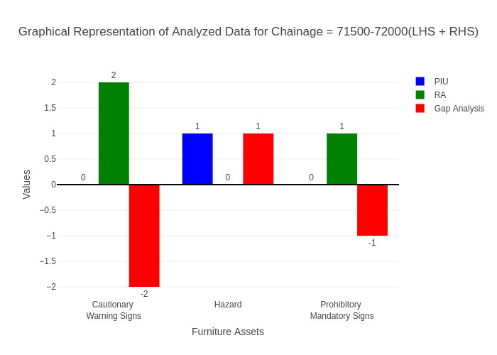

# Chainage: 72000-72500

## PIU Data:

|  |  |  |  |
| --- | --- | --- | --- |
| **Furniture Assets** | **72000-72500** | **72500-72000** | **LHS+RHS** |
| Chevron | 0.0 | 0.0 | 0.0 |
| Cautionary Warning Signs | 0.0 | 0.0 | 0.0 |
| Hazard | 1.0 | 0.0 | 1.0 |
| Prohibitory Mandatory Signs | 0.0 | 0.0 | 0.0 |
| Informatory Signs | 1.0 | 0.0 | 1.0 |

## RA Data:

|  |  |  |  |
| --- | --- | --- | --- |
| **Furniture Assets** | **72000-72500** | **72500-72000** | **LHS+RHS** |
| Chevron | 0.0 | 0.0 | 0.0 |
| Cautionary Warning Signs | 0.0 | 0.0 | 0.0 |
| Hazard | 0.0 | 0.0 | 0.0 |
| Prohibitory Mandatory Signs | 0.0 | 0.0 | 0.0 |
| Informatory Signs | 0.0 | 0.0 | 0.0 |

## Gap Analysis:

|  |  |  |  |
| --- | --- | --- | --- |
| **Furniture Assets** | **72000-72500** | **72500-72000** | **LHS+RHS** |
| Chevron | 0.0 | 0.0 | 0.0 |
| Cautionary Warning Signs | 0.0 | 0.0 | 0.0 |
| Hazard | 1.0 | 0.0 | 1.0 |
| Prohibitory Mandatory Signs | 0.0 | 0.0 | 0.0 |
| Informatory Signs | 1.0 | 0.0 | 1.0 |

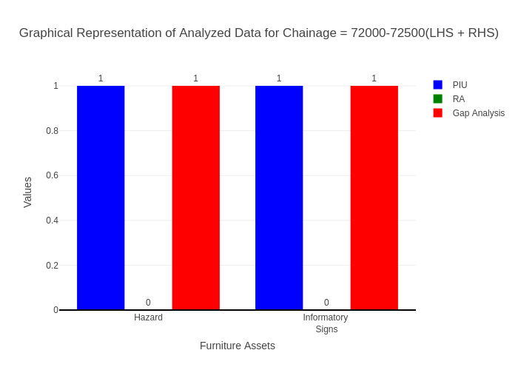

# Chainage: 72500-73000

## PIU Data:

|  |  |  |  |
| --- | --- | --- | --- |
| **Furniture Assets** | **72500-73000** | **73000-72500** | **LHS+RHS** |
| Chevron | 0.0 | 0.0 | 0.0 |
| Cautionary Warning Signs | 0.0 | 0.0 | 0.0 |
| Hazard | 0.0 | 0.0 | 0.0 |
| Prohibitory Mandatory Signs | 0.0 | 0.0 | 0.0 |
| Informatory Signs | 0.0 | 0.0 | 0.0 |

## RA Data:

|  |  |  |  |
| --- | --- | --- | --- |
| **Furniture Assets** | **72500-73000** | **73000-72500** | **LHS+RHS** |
| Chevron | 0.0 | 0.0 | 0.0 |
| Cautionary Warning Signs | 0.0 | 0.0 | 0.0 |
| Hazard | 0.0 | 0.0 | 0.0 |
| Prohibitory Mandatory Signs | 0.0 | 0.0 | 0.0 |
| Informatory Signs | 0.0 | 0.0 | 0.0 |

## Gap Analysis:

|  |  |  |  |
| --- | --- | --- | --- |
| **Furniture Assets** | **72500-73000** | **73000-72500** | **LHS+RHS** |
| Chevron | 0.0 | 0.0 | 0.0 |
| Cautionary Warning Signs | 0.0 | 0.0 | 0.0 |
| Hazard | 0.0 | 0.0 | 0.0 |
| Prohibitory Mandatory Signs | 0.0 | 0.0 | 0.0 |
| Informatory Signs | 0.0 | 0.0 | 0.0 |



# Chainage: 73000-73500

## PIU Data:

|  |  |  |  |
| --- | --- | --- | --- |
| **Furniture Assets** | **73000-73500** | **73500-73000** | **LHS+RHS** |
| Chevron | 0.0 | 0.0 | 0.0 |
| Cautionary Warning Signs | 1.0 | 0.0 | 1.0 |
| Hazard | 0.0 | 0.0 | 0.0 |
| Prohibitory Mandatory Signs | 0.0 | 0.0 | 0.0 |
| Informatory Signs | 1.0 | 0.0 | 1.0 |

## RA Data:

|  |  |  |  |
| --- | --- | --- | --- |
| **Furniture Assets** | **73000-73500** | **73500-73000** | **LHS+RHS** |
| Chevron | 0.0 | 0.0 | 0.0 |
| Cautionary Warning Signs | 1.0 | 0.0 | 1.0 |
| Hazard | 0.0 | 0.0 | 0.0 |
| Prohibitory Mandatory Signs | 1.0 | 0.0 | 1.0 |
| Informatory Signs | 1.0 | 0.0 | 1.0 |

## Gap Analysis:

|  |  |  |  |
| --- | --- | --- | --- |
| **Furniture Assets** | **73000-73500** | **73500-73000** | **LHS+RHS** |
| Chevron | 0.0 | 0.0 | 0.0 |
| Cautionary Warning Signs | 0.0 | 0.0 | 0.0 |
| Hazard | 0.0 | 0.0 | 0.0 |
| Prohibitory Mandatory Signs | -1.0 | 0.0 | -1.0 |
| Informatory Signs | 0.0 | 0.0 | 0.0 |

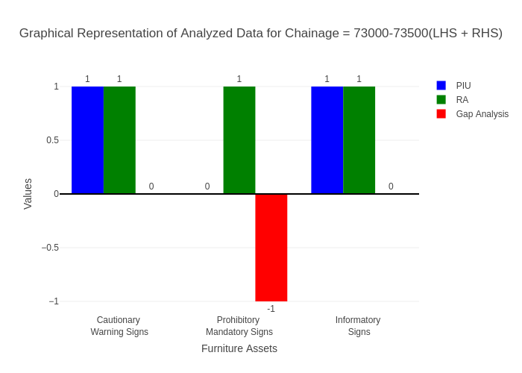

# Chainage: 73500-74000

## PIU Data:

|  |  |  |  |
| --- | --- | --- | --- |
| **Furniture Assets** | **73500-74000** | **74000-73500** | **LHS+RHS** |
| Chevron | 0.0 | 0.0 | 0.0 |
| Cautionary Warning Signs | 1.0 | 0.0 | 1.0 |
| Hazard | 0.0 | 0.0 | 0.0 |
| Prohibitory Mandatory Signs | 0.0 | 0.0 | 0.0 |
| Informatory Signs | 0.0 | 0.0 | 0.0 |

## RA Data:

|  |  |  |  |
| --- | --- | --- | --- |
| **Furniture Assets** | **73500-74000** | **74000-73500** | **LHS+RHS** |
| Chevron | 0.0 | 0.0 | 0.0 |
| Cautionary Warning Signs | 0.0 | 1.0 | 1.0 |
| Hazard | 0.0 | 0.0 | 0.0 |
| Prohibitory Mandatory Signs | 1.0 | 1.0 | 2.0 |
| Informatory Signs | 0.0 | 0.0 | 0.0 |

## Gap Analysis:

|  |  |  |  |
| --- | --- | --- | --- |
| **Furniture Assets** | **73500-74000** | **74000-73500** | **LHS+RHS** |
| Chevron | 0.0 | 0.0 | 0.0 |
| Cautionary Warning Signs | 1.0 | -1.0 | 0.0 |
| Hazard | 0.0 | 0.0 | 0.0 |
| Prohibitory Mandatory Signs | -1.0 | -1.0 | -2.0 |
| Informatory Signs | 0.0 | 0.0 | 0.0 |

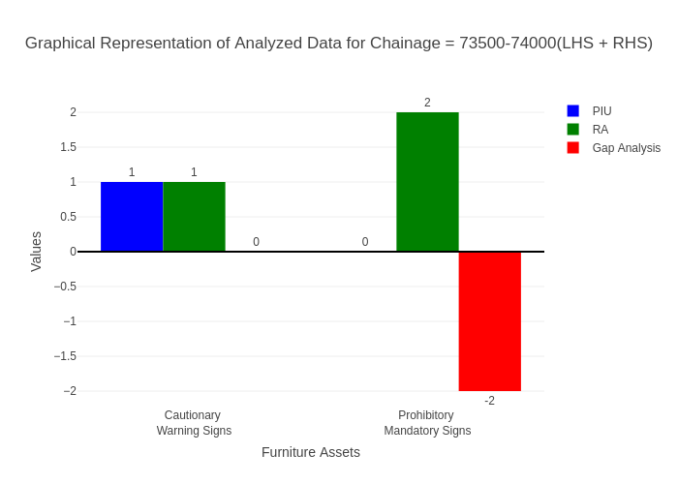

# Chainage: 74000-74500

## PIU Data:

|  |  |  |  |
| --- | --- | --- | --- |
| **Furniture Assets** | **74000-74500** | **74500-74000** | **LHS+RHS** |
| Chevron | 0.0 | 0.0 | 0.0 |
| Cautionary Warning Signs | 0.0 | 0.0 | 0.0 |
| Hazard | 1.0 | 0.0 | 1.0 |
| Prohibitory Mandatory Signs | 0.0 | 0.0 | 0.0 |
| Informatory Signs | 2.0 | 0.0 | 2.0 |

## RA Data:

|  |  |  |  |
| --- | --- | --- | --- |
| **Furniture Assets** | **74000-74500** | **74500-74000** | **LHS+RHS** |
| Chevron | 0.0 | 0.0 | 0.0 |
| Cautionary Warning Signs | 0.0 | 1.0 | 1.0 |
| Hazard | 0.0 | 0.0 | 0.0 |
| Prohibitory Mandatory Signs | 0.0 | 1.0 | 1.0 |
| Informatory Signs | 0.0 | 0.0 | 0.0 |

## Gap Analysis:

|  |  |  |  |
| --- | --- | --- | --- |
| **Furniture Assets** | **74000-74500** | **74500-74000** | **LHS+RHS** |
| Chevron | 0.0 | 0.0 | 0.0 |
| Cautionary Warning Signs | 0.0 | -1.0 | -1.0 |
| Hazard | 1.0 | 0.0 | 1.0 |
| Prohibitory Mandatory Signs | 0.0 | -1.0 | -1.0 |
| Informatory Signs | 2.0 | 0.0 | 2.0 |

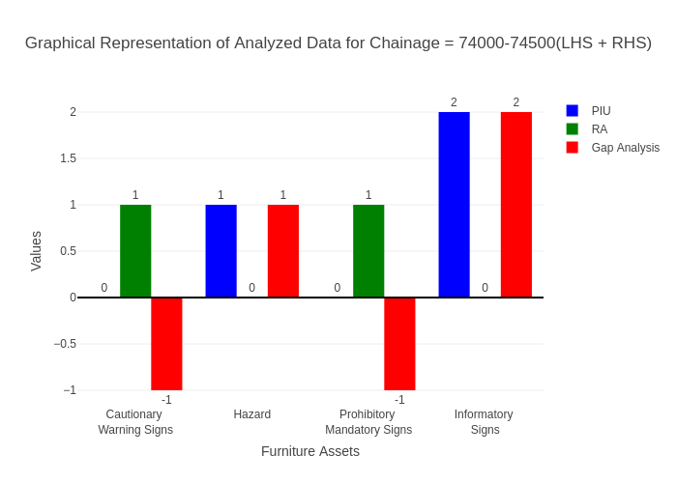

# Chainage: 74500-75000

## PIU Data:

|  |  |  |  |
| --- | --- | --- | --- |
| **Furniture Assets** | **74500-75000** | **75000-74500** | **LHS+RHS** |
| Chevron | 0.0 | 0.0 | 0.0 |
| Cautionary Warning Signs | 0.0 | 0.0 | 0.0 |
| Hazard | 1.0 | 0.0 | 1.0 |
| Prohibitory Mandatory Signs | 0.0 | 0.0 | 0.0 |
| Informatory Signs | 0.0 | 0.0 | 0.0 |

## RA Data:

|  |  |  |  |
| --- | --- | --- | --- |
| **Furniture Assets** | **74500-75000** | **75000-74500** | **LHS+RHS** |
| Chevron | 0.0 | 0.0 | 0.0 |
| Cautionary Warning Signs | 0.0 | 1.0 | 1.0 |
| Hazard | 0.0 | 0.0 | 0.0 |
| Prohibitory Mandatory Signs | 0.0 | 0.0 | 0.0 |
| Informatory Signs | 0.0 | 1.0 | 1.0 |

## Gap Analysis:

|  |  |  |  |
| --- | --- | --- | --- |
| **Furniture Assets** | **74500-75000** | **75000-74500** | **LHS+RHS** |
| Chevron | 0.0 | 0.0 | 0.0 |
| Cautionary Warning Signs | 0.0 | -1.0 | -1.0 |
| Hazard | 1.0 | 0.0 | 1.0 |
| Prohibitory Mandatory Signs | 0.0 | 0.0 | 0.0 |
| Informatory Signs | 0.0 | -1.0 | -1.0 |

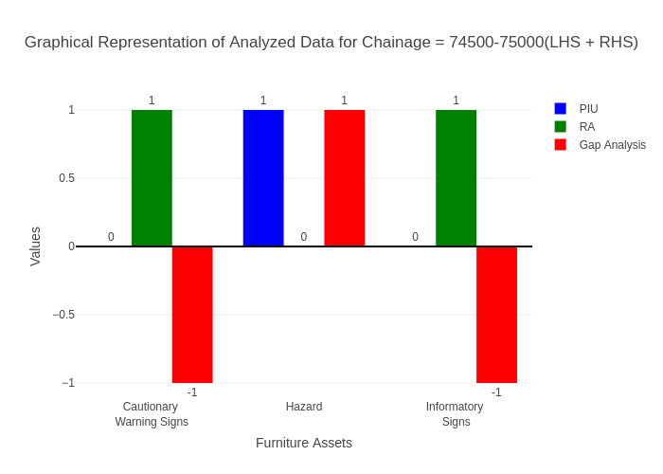

# Chainage: 75000-75500

## PIU Data:

|  |  |  |  |
| --- | --- | --- | --- |
| **Furniture Assets** | **75000-75500** | **75500-75000** | **LHS+RHS** |
| Chevron | 0.0 | 0.0 | 0.0 |
| Cautionary Warning Signs | 1.0 | 0.0 | 1.0 |
| Hazard | 0.0 | 0.0 | 0.0 |
| Prohibitory Mandatory Signs | 0.0 | 0.0 | 0.0 |
| Informatory Signs | 1.0 | 0.0 | 1.0 |

## RA Data:

|  |  |  |  |
| --- | --- | --- | --- |
| **Furniture Assets** | **75000-75500** | **75500-75000** | **LHS+RHS** |
| Chevron | 0.0 | 0.0 | 0.0 |
| Cautionary Warning Signs | 0.0 | 0.0 | 0.0 |
| Hazard | 0.0 | 0.0 | 0.0 |
| Prohibitory Mandatory Signs | 0.0 | 0.0 | 0.0 |
| Informatory Signs | 1.0 | 1.0 | 2.0 |

## Gap Analysis:

|  |  |  |  |
| --- | --- | --- | --- |
| **Furniture Assets** | **75000-75500** | **75500-75000** | **LHS+RHS** |
| Chevron | 0.0 | 0.0 | 0.0 |
| Cautionary Warning Signs | 1.0 | 0.0 | 1.0 |
| Hazard | 0.0 | 0.0 | 0.0 |
| Prohibitory Mandatory Signs | 0.0 | 0.0 | 0.0 |
| Informatory Signs | 0.0 | -1.0 | -1.0 |

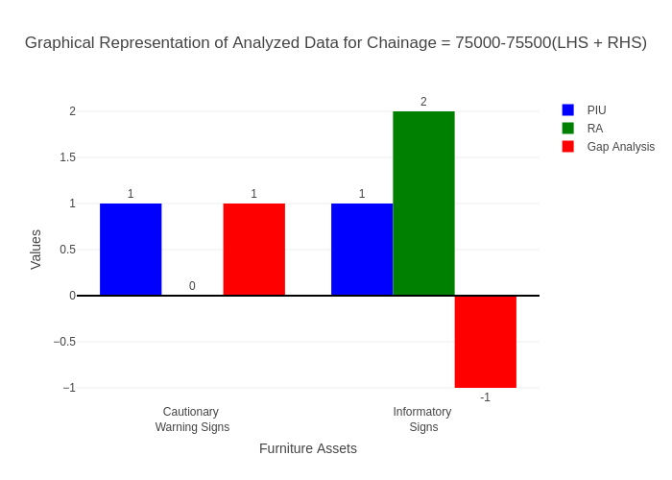

# Chainage: 75500-76000

## PIU Data:

|  |  |  |  |
| --- | --- | --- | --- |
| **Furniture Assets** | **75500-76000** | **76000-75500** | **LHS+RHS** |
| Chevron | 0.0 | 0.0 | 0.0 |
| Cautionary Warning Signs | 3.0 | 0.0 | 3.0 |
| Hazard | 5.0 | 0.0 | 5.0 |
| Prohibitory Mandatory Signs | 0.0 | 0.0 | 0.0 |
| Informatory Signs | 3.0 | 0.0 | 3.0 |

## RA Data:

|  |  |  |  |
| --- | --- | --- | --- |
| **Furniture Assets** | **75500-76000** | **76000-75500** | **LHS+RHS** |
| Chevron | 2.0 | 0.0 | 2.0 |
| Cautionary Warning Signs | 3.0 | 0.0 | 3.0 |
| Hazard | 0.0 | 0.0 | 0.0 |
| Prohibitory Mandatory Signs | 0.0 | 0.0 | 0.0 |
| Informatory Signs | 1.0 | 0.0 | 1.0 |

## Gap Analysis:

|  |  |  |  |
| --- | --- | --- | --- |
| **Furniture Assets** | **75500-76000** | **76000-75500** | **LHS+RHS** |
| Chevron | -2.0 | 0.0 | -2.0 |
| Cautionary Warning Signs | 0.0 | 0.0 | 0.0 |
| Hazard | 5.0 | 0.0 | 5.0 |
| Prohibitory Mandatory Signs | 0.0 | 0.0 | 0.0 |
| Informatory Signs | 2.0 | 0.0 | 2.0 |

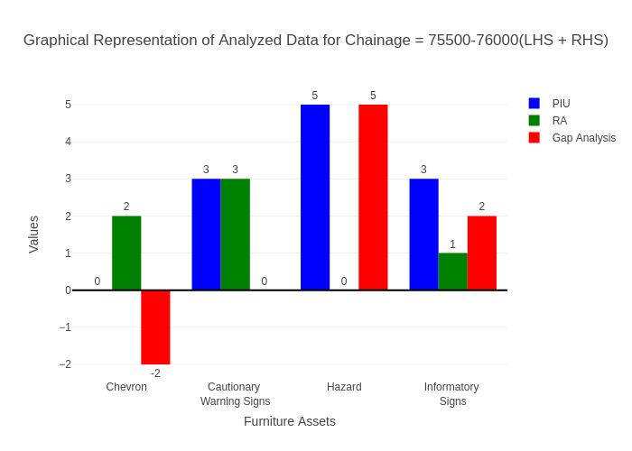

# Chainage: 76000-76500

## PIU Data:

|  |  |  |  |
| --- | --- | --- | --- |
| **Furniture Assets** | **76000-76500** | **76500-76000** | **LHS+RHS** |
| Chevron | 0.0 | 0.0 | 0.0 |
| Cautionary Warning Signs | 0.0 | 0.0 | 0.0 |
| Hazard | 0.0 | 1.0 | 1.0 |
| Prohibitory Mandatory Signs | 0.0 | 0.0 | 0.0 |
| Informatory Signs | 0.0 | 0.0 | 0.0 |

## RA Data:

|  |  |  |  |
| --- | --- | --- | --- |
| **Furniture Assets** | **76000-76500** | **76500-76000** | **LHS+RHS** |
| Chevron | 2.0 | 4.0 | 6.0 |
| Cautionary Warning Signs | 1.0 | 2.0 | 3.0 |
| Hazard | 1.0 | 1.0 | 2.0 |
| Prohibitory Mandatory Signs | 0.0 | 3.0 | 3.0 |
| Informatory Signs | 1.0 | 1.0 | 2.0 |

## Gap Analysis:

|  |  |  |  |
| --- | --- | --- | --- |
| **Furniture Assets** | **76000-76500** | **76500-76000** | **LHS+RHS** |
| Chevron | -2.0 | -4.0 | -6.0 |
| Cautionary Warning Signs | -1.0 | -2.0 | -3.0 |
| Hazard | -1.0 | 0.0 | -1.0 |
| Prohibitory Mandatory Signs | 0.0 | -3.0 | -3.0 |
| Informatory Signs | -1.0 | -1.0 | -2.0 |

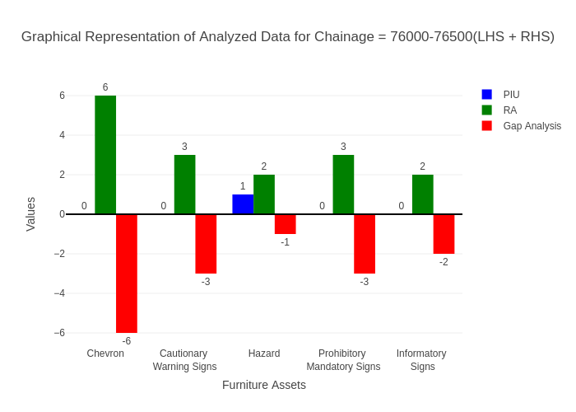

# Chainage: 76500-77000

## PIU Data:

|  |  |  |  |
| --- | --- | --- | --- |
| **Furniture Assets** | **76500-77000** | **77000-76500** | **LHS+RHS** |
| Chevron | 0.0 | 0.0 | 0.0 |
| Cautionary Warning Signs | 0.0 | 0.0 | 0.0 |
| Hazard | 0.0 | 0.0 | 0.0 |
| Prohibitory Mandatory Signs | 0.0 | 0.0 | 0.0 |
| Informatory Signs | 0.0 | 0.0 | 0.0 |

## RA Data:

|  |  |  |  |
| --- | --- | --- | --- |
| **Furniture Assets** | **76500-77000** | **77000-76500** | **LHS+RHS** |
| Chevron | 0.0 | 0.0 | 0.0 |
| Cautionary Warning Signs | 0.0 | 1.0 | 1.0 |
| Hazard | 0.0 | 0.0 | 0.0 |
| Prohibitory Mandatory Signs | 0.0 | 0.0 | 0.0 |
| Informatory Signs | 0.0 | 0.0 | 0.0 |

## Gap Analysis:

|  |  |  |  |
| --- | --- | --- | --- |
| **Furniture Assets** | **76500-77000** | **77000-76500** | **LHS+RHS** |
| Chevron | 0.0 | 0.0 | 0.0 |
| Cautionary Warning Signs | 0.0 | -1.0 | -1.0 |
| Hazard | 0.0 | 0.0 | 0.0 |
| Prohibitory Mandatory Signs | 0.0 | 0.0 | 0.0 |
| Informatory Signs | 0.0 | 0.0 | 0.0 |

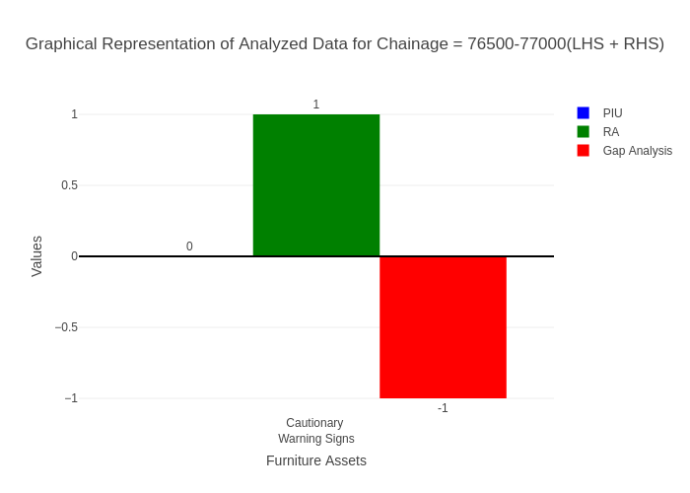

# Chainage: 77000-77500

## PIU Data:

|  |  |  |  |
| --- | --- | --- | --- |
| **Furniture Assets** | **77000-77500** | **77500-77000** | **LHS+RHS** |
| Chevron | 0.0 | 0.0 | 0.0 |
| Cautionary Warning Signs | 1.0 | 0.0 | 1.0 |
| Hazard | 0.0 | 0.0 | 0.0 |
| Prohibitory Mandatory Signs | 0.0 | 0.0 | 0.0 |
| Informatory Signs | 0.0 | 0.0 | 0.0 |

## RA Data:

|  |  |  |  |
| --- | --- | --- | --- |
| **Furniture Assets** | **77000-77500** | **77500-77000** | **LHS+RHS** |
| Chevron | 0.0 | 0.0 | 0.0 |
| Cautionary Warning Signs | 1.0 | 0.0 | 1.0 |
| Hazard | 0.0 | 0.0 | 0.0 |
| Prohibitory Mandatory Signs | 0.0 | 0.0 | 0.0 |
| Informatory Signs | 0.0 | 0.0 | 0.0 |

## Gap Analysis:

|  |  |  |  |
| --- | --- | --- | --- |
| **Furniture Assets** | **77000-77500** | **77500-77000** | **LHS+RHS** |
| Chevron | 0.0 | 0.0 | 0.0 |
| Cautionary Warning Signs | 0.0 | 0.0 | 0.0 |
| Hazard | 0.0 | 0.0 | 0.0 |
| Prohibitory Mandatory Signs | 0.0 | 0.0 | 0.0 |
| Informatory Signs | 0.0 | 0.0 | 0.0 |

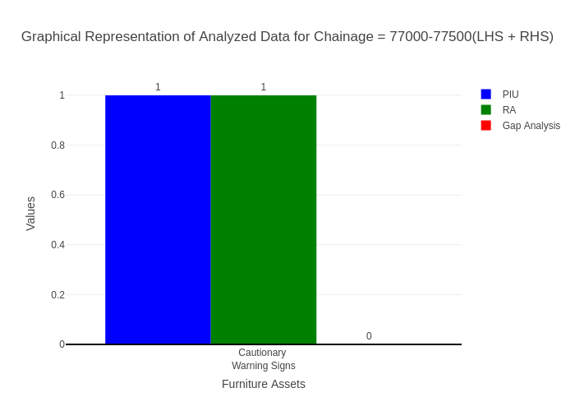

# Chainage: 77500-78000

## PIU Data:

|  |  |  |  |
| --- | --- | --- | --- |
| **Furniture Assets** | **77500-78000** | **78000-77500** | **LHS+RHS** |
| Chevron | 0.0 | 0.0 | 0.0 |
| Cautionary Warning Signs | 1.0 | 0.0 | 1.0 |
| Hazard | 2.0 | 0.0 | 2.0 |
| Prohibitory Mandatory Signs | 0.0 | 0.0 | 0.0 |
| Informatory Signs | 0.0 | 0.0 | 0.0 |

## RA Data:

|  |  |  |  |
| --- | --- | --- | --- |
| **Furniture Assets** | **77500-78000** | **78000-77500** | **LHS+RHS** |
| Chevron | 0.0 | 0.0 | 0.0 |
| Cautionary Warning Signs | 1.0 | 0.0 | 1.0 |
| Hazard | 1.0 | 0.0 | 1.0 |
| Prohibitory Mandatory Signs | 1.0 | 0.0 | 1.0 |
| Informatory Signs | 0.0 | 0.0 | 0.0 |

## Gap Analysis:

|  |  |  |  |
| --- | --- | --- | --- |
| **Furniture Assets** | **77500-78000** | **78000-77500** | **LHS+RHS** |
| Chevron | 0.0 | 0.0 | 0.0 |
| Cautionary Warning Signs | 0.0 | 0.0 | 0.0 |
| Hazard | 1.0 | 0.0 | 1.0 |
| Prohibitory Mandatory Signs | -1.0 | 0.0 | -1.0 |
| Informatory Signs | 0.0 | 0.0 | 0.0 |

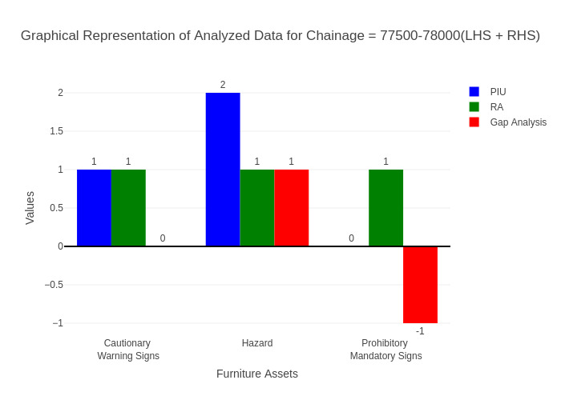

# Chainage: 78000-78500

## PIU Data:

|  |  |  |  |
| --- | --- | --- | --- |
| **Furniture Assets** | **78000-78500** | **78500-78000** | **LHS+RHS** |
| Chevron | 0.0 | 0.0 | 0.0 |
| Cautionary Warning Signs | 0.0 | 0.0 | 0.0 |
| Hazard | 0.0 | 0.0 | 0.0 |
| Prohibitory Mandatory Signs | 0.0 | 0.0 | 0.0 |
| Informatory Signs | 0.0 | 0.0 | 0.0 |

## RA Data:

|  |  |  |  |
| --- | --- | --- | --- |
| **Furniture Assets** | **78000-78500** | **78500-78000** | **LHS+RHS** |
| Chevron | 0.0 | 0.0 | 0.0 |
| Cautionary Warning Signs | 0.0 | 0.0 | 0.0 |
| Hazard | 0.0 | 0.0 | 0.0 |
| Prohibitory Mandatory Signs | 0.0 | 0.0 | 0.0 |
| Informatory Signs | 0.0 | 0.0 | 0.0 |

## Gap Analysis:

|  |  |  |  |
| --- | --- | --- | --- |
| **Furniture Assets** | **78000-78500** | **78500-78000** | **LHS+RHS** |
| Chevron | 0.0 | 0.0 | 0.0 |
| Cautionary Warning Signs | 0.0 | 0.0 | 0.0 |
| Hazard | 0.0 | 0.0 | 0.0 |
| Prohibitory Mandatory Signs | 0.0 | 0.0 | 0.0 |
| Informatory Signs | 0.0 | 0.0 | 0.0 |



# Chainage: 78500-79000

## PIU Data:

|  |  |  |  |
| --- | --- | --- | --- |
| **Furniture Assets** | **78500-79000** | **79000-78500** | **LHS+RHS** |
| Chevron | 0.0 | 0.0 | 0.0 |
| Cautionary Warning Signs | 0.0 | 0.0 | 0.0 |
| Hazard | 0.0 | 0.0 | 0.0 |
| Prohibitory Mandatory Signs | 0.0 | 0.0 | 0.0 |
| Informatory Signs | 0.0 | 0.0 | 0.0 |

## RA Data:

|  |  |  |  |
| --- | --- | --- | --- |
| **Furniture Assets** | **78500-79000** | **79000-78500** | **LHS+RHS** |
| Chevron | 0.0 | 0.0 | 0.0 |
| Cautionary Warning Signs | 0.0 | 1.0 | 1.0 |
| Hazard | 0.0 | 0.0 | 0.0 |
| Prohibitory Mandatory Signs | 0.0 | 1.0 | 1.0 |
| Informatory Signs | 0.0 | 0.0 | 0.0 |

## Gap Analysis:

|  |  |  |  |
| --- | --- | --- | --- |
| **Furniture Assets** | **78500-79000** | **79000-78500** | **LHS+RHS** |
| Chevron | 0.0 | 0.0 | 0.0 |
| Cautionary Warning Signs | 0.0 | -1.0 | -1.0 |
| Hazard | 0.0 | 0.0 | 0.0 |
| Prohibitory Mandatory Signs | 0.0 | -1.0 | -1.0 |
| Informatory Signs | 0.0 | 0.0 | 0.0 |

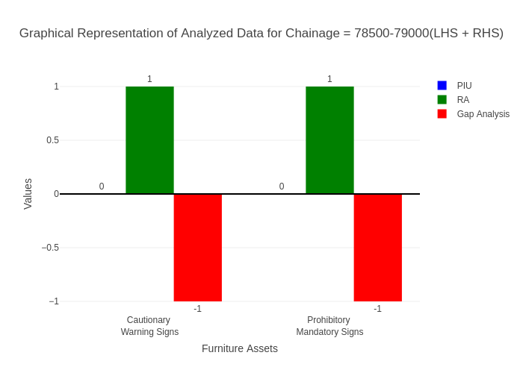

# Chainage: 79000-79500

## PIU Data:

|  |  |  |  |
| --- | --- | --- | --- |
| **Furniture Assets** | **79000-79500** | **79500-79000** | **LHS+RHS** |
| Chevron | 0.0 | 0.0 | 0.0 |
| Cautionary Warning Signs | 0.0 | 0.0 | 0.0 |
| Hazard | 0.0 | 0.0 | 0.0 |
| Prohibitory Mandatory Signs | 0.0 | 0.0 | 0.0 |
| Informatory Signs | 0.0 | 0.0 | 0.0 |

## RA Data:

|  |  |  |  |
| --- | --- | --- | --- |
| **Furniture Assets** | **79000-79500** | **79500-79000** | **LHS+RHS** |
| Chevron | 0.0 | 0.0 | 0.0 |
| Cautionary Warning Signs | 0.0 | 0.0 | 0.0 |
| Hazard | 0.0 | 0.0 | 0.0 |
| Prohibitory Mandatory Signs | 0.0 | 0.0 | 0.0 |
| Informatory Signs | 0.0 | 0.0 | 0.0 |

## Gap Analysis:

|  |  |  |  |
| --- | --- | --- | --- |
| **Furniture Assets** | **79000-79500** | **79500-79000** | **LHS+RHS** |
| Chevron | 0.0 | 0.0 | 0.0 |
| Cautionary Warning Signs | 0.0 | 0.0 | 0.0 |
| Hazard | 0.0 | 0.0 | 0.0 |
| Prohibitory Mandatory Signs | 0.0 | 0.0 | 0.0 |
| Informatory Signs | 0.0 | 0.0 | 0.0 |



# Chainage: 79500-80000

## PIU Data:

|  |  |  |  |
| --- | --- | --- | --- |
| **Furniture Assets** | **79500-80000** | **80000-79500** | **LHS+RHS** |
| Chevron | 3.0 | 0.0 | 3.0 |
| Cautionary Warning Signs | 1.0 | 0.0 | 1.0 |
| Hazard | 2.0 | 0.0 | 2.0 |
| Prohibitory Mandatory Signs | 0.0 | 0.0 | 0.0 |
| Informatory Signs | 1.0 | 0.0 | 1.0 |

## RA Data:

|  |  |  |  |
| --- | --- | --- | --- |
| **Furniture Assets** | **79500-80000** | **80000-79500** | **LHS+RHS** |
| Chevron | 0.0 | 0.0 | 0.0 |
| Cautionary Warning Signs | 1.0 | 0.0 | 1.0 |
| Hazard | 2.0 | 0.0 | 2.0 |
| Prohibitory Mandatory Signs | 0.0 | 0.0 | 0.0 |
| Informatory Signs | 1.0 | 0.0 | 1.0 |

## Gap Analysis:

|  |  |  |  |
| --- | --- | --- | --- |
| **Furniture Assets** | **79500-80000** | **80000-79500** | **LHS+RHS** |
| Chevron | 3.0 | 0.0 | 3.0 |
| Cautionary Warning Signs | 0.0 | 0.0 | 0.0 |
| Hazard | 0.0 | 0.0 | 0.0 |
| Prohibitory Mandatory Signs | 0.0 | 0.0 | 0.0 |
| Informatory Signs | 0.0 | 0.0 | 0.0 |

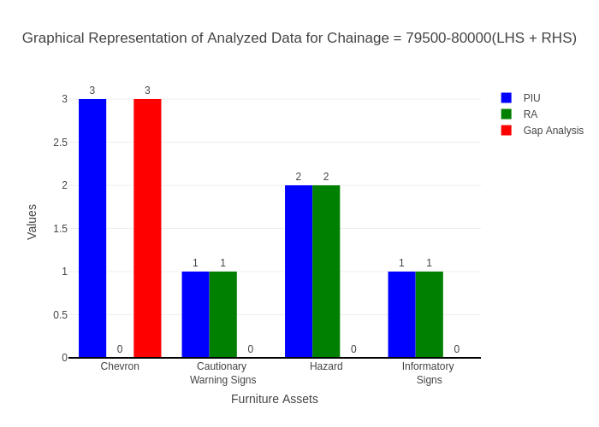

# Chainage: 80000-80500

## PIU Data:

|  |  |  |  |
| --- | --- | --- | --- |
| **Furniture Assets** | **80000-80500** | **80500-80000** | **LHS+RHS** |
| Chevron | 0.0 | 0.0 | 0.0 |
| Cautionary Warning Signs | 1.0 | 0.0 | 1.0 |
| Hazard | 0.0 | 0.0 | 0.0 |
| Prohibitory Mandatory Signs | 0.0 | 0.0 | 0.0 |
| Informatory Signs | 2.0 | 1.0 | 3.0 |

## RA Data:

|  |  |  |  |
| --- | --- | --- | --- |
| **Furniture Assets** | **80000-80500** | **80500-80000** | **LHS+RHS** |
| Chevron | 3.0 | 2.0 | 5.0 |
| Cautionary Warning Signs | 0.0 | 0.0 | 0.0 |
| Hazard | 0.0 | 0.0 | 0.0 |
| Prohibitory Mandatory Signs | 1.0 | 3.0 | 4.0 |
| Informatory Signs | 1.0 | 1.0 | 2.0 |

## Gap Analysis:

|  |  |  |  |
| --- | --- | --- | --- |
| **Furniture Assets** | **80000-80500** | **80500-80000** | **LHS+RHS** |
| Chevron | -3.0 | -2.0 | -5.0 |
| Cautionary Warning Signs | 1.0 | 0.0 | 1.0 |
| Hazard | 0.0 | 0.0 | 0.0 |
| Prohibitory Mandatory Signs | -1.0 | -3.0 | -4.0 |
| Informatory Signs | 1.0 | 0.0 | 1.0 |

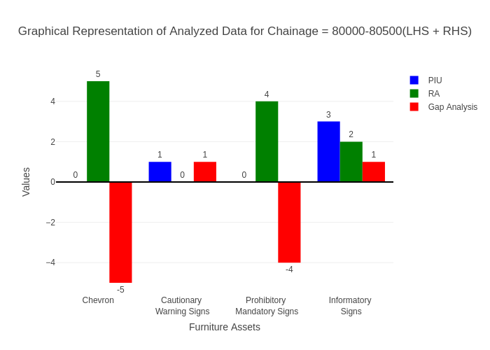

# Chainage: 80500-81000

## PIU Data:

|  |  |  |  |
| --- | --- | --- | --- |
| **Furniture Assets** | **80500-81000** | **81000-80500** | **LHS+RHS** |
| Chevron | 0.0 | 0.0 | 0.0 |
| Cautionary Warning Signs | 0.0 | 0.0 | 0.0 |
| Hazard | 1.0 | 0.0 | 1.0 |
| Prohibitory Mandatory Signs | 0.0 | 0.0 | 0.0 |
| Informatory Signs | 1.0 | 0.0 | 1.0 |

## RA Data:

|  |  |  |  |
| --- | --- | --- | --- |
| **Furniture Assets** | **80500-81000** | **81000-80500** | **LHS+RHS** |
| Chevron | 0.0 | 2.0 | 2.0 |
| Cautionary Warning Signs | 1.0 | 1.0 | 2.0 |
| Hazard | 0.0 | 0.0 | 0.0 |
| Prohibitory Mandatory Signs | 0.0 | 0.0 | 0.0 |
| Informatory Signs | 3.0 | 4.0 | 7.0 |

## Gap Analysis:

|  |  |  |  |
| --- | --- | --- | --- |
| **Furniture Assets** | **80500-81000** | **81000-80500** | **LHS+RHS** |
| Chevron | 0.0 | -2.0 | -2.0 |
| Cautionary Warning Signs | -1.0 | -1.0 | -2.0 |
| Hazard | 1.0 | 0.0 | 1.0 |
| Prohibitory Mandatory Signs | 0.0 | 0.0 | 0.0 |
| Informatory Signs | -2.0 | -4.0 | -6.0 |

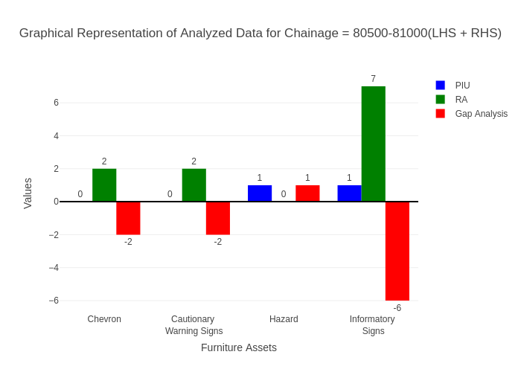

# Chainage: 81000-81500

## PIU Data:

|  |  |  |  |
| --- | --- | --- | --- |
| **Furniture Assets** | **81000-81500** | **81500-81000** | **LHS+RHS** |
| Chevron | 0.0 | 0.0 | 0.0 |
| Cautionary Warning Signs | 0.0 | 0.0 | 0.0 |
| Hazard | 0.0 | 0.0 | 0.0 |
| Prohibitory Mandatory Signs | 0.0 | 0.0 | 0.0 |
| Informatory Signs | 1.0 | 0.0 | 1.0 |

## RA Data:

|  |  |  |  |
| --- | --- | --- | --- |
| **Furniture Assets** | **81000-81500** | **81500-81000** | **LHS+RHS** |
| Chevron | 0.0 | 0.0 | 0.0 |
| Cautionary Warning Signs | 0.0 | 0.0 | 0.0 |
| Hazard | 0.0 | 0.0 | 0.0 |
| Prohibitory Mandatory Signs | 0.0 | 0.0 | 0.0 |
| Informatory Signs | 1.0 | 0.0 | 1.0 |

## Gap Analysis:

|  |  |  |  |
| --- | --- | --- | --- |
| **Furniture Assets** | **81000-81500** | **81500-81000** | **LHS+RHS** |
| Chevron | 0.0 | 0.0 | 0.0 |
| Cautionary Warning Signs | 0.0 | 0.0 | 0.0 |
| Hazard | 0.0 | 0.0 | 0.0 |
| Prohibitory Mandatory Signs | 0.0 | 0.0 | 0.0 |
| Informatory Signs | 0.0 | 0.0 | 0.0 |

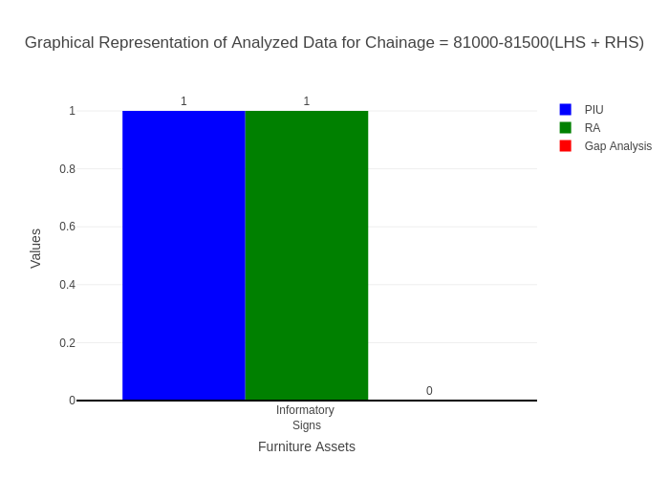

# Chainage: 81500-82000

## PIU Data:

|  |  |  |  |
| --- | --- | --- | --- |
| **Furniture Assets** | **81500-82000** | **82000-81500** | **LHS+RHS** |
| Chevron | 0.0 | 0.0 | 0.0 |
| Cautionary Warning Signs | 1.0 | 0.0 | 1.0 |
| Hazard | 1.0 | 0.0 | 1.0 |
| Prohibitory Mandatory Signs | 0.0 | 0.0 | 0.0 |
| Informatory Signs | 0.0 | 0.0 | 0.0 |

## RA Data:

|  |  |  |  |
| --- | --- | --- | --- |
| **Furniture Assets** | **81500-82000** | **82000-81500** | **LHS+RHS** |
| Chevron | 0.0 | 0.0 | 0.0 |
| Cautionary Warning Signs | 0.0 | 0.0 | 0.0 |
| Hazard | 0.0 | 0.0 | 0.0 |
| Prohibitory Mandatory Signs | 0.0 | 0.0 | 0.0 |
| Informatory Signs | 0.0 | 1.0 | 1.0 |

## Gap Analysis:

|  |  |  |  |
| --- | --- | --- | --- |
| **Furniture Assets** | **81500-82000** | **82000-81500** | **LHS+RHS** |
| Chevron | 0.0 | 0.0 | 0.0 |
| Cautionary Warning Signs | 1.0 | 0.0 | 1.0 |
| Hazard | 1.0 | 0.0 | 1.0 |
| Prohibitory Mandatory Signs | 0.0 | 0.0 | 0.0 |
| Informatory Signs | 0.0 | -1.0 | -1.0 |

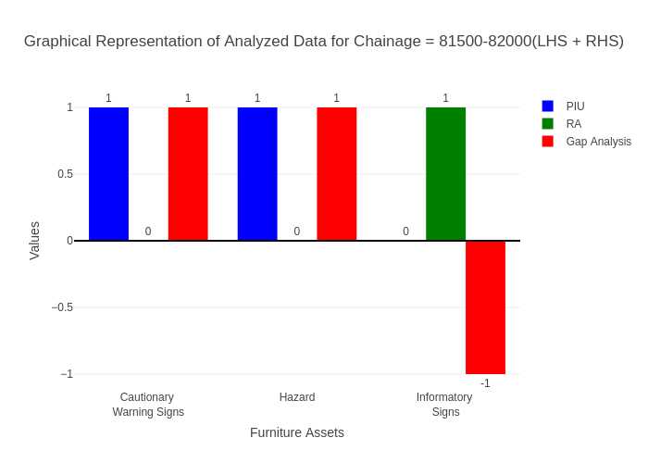

# Chainage: 82000-82500

## PIU Data:

|  |  |  |  |
| --- | --- | --- | --- |
| **Furniture Assets** | **82000-82500** | **82500-82000** | **LHS+RHS** |
| Chevron | 0.0 | 0.0 | 0.0 |
| Cautionary Warning Signs | 1.0 | 0.0 | 1.0 |
| Hazard | 0.0 | 0.0 | 0.0 |
| Prohibitory Mandatory Signs | 0.0 | 0.0 | 0.0 |
| Informatory Signs | 1.0 | 0.0 | 1.0 |

## RA Data:

|  |  |  |  |
| --- | --- | --- | --- |
| **Furniture Assets** | **82000-82500** | **82500-82000** | **LHS+RHS** |
| Chevron | 0.0 | 0.0 | 0.0 |
| Cautionary Warning Signs | 1.0 | 0.0 | 1.0 |
| Hazard | 0.0 | 0.0 | 0.0 |
| Prohibitory Mandatory Signs | 0.0 | 0.0 | 0.0 |
| Informatory Signs | 1.0 | 0.0 | 1.0 |

## Gap Analysis:

|  |  |  |  |
| --- | --- | --- | --- |
| **Furniture Assets** | **82000-82500** | **82500-82000** | **LHS+RHS** |
| Chevron | 0.0 | 0.0 | 0.0 |
| Cautionary Warning Signs | 0.0 | 0.0 | 0.0 |
| Hazard | 0.0 | 0.0 | 0.0 |
| Prohibitory Mandatory Signs | 0.0 | 0.0 | 0.0 |
| Informatory Signs | 0.0 | 0.0 | 0.0 |

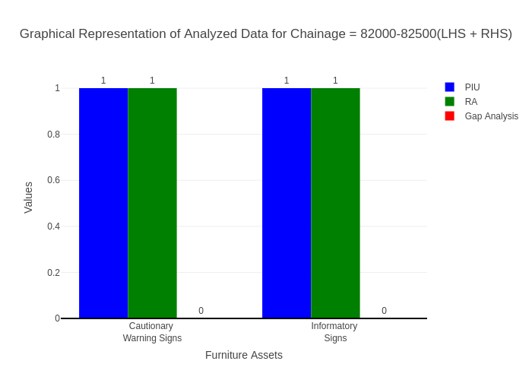

# Chainage: 82500-83000

## PIU Data:

|  |  |  |  |
| --- | --- | --- | --- |
| **Furniture Assets** | **82500-83000** | **83000-82500** | **LHS+RHS** |
| Chevron | 0.0 | 0.0 | 0.0 |
| Cautionary Warning Signs | 0.0 | 0.0 | 0.0 |
| Hazard | 0.0 | 0.0 | 0.0 |
| Prohibitory Mandatory Signs | 0.0 | 0.0 | 0.0 |
| Informatory Signs | 0.0 | 0.0 | 0.0 |

## RA Data:

|  |  |  |  |
| --- | --- | --- | --- |
| **Furniture Assets** | **82500-83000** | **83000-82500** | **LHS+RHS** |
| Chevron | 0.0 | 0.0 | 0.0 |
| Cautionary Warning Signs | 0.0 | 0.0 | 0.0 |
| Hazard | 0.0 | 0.0 | 0.0 |
| Prohibitory Mandatory Signs | 1.0 | 0.0 | 1.0 |
| Informatory Signs | 0.0 | 1.0 | 1.0 |

## Gap Analysis:

|  |  |  |  |
| --- | --- | --- | --- |
| **Furniture Assets** | **82500-83000** | **83000-82500** | **LHS+RHS** |
| Chevron | 0.0 | 0.0 | 0.0 |
| Cautionary Warning Signs | 0.0 | 0.0 | 0.0 |
| Hazard | 0.0 | 0.0 | 0.0 |
| Prohibitory Mandatory Signs | -1.0 | 0.0 | -1.0 |
| Informatory Signs | 0.0 | -1.0 | -1.0 |

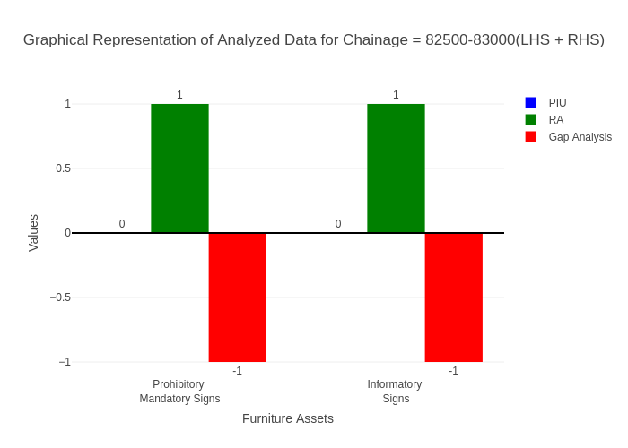

# Chainage: 83000-83500

## PIU Data:

|  |  |  |  |
| --- | --- | --- | --- |
| **Furniture Assets** | **83000-83500** | **83500-83000** | **LHS+RHS** |
| Chevron | 0.0 | 0.0 | 0.0 |
| Cautionary Warning Signs | 0.0 | 0.0 | 0.0 |
| Hazard | 0.0 | 0.0 | 0.0 |
| Prohibitory Mandatory Signs | 0.0 | 0.0 | 0.0 |
| Informatory Signs | 2.0 | 0.0 | 2.0 |

## RA Data:

|  |  |  |  |
| --- | --- | --- | --- |
| **Furniture Assets** | **83000-83500** | **83500-83000** | **LHS+RHS** |
| Chevron | 0.0 | 0.0 | 0.0 |
| Cautionary Warning Signs | 0.0 | 0.0 | 0.0 |
| Hazard | 0.0 | 0.0 | 0.0 |
| Prohibitory Mandatory Signs | 0.0 | 0.0 | 0.0 |
| Informatory Signs | 0.0 | 0.0 | 0.0 |

## Gap Analysis:

|  |  |  |  |
| --- | --- | --- | --- |
| **Furniture Assets** | **83000-83500** | **83500-83000** | **LHS+RHS** |
| Chevron | 0.0 | 0.0 | 0.0 |
| Cautionary Warning Signs | 0.0 | 0.0 | 0.0 |
| Hazard | 0.0 | 0.0 | 0.0 |
| Prohibitory Mandatory Signs | 0.0 | 0.0 | 0.0 |
| Informatory Signs | 2.0 | 0.0 | 2.0 |

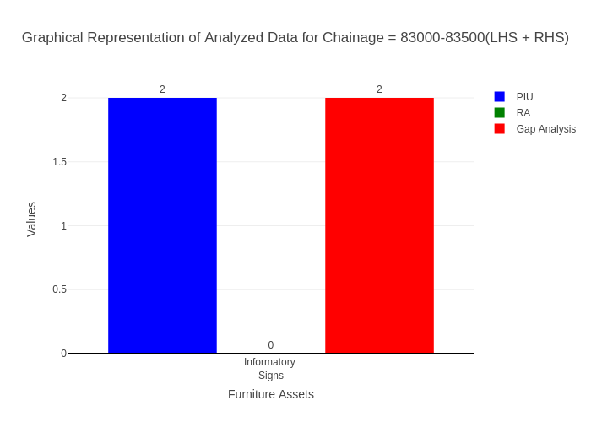

# Chainage: 83500-84000

## PIU Data:

|  |  |  |  |
| --- | --- | --- | --- |
| **Furniture Assets** | **83500-84000** | **84000-83500** | **LHS+RHS** |
| Chevron | 0.0 | 0.0 | 0.0 |
| Cautionary Warning Signs | 1.0 | 0.0 | 1.0 |
| Hazard | 0.0 | 0.0 | 0.0 |
| Prohibitory Mandatory Signs | 0.0 | 0.0 | 0.0 |
| Informatory Signs | 0.0 | 0.0 | 0.0 |

## RA Data:

|  |  |  |  |
| --- | --- | --- | --- |
| **Furniture Assets** | **83500-84000** | **84000-83500** | **LHS+RHS** |
| Chevron | 0.0 | 0.0 | 0.0 |
| Cautionary Warning Signs | 0.0 | 0.0 | 0.0 |
| Hazard | 0.0 | 0.0 | 0.0 |
| Prohibitory Mandatory Signs | 1.0 | 0.0 | 1.0 |
| Informatory Signs | 0.0 | 0.0 | 0.0 |

## Gap Analysis:

|  |  |  |  |
| --- | --- | --- | --- |
| **Furniture Assets** | **83500-84000** | **84000-83500** | **LHS+RHS** |
| Chevron | 0.0 | 0.0 | 0.0 |
| Cautionary Warning Signs | 1.0 | 0.0 | 1.0 |
| Hazard | 0.0 | 0.0 | 0.0 |
| Prohibitory Mandatory Signs | -1.0 | 0.0 | -1.0 |
| Informatory Signs | 0.0 | 0.0 | 0.0 |

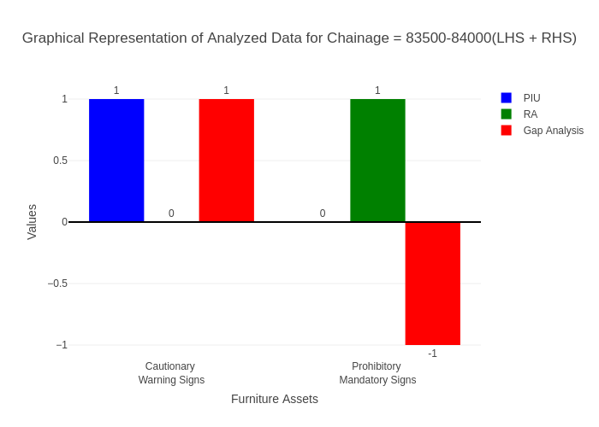

# Chainage: 84000-84500

## PIU Data:

|  |  |  |  |
| --- | --- | --- | --- |
| **Furniture Assets** | **84000-84500** | **84500-84000** | **LHS+RHS** |
| Chevron | 0.0 | 0.0 | 0.0 |
| Cautionary Warning Signs | 2.0 | 0.0 | 2.0 |
| Hazard | 1.0 | 0.0 | 1.0 |
| Prohibitory Mandatory Signs | 0.0 | 0.0 | 0.0 |
| Informatory Signs | 2.0 | 1.0 | 3.0 |

## RA Data:

|  |  |  |  |
| --- | --- | --- | --- |
| **Furniture Assets** | **84000-84500** | **84500-84000** | **LHS+RHS** |
| Chevron | 0.0 | 0.0 | 0.0 |
| Cautionary Warning Signs | 8.0 | 1.0 | 9.0 |
| Hazard | 3.0 | 0.0 | 3.0 |
| Prohibitory Mandatory Signs | 0.0 | 1.0 | 1.0 |
| Informatory Signs | 7.0 | 0.0 | 7.0 |

## Gap Analysis:

|  |  |  |  |
| --- | --- | --- | --- |
| **Furniture Assets** | **84000-84500** | **84500-84000** | **LHS+RHS** |
| Chevron | 0.0 | 0.0 | 0.0 |
| Cautionary Warning Signs | -6.0 | -1.0 | -7.0 |
| Hazard | -2.0 | 0.0 | -2.0 |
| Prohibitory Mandatory Signs | 0.0 | -1.0 | -1.0 |
| Informatory Signs | -5.0 | 1.0 | -4.0 |

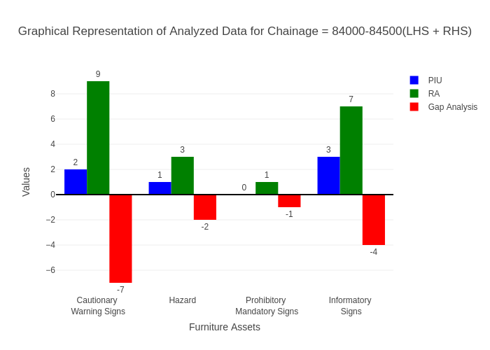

# Chainage: 84500-85000

## PIU Data:

|  |  |  |  |
| --- | --- | --- | --- |
| **Furniture Assets** | **84500-85000** | **85000-84500** | **LHS+RHS** |
| Chevron | 0.0 | 0.0 | 0.0 |
| Cautionary Warning Signs | 5.0 | 0.0 | 5.0 |
| Hazard | 0.0 | 0.0 | 0.0 |
| Prohibitory Mandatory Signs | 0.0 | 0.0 | 0.0 |
| Informatory Signs | 2.0 | 0.0 | 2.0 |

## RA Data:

|  |  |  |  |
| --- | --- | --- | --- |
| **Furniture Assets** | **84500-85000** | **85000-84500** | **LHS+RHS** |
| Chevron | 0.0 | 0.0 | 0.0 |
| Cautionary Warning Signs | 0.0 | 3.0 | 3.0 |
| Hazard | 0.0 | 0.0 | 0.0 |
| Prohibitory Mandatory Signs | 1.0 | 3.0 | 4.0 |
| Informatory Signs | 1.0 | 2.0 | 3.0 |

## Gap Analysis:

|  |  |  |  |
| --- | --- | --- | --- |
| **Furniture Assets** | **84500-85000** | **85000-84500** | **LHS+RHS** |
| Chevron | 0.0 | 0.0 | 0.0 |
| Cautionary Warning Signs | 5.0 | -3.0 | 2.0 |
| Hazard | 0.0 | 0.0 | 0.0 |
| Prohibitory Mandatory Signs | -1.0 | -3.0 | -4.0 |
| Informatory Signs | 1.0 | -2.0 | -1.0 |

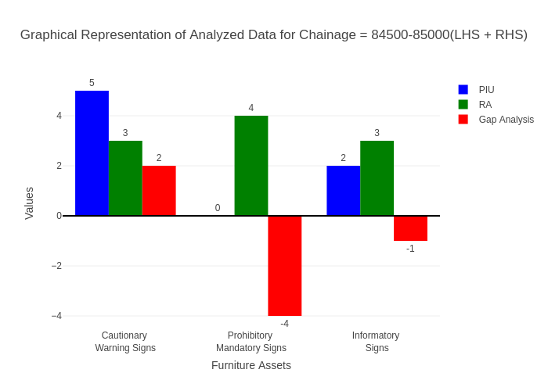

# Chainage: 85000-85500

## PIU Data:

|  |  |  |  |
| --- | --- | --- | --- |
| **Furniture Assets** | **85000-85500** | **85500-85000** | **LHS+RHS** |
| Chevron | 0.0 | 0.0 | 0.0 |
| Cautionary Warning Signs | 2.0 | 0.0 | 2.0 |
| Hazard | 0.0 | 0.0 | 0.0 |
| Prohibitory Mandatory Signs | 0.0 | 0.0 | 0.0 |
| Informatory Signs | 0.0 | 2.0 | 2.0 |

## RA Data:

|  |  |  |  |
| --- | --- | --- | --- |
| **Furniture Assets** | **85000-85500** | **85500-85000** | **LHS+RHS** |
| Chevron | 0.0 | 0.0 | 0.0 |
| Cautionary Warning Signs | 0.0 | 2.0 | 2.0 |
| Hazard | 0.0 | 0.0 | 0.0 |
| Prohibitory Mandatory Signs | 2.0 | 0.0 | 2.0 |
| Informatory Signs | 3.0 | 5.0 | 8.0 |

## Gap Analysis:

|  |  |  |  |
| --- | --- | --- | --- |
| **Furniture Assets** | **85000-85500** | **85500-85000** | **LHS+RHS** |
| Chevron | 0.0 | 0.0 | 0.0 |
| Cautionary Warning Signs | 2.0 | -2.0 | 0.0 |
| Hazard | 0.0 | 0.0 | 0.0 |
| Prohibitory Mandatory Signs | -2.0 | 0.0 | -2.0 |
| Informatory Signs | -3.0 | -3.0 | -6.0 |

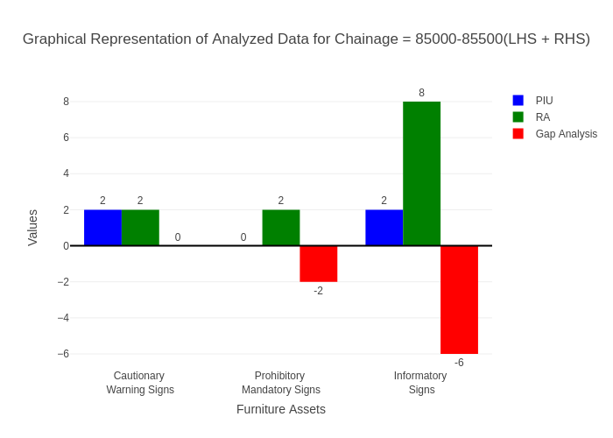

# Chainage: 85500-86000

## PIU Data:

|  |  |  |  |
| --- | --- | --- | --- |
| **Furniture Assets** | **85500-86000** | **86000-85500** | **LHS+RHS** |
| Chevron | 0.0 | 0.0 | 0.0 |
| Cautionary Warning Signs | 2.0 | 0.0 | 2.0 |
| Hazard | 0.0 | 1.0 | 1.0 |
| Prohibitory Mandatory Signs | 0.0 | 0.0 | 0.0 |
| Informatory Signs | 1.0 | 0.0 | 1.0 |

## RA Data:

|  |  |  |  |
| --- | --- | --- | --- |
| **Furniture Assets** | **85500-86000** | **86000-85500** | **LHS+RHS** |
| Chevron | 0.0 | 0.0 | 0.0 |
| Cautionary Warning Signs | 1.0 | 0.0 | 1.0 |
| Hazard | 0.0 | 0.0 | 0.0 |
| Prohibitory Mandatory Signs | 1.0 | 0.0 | 1.0 |
| Informatory Signs | 0.0 | 1.0 | 1.0 |

## Gap Analysis:

|  |  |  |  |
| --- | --- | --- | --- |
| **Furniture Assets** | **85500-86000** | **86000-85500** | **LHS+RHS** |
| Chevron | 0.0 | 0.0 | 0.0 |
| Cautionary Warning Signs | 1.0 | 0.0 | 1.0 |
| Hazard | 0.0 | 1.0 | 1.0 |
| Prohibitory Mandatory Signs | -1.0 | 0.0 | -1.0 |
| Informatory Signs | 1.0 | -1.0 | 0.0 |

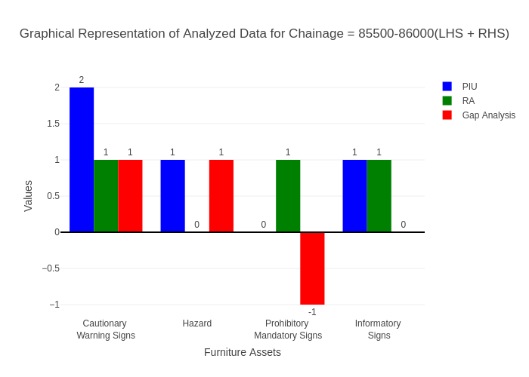

# Chainage: 86000-86500

## PIU Data:

|  |  |  |  |
| --- | --- | --- | --- |
| **Furniture Assets** | **86000-86500** | **86500-86000** | **LHS+RHS** |
| Chevron | 0.0 | 0.0 | 0.0 |
| Cautionary Warning Signs | 3.0 | 0.0 | 3.0 |
| Hazard | 1.0 | 0.0 | 1.0 |
| Prohibitory Mandatory Signs | 0.0 | 0.0 | 0.0 |
| Informatory Signs | 0.0 | 0.0 | 0.0 |

## RA Data:

|  |  |  |  |
| --- | --- | --- | --- |
| **Furniture Assets** | **86000-86500** | **86500-86000** | **LHS+RHS** |
| Chevron | 0.0 | 0.0 | 0.0 |
| Cautionary Warning Signs | 3.0 | 5.0 | 8.0 |
| Hazard | 1.0 | 1.0 | 2.0 |
| Prohibitory Mandatory Signs | 1.0 | 1.0 | 2.0 |
| Informatory Signs | 1.0 | 1.0 | 2.0 |

## Gap Analysis:

|  |  |  |  |
| --- | --- | --- | --- |
| **Furniture Assets** | **86000-86500** | **86500-86000** | **LHS+RHS** |
| Chevron | 0.0 | 0.0 | 0.0 |
| Cautionary Warning Signs | 0.0 | -5.0 | -5.0 |
| Hazard | 0.0 | -1.0 | -1.0 |
| Prohibitory Mandatory Signs | -1.0 | -1.0 | -2.0 |
| Informatory Signs | -1.0 | -1.0 | -2.0 |

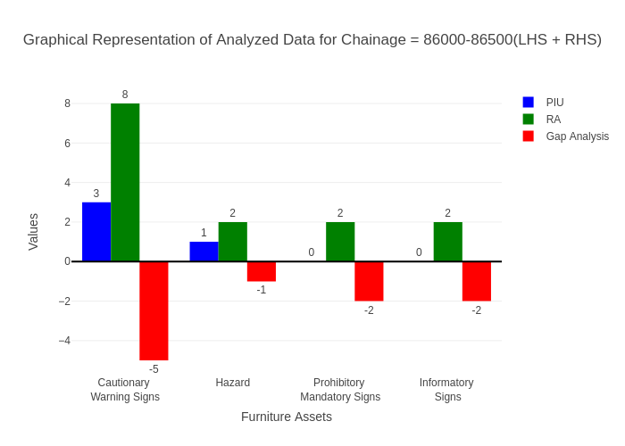

# Chainage: 86500-87000

## PIU Data:

|  |  |  |  |
| --- | --- | --- | --- |
| **Furniture Assets** | **86500-87000** | **87000-86500** | **LHS+RHS** |
| Chevron | 0.0 | 0.0 | 0.0 |
| Cautionary Warning Signs | 0.0 | 0.0 | 0.0 |
| Hazard | 1.0 | 0.0 | 1.0 |
| Prohibitory Mandatory Signs | 0.0 | 0.0 | 0.0 |
| Informatory Signs | 1.0 | 0.0 | 1.0 |

## RA Data:

|  |  |  |  |
| --- | --- | --- | --- |
| **Furniture Assets** | **86500-87000** | **87000-86500** | **LHS+RHS** |
| Chevron | 0.0 | 0.0 | 0.0 |
| Cautionary Warning Signs | 0.0 | 0.0 | 0.0 |
| Hazard | 0.0 | 2.0 | 2.0 |
| Prohibitory Mandatory Signs | 0.0 | 1.0 | 1.0 |
| Informatory Signs | 1.0 | 1.0 | 2.0 |

## Gap Analysis:

|  |  |  |  |
| --- | --- | --- | --- |
| **Furniture Assets** | **86500-87000** | **87000-86500** | **LHS+RHS** |
| Chevron | 0.0 | 0.0 | 0.0 |
| Cautionary Warning Signs | 0.0 | 0.0 | 0.0 |
| Hazard | 1.0 | -2.0 | -1.0 |
| Prohibitory Mandatory Signs | 0.0 | -1.0 | -1.0 |
| Informatory Signs | 0.0 | -1.0 | -1.0 |

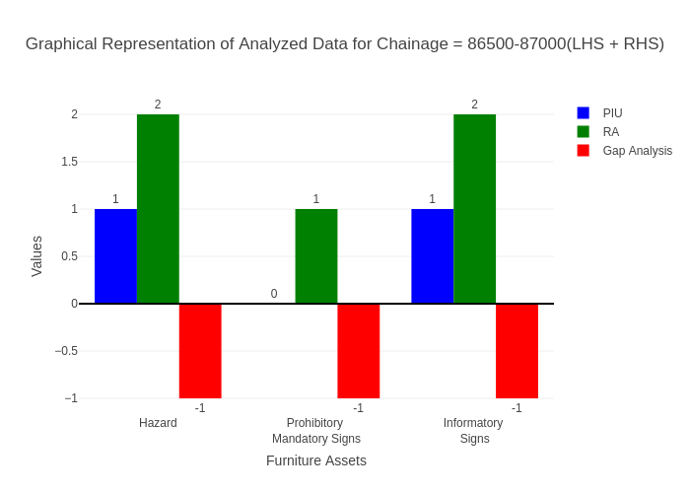

# Chainage: 87000-87500

## PIU Data:

|  |  |  |  |
| --- | --- | --- | --- |
| **Furniture Assets** | **87000-87500** | **87500-87000** | **LHS+RHS** |
| Chevron | 0.0 | 0.0 | 0.0 |
| Cautionary Warning Signs | 3.0 | 0.0 | 3.0 |
| Hazard | 1.0 | 0.0 | 1.0 |
| Prohibitory Mandatory Signs | 0.0 | 0.0 | 0.0 |
| Informatory Signs | 1.0 | 0.0 | 1.0 |

## RA Data:

|  |  |  |  |
| --- | --- | --- | --- |
| **Furniture Assets** | **87000-87500** | **87500-87000** | **LHS+RHS** |
| Chevron | 0.0 | 0.0 | 0.0 |
| Cautionary Warning Signs | 0.0 | 0.0 | 0.0 |
| Hazard | 0.0 | 0.0 | 0.0 |
| Prohibitory Mandatory Signs | 0.0 | 1.0 | 1.0 |
| Informatory Signs | 0.0 | 0.0 | 0.0 |

## Gap Analysis:

|  |  |  |  |
| --- | --- | --- | --- |
| **Furniture Assets** | **87000-87500** | **87500-87000** | **LHS+RHS** |
| Chevron | 0.0 | 0.0 | 0.0 |
| Cautionary Warning Signs | 3.0 | 0.0 | 3.0 |
| Hazard | 1.0 | 0.0 | 1.0 |
| Prohibitory Mandatory Signs | 0.0 | -1.0 | -1.0 |
| Informatory Signs | 1.0 | 0.0 | 1.0 |

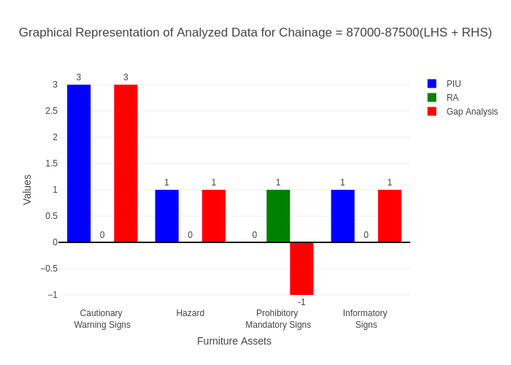

# Chainage: 87500-88000

## PIU Data:

|  |  |  |  |
| --- | --- | --- | --- |
| **Furniture Assets** | **87500-88000** | **88000-87500** | **LHS+RHS** |
| Chevron | 0.0 | 0.0 | 0.0 |
| Cautionary Warning Signs | 1.0 | 0.0 | 1.0 |
| Hazard | 1.0 | 0.0 | 1.0 |
| Prohibitory Mandatory Signs | 0.0 | 0.0 | 0.0 |
| Informatory Signs | 1.0 | 0.0 | 1.0 |

## RA Data:

|  |  |  |  |
| --- | --- | --- | --- |
| **Furniture Assets** | **87500-88000** | **88000-87500** | **LHS+RHS** |
| Chevron | 0.0 | 0.0 | 0.0 |
| Cautionary Warning Signs | 1.0 | 0.0 | 1.0 |
| Hazard | 0.0 | 1.0 | 1.0 |
| Prohibitory Mandatory Signs | 0.0 | 0.0 | 0.0 |
| Informatory Signs | 0.0 | 0.0 | 0.0 |

## Gap Analysis:

|  |  |  |  |
| --- | --- | --- | --- |
| **Furniture Assets** | **87500-88000** | **88000-87500** | **LHS+RHS** |
| Chevron | 0.0 | 0.0 | 0.0 |
| Cautionary Warning Signs | 0.0 | 0.0 | 0.0 |
| Hazard | 1.0 | -1.0 | 0.0 |
| Prohibitory Mandatory Signs | 0.0 | 0.0 | 0.0 |
| Informatory Signs | 1.0 | 0.0 | 1.0 |

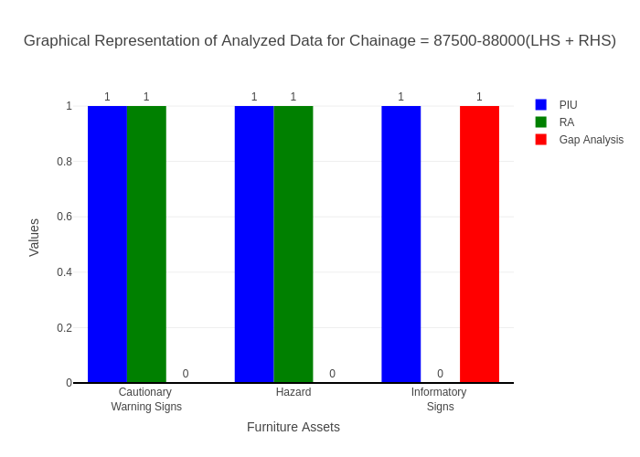

# Chainage: 88000-88500

## PIU Data:

|  |  |  |  |
| --- | --- | --- | --- |
| **Furniture Assets** | **88000-88500** | **88500-88000** | **LHS+RHS** |
| Chevron | 0.0 | 0.0 | 0.0 |
| Cautionary Warning Signs | 0.0 | 0.0 | 0.0 |
| Hazard | 0.0 | 0.0 | 0.0 |
| Prohibitory Mandatory Signs | 0.0 | 0.0 | 0.0 |
| Informatory Signs | 0.0 | 0.0 | 0.0 |

## RA Data:

|  |  |  |  |
| --- | --- | --- | --- |
| **Furniture Assets** | **88000-88500** | **88500-88000** | **LHS+RHS** |
| Chevron | 0.0 | 0.0 | 0.0 |
| Cautionary Warning Signs | 0.0 | 0.0 | 0.0 |
| Hazard | 1.0 | 1.0 | 2.0 |
| Prohibitory Mandatory Signs | 0.0 | 0.0 | 0.0 |
| Informatory Signs | 0.0 | 1.0 | 1.0 |

## Gap Analysis:

|  |  |  |  |
| --- | --- | --- | --- |
| **Furniture Assets** | **88000-88500** | **88500-88000** | **LHS+RHS** |
| Chevron | 0.0 | 0.0 | 0.0 |
| Cautionary Warning Signs | 0.0 | 0.0 | 0.0 |
| Hazard | -1.0 | -1.0 | -2.0 |
| Prohibitory Mandatory Signs | 0.0 | 0.0 | 0.0 |
| Informatory Signs | 0.0 | -1.0 | -1.0 |

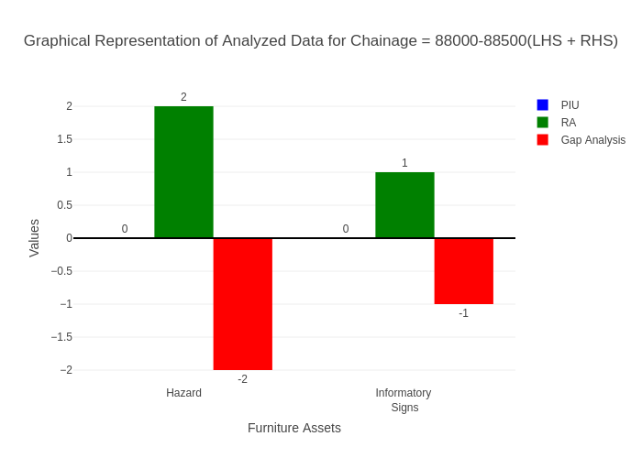

# Chainage: 88500-89000

## PIU Data:

|  |  |  |  |
| --- | --- | --- | --- |
| **Furniture Assets** | **88500-89000** | **89000-88500** | **LHS+RHS** |
| Chevron | 0.0 | 0.0 | 0.0 |
| Cautionary Warning Signs | 1.0 | 0.0 | 1.0 |
| Hazard | 0.0 | 0.0 | 0.0 |
| Prohibitory Mandatory Signs | 0.0 | 0.0 | 0.0 |
| Informatory Signs | 3.0 | 0.0 | 3.0 |

## RA Data:

|  |  |  |  |
| --- | --- | --- | --- |
| **Furniture Assets** | **88500-89000** | **89000-88500** | **LHS+RHS** |
| Chevron | 0.0 | 0.0 | 0.0 |
| Cautionary Warning Signs | 0.0 | 0.0 | 0.0 |
| Hazard | 0.0 | 0.0 | 0.0 |
| Prohibitory Mandatory Signs | 0.0 | 0.0 | 0.0 |
| Informatory Signs | 1.0 | 0.0 | 1.0 |

## Gap Analysis:

|  |  |  |  |
| --- | --- | --- | --- |
| **Furniture Assets** | **88500-89000** | **89000-88500** | **LHS+RHS** |
| Chevron | 0.0 | 0.0 | 0.0 |
| Cautionary Warning Signs | 1.0 | 0.0 | 1.0 |
| Hazard | 0.0 | 0.0 | 0.0 |
| Prohibitory Mandatory Signs | 0.0 | 0.0 | 0.0 |
| Informatory Signs | 2.0 | 0.0 | 2.0 |

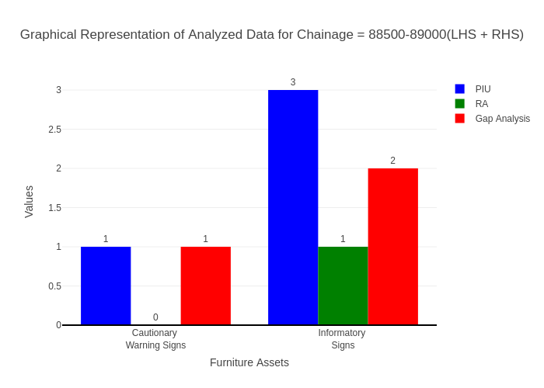

# Chainage: 89000-89500

## PIU Data:

|  |  |  |  |
| --- | --- | --- | --- |
| **Furniture Assets** | **89000-89500** | **89500-89000** | **LHS+RHS** |
| Chevron | 0.0 | 0.0 | 0.0 |
| Cautionary Warning Signs | 0.0 | 0.0 | 0.0 |
| Hazard | 0.0 | 0.0 | 0.0 |
| Prohibitory Mandatory Signs | 0.0 | 0.0 | 0.0 |
| Informatory Signs | 2.0 | 0.0 | 2.0 |

## RA Data:

|  |  |  |  |
| --- | --- | --- | --- |
| **Furniture Assets** | **89000-89500** | **89500-89000** | **LHS+RHS** |
| Chevron | 0.0 | 0.0 | 0.0 |
| Cautionary Warning Signs | 2.0 | 1.0 | 3.0 |
| Hazard | 0.0 | 0.0 | 0.0 |
| Prohibitory Mandatory Signs | 1.0 | 2.0 | 3.0 |
| Informatory Signs | 3.0 | 1.0 | 4.0 |

## Gap Analysis:

|  |  |  |  |
| --- | --- | --- | --- |
| **Furniture Assets** | **89000-89500** | **89500-89000** | **LHS+RHS** |
| Chevron | 0.0 | 0.0 | 0.0 |
| Cautionary Warning Signs | -2.0 | -1.0 | -3.0 |
| Hazard | 0.0 | 0.0 | 0.0 |
| Prohibitory Mandatory Signs | -1.0 | -2.0 | -3.0 |
| Informatory Signs | -1.0 | -1.0 | -2.0 |

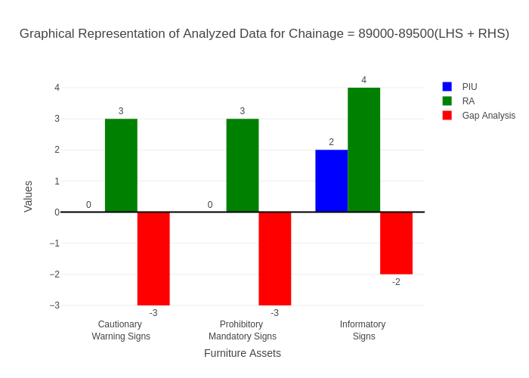

# Chainage: 89500-90000

## PIU Data:

|  |  |  |  |
| --- | --- | --- | --- |
| **Furniture Assets** | **89500-90000** | **90000-89500** | **LHS+RHS** |
| Chevron | 0.0 | 0.0 | 0.0 |
| Cautionary Warning Signs | 0.0 | 0.0 | 0.0 |
| Hazard | 0.0 | 0.0 | 0.0 |
| Prohibitory Mandatory Signs | 0.0 | 0.0 | 0.0 |
| Informatory Signs | 0.0 | 0.0 | 0.0 |

## RA Data:

|  |  |  |  |
| --- | --- | --- | --- |
| **Furniture Assets** | **89500-90000** | **90000-89500** | **LHS+RHS** |
| Chevron | 0.0 | 0.0 | 0.0 |
| Cautionary Warning Signs | 0.0 | 2.0 | 2.0 |
| Hazard | 0.0 | 0.0 | 0.0 |
| Prohibitory Mandatory Signs | 0.0 | 0.0 | 0.0 |
| Informatory Signs | 1.0 | 1.0 | 2.0 |

## Gap Analysis:

|  |  |  |  |
| --- | --- | --- | --- |
| **Furniture Assets** | **89500-90000** | **90000-89500** | **LHS+RHS** |
| Chevron | 0.0 | 0.0 | 0.0 |
| Cautionary Warning Signs | 0.0 | -2.0 | -2.0 |
| Hazard | 0.0 | 0.0 | 0.0 |
| Prohibitory Mandatory Signs | 0.0 | 0.0 | 0.0 |
| Informatory Signs | -1.0 | -1.0 | -2.0 |

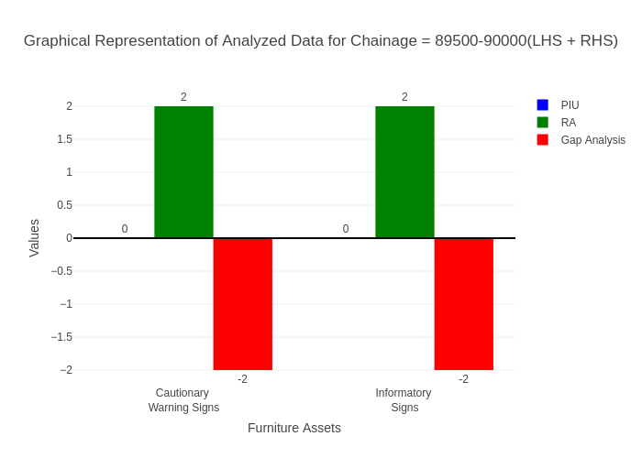

# Chainage: 90000-90500

## PIU Data:

|  |  |  |  |
| --- | --- | --- | --- |
| **Furniture Assets** | **90000-90500** | **90500-90000** | **LHS+RHS** |
| Chevron | 0.0 | 0.0 | 0.0 |
| Cautionary Warning Signs | 2.0 | 0.0 | 2.0 |
| Hazard | 0.0 | 0.0 | 0.0 |
| Prohibitory Mandatory Signs | 0.0 | 0.0 | 0.0 |
| Informatory Signs | 1.0 | 1.0 | 2.0 |

## RA Data:

|  |  |  |  |
| --- | --- | --- | --- |
| **Furniture Assets** | **90000-90500** | **90500-90000** | **LHS+RHS** |
| Chevron | 0.0 | 0.0 | 0.0 |
| Cautionary Warning Signs | 1.0 | 0.0 | 1.0 |
| Hazard | 0.0 | 0.0 | 0.0 |
| Prohibitory Mandatory Signs | 1.0 | 0.0 | 1.0 |
| Informatory Signs | 0.0 | 1.0 | 1.0 |

## Gap Analysis:

|  |  |  |  |
| --- | --- | --- | --- |
| **Furniture Assets** | **90000-90500** | **90500-90000** | **LHS+RHS** |
| Chevron | 0.0 | 0.0 | 0.0 |
| Cautionary Warning Signs | 1.0 | 0.0 | 1.0 |
| Hazard | 0.0 | 0.0 | 0.0 |
| Prohibitory Mandatory Signs | -1.0 | 0.0 | -1.0 |
| Informatory Signs | 1.0 | 0.0 | 1.0 |

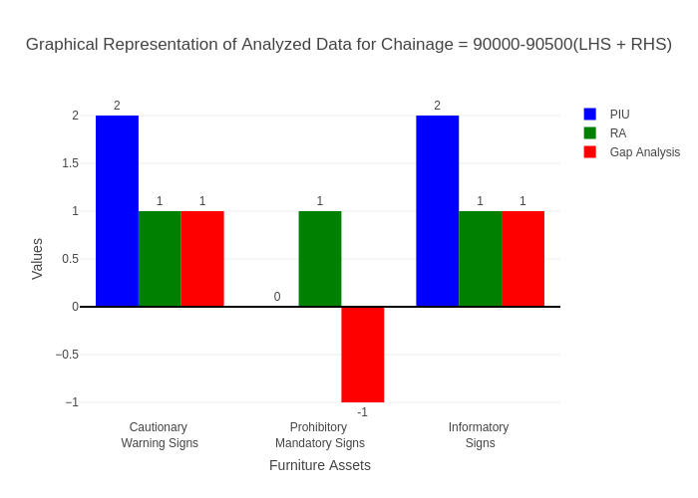

# Chainage: 90500-91000

## PIU Data:

|  |  |  |  |
| --- | --- | --- | --- |
| **Furniture Assets** | **90500-91000** | **91000-90500** | **LHS+RHS** |
| Chevron | 0.0 | 0.0 | 0.0 |
| Cautionary Warning Signs | 0.0 | 0.0 | 0.0 |
| Hazard | 0.0 | 0.0 | 0.0 |
| Prohibitory Mandatory Signs | 0.0 | 0.0 | 0.0 |
| Informatory Signs | 2.0 | 0.0 | 2.0 |

## RA Data:

|  |  |  |  |
| --- | --- | --- | --- |
| **Furniture Assets** | **90500-91000** | **91000-90500** | **LHS+RHS** |
| Chevron | 0.0 | 0.0 | 0.0 |
| Cautionary Warning Signs | 2.0 | 1.0 | 3.0 |
| Hazard | 0.0 | 0.0 | 0.0 |
| Prohibitory Mandatory Signs | 0.0 | 1.0 | 1.0 |
| Informatory Signs | 0.0 | 2.0 | 2.0 |

## Gap Analysis:

|  |  |  |  |
| --- | --- | --- | --- |
| **Furniture Assets** | **90500-91000** | **91000-90500** | **LHS+RHS** |
| Chevron | 0.0 | 0.0 | 0.0 |
| Cautionary Warning Signs | -2.0 | -1.0 | -3.0 |
| Hazard | 0.0 | 0.0 | 0.0 |
| Prohibitory Mandatory Signs | 0.0 | -1.0 | -1.0 |
| Informatory Signs | 2.0 | -2.0 | 0.0 |

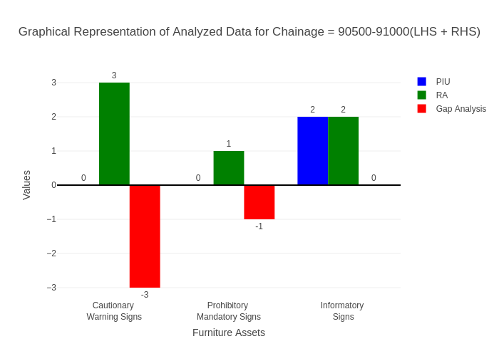

# Chainage: 91000-91500

## PIU Data:

|  |  |  |  |
| --- | --- | --- | --- |
| **Furniture Assets** | **91000-91500** | **91500-91000** | **LHS+RHS** |
| Chevron | 0.0 | 0.0 | 0.0 |
| Cautionary Warning Signs | 0.0 | 0.0 | 0.0 |
| Hazard | 0.0 | 0.0 | 0.0 |
| Prohibitory Mandatory Signs | 0.0 | 0.0 | 0.0 |
| Informatory Signs | 0.0 | 0.0 | 0.0 |

## RA Data:

|  |  |  |  |
| --- | --- | --- | --- |
| **Furniture Assets** | **91000-91500** | **91500-91000** | **LHS+RHS** |
| Chevron | 0.0 | 0.0 | 0.0 |
| Cautionary Warning Signs | 0.0 | 2.0 | 2.0 |
| Hazard | 0.0 | 1.0 | 1.0 |
| Prohibitory Mandatory Signs | 0.0 | 1.0 | 1.0 |
| Informatory Signs | 0.0 | 0.0 | 0.0 |

## Gap Analysis:

|  |  |  |  |
| --- | --- | --- | --- |
| **Furniture Assets** | **91000-91500** | **91500-91000** | **LHS+RHS** |
| Chevron | 0.0 | 0.0 | 0.0 |
| Cautionary Warning Signs | 0.0 | -2.0 | -2.0 |
| Hazard | 0.0 | -1.0 | -1.0 |
| Prohibitory Mandatory Signs | 0.0 | -1.0 | -1.0 |
| Informatory Signs | 0.0 | 0.0 | 0.0 |

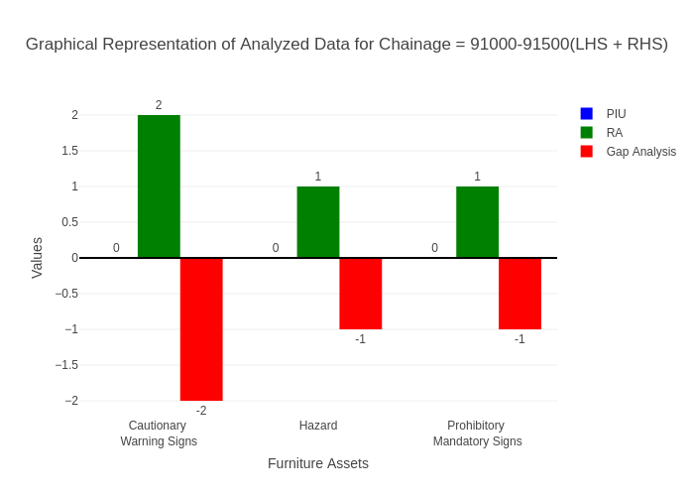

# Chainage: 91500-92000

## PIU Data:

|  |  |  |  |
| --- | --- | --- | --- |
| **Furniture Assets** | **91500-92000** | **92000-91500** | **LHS+RHS** |
| Chevron | 0.0 | 0.0 | 0.0 |
| Cautionary Warning Signs | 0.0 | 0.0 | 0.0 |
| Hazard | 0.0 | 0.0 | 0.0 |
| Prohibitory Mandatory Signs | 0.0 | 0.0 | 0.0 |
| Informatory Signs | 0.0 | 0.0 | 0.0 |

## RA Data:

|  |  |  |  |
| --- | --- | --- | --- |
| **Furniture Assets** | **91500-92000** | **92000-91500** | **LHS+RHS** |
| Chevron | 0.0 | 0.0 | 0.0 |
| Cautionary Warning Signs | 0.0 | 0.0 | 0.0 |
| Hazard | 0.0 | 0.0 | 0.0 |
| Prohibitory Mandatory Signs | 0.0 | 0.0 | 0.0 |
| Informatory Signs | 0.0 | 1.0 | 1.0 |

## Gap Analysis:

|  |  |  |  |
| --- | --- | --- | --- |
| **Furniture Assets** | **91500-92000** | **92000-91500** | **LHS+RHS** |
| Chevron | 0.0 | 0.0 | 0.0 |
| Cautionary Warning Signs | 0.0 | 0.0 | 0.0 |
| Hazard | 0.0 | 0.0 | 0.0 |
| Prohibitory Mandatory Signs | 0.0 | 0.0 | 0.0 |
| Informatory Signs | 0.0 | -1.0 | -1.0 |

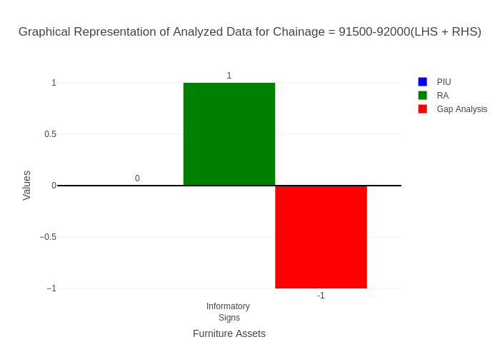

# Chainage: 92000-92500

## PIU Data:

|  |  |  |  |
| --- | --- | --- | --- |
| **Furniture Assets** | **92000-92500** | **92500-92000** | **LHS+RHS** |
| Chevron | 0.0 | 0.0 | 0.0 |
| Cautionary Warning Signs | 0.0 | 0.0 | 0.0 |
| Hazard | 0.0 | 0.0 | 0.0 |
| Prohibitory Mandatory Signs | 0.0 | 0.0 | 0.0 |
| Informatory Signs | 0.0 | 0.0 | 0.0 |

## RA Data:

|  |  |  |  |
| --- | --- | --- | --- |
| **Furniture Assets** | **92000-92500** | **92500-92000** | **LHS+RHS** |
| Chevron | 0.0 | 0.0 | 0.0 |
| Cautionary Warning Signs | 0.0 | 0.0 | 0.0 |
| Hazard | 0.0 | 0.0 | 0.0 |
| Prohibitory Mandatory Signs | 0.0 | 0.0 | 0.0 |
| Informatory Signs | 0.0 | 1.0 | 1.0 |

## Gap Analysis:

|  |  |  |  |
| --- | --- | --- | --- |
| **Furniture Assets** | **92000-92500** | **92500-92000** | **LHS+RHS** |
| Chevron | 0.0 | 0.0 | 0.0 |
| Cautionary Warning Signs | 0.0 | 0.0 | 0.0 |
| Hazard | 0.0 | 0.0 | 0.0 |
| Prohibitory Mandatory Signs | 0.0 | 0.0 | 0.0 |
| Informatory Signs | 0.0 | -1.0 | -1.0 |

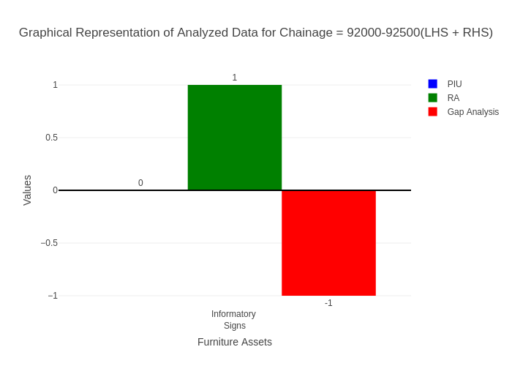

# Chainage: 92500-93000

## PIU Data:

|  |  |  |  |
| --- | --- | --- | --- |
| **Furniture Assets** | **92500-93000** | **93000-92500** | **LHS+RHS** |
| Chevron | 0.0 | 0.0 | 0.0 |
| Cautionary Warning Signs | 0.0 | 0.0 | 0.0 |
| Hazard | 0.0 | 0.0 | 0.0 |
| Prohibitory Mandatory Signs | 0.0 | 0.0 | 0.0 |
| Informatory Signs | 0.0 | 0.0 | 0.0 |

## RA Data:

|  |  |  |  |
| --- | --- | --- | --- |
| **Furniture Assets** | **92500-93000** | **93000-92500** | **LHS+RHS** |
| Chevron | 0.0 | 0.0 | 0.0 |
| Cautionary Warning Signs | 0.0 | 0.0 | 0.0 |
| Hazard | 0.0 | 0.0 | 0.0 |
| Prohibitory Mandatory Signs | 0.0 | 0.0 | 0.0 |
| Informatory Signs | 0.0 | 0.0 | 0.0 |

## Gap Analysis:

|  |  |  |  |
| --- | --- | --- | --- |
| **Furniture Assets** | **92500-93000** | **93000-92500** | **LHS+RHS** |
| Chevron | 0.0 | 0.0 | 0.0 |
| Cautionary Warning Signs | 0.0 | 0.0 | 0.0 |
| Hazard | 0.0 | 0.0 | 0.0 |
| Prohibitory Mandatory Signs | 0.0 | 0.0 | 0.0 |
| Informatory Signs | 0.0 | 0.0 | 0.0 |



# Chainage: 93000-93500

## PIU Data:

|  |  |  |  |
| --- | --- | --- | --- |
| **Furniture Assets** | **93000-93500** | **93500-93000** | **LHS+RHS** |
| Chevron | 0.0 | 0.0 | 0.0 |
| Cautionary Warning Signs | 0.0 | 0.0 | 0.0 |
| Hazard | 0.0 | 0.0 | 0.0 |
| Prohibitory Mandatory Signs | 0.0 | 0.0 | 0.0 |
| Informatory Signs | 0.0 | 0.0 | 0.0 |

## RA Data:

|  |  |  |  |
| --- | --- | --- | --- |
| **Furniture Assets** | **93000-93500** | **93500-93000** | **LHS+RHS** |
| Chevron | 0.0 | 0.0 | 0.0 |
| Cautionary Warning Signs | 0.0 | 0.0 | 0.0 |
| Hazard | 0.0 | 0.0 | 0.0 |
| Prohibitory Mandatory Signs | 0.0 | 0.0 | 0.0 |
| Informatory Signs | 0.0 | 0.0 | 0.0 |

## Gap Analysis:

|  |  |  |  |
| --- | --- | --- | --- |
| **Furniture Assets** | **93000-93500** | **93500-93000** | **LHS+RHS** |
| Chevron | 0.0 | 0.0 | 0.0 |
| Cautionary Warning Signs | 0.0 | 0.0 | 0.0 |
| Hazard | 0.0 | 0.0 | 0.0 |
| Prohibitory Mandatory Signs | 0.0 | 0.0 | 0.0 |
| Informatory Signs | 0.0 | 0.0 | 0.0 |



# Chainage: 93500-94000

## PIU Data:

|  |  |  |  |
| --- | --- | --- | --- |
| **Furniture Assets** | **93500-94000** | **94000-93500** | **LHS+RHS** |
| Chevron | 0.0 | 0.0 | 0.0 |
| Cautionary Warning Signs | 0.0 | 0.0 | 0.0 |
| Hazard | 0.0 | 0.0 | 0.0 |
| Prohibitory Mandatory Signs | 0.0 | 0.0 | 0.0 |
| Informatory Signs | 0.0 | 0.0 | 0.0 |

## RA Data:

|  |  |  |  |
| --- | --- | --- | --- |
| **Furniture Assets** | **93500-94000** | **94000-93500** | **LHS+RHS** |
| Chevron | 0.0 | 0.0 | 0.0 |
| Cautionary Warning Signs | 0.0 | 0.0 | 0.0 |
| Hazard | 0.0 | 0.0 | 0.0 |
| Prohibitory Mandatory Signs | 0.0 | 0.0 | 0.0 |
| Informatory Signs | 0.0 | 0.0 | 0.0 |

## Gap Analysis:

|  |  |  |  |
| --- | --- | --- | --- |
| **Furniture Assets** | **93500-94000** | **94000-93500** | **LHS+RHS** |
| Chevron | 0.0 | 0.0 | 0.0 |
| Cautionary Warning Signs | 0.0 | 0.0 | 0.0 |
| Hazard | 0.0 | 0.0 | 0.0 |
| Prohibitory Mandatory Signs | 0.0 | 0.0 | 0.0 |
| Informatory Signs | 0.0 | 0.0 | 0.0 |



# Chainage: 94000-94500

## PIU Data:

|  |  |  |  |
| --- | --- | --- | --- |
| **Furniture Assets** | **94000-94500** | **94500-94000** | **LHS+RHS** |
| Chevron | 0.0 | 0.0 | 0.0 |
| Cautionary Warning Signs | 0.0 | 0.0 | 0.0 |
| Hazard | 0.0 | 0.0 | 0.0 |
| Prohibitory Mandatory Signs | 0.0 | 0.0 | 0.0 |
| Informatory Signs | 0.0 | 0.0 | 0.0 |

## RA Data:

|  |  |  |  |
| --- | --- | --- | --- |
| **Furniture Assets** | **94000-94500** | **94500-94000** | **LHS+RHS** |
| Chevron | 0.0 | 0.0 | 0.0 |
| Cautionary Warning Signs | 0.0 | 0.0 | 0.0 |
| Hazard | 0.0 | 0.0 | 0.0 |
| Prohibitory Mandatory Signs | 0.0 | 0.0 | 0.0 |
| Informatory Signs | 0.0 | 0.0 | 0.0 |

## Gap Analysis:

|  |  |  |  |
| --- | --- | --- | --- |
| **Furniture Assets** | **94000-94500** | **94500-94000** | **LHS+RHS** |
| Chevron | 0.0 | 0.0 | 0.0 |
| Cautionary Warning Signs | 0.0 | 0.0 | 0.0 |
| Hazard | 0.0 | 0.0 | 0.0 |
| Prohibitory Mandatory Signs | 0.0 | 0.0 | 0.0 |
| Informatory Signs | 0.0 | 0.0 | 0.0 |



# Chainage: 94500-95000

## PIU Data:

|  |  |  |  |
| --- | --- | --- | --- |
| **Furniture Assets** | **94500-95000** | **95000-94500** | **LHS+RHS** |
| Chevron | 0.0 | 0.0 | 0.0 |
| Cautionary Warning Signs | 0.0 | 1.0 | 1.0 |
| Hazard | 5.0 | 0.0 | 5.0 |
| Prohibitory Mandatory Signs | 0.0 | 0.0 | 0.0 |
| Informatory Signs | 1.0 | 0.0 | 1.0 |

## RA Data:

|  |  |  |  |
| --- | --- | --- | --- |
| **Furniture Assets** | **94500-95000** | **95000-94500** | **LHS+RHS** |
| Chevron | 0.0 | 0.0 | 0.0 |
| Cautionary Warning Signs | 0.0 | 0.0 | 0.0 |
| Hazard | 0.0 | 0.0 | 0.0 |
| Prohibitory Mandatory Signs | 0.0 | 0.0 | 0.0 |
| Informatory Signs | 0.0 | 0.0 | 0.0 |

## Gap Analysis:

|  |  |  |  |
| --- | --- | --- | --- |
| **Furniture Assets** | **94500-95000** | **95000-94500** | **LHS+RHS** |
| Chevron | 0.0 | 0.0 | 0.0 |
| Cautionary Warning Signs | 0.0 | 1.0 | 1.0 |
| Hazard | 5.0 | 0.0 | 5.0 |
| Prohibitory Mandatory Signs | 0.0 | 0.0 | 0.0 |
| Informatory Signs | 1.0 | 0.0 | 1.0 |

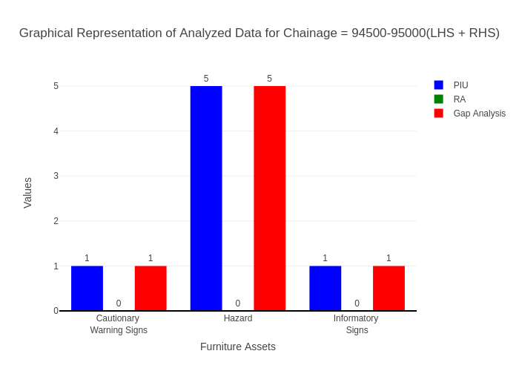

# Chainage: 95000-95500

## PIU Data:

|  |  |  |  |
| --- | --- | --- | --- |
| **Furniture Assets** | **95000-95500** | **95500-95000** | **LHS+RHS** |
| Chevron | 0.0 | 0.0 | 0.0 |
| Cautionary Warning Signs | 2.0 | 0.0 | 2.0 |
| Hazard | 1.0 | 0.0 | 1.0 |
| Prohibitory Mandatory Signs | 0.0 | 0.0 | 0.0 |
| Informatory Signs | 3.0 | 0.0 | 3.0 |

## RA Data:

|  |  |  |  |
| --- | --- | --- | --- |
| **Furniture Assets** | **95000-95500** | **95500-95000** | **LHS+RHS** |
| Chevron | 0.0 | 0.0 | 0.0 |
| Cautionary Warning Signs | 0.0 | 0.0 | 0.0 |
| Hazard | 1.0 | 0.0 | 1.0 |
| Prohibitory Mandatory Signs | 0.0 | 0.0 | 0.0 |
| Informatory Signs | 1.0 | 0.0 | 1.0 |

## Gap Analysis:

|  |  |  |  |
| --- | --- | --- | --- |
| **Furniture Assets** | **95000-95500** | **95500-95000** | **LHS+RHS** |
| Chevron | 0.0 | 0.0 | 0.0 |
| Cautionary Warning Signs | 2.0 | 0.0 | 2.0 |
| Hazard | 0.0 | 0.0 | 0.0 |
| Prohibitory Mandatory Signs | 0.0 | 0.0 | 0.0 |
| Informatory Signs | 2.0 | 0.0 | 2.0 |

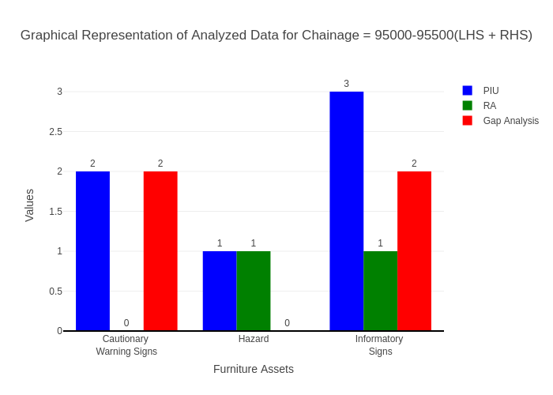

# Chainage: 95500-96000

## PIU Data:

|  |  |  |  |
| --- | --- | --- | --- |
| **Furniture Assets** | **95500-96000** | **96000-95500** | **LHS+RHS** |
| Chevron | 0.0 | 0.0 | 0.0 |
| Cautionary Warning Signs | 1.0 | 0.0 | 1.0 |
| Hazard | 1.0 | 0.0 | 1.0 |
| Prohibitory Mandatory Signs | 0.0 | 0.0 | 0.0 |
| Informatory Signs | 1.0 | 0.0 | 1.0 |

## RA Data:

|  |  |  |  |
| --- | --- | --- | --- |
| **Furniture Assets** | **95500-96000** | **96000-95500** | **LHS+RHS** |
| Chevron | 0.0 | 0.0 | 0.0 |
| Cautionary Warning Signs | 1.0 | 0.0 | 1.0 |
| Hazard | 0.0 | 0.0 | 0.0 |
| Prohibitory Mandatory Signs | 1.0 | 0.0 | 1.0 |
| Informatory Signs | 2.0 | 1.0 | 3.0 |

## Gap Analysis:

|  |  |  |  |
| --- | --- | --- | --- |
| **Furniture Assets** | **95500-96000** | **96000-95500** | **LHS+RHS** |
| Chevron | 0.0 | 0.0 | 0.0 |
| Cautionary Warning Signs | 0.0 | 0.0 | 0.0 |
| Hazard | 1.0 | 0.0 | 1.0 |
| Prohibitory Mandatory Signs | -1.0 | 0.0 | -1.0 |
| Informatory Signs | -1.0 | -1.0 | -2.0 |

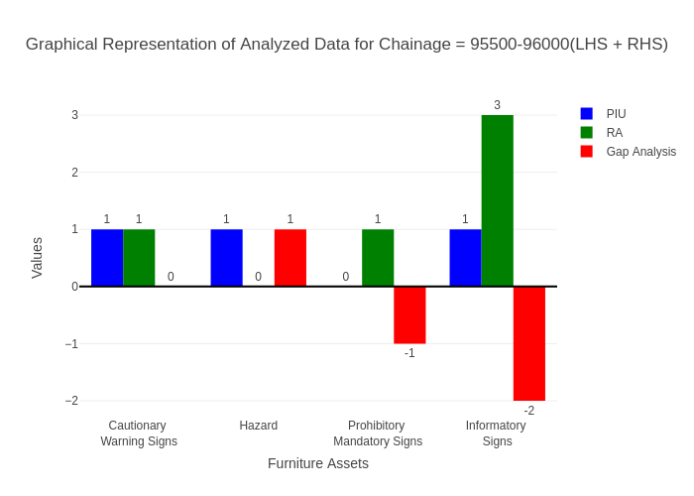

# Chainage: 96000-96500

## PIU Data:

|  |  |  |  |
| --- | --- | --- | --- |
| **Furniture Assets** | **96000-96500** | **96500-96000** | **LHS+RHS** |
| Chevron | 0.0 | 0.0 | 0.0 |
| Cautionary Warning Signs | 1.0 | 0.0 | 1.0 |
| Hazard | 2.0 | 0.0 | 2.0 |
| Prohibitory Mandatory Signs | 0.0 | 0.0 | 0.0 |
| Informatory Signs | 3.0 | 1.0 | 4.0 |

## RA Data:

|  |  |  |  |
| --- | --- | --- | --- |
| **Furniture Assets** | **96000-96500** | **96500-96000** | **LHS+RHS** |
| Chevron | 0.0 | 0.0 | 0.0 |
| Cautionary Warning Signs | 1.0 | 1.0 | 2.0 |
| Hazard | 2.0 | 1.0 | 3.0 |
| Prohibitory Mandatory Signs | 1.0 | 1.0 | 2.0 |
| Informatory Signs | 2.0 | 1.0 | 3.0 |

## Gap Analysis:

|  |  |  |  |
| --- | --- | --- | --- |
| **Furniture Assets** | **96000-96500** | **96500-96000** | **LHS+RHS** |
| Chevron | 0.0 | 0.0 | 0.0 |
| Cautionary Warning Signs | 0.0 | -1.0 | -1.0 |
| Hazard | 0.0 | -1.0 | -1.0 |
| Prohibitory Mandatory Signs | -1.0 | -1.0 | -2.0 |
| Informatory Signs | 1.0 | 0.0 | 1.0 |

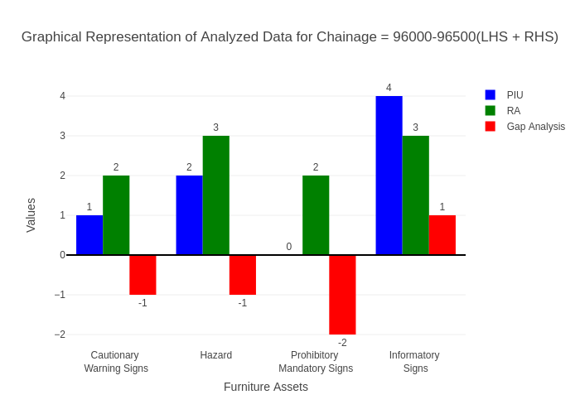

# Chainage: 96500-97000

## PIU Data:

|  |  |  |  |
| --- | --- | --- | --- |
| **Furniture Assets** | **96500-97000** | **97000-96500** | **LHS+RHS** |
| Chevron | 3.0 | 1.0 | 4.0 |
| Cautionary Warning Signs | 0.0 | 0.0 | 0.0 |
| Hazard | 5.0 | 1.0 | 6.0 |
| Prohibitory Mandatory Signs | 0.0 | 0.0 | 0.0 |
| Informatory Signs | 0.0 | 0.0 | 0.0 |

## RA Data:

|  |  |  |  |
| --- | --- | --- | --- |
| **Furniture Assets** | **96500-97000** | **97000-96500** | **LHS+RHS** |
| Chevron | 2.0 | 0.0 | 2.0 |
| Cautionary Warning Signs | 0.0 | 0.0 | 0.0 |
| Hazard | 0.0 | 0.0 | 0.0 |
| Prohibitory Mandatory Signs | 0.0 | 0.0 | 0.0 |
| Informatory Signs | 0.0 | 0.0 | 0.0 |

## Gap Analysis:

|  |  |  |  |
| --- | --- | --- | --- |
| **Furniture Assets** | **96500-97000** | **97000-96500** | **LHS+RHS** |
| Chevron | 1.0 | 1.0 | 2.0 |
| Cautionary Warning Signs | 0.0 | 0.0 | 0.0 |
| Hazard | 5.0 | 1.0 | 6.0 |
| Prohibitory Mandatory Signs | 0.0 | 0.0 | 0.0 |
| Informatory Signs | 0.0 | 0.0 | 0.0 |

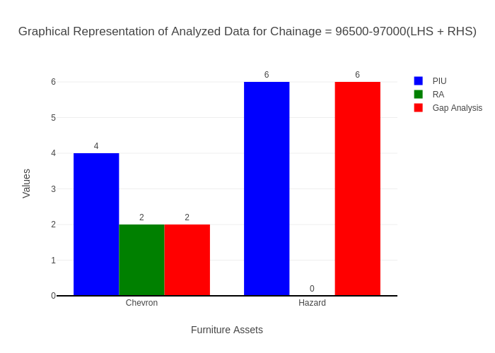

# Chainage: 97000-97500

## PIU Data:

|  |  |  |  |
| --- | --- | --- | --- |
| **Furniture Assets** | **97000-97500** | **97500-97000** | **LHS+RHS** |
| Chevron | 0.0 | 0.0 | 0.0 |
| Cautionary Warning Signs | 0.0 | 0.0 | 0.0 |
| Hazard | 1.0 | 0.0 | 1.0 |
| Prohibitory Mandatory Signs | 0.0 | 0.0 | 0.0 |
| Informatory Signs | 1.0 | 0.0 | 1.0 |

## RA Data:

|  |  |  |  |
| --- | --- | --- | --- |
| **Furniture Assets** | **97000-97500** | **97500-97000** | **LHS+RHS** |
| Chevron | 1.0 | 4.0 | 5.0 |
| Cautionary Warning Signs | 0.0 | 0.0 | 0.0 |
| Hazard | 1.0 | 1.0 | 2.0 |
| Prohibitory Mandatory Signs | 0.0 | 0.0 | 0.0 |
| Informatory Signs | 0.0 | 0.0 | 0.0 |

## Gap Analysis:

|  |  |  |  |
| --- | --- | --- | --- |
| **Furniture Assets** | **97000-97500** | **97500-97000** | **LHS+RHS** |
| Chevron | -1.0 | -4.0 | -5.0 |
| Cautionary Warning Signs | 0.0 | 0.0 | 0.0 |
| Hazard | 0.0 | -1.0 | -1.0 |
| Prohibitory Mandatory Signs | 0.0 | 0.0 | 0.0 |
| Informatory Signs | 1.0 | 0.0 | 1.0 |

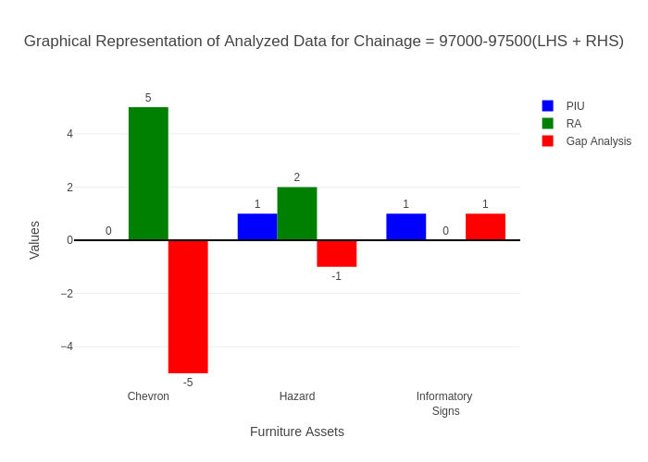

# Chainage: 97500-98000

## PIU Data:

|  |  |  |  |
| --- | --- | --- | --- |
| **Furniture Assets** | **97500-98000** | **98000-97500** | **LHS+RHS** |
| Chevron | 1.0 | 0.0 | 1.0 |
| Cautionary Warning Signs | 3.0 | 0.0 | 3.0 |
| Hazard | 1.0 | 0.0 | 1.0 |
| Prohibitory Mandatory Signs | 0.0 | 0.0 | 0.0 |
| Informatory Signs | 0.0 | 0.0 | 0.0 |

## RA Data:

|  |  |  |  |
| --- | --- | --- | --- |
| **Furniture Assets** | **97500-98000** | **98000-97500** | **LHS+RHS** |
| Chevron | 0.0 | 0.0 | 0.0 |
| Cautionary Warning Signs | 1.0 | 1.0 | 2.0 |
| Hazard | 0.0 | 0.0 | 0.0 |
| Prohibitory Mandatory Signs | 0.0 | 0.0 | 0.0 |
| Informatory Signs | 0.0 | 0.0 | 0.0 |

## Gap Analysis:

|  |  |  |  |
| --- | --- | --- | --- |
| **Furniture Assets** | **97500-98000** | **98000-97500** | **LHS+RHS** |
| Chevron | 1.0 | 0.0 | 1.0 |
| Cautionary Warning Signs | 2.0 | -1.0 | 1.0 |
| Hazard | 1.0 | 0.0 | 1.0 |
| Prohibitory Mandatory Signs | 0.0 | 0.0 | 0.0 |
| Informatory Signs | 0.0 | 0.0 | 0.0 |

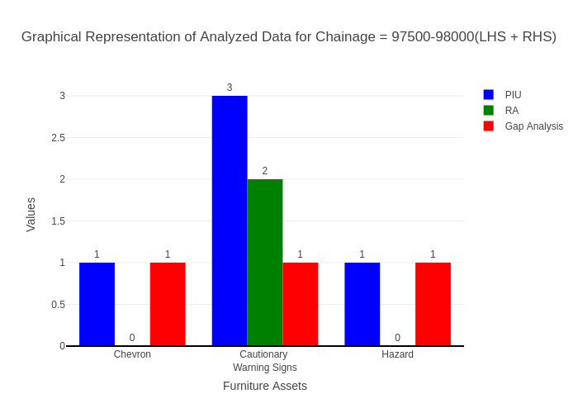

# Chainage: 98000-98500

## PIU Data:

|  |  |  |  |
| --- | --- | --- | --- |
| **Furniture Assets** | **98000-98500** | **98500-98000** | **LHS+RHS** |
| Chevron | 0.0 | 0.0 | 0.0 |
| Cautionary Warning Signs | 1.0 | 0.0 | 1.0 |
| Hazard | 0.0 | 0.0 | 0.0 |
| Prohibitory Mandatory Signs | 0.0 | 0.0 | 0.0 |
| Informatory Signs | 1.0 | 0.0 | 1.0 |

## RA Data:

|  |  |  |  |
| --- | --- | --- | --- |
| **Furniture Assets** | **98000-98500** | **98500-98000** | **LHS+RHS** |
| Chevron | 0.0 | 0.0 | 0.0 |
| Cautionary Warning Signs | 1.0 | 0.0 | 1.0 |
| Hazard | 0.0 | 0.0 | 0.0 |
| Prohibitory Mandatory Signs | 1.0 | 1.0 | 2.0 |
| Informatory Signs | 3.0 | 1.0 | 4.0 |

## Gap Analysis:

|  |  |  |  |
| --- | --- | --- | --- |
| **Furniture Assets** | **98000-98500** | **98500-98000** | **LHS+RHS** |
| Chevron | 0.0 | 0.0 | 0.0 |
| Cautionary Warning Signs | 0.0 | 0.0 | 0.0 |
| Hazard | 0.0 | 0.0 | 0.0 |
| Prohibitory Mandatory Signs | -1.0 | -1.0 | -2.0 |
| Informatory Signs | -2.0 | -1.0 | -3.0 |

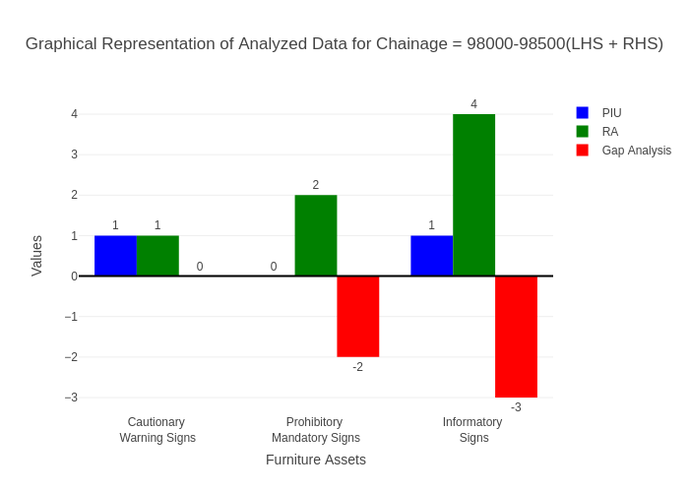

# Chainage: 98500-99000

## PIU Data:

|  |  |  |  |
| --- | --- | --- | --- |
| **Furniture Assets** | **98500-99000** | **99000-98500** | **LHS+RHS** |
| Chevron | 0.0 | 0.0 | 0.0 |
| Cautionary Warning Signs | 2.0 | 0.0 | 2.0 |
| Hazard | 0.0 | 0.0 | 0.0 |
| Prohibitory Mandatory Signs | 0.0 | 0.0 | 0.0 |
| Informatory Signs | 3.0 | 1.0 | 4.0 |

## RA Data:

|  |  |  |  |
| --- | --- | --- | --- |
| **Furniture Assets** | **98500-99000** | **99000-98500** | **LHS+RHS** |
| Chevron | 0.0 | 0.0 | 0.0 |
| Cautionary Warning Signs | 2.0 | 1.0 | 3.0 |
| Hazard | 0.0 | 0.0 | 0.0 |
| Prohibitory Mandatory Signs | 1.0 | 0.0 | 1.0 |
| Informatory Signs | 0.0 | 0.0 | 0.0 |

## Gap Analysis:

|  |  |  |  |
| --- | --- | --- | --- |
| **Furniture Assets** | **98500-99000** | **99000-98500** | **LHS+RHS** |
| Chevron | 0.0 | 0.0 | 0.0 |
| Cautionary Warning Signs | 0.0 | -1.0 | -1.0 |
| Hazard | 0.0 | 0.0 | 0.0 |
| Prohibitory Mandatory Signs | -1.0 | 0.0 | -1.0 |
| Informatory Signs | 3.0 | 1.0 | 4.0 |

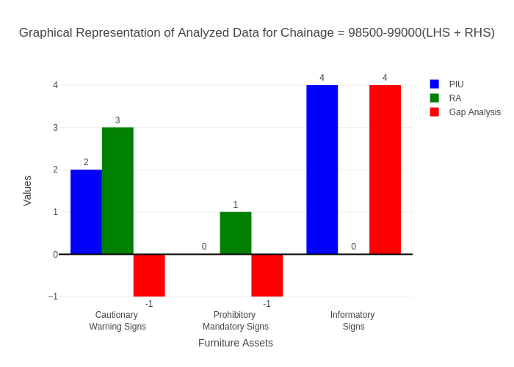

# Chainage: 99000-99500

## PIU Data:

|  |  |  |  |
| --- | --- | --- | --- |
| **Furniture Assets** | **99000-99500** | **99500-99000** | **LHS+RHS** |
| Chevron | 0.0 | 0.0 | 0.0 |
| Cautionary Warning Signs | 0.0 | 0.0 | 0.0 |
| Hazard | 1.0 | 0.0 | 1.0 |
| Prohibitory Mandatory Signs | 0.0 | 0.0 | 0.0 |
| Informatory Signs | 1.0 | 0.0 | 1.0 |

## RA Data:

|  |  |  |  |
| --- | --- | --- | --- |
| **Furniture Assets** | **99000-99500** | **99500-99000** | **LHS+RHS** |
| Chevron | 0.0 | 0.0 | 0.0 |
| Cautionary Warning Signs | 1.0 | 0.0 | 1.0 |
| Hazard | 0.0 | 0.0 | 0.0 |
| Prohibitory Mandatory Signs | 0.0 | 3.0 | 3.0 |
| Informatory Signs | 1.0 | 3.0 | 4.0 |

## Gap Analysis:

|  |  |  |  |
| --- | --- | --- | --- |
| **Furniture Assets** | **99000-99500** | **99500-99000** | **LHS+RHS** |
| Chevron | 0.0 | 0.0 | 0.0 |
| Cautionary Warning Signs | -1.0 | 0.0 | -1.0 |
| Hazard | 1.0 | 0.0 | 1.0 |
| Prohibitory Mandatory Signs | 0.0 | -3.0 | -3.0 |
| Informatory Signs | 0.0 | -3.0 | -3.0 |

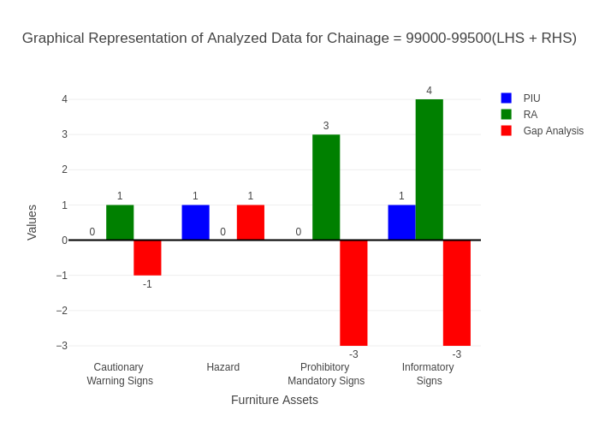

# Chainage: 100000-99500

## PIU Data:

|  |  |  |  |
| --- | --- | --- | --- |
| **Furniture Assets** | **100000-99500** | **99500-100000** | **LHS+RHS** |
| Chevron | 0.0 | 0.0 | 0.0 |
| Cautionary Warning Signs | 1.0 | 1.0 | 2.0 |
| Hazard | 0.0 | 0.0 | 0.0 |
| Prohibitory Mandatory Signs | 0.0 | 0.0 | 0.0 |
| Informatory Signs | 0.0 | 1.0 | 1.0 |

## RA Data:

|  |  |  |  |
| --- | --- | --- | --- |
| **Furniture Assets** | **100000-99500** | **99500-100000** | **LHS+RHS** |
| Chevron | 0.0 | 0.0 | 0.0 |
| Cautionary Warning Signs | 0.0 | 0.0 | 0.0 |
| Hazard | 0.0 | 0.0 | 0.0 |
| Prohibitory Mandatory Signs | 0.0 | 0.0 | 0.0 |
| Informatory Signs | 5.0 | 1.0 | 6.0 |

## Gap Analysis:

|  |  |  |  |
| --- | --- | --- | --- |
| **Furniture Assets** | **100000-99500** | **99500-100000** | **LHS+RHS** |
| Chevron | 0.0 | 0.0 | 0.0 |
| Cautionary Warning Signs | 1.0 | 1.0 | 2.0 |
| Hazard | 0.0 | 0.0 | 0.0 |
| Prohibitory Mandatory Signs | 0.0 | 0.0 | 0.0 |
| Informatory Signs | -5.0 | 0.0 | -5.0 |

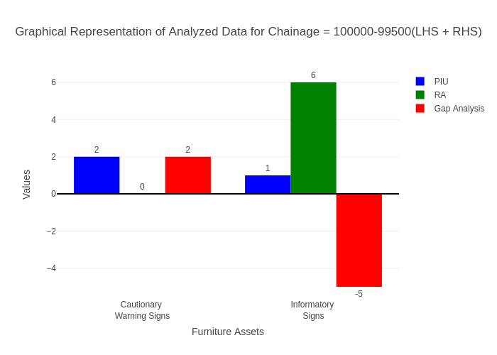

# Chainage: 100000-100500

## PIU Data:

|  |  |  |  |
| --- | --- | --- | --- |
| **Furniture Assets** | **100000-100500** | **100500-100000** | **LHS+RHS** |
| Chevron | 0.0 | 0.0 | 0.0 |
| Cautionary Warning Signs | 2.0 | 0.0 | 2.0 |
| Hazard | 0.0 | 0.0 | 0.0 |
| Prohibitory Mandatory Signs | 0.0 | 0.0 | 0.0 |
| Informatory Signs | 2.0 | 1.0 | 3.0 |

## RA Data:

|  |  |  |  |
| --- | --- | --- | --- |
| **Furniture Assets** | **100000-100500** | **100500-100000** | **LHS+RHS** |
| Chevron | 0.0 | 0.0 | 0.0 |
| Cautionary Warning Signs | 4.0 | 0.0 | 4.0 |
| Hazard | 0.0 | 1.0 | 1.0 |
| Prohibitory Mandatory Signs | 1.0 | 1.0 | 2.0 |
| Informatory Signs | 3.0 | 0.0 | 3.0 |

## Gap Analysis:

|  |  |  |  |
| --- | --- | --- | --- |
| **Furniture Assets** | **100000-100500** | **100500-100000** | **LHS+RHS** |
| Chevron | 0.0 | 0.0 | 0.0 |
| Cautionary Warning Signs | -2.0 | 0.0 | -2.0 |
| Hazard | 0.0 | -1.0 | -1.0 |
| Prohibitory Mandatory Signs | -1.0 | -1.0 | -2.0 |
| Informatory Signs | -1.0 | 1.0 | 0.0 |

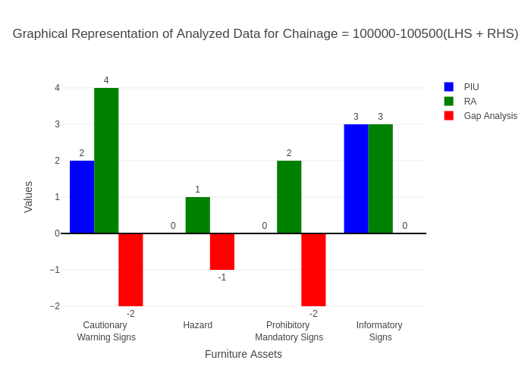

# Chainage: 100500-101000

## PIU Data:

|  |  |  |  |
| --- | --- | --- | --- |
| **Furniture Assets** | **100500-101000** | **101000-100500** | **LHS+RHS** |
| Chevron | 0.0 | 0.0 | 0.0 |
| Cautionary Warning Signs | 0.0 | 0.0 | 0.0 |
| Hazard | 0.0 | 0.0 | 0.0 |
| Prohibitory Mandatory Signs | 0.0 | 0.0 | 0.0 |
| Informatory Signs | 0.0 | 0.0 | 0.0 |

## RA Data:

|  |  |  |  |
| --- | --- | --- | --- |
| **Furniture Assets** | **100500-101000** | **101000-100500** | **LHS+RHS** |
| Chevron | 0.0 | 0.0 | 0.0 |
| Cautionary Warning Signs | 1.0 | 1.0 | 2.0 |
| Hazard | 0.0 | 0.0 | 0.0 |
| Prohibitory Mandatory Signs | 3.0 | 0.0 | 3.0 |
| Informatory Signs | 1.0 | 1.0 | 2.0 |

## Gap Analysis:

|  |  |  |  |
| --- | --- | --- | --- |
| **Furniture Assets** | **100500-101000** | **101000-100500** | **LHS+RHS** |
| Chevron | 0.0 | 0.0 | 0.0 |
| Cautionary Warning Signs | -1.0 | -1.0 | -2.0 |
| Hazard | 0.0 | 0.0 | 0.0 |
| Prohibitory Mandatory Signs | -3.0 | 0.0 | -3.0 |
| Informatory Signs | -1.0 | -1.0 | -2.0 |

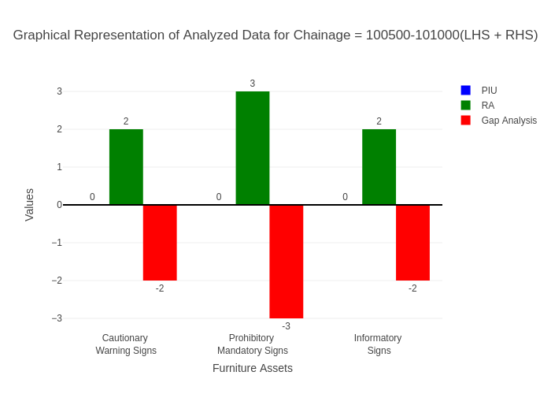

# Chainage: 101000-101500

## PIU Data:

|  |  |  |  |
| --- | --- | --- | --- |
| **Furniture Assets** | **101000-101500** | **101500-101000** | **LHS+RHS** |
| Chevron | 0.0 | 0.0 | 0.0 |
| Cautionary Warning Signs | 0.0 | 0.0 | 0.0 |
| Hazard | 0.0 | 0.0 | 0.0 |
| Prohibitory Mandatory Signs | 0.0 | 0.0 | 0.0 |
| Informatory Signs | 0.0 | 0.0 | 0.0 |

## RA Data:

|  |  |  |  |
| --- | --- | --- | --- |
| **Furniture Assets** | **101000-101500** | **101500-101000** | **LHS+RHS** |
| Chevron | 0.0 | 0.0 | 0.0 |
| Cautionary Warning Signs | 0.0 | 0.0 | 0.0 |
| Hazard | 0.0 | 0.0 | 0.0 |
| Prohibitory Mandatory Signs | 0.0 | 0.0 | 0.0 |
| Informatory Signs | 0.0 | 0.0 | 0.0 |

## Gap Analysis:

|  |  |  |  |
| --- | --- | --- | --- |
| **Furniture Assets** | **101000-101500** | **101500-101000** | **LHS+RHS** |
| Chevron | 0.0 | 0.0 | 0.0 |
| Cautionary Warning Signs | 0.0 | 0.0 | 0.0 |
| Hazard | 0.0 | 0.0 | 0.0 |
| Prohibitory Mandatory Signs | 0.0 | 0.0 | 0.0 |
| Informatory Signs | 0.0 | 0.0 | 0.0 |



# Chainage: 101500-102000

## PIU Data:

|  |  |  |  |
| --- | --- | --- | --- |
| **Furniture Assets** | **101500-102000** | **102000-101500** | **LHS+RHS** |
| Chevron | 0.0 | 0.0 | 0.0 |
| Cautionary Warning Signs | 0.0 | 0.0 | 0.0 |
| Hazard | 0.0 | 0.0 | 0.0 |
| Prohibitory Mandatory Signs | 0.0 | 0.0 | 0.0 |
| Informatory Signs | 0.0 | 0.0 | 0.0 |

## RA Data:

|  |  |  |  |
| --- | --- | --- | --- |
| **Furniture Assets** | **101500-102000** | **102000-101500** | **LHS+RHS** |
| Chevron | 0.0 | 0.0 | 0.0 |
| Cautionary Warning Signs | 1.0 | 0.0 | 1.0 |
| Hazard | 0.0 | 0.0 | 0.0 |
| Prohibitory Mandatory Signs | 3.0 | 0.0 | 3.0 |
| Informatory Signs | 1.0 | 1.0 | 2.0 |

## Gap Analysis:

|  |  |  |  |
| --- | --- | --- | --- |
| **Furniture Assets** | **101500-102000** | **102000-101500** | **LHS+RHS** |
| Chevron | 0.0 | 0.0 | 0.0 |
| Cautionary Warning Signs | -1.0 | 0.0 | -1.0 |
| Hazard | 0.0 | 0.0 | 0.0 |
| Prohibitory Mandatory Signs | -3.0 | 0.0 | -3.0 |
| Informatory Signs | -1.0 | -1.0 | -2.0 |

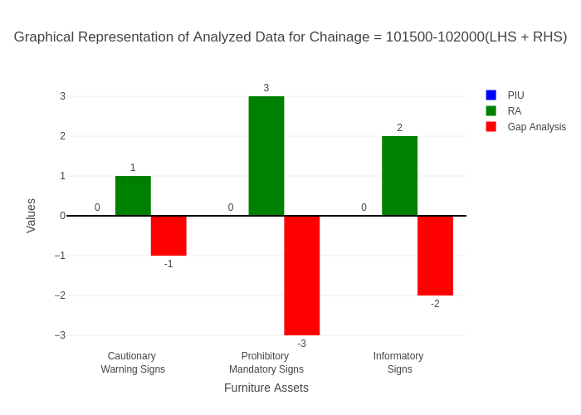

# Chainage: 102000-102500

## PIU Data:

|  |  |  |  |
| --- | --- | --- | --- |
| **Furniture Assets** | **102000-102500** | **102500-102000** | **LHS+RHS** |
| Chevron | 0.0 | 0.0 | 0.0 |
| Cautionary Warning Signs | 1.0 | 0.0 | 1.0 |
| Hazard | 0.0 | 0.0 | 0.0 |
| Prohibitory Mandatory Signs | 0.0 | 0.0 | 0.0 |
| Informatory Signs | 0.0 | 0.0 | 0.0 |

## RA Data:

|  |  |  |  |
| --- | --- | --- | --- |
| **Furniture Assets** | **102000-102500** | **102500-102000** | **LHS+RHS** |
| Chevron | 0.0 | 0.0 | 0.0 |
| Cautionary Warning Signs | 1.0 | 0.0 | 1.0 |
| Hazard | 0.0 | 0.0 | 0.0 |
| Prohibitory Mandatory Signs | 0.0 | 1.0 | 1.0 |
| Informatory Signs | 0.0 | 0.0 | 0.0 |

## Gap Analysis:

|  |  |  |  |
| --- | --- | --- | --- |
| **Furniture Assets** | **102000-102500** | **102500-102000** | **LHS+RHS** |
| Chevron | 0.0 | 0.0 | 0.0 |
| Cautionary Warning Signs | 0.0 | 0.0 | 0.0 |
| Hazard | 0.0 | 0.0 | 0.0 |
| Prohibitory Mandatory Signs | 0.0 | -1.0 | -1.0 |
| Informatory Signs | 0.0 | 0.0 | 0.0 |

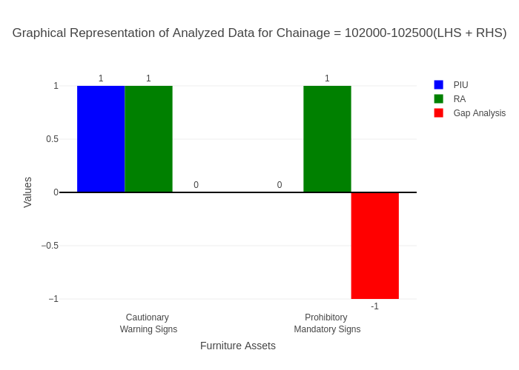

# Chainage: 102500-103000

## PIU Data:

|  |  |  |  |
| --- | --- | --- | --- |
| **Furniture Assets** | **102500-103000** | **103000-102500** | **LHS+RHS** |
| Chevron | 0.0 | 0.0 | 0.0 |
| Cautionary Warning Signs | 1.0 | 1.0 | 2.0 |
| Hazard | 1.0 | 1.0 | 2.0 |
| Prohibitory Mandatory Signs | 0.0 | 0.0 | 0.0 |
| Informatory Signs | 0.0 | 1.0 | 1.0 |

## RA Data:

|  |  |  |  |
| --- | --- | --- | --- |
| **Furniture Assets** | **102500-103000** | **103000-102500** | **LHS+RHS** |
| Chevron | 0.0 | 0.0 | 0.0 |
| Cautionary Warning Signs | 1.0 | 0.0 | 1.0 |
| Hazard | 0.0 | 0.0 | 0.0 |
| Prohibitory Mandatory Signs | 0.0 | 0.0 | 0.0 |
| Informatory Signs | 0.0 | 0.0 | 0.0 |

## Gap Analysis:

|  |  |  |  |
| --- | --- | --- | --- |
| **Furniture Assets** | **102500-103000** | **103000-102500** | **LHS+RHS** |
| Chevron | 0.0 | 0.0 | 0.0 |
| Cautionary Warning Signs | 0.0 | 1.0 | 1.0 |
| Hazard | 1.0 | 1.0 | 2.0 |
| Prohibitory Mandatory Signs | 0.0 | 0.0 | 0.0 |
| Informatory Signs | 0.0 | 1.0 | 1.0 |

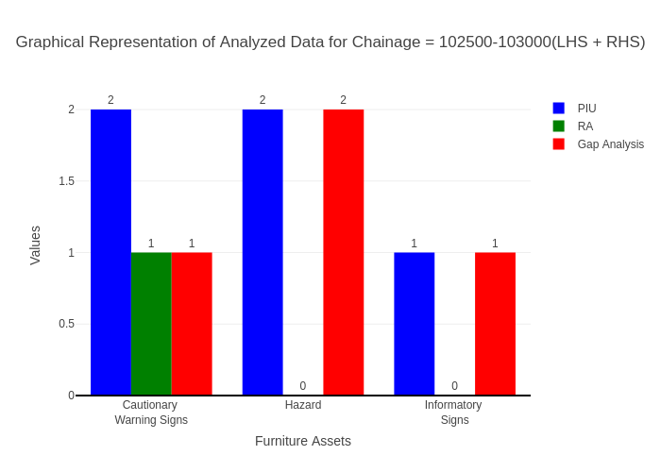

# Chainage: 103000-103500

## PIU Data:

|  |  |  |  |
| --- | --- | --- | --- |
| **Furniture Assets** | **103000-103500** | **103500-103000** | **LHS+RHS** |
| Chevron | 0.0 | 0.0 | 0.0 |
| Cautionary Warning Signs | 1.0 | 0.0 | 1.0 |
| Hazard | 2.0 | 0.0 | 2.0 |
| Prohibitory Mandatory Signs | 0.0 | 0.0 | 0.0 |
| Informatory Signs | 0.0 | 0.0 | 0.0 |

## RA Data:

|  |  |  |  |
| --- | --- | --- | --- |
| **Furniture Assets** | **103000-103500** | **103500-103000** | **LHS+RHS** |
| Chevron | 0.0 | 0.0 | 0.0 |
| Cautionary Warning Signs | 1.0 | 0.0 | 1.0 |
| Hazard | 2.0 | 0.0 | 2.0 |
| Prohibitory Mandatory Signs | 0.0 | 0.0 | 0.0 |
| Informatory Signs | 1.0 | 0.0 | 1.0 |

## Gap Analysis:

|  |  |  |  |
| --- | --- | --- | --- |
| **Furniture Assets** | **103000-103500** | **103500-103000** | **LHS+RHS** |
| Chevron | 0.0 | 0.0 | 0.0 |
| Cautionary Warning Signs | 0.0 | 0.0 | 0.0 |
| Hazard | 0.0 | 0.0 | 0.0 |
| Prohibitory Mandatory Signs | 0.0 | 0.0 | 0.0 |
| Informatory Signs | -1.0 | 0.0 | -1.0 |

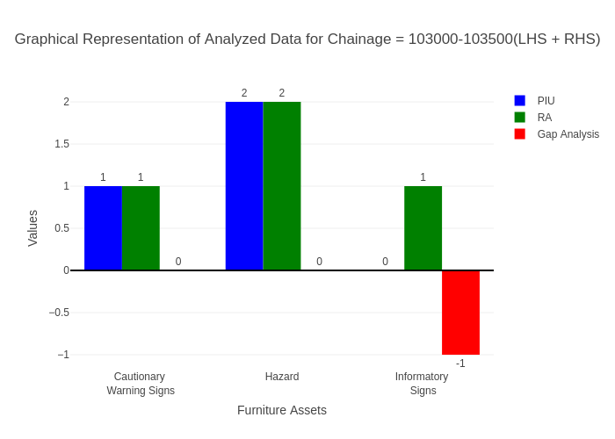

# Chainage: 103500-104000

## PIU Data:

|  |  |  |  |
| --- | --- | --- | --- |
| **Furniture Assets** | **103500-104000** | **104000-103500** | **LHS+RHS** |
| Chevron | 0.0 | 0.0 | 0.0 |
| Cautionary Warning Signs | 0.0 | 0.0 | 0.0 |
| Hazard | 0.0 | 0.0 | 0.0 |
| Prohibitory Mandatory Signs | 0.0 | 0.0 | 0.0 |
| Informatory Signs | 0.0 | 0.0 | 0.0 |

## RA Data:

|  |  |  |  |
| --- | --- | --- | --- |
| **Furniture Assets** | **103500-104000** | **104000-103500** | **LHS+RHS** |
| Chevron | 0.0 | 0.0 | 0.0 |
| Cautionary Warning Signs | 4.0 | 2.0 | 6.0 |
| Hazard | 2.0 | 1.0 | 3.0 |
| Prohibitory Mandatory Signs | 2.0 | 0.0 | 2.0 |
| Informatory Signs | 1.0 | 0.0 | 1.0 |

## Gap Analysis:

|  |  |  |  |
| --- | --- | --- | --- |
| **Furniture Assets** | **103500-104000** | **104000-103500** | **LHS+RHS** |
| Chevron | 0.0 | 0.0 | 0.0 |
| Cautionary Warning Signs | -4.0 | -2.0 | -6.0 |
| Hazard | -2.0 | -1.0 | -3.0 |
| Prohibitory Mandatory Signs | -2.0 | 0.0 | -2.0 |
| Informatory Signs | -1.0 | 0.0 | -1.0 |

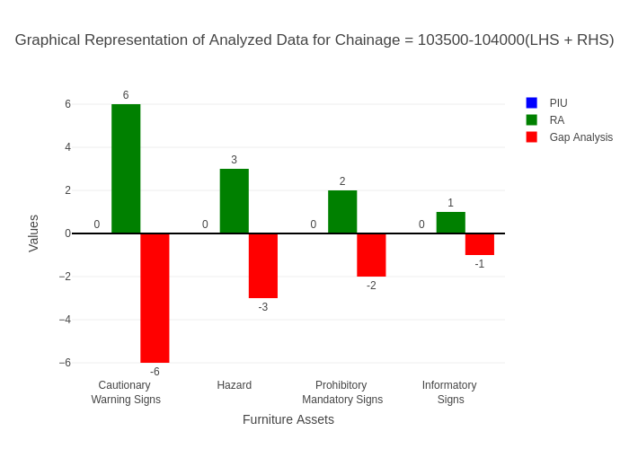

# Chainage: 104000-104500

## PIU Data:

|  |  |  |  |
| --- | --- | --- | --- |
| **Furniture Assets** | **104000-104500** | **104500-104000** | **LHS+RHS** |
| Chevron | 0.0 | 0.0 | 0.0 |
| Cautionary Warning Signs | 1.0 | 0.0 | 1.0 |
| Hazard | 0.0 | 0.0 | 0.0 |
| Prohibitory Mandatory Signs | 0.0 | 0.0 | 0.0 |
| Informatory Signs | 0.0 | 0.0 | 0.0 |

## RA Data:

|  |  |  |  |
| --- | --- | --- | --- |
| **Furniture Assets** | **104000-104500** | **104500-104000** | **LHS+RHS** |
| Chevron | 0.0 | 0.0 | 0.0 |
| Cautionary Warning Signs | 2.0 | 0.0 | 2.0 |
| Hazard | 0.0 | 0.0 | 0.0 |
| Prohibitory Mandatory Signs | 2.0 | 0.0 | 2.0 |
| Informatory Signs | 0.0 | 3.0 | 3.0 |

## Gap Analysis:

|  |  |  |  |
| --- | --- | --- | --- |
| **Furniture Assets** | **104000-104500** | **104500-104000** | **LHS+RHS** |
| Chevron | 0.0 | 0.0 | 0.0 |
| Cautionary Warning Signs | -1.0 | 0.0 | -1.0 |
| Hazard | 0.0 | 0.0 | 0.0 |
| Prohibitory Mandatory Signs | -2.0 | 0.0 | -2.0 |
| Informatory Signs | 0.0 | -3.0 | -3.0 |

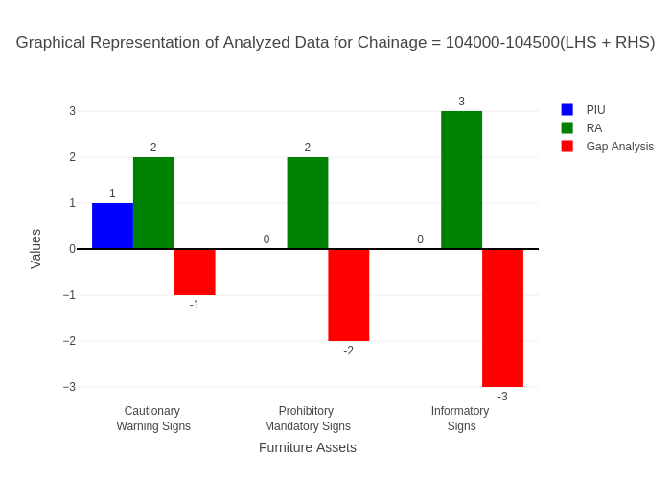

# Chainage: 104500-105000

## PIU Data:

|  |  |  |  |
| --- | --- | --- | --- |
| **Furniture Assets** | **104500-105000** | **105000-104500** | **LHS+RHS** |
| Chevron | 0.0 | 0.0 | 0.0 |
| Cautionary Warning Signs | 0.0 | 0.0 | 0.0 |
| Hazard | 0.0 | 0.0 | 0.0 |
| Prohibitory Mandatory Signs | 0.0 | 0.0 | 0.0 |
| Informatory Signs | 1.0 | 1.0 | 2.0 |

## RA Data:

|  |  |  |  |
| --- | --- | --- | --- |
| **Furniture Assets** | **104500-105000** | **105000-104500** | **LHS+RHS** |
| Chevron | 0.0 | 0.0 | 0.0 |
| Cautionary Warning Signs | 0.0 | 0.0 | 0.0 |
| Hazard | 0.0 | 0.0 | 0.0 |
| Prohibitory Mandatory Signs | 0.0 | 0.0 | 0.0 |
| Informatory Signs | 0.0 | 0.0 | 0.0 |

## Gap Analysis:

|  |  |  |  |
| --- | --- | --- | --- |
| **Furniture Assets** | **104500-105000** | **105000-104500** | **LHS+RHS** |
| Chevron | 0.0 | 0.0 | 0.0 |
| Cautionary Warning Signs | 0.0 | 0.0 | 0.0 |
| Hazard | 0.0 | 0.0 | 0.0 |
| Prohibitory Mandatory Signs | 0.0 | 0.0 | 0.0 |
| Informatory Signs | 1.0 | 1.0 | 2.0 |

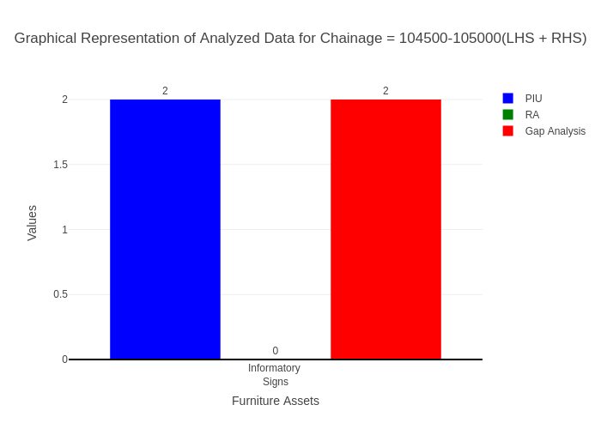

# Chainage: 105000-105500

## PIU Data:

|  |  |  |  |
| --- | --- | --- | --- |
| **Furniture Assets** | **105000-105500** | **105500-105000** | **LHS+RHS** |
| Chevron | 0.0 | 0.0 | 0.0 |
| Cautionary Warning Signs | 0.0 | 0.0 | 0.0 |
| Hazard | 1.0 | 0.0 | 1.0 |
| Prohibitory Mandatory Signs | 0.0 | 0.0 | 0.0 |
| Informatory Signs | 1.0 | 0.0 | 1.0 |

## RA Data:

|  |  |  |  |
| --- | --- | --- | --- |
| **Furniture Assets** | **105000-105500** | **105500-105000** | **LHS+RHS** |
| Chevron | 0.0 | 0.0 | 0.0 |
| Cautionary Warning Signs | 0.0 | 0.0 | 0.0 |
| Hazard | 1.0 | 0.0 | 1.0 |
| Prohibitory Mandatory Signs | 0.0 | 0.0 | 0.0 |
| Informatory Signs | 2.0 | 0.0 | 2.0 |

## Gap Analysis:

|  |  |  |  |
| --- | --- | --- | --- |
| **Furniture Assets** | **105000-105500** | **105500-105000** | **LHS+RHS** |
| Chevron | 0.0 | 0.0 | 0.0 |
| Cautionary Warning Signs | 0.0 | 0.0 | 0.0 |
| Hazard | 0.0 | 0.0 | 0.0 |
| Prohibitory Mandatory Signs | 0.0 | 0.0 | 0.0 |
| Informatory Signs | -1.0 | 0.0 | -1.0 |

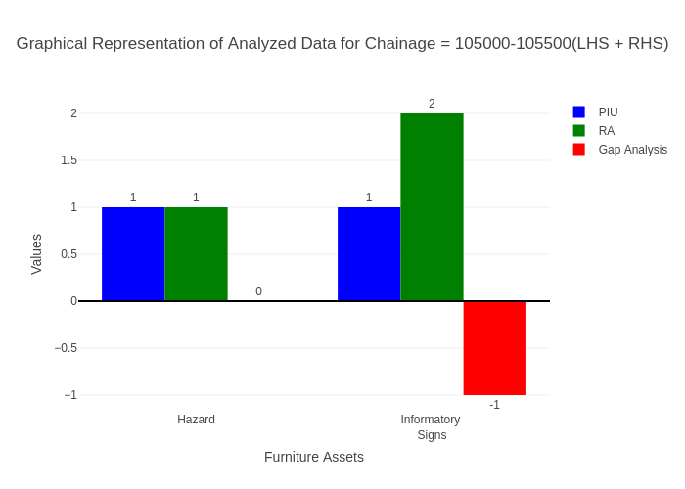

# Chainage: 105500-106000

## PIU Data:

|  |  |  |  |
| --- | --- | --- | --- |
| **Furniture Assets** | **105500-106000** | **106000-105500** | **LHS+RHS** |
| Chevron | 0.0 | 0.0 | 0.0 |
| Cautionary Warning Signs | 0.0 | 0.0 | 0.0 |
| Hazard | 1.0 | 0.0 | 1.0 |
| Prohibitory Mandatory Signs | 0.0 | 0.0 | 0.0 |
| Informatory Signs | 1.0 | 0.0 | 1.0 |

## RA Data:

|  |  |  |  |
| --- | --- | --- | --- |
| **Furniture Assets** | **105500-106000** | **106000-105500** | **LHS+RHS** |
| Chevron | 0.0 | 0.0 | 0.0 |
| Cautionary Warning Signs | 0.0 | 0.0 | 0.0 |
| Hazard | 1.0 | 0.0 | 1.0 |
| Prohibitory Mandatory Signs | 0.0 | 0.0 | 0.0 |
| Informatory Signs | 0.0 | 2.0 | 2.0 |

## Gap Analysis:

|  |  |  |  |
| --- | --- | --- | --- |
| **Furniture Assets** | **105500-106000** | **106000-105500** | **LHS+RHS** |
| Chevron | 0.0 | 0.0 | 0.0 |
| Cautionary Warning Signs | 0.0 | 0.0 | 0.0 |
| Hazard | 0.0 | 0.0 | 0.0 |
| Prohibitory Mandatory Signs | 0.0 | 0.0 | 0.0 |
| Informatory Signs | 1.0 | -2.0 | -1.0 |

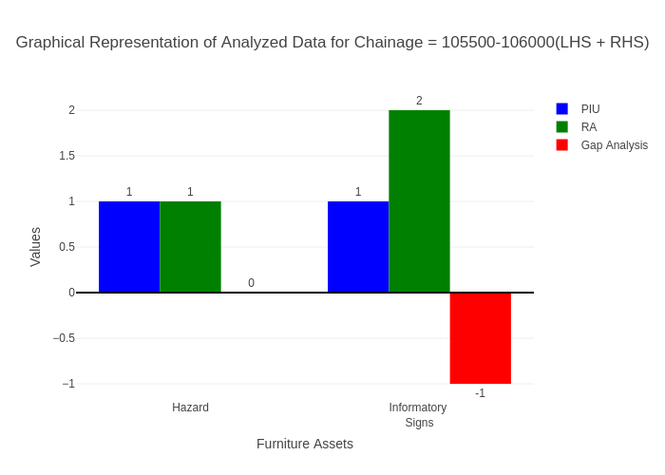

# Chainage: 106000-106500

## PIU Data:

|  |  |  |  |
| --- | --- | --- | --- |
| **Furniture Assets** | **106000-106500** | **106500-106000** | **LHS+RHS** |
| Chevron | 0.0 | 0.0 | 0.0 |
| Cautionary Warning Signs | 0.0 | 0.0 | 0.0 |
| Hazard | 1.0 | 0.0 | 1.0 |
| Prohibitory Mandatory Signs | 0.0 | 0.0 | 0.0 |
| Informatory Signs | 0.0 | 0.0 | 0.0 |

## RA Data:

|  |  |  |  |
| --- | --- | --- | --- |
| **Furniture Assets** | **106000-106500** | **106500-106000** | **LHS+RHS** |
| Chevron | 0.0 | 0.0 | 0.0 |
| Cautionary Warning Signs | 0.0 | 0.0 | 0.0 |
| Hazard | 1.0 | 0.0 | 1.0 |
| Prohibitory Mandatory Signs | 0.0 | 0.0 | 0.0 |
| Informatory Signs | 0.0 | 0.0 | 0.0 |

## Gap Analysis:

|  |  |  |  |
| --- | --- | --- | --- |
| **Furniture Assets** | **106000-106500** | **106500-106000** | **LHS+RHS** |
| Chevron | 0.0 | 0.0 | 0.0 |
| Cautionary Warning Signs | 0.0 | 0.0 | 0.0 |
| Hazard | 0.0 | 0.0 | 0.0 |
| Prohibitory Mandatory Signs | 0.0 | 0.0 | 0.0 |
| Informatory Signs | 0.0 | 0.0 | 0.0 |

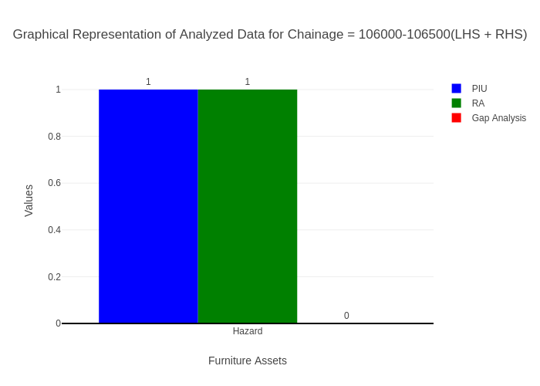

# Chainage: 106500-107000

## PIU Data:

|  |  |  |  |
| --- | --- | --- | --- |
| **Furniture Assets** | **106500-107000** | **107000-106500** | **LHS+RHS** |
| Chevron | 0.0 | 0.0 | 0.0 |
| Cautionary Warning Signs | 1.0 | 0.0 | 1.0 |
| Hazard | 1.0 | 0.0 | 1.0 |
| Prohibitory Mandatory Signs | 0.0 | 0.0 | 0.0 |
| Informatory Signs | 1.0 | 0.0 | 1.0 |

## RA Data:

|  |  |  |  |
| --- | --- | --- | --- |
| **Furniture Assets** | **106500-107000** | **107000-106500** | **LHS+RHS** |
| Chevron | 0.0 | 0.0 | 0.0 |
| Cautionary Warning Signs | 1.0 | 0.0 | 1.0 |
| Hazard | 1.0 | 0.0 | 1.0 |
| Prohibitory Mandatory Signs | 0.0 | 0.0 | 0.0 |
| Informatory Signs | 2.0 | 0.0 | 2.0 |

## Gap Analysis:

|  |  |  |  |
| --- | --- | --- | --- |
| **Furniture Assets** | **106500-107000** | **107000-106500** | **LHS+RHS** |
| Chevron | 0.0 | 0.0 | 0.0 |
| Cautionary Warning Signs | 0.0 | 0.0 | 0.0 |
| Hazard | 0.0 | 0.0 | 0.0 |
| Prohibitory Mandatory Signs | 0.0 | 0.0 | 0.0 |
| Informatory Signs | -1.0 | 0.0 | -1.0 |

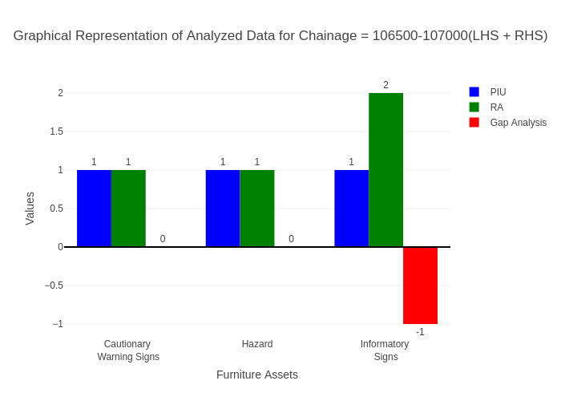

# Chainage: 107000-107500

## PIU Data:

|  |  |  |  |
| --- | --- | --- | --- |
| **Furniture Assets** | **107000-107500** | **107500-107000** | **LHS+RHS** |
| Chevron | 0.0 | 0.0 | 0.0 |
| Cautionary Warning Signs | 0.0 | 0.0 | 0.0 |
| Hazard | 0.0 | 0.0 | 0.0 |
| Prohibitory Mandatory Signs | 0.0 | 0.0 | 0.0 |
| Informatory Signs | 0.0 | 0.0 | 0.0 |

## RA Data:

|  |  |  |  |
| --- | --- | --- | --- |
| **Furniture Assets** | **107000-107500** | **107500-107000** | **LHS+RHS** |
| Chevron | 0.0 | 0.0 | 0.0 |
| Cautionary Warning Signs | 0.0 | 1.0 | 1.0 |
| Hazard | 0.0 | 0.0 | 0.0 |
| Prohibitory Mandatory Signs | 1.0 | 1.0 | 2.0 |
| Informatory Signs | 0.0 | 0.0 | 0.0 |

## Gap Analysis:

|  |  |  |  |
| --- | --- | --- | --- |
| **Furniture Assets** | **107000-107500** | **107500-107000** | **LHS+RHS** |
| Chevron | 0.0 | 0.0 | 0.0 |
| Cautionary Warning Signs | 0.0 | -1.0 | -1.0 |
| Hazard | 0.0 | 0.0 | 0.0 |
| Prohibitory Mandatory Signs | -1.0 | -1.0 | -2.0 |
| Informatory Signs | 0.0 | 0.0 | 0.0 |

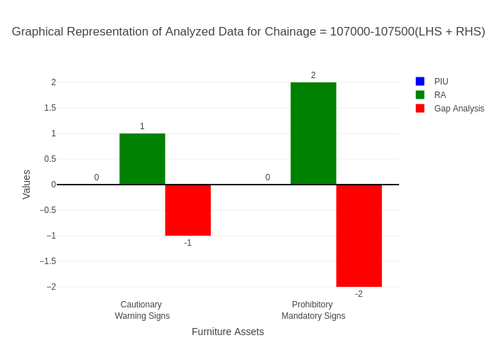

# Chainage: 107500-108000

## PIU Data:

|  |  |  |  |
| --- | --- | --- | --- |
| **Furniture Assets** | **107500-108000** | **108000-107500** | **LHS+RHS** |
| Chevron | 0.0 | 0.0 | 0.0 |
| Cautionary Warning Signs | 0.0 | 0.0 | 0.0 |
| Hazard | 0.0 | 0.0 | 0.0 |
| Prohibitory Mandatory Signs | 0.0 | 0.0 | 0.0 |
| Informatory Signs | 0.0 | 0.0 | 0.0 |

## RA Data:

|  |  |  |  |
| --- | --- | --- | --- |
| **Furniture Assets** | **107500-108000** | **108000-107500** | **LHS+RHS** |
| Chevron | 0.0 | 0.0 | 0.0 |
| Cautionary Warning Signs | 2.0 | 1.0 | 3.0 |
| Hazard | 0.0 | 0.0 | 0.0 |
| Prohibitory Mandatory Signs | 3.0 | 0.0 | 3.0 |
| Informatory Signs | 0.0 | 1.0 | 1.0 |

## Gap Analysis:

|  |  |  |  |
| --- | --- | --- | --- |
| **Furniture Assets** | **107500-108000** | **108000-107500** | **LHS+RHS** |
| Chevron | 0.0 | 0.0 | 0.0 |
| Cautionary Warning Signs | -2.0 | -1.0 | -3.0 |
| Hazard | 0.0 | 0.0 | 0.0 |
| Prohibitory Mandatory Signs | -3.0 | 0.0 | -3.0 |
| Informatory Signs | 0.0 | -1.0 | -1.0 |

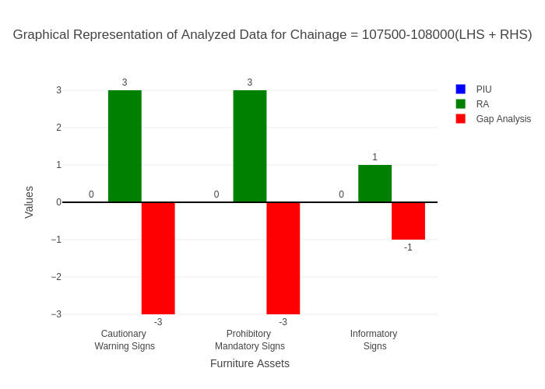

# Chainage: 108000-108500

## PIU Data:

|  |  |  |  |
| --- | --- | --- | --- |
| **Furniture Assets** | **108000-108500** | **108500-108000** | **LHS+RHS** |
| Chevron | 0.0 | 0.0 | 0.0 |
| Cautionary Warning Signs | 2.0 | 1.0 | 3.0 |
| Hazard | 1.0 | 0.0 | 1.0 |
| Prohibitory Mandatory Signs | 0.0 | 0.0 | 0.0 |
| Informatory Signs | 1.0 | 0.0 | 1.0 |

## RA Data:

|  |  |  |  |
| --- | --- | --- | --- |
| **Furniture Assets** | **108000-108500** | **108500-108000** | **LHS+RHS** |
| Chevron | 0.0 | 0.0 | 0.0 |
| Cautionary Warning Signs | 1.0 | 3.0 | 4.0 |
| Hazard | 0.0 | 0.0 | 0.0 |
| Prohibitory Mandatory Signs | 1.0 | 0.0 | 1.0 |
| Informatory Signs | 0.0 | 2.0 | 2.0 |

## Gap Analysis:

|  |  |  |  |
| --- | --- | --- | --- |
| **Furniture Assets** | **108000-108500** | **108500-108000** | **LHS+RHS** |
| Chevron | 0.0 | 0.0 | 0.0 |
| Cautionary Warning Signs | 1.0 | -2.0 | -1.0 |
| Hazard | 1.0 | 0.0 | 1.0 |
| Prohibitory Mandatory Signs | -1.0 | 0.0 | -1.0 |
| Informatory Signs | 1.0 | -2.0 | -1.0 |

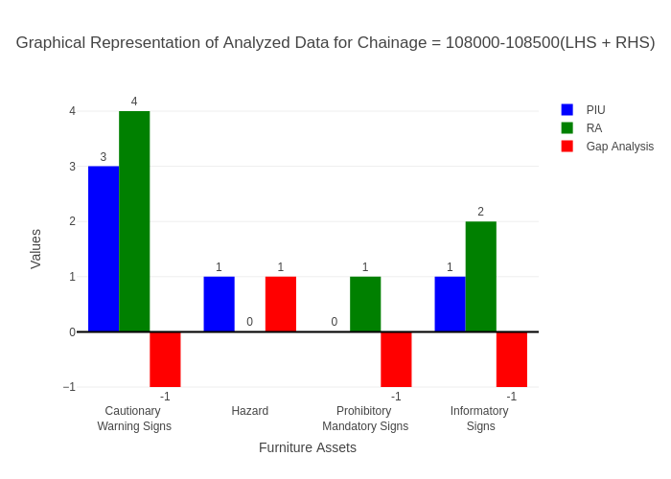

# Chainage: 108500-109000

## PIU Data:

|  |  |  |  |
| --- | --- | --- | --- |
| **Furniture Assets** | **108500-109000** | **109000-108500** | **LHS+RHS** |
| Chevron | 0.0 | 0.0 | 0.0 |
| Cautionary Warning Signs | 0.0 | 0.0 | 0.0 |
| Hazard | 0.0 | 0.0 | 0.0 |
| Prohibitory Mandatory Signs | 0.0 | 0.0 | 0.0 |
| Informatory Signs | 1.0 | 0.0 | 1.0 |

## RA Data:

|  |  |  |  |
| --- | --- | --- | --- |
| **Furniture Assets** | **108500-109000** | **109000-108500** | **LHS+RHS** |
| Chevron | 0.0 | 0.0 | 0.0 |
| Cautionary Warning Signs | 0.0 | 1.0 | 1.0 |
| Hazard | 1.0 | 0.0 | 1.0 |
| Prohibitory Mandatory Signs | 0.0 | 0.0 | 0.0 |
| Informatory Signs | 0.0 | 0.0 | 0.0 |

## Gap Analysis:

|  |  |  |  |
| --- | --- | --- | --- |
| **Furniture Assets** | **108500-109000** | **109000-108500** | **LHS+RHS** |
| Chevron | 0.0 | 0.0 | 0.0 |
| Cautionary Warning Signs | 0.0 | -1.0 | -1.0 |
| Hazard | -1.0 | 0.0 | -1.0 |
| Prohibitory Mandatory Signs | 0.0 | 0.0 | 0.0 |
| Informatory Signs | 1.0 | 0.0 | 1.0 |

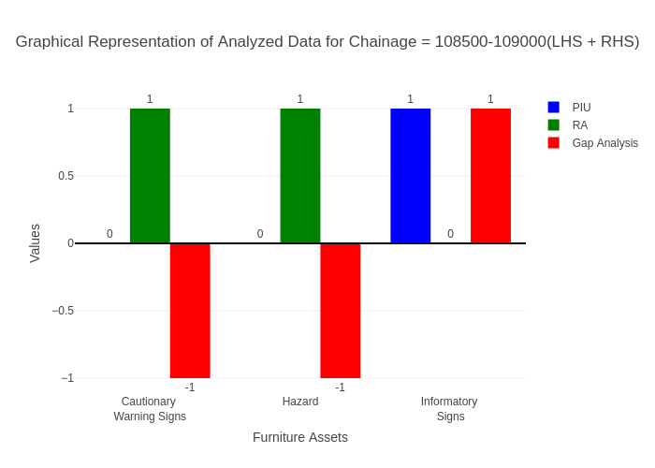

# Chainage: 109000-109500

## PIU Data:

|  |  |  |  |
| --- | --- | --- | --- |
| **Furniture Assets** | **109000-109500** | **109500-109000** | **LHS+RHS** |
| Chevron | 0.0 | 0.0 | 0.0 |
| Cautionary Warning Signs | 2.0 | 0.0 | 2.0 |
| Hazard | 0.0 | 0.0 | 0.0 |
| Prohibitory Mandatory Signs | 0.0 | 0.0 | 0.0 |
| Informatory Signs | 1.0 | 0.0 | 1.0 |

## RA Data:

|  |  |  |  |
| --- | --- | --- | --- |
| **Furniture Assets** | **109000-109500** | **109500-109000** | **LHS+RHS** |
| Chevron | 0.0 | 0.0 | 0.0 |
| Cautionary Warning Signs | 0.0 | 1.0 | 1.0 |
| Hazard | 1.0 | 0.0 | 1.0 |
| Prohibitory Mandatory Signs | 2.0 | 0.0 | 2.0 |
| Informatory Signs | 1.0 | 0.0 | 1.0 |

## Gap Analysis:

|  |  |  |  |
| --- | --- | --- | --- |
| **Furniture Assets** | **109000-109500** | **109500-109000** | **LHS+RHS** |
| Chevron | 0.0 | 0.0 | 0.0 |
| Cautionary Warning Signs | 2.0 | -1.0 | 1.0 |
| Hazard | -1.0 | 0.0 | -1.0 |
| Prohibitory Mandatory Signs | -2.0 | 0.0 | -2.0 |
| Informatory Signs | 0.0 | 0.0 | 0.0 |

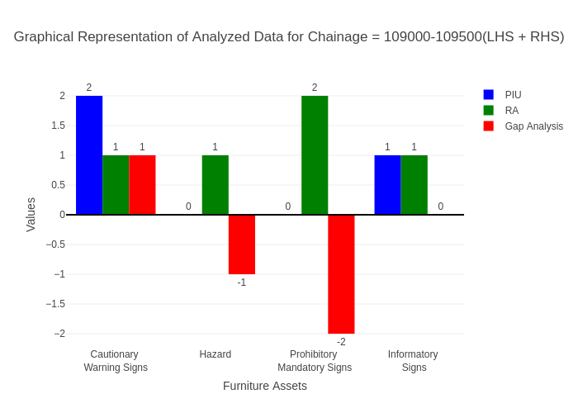

# Chainage: 109500-110000

## PIU Data:

|  |  |  |  |
| --- | --- | --- | --- |
| **Furniture Assets** | **109500-110000** | **110000-109500** | **LHS+RHS** |
| Chevron | 0.0 | 0.0 | 0.0 |
| Cautionary Warning Signs | 0.0 | 1.0 | 1.0 |
| Hazard | 1.0 | 0.0 | 1.0 |
| Prohibitory Mandatory Signs | 0.0 | 0.0 | 0.0 |
| Informatory Signs | 8.0 | 0.0 | 8.0 |

## RA Data:

|  |  |  |  |
| --- | --- | --- | --- |
| **Furniture Assets** | **109500-110000** | **110000-109500** | **LHS+RHS** |
| Chevron | 0.0 | 0.0 | 0.0 |
| Cautionary Warning Signs | 0.0 | 0.0 | 0.0 |
| Hazard | 0.0 | 2.0 | 2.0 |
| Prohibitory Mandatory Signs | 0.0 | 0.0 | 0.0 |
| Informatory Signs | 4.0 | 2.0 | 6.0 |

## Gap Analysis:

|  |  |  |  |
| --- | --- | --- | --- |
| **Furniture Assets** | **109500-110000** | **110000-109500** | **LHS+RHS** |
| Chevron | 0.0 | 0.0 | 0.0 |
| Cautionary Warning Signs | 0.0 | 1.0 | 1.0 |
| Hazard | 1.0 | -2.0 | -1.0 |
| Prohibitory Mandatory Signs | 0.0 | 0.0 | 0.0 |
| Informatory Signs | 4.0 | -2.0 | 2.0 |

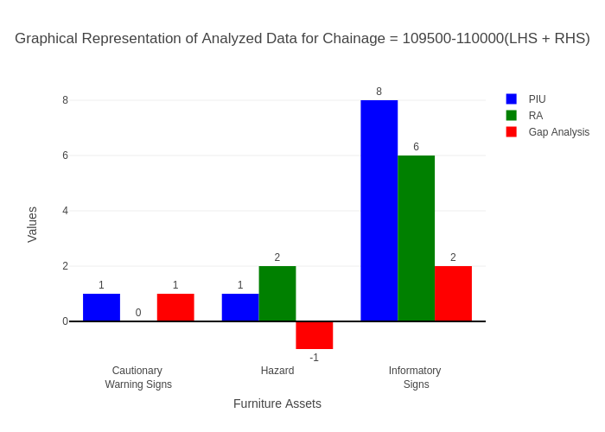

# Chainage: 110000-110500

## PIU Data:

|  |  |  |  |
| --- | --- | --- | --- |
| **Furniture Assets** | **110000-110500** | **110500-110000** | **LHS+RHS** |
| Chevron | 0.0 | 0.0 | 0.0 |
| Cautionary Warning Signs | 0.0 | 0.0 | 0.0 |
| Hazard | 0.0 | 0.0 | 0.0 |
| Prohibitory Mandatory Signs | 0.0 | 0.0 | 0.0 |
| Informatory Signs | 4.0 | 3.0 | 7.0 |

## RA Data:

|  |  |  |  |
| --- | --- | --- | --- |
| **Furniture Assets** | **110000-110500** | **110500-110000** | **LHS+RHS** |
| Chevron | 0.0 | 0.0 | 0.0 |
| Cautionary Warning Signs | 0.0 | 1.0 | 1.0 |
| Hazard | 2.0 | 0.0 | 2.0 |
| Prohibitory Mandatory Signs | 0.0 | 0.0 | 0.0 |
| Informatory Signs | 7.0 | 1.0 | 8.0 |

## Gap Analysis:

|  |  |  |  |
| --- | --- | --- | --- |
| **Furniture Assets** | **110000-110500** | **110500-110000** | **LHS+RHS** |
| Chevron | 0.0 | 0.0 | 0.0 |
| Cautionary Warning Signs | 0.0 | -1.0 | -1.0 |
| Hazard | -2.0 | 0.0 | -2.0 |
| Prohibitory Mandatory Signs | 0.0 | 0.0 | 0.0 |
| Informatory Signs | -3.0 | 2.0 | -1.0 |

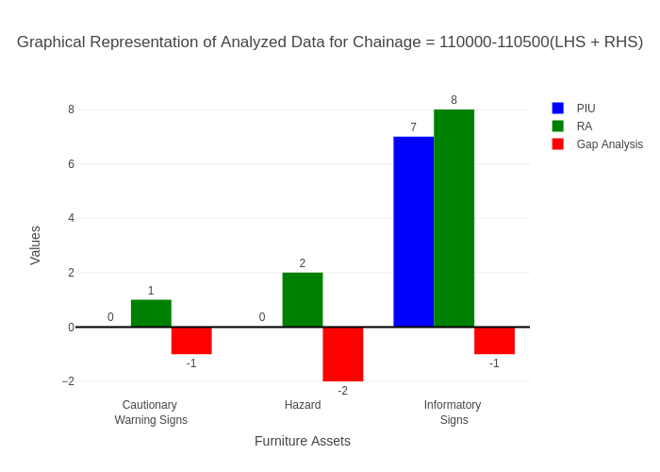

# Chainage: 110500-111000

## PIU Data:

|  |  |  |  |
| --- | --- | --- | --- |
| **Furniture Assets** | **110500-111000** | **111000-110500** | **LHS+RHS** |
| Chevron | 0.0 | 0.0 | 0.0 |
| Cautionary Warning Signs | 0.0 | 1.0 | 1.0 |
| Hazard | 0.0 | 0.0 | 0.0 |
| Prohibitory Mandatory Signs | 0.0 | 0.0 | 0.0 |
| Informatory Signs | 1.0 | 2.0 | 3.0 |

## RA Data:

|  |  |  |  |
| --- | --- | --- | --- |
| **Furniture Assets** | **110500-111000** | **111000-110500** | **LHS+RHS** |
| Chevron | 0.0 | 1.0 | 1.0 |
| Cautionary Warning Signs | 0.0 | 0.0 | 0.0 |
| Hazard | 1.0 | 1.0 | 2.0 |
| Prohibitory Mandatory Signs | 0.0 | 0.0 | 0.0 |
| Informatory Signs | 3.0 | 2.0 | 5.0 |

## Gap Analysis:

|  |  |  |  |
| --- | --- | --- | --- |
| **Furniture Assets** | **110500-111000** | **111000-110500** | **LHS+RHS** |
| Chevron | 0.0 | -1.0 | -1.0 |
| Cautionary Warning Signs | 0.0 | 1.0 | 1.0 |
| Hazard | -1.0 | -1.0 | -2.0 |
| Prohibitory Mandatory Signs | 0.0 | 0.0 | 0.0 |
| Informatory Signs | -2.0 | 0.0 | -2.0 |

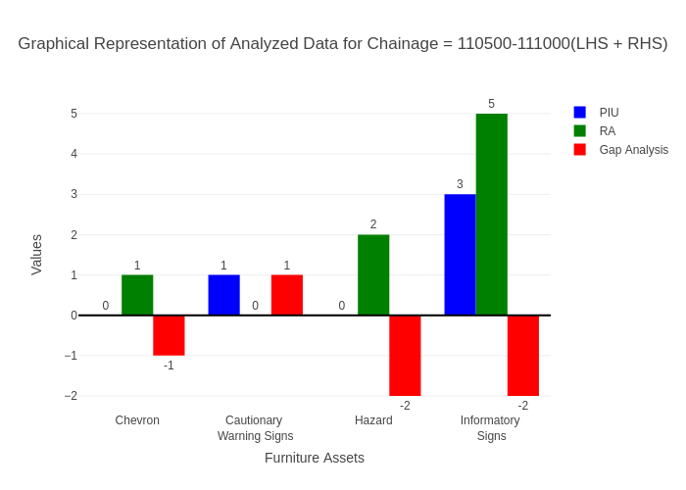

# Chainage: 111000-111500

## PIU Data:

|  |  |  |  |
| --- | --- | --- | --- |
| **Furniture Assets** | **111000-111500** | **111500-111000** | **LHS+RHS** |
| Chevron | 0.0 | 0.0 | 0.0 |
| Cautionary Warning Signs | 0.0 | 0.0 | 0.0 |
| Hazard | 0.0 | 0.0 | 0.0 |
| Prohibitory Mandatory Signs | 0.0 | 0.0 | 0.0 |
| Informatory Signs | 1.0 | 1.0 | 2.0 |

## RA Data:

|  |  |  |  |
| --- | --- | --- | --- |
| **Furniture Assets** | **111000-111500** | **111500-111000** | **LHS+RHS** |
| Chevron | 0.0 | 0.0 | 0.0 |
| Cautionary Warning Signs | 0.0 | 0.0 | 0.0 |
| Hazard | 0.0 | 1.0 | 1.0 |
| Prohibitory Mandatory Signs | 0.0 | 0.0 | 0.0 |
| Informatory Signs | 0.0 | 8.0 | 8.0 |

## Gap Analysis:

|  |  |  |  |
| --- | --- | --- | --- |
| **Furniture Assets** | **111000-111500** | **111500-111000** | **LHS+RHS** |
| Chevron | 0.0 | 0.0 | 0.0 |
| Cautionary Warning Signs | 0.0 | 0.0 | 0.0 |
| Hazard | 0.0 | -1.0 | -1.0 |
| Prohibitory Mandatory Signs | 0.0 | 0.0 | 0.0 |
| Informatory Signs | 1.0 | -7.0 | -6.0 |

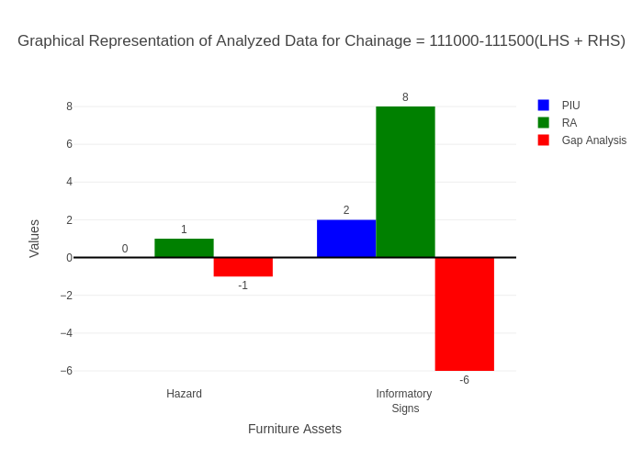

# Chainage: 111500-112000

## PIU Data:

|  |  |  |  |
| --- | --- | --- | --- |
| **Furniture Assets** | **111500-112000** | **112000-111500** | **LHS+RHS** |
| Chevron | 1.0 | 0.0 | 1.0 |
| Cautionary Warning Signs | 0.0 | 0.0 | 0.0 |
| Hazard | 0.0 | 0.0 | 0.0 |
| Prohibitory Mandatory Signs | 0.0 | 0.0 | 0.0 |
| Informatory Signs | 1.0 | 0.0 | 1.0 |

## RA Data:

|  |  |  |  |
| --- | --- | --- | --- |
| **Furniture Assets** | **111500-112000** | **112000-111500** | **LHS+RHS** |
| Chevron | 0.0 | 0.0 | 0.0 |
| Cautionary Warning Signs | 0.0 | 0.0 | 0.0 |
| Hazard | 0.0 | 0.0 | 0.0 |
| Prohibitory Mandatory Signs | 0.0 | 0.0 | 0.0 |
| Informatory Signs | 0.0 | 4.0 | 4.0 |

## Gap Analysis:

|  |  |  |  |
| --- | --- | --- | --- |
| **Furniture Assets** | **111500-112000** | **112000-111500** | **LHS+RHS** |
| Chevron | 1.0 | 0.0 | 1.0 |
| Cautionary Warning Signs | 0.0 | 0.0 | 0.0 |
| Hazard | 0.0 | 0.0 | 0.0 |
| Prohibitory Mandatory Signs | 0.0 | 0.0 | 0.0 |
| Informatory Signs | 1.0 | -4.0 | -3.0 |

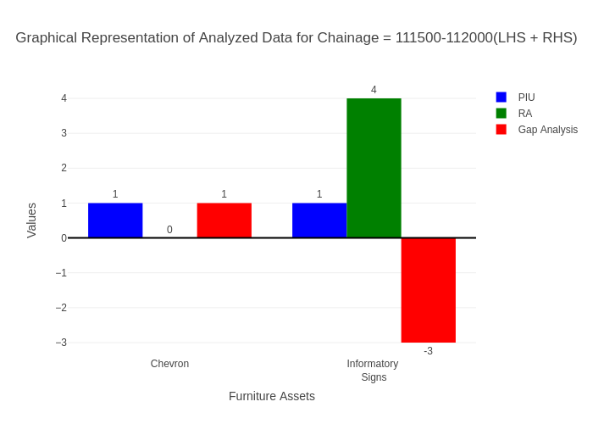

# Chainage: 112000-112500

## PIU Data:

|  |  |  |  |
| --- | --- | --- | --- |
| **Furniture Assets** | **112000-112500** | **112500-112000** | **LHS+RHS** |
| Chevron | 0.0 | 0.0 | 0.0 |
| Cautionary Warning Signs | 0.0 | 0.0 | 0.0 |
| Hazard | 0.0 | 0.0 | 0.0 |
| Prohibitory Mandatory Signs | 0.0 | 0.0 | 0.0 |
| Informatory Signs | 1.0 | 0.0 | 1.0 |

## RA Data:

|  |  |  |  |
| --- | --- | --- | --- |
| **Furniture Assets** | **112000-112500** | **112500-112000** | **LHS+RHS** |
| Chevron | 0.0 | 0.0 | 0.0 |
| Cautionary Warning Signs | 0.0 | 0.0 | 0.0 |
| Hazard | 0.0 | 0.0 | 0.0 |
| Prohibitory Mandatory Signs | 0.0 | 0.0 | 0.0 |
| Informatory Signs | 0.0 | 0.0 | 0.0 |

## Gap Analysis:

|  |  |  |  |
| --- | --- | --- | --- |
| **Furniture Assets** | **112000-112500** | **112500-112000** | **LHS+RHS** |
| Chevron | 0.0 | 0.0 | 0.0 |
| Cautionary Warning Signs | 0.0 | 0.0 | 0.0 |
| Hazard | 0.0 | 0.0 | 0.0 |
| Prohibitory Mandatory Signs | 0.0 | 0.0 | 0.0 |
| Informatory Signs | 1.0 | 0.0 | 1.0 |

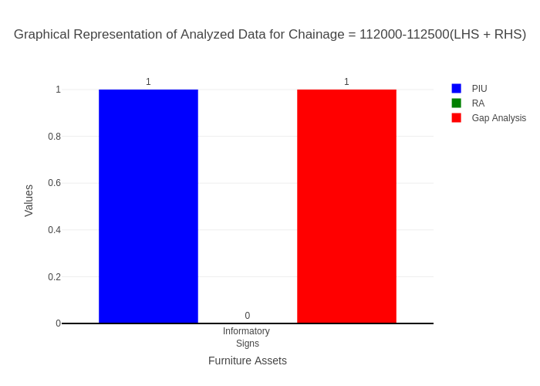

# Chainage: 112500-113000

## PIU Data:

|  |  |  |  |
| --- | --- | --- | --- |
| **Furniture Assets** | **112500-113000** | **113000-112500** | **LHS+RHS** |
| Chevron | 0.0 | 0.0 | 0.0 |
| Cautionary Warning Signs | 1.0 | 0.0 | 1.0 |
| Hazard | 1.0 | 0.0 | 1.0 |
| Prohibitory Mandatory Signs | 0.0 | 0.0 | 0.0 |
| Informatory Signs | 1.0 | 0.0 | 1.0 |

## RA Data:

|  |  |  |  |
| --- | --- | --- | --- |
| **Furniture Assets** | **112500-113000** | **113000-112500** | **LHS+RHS** |
| Chevron | 0.0 | 0.0 | 0.0 |
| Cautionary Warning Signs | 1.0 | 0.0 | 1.0 |
| Hazard | 1.0 | 0.0 | 1.0 |
| Prohibitory Mandatory Signs | 0.0 | 0.0 | 0.0 |
| Informatory Signs | 0.0 | 0.0 | 0.0 |

## Gap Analysis:

|  |  |  |  |
| --- | --- | --- | --- |
| **Furniture Assets** | **112500-113000** | **113000-112500** | **LHS+RHS** |
| Chevron | 0.0 | 0.0 | 0.0 |
| Cautionary Warning Signs | 0.0 | 0.0 | 0.0 |
| Hazard | 0.0 | 0.0 | 0.0 |
| Prohibitory Mandatory Signs | 0.0 | 0.0 | 0.0 |
| Informatory Signs | 1.0 | 0.0 | 1.0 |

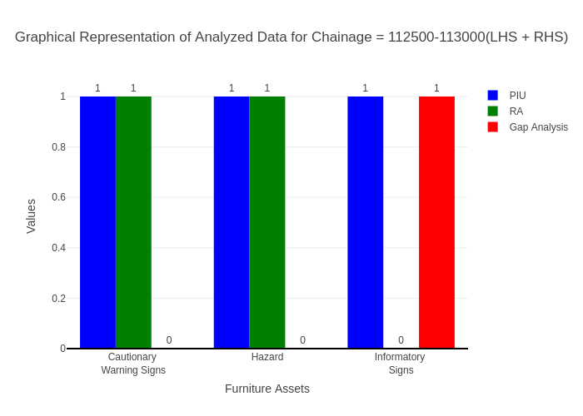

# Chainage: 113000-113500

## PIU Data:

|  |  |  |  |
| --- | --- | --- | --- |
| **Furniture Assets** | **113000-113500** | **113500-113000** | **LHS+RHS** |
| Chevron | 0.0 | 0.0 | 0.0 |
| Cautionary Warning Signs | 0.0 | 0.0 | 0.0 |
| Hazard | 1.0 | 0.0 | 1.0 |
| Prohibitory Mandatory Signs | 0.0 | 0.0 | 0.0 |
| Informatory Signs | 1.0 | 0.0 | 1.0 |

## RA Data:

|  |  |  |  |
| --- | --- | --- | --- |
| **Furniture Assets** | **113000-113500** | **113500-113000** | **LHS+RHS** |
| Chevron | 0.0 | 0.0 | 0.0 |
| Cautionary Warning Signs | 2.0 | 1.0 | 3.0 |
| Hazard | 1.0 | 0.0 | 1.0 |
| Prohibitory Mandatory Signs | 0.0 | 0.0 | 0.0 |
| Informatory Signs | 1.0 | 0.0 | 1.0 |

## Gap Analysis:

|  |  |  |  |
| --- | --- | --- | --- |
| **Furniture Assets** | **113000-113500** | **113500-113000** | **LHS+RHS** |
| Chevron | 0.0 | 0.0 | 0.0 |
| Cautionary Warning Signs | -2.0 | -1.0 | -3.0 |
| Hazard | 0.0 | 0.0 | 0.0 |
| Prohibitory Mandatory Signs | 0.0 | 0.0 | 0.0 |
| Informatory Signs | 0.0 | 0.0 | 0.0 |

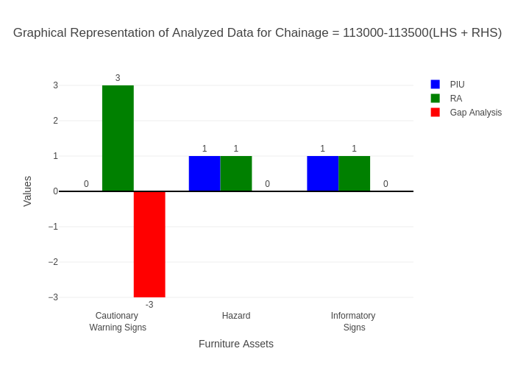

# Chainage: 113500-114000

## PIU Data:

|  |  |  |  |
| --- | --- | --- | --- |
| **Furniture Assets** | **113500-114000** | **114000-113500** | **LHS+RHS** |
| Chevron | 0.0 | 0.0 | 0.0 |
| Cautionary Warning Signs | 2.0 | 1.0 | 3.0 |
| Hazard | 1.0 | 0.0 | 1.0 |
| Prohibitory Mandatory Signs | 0.0 | 0.0 | 0.0 |
| Informatory Signs | 8.0 | 1.0 | 9.0 |

## RA Data:

|  |  |  |  |
| --- | --- | --- | --- |
| **Furniture Assets** | **113500-114000** | **114000-113500** | **LHS+RHS** |
| Chevron | 0.0 | 0.0 | 0.0 |
| Cautionary Warning Signs | 0.0 | 0.0 | 0.0 |
| Hazard | 0.0 | 0.0 | 0.0 |
| Prohibitory Mandatory Signs | 1.0 | 0.0 | 1.0 |
| Informatory Signs | 2.0 | 0.0 | 2.0 |

## Gap Analysis:

|  |  |  |  |
| --- | --- | --- | --- |
| **Furniture Assets** | **113500-114000** | **114000-113500** | **LHS+RHS** |
| Chevron | 0.0 | 0.0 | 0.0 |
| Cautionary Warning Signs | 2.0 | 1.0 | 3.0 |
| Hazard | 1.0 | 0.0 | 1.0 |
| Prohibitory Mandatory Signs | -1.0 | 0.0 | -1.0 |
| Informatory Signs | 6.0 | 1.0 | 7.0 |

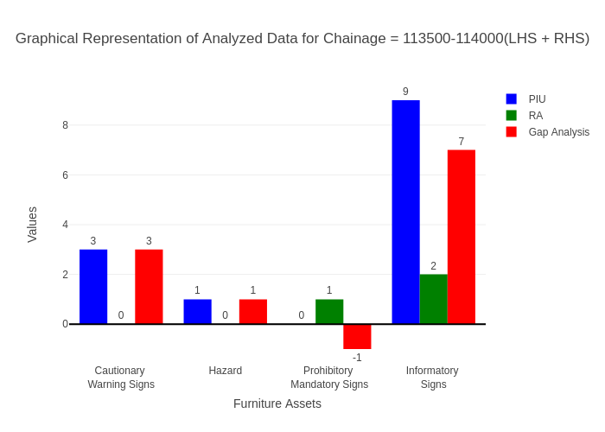

# Chainage: 114000-114500

## PIU Data:

|  |  |  |  |
| --- | --- | --- | --- |
| **Furniture Assets** | **114000-114500** | **114500-114000** | **LHS+RHS** |
| Chevron | 0.0 | 0.0 | 0.0 |
| Cautionary Warning Signs | 2.0 | 0.0 | 2.0 |
| Hazard | 1.0 | 0.0 | 1.0 |
| Prohibitory Mandatory Signs | 0.0 | 0.0 | 0.0 |
| Informatory Signs | 1.0 | 0.0 | 1.0 |

## RA Data:

|  |  |  |  |
| --- | --- | --- | --- |
| **Furniture Assets** | **114000-114500** | **114500-114000** | **LHS+RHS** |
| Chevron | 0.0 | 0.0 | 0.0 |
| Cautionary Warning Signs | 7.0 | 4.0 | 11.0 |
| Hazard | 0.0 | 1.0 | 1.0 |
| Prohibitory Mandatory Signs | 3.0 | 0.0 | 3.0 |
| Informatory Signs | 4.0 | 0.0 | 4.0 |

## Gap Analysis:

|  |  |  |  |
| --- | --- | --- | --- |
| **Furniture Assets** | **114000-114500** | **114500-114000** | **LHS+RHS** |
| Chevron | 0.0 | 0.0 | 0.0 |
| Cautionary Warning Signs | -5.0 | -4.0 | -9.0 |
| Hazard | 1.0 | -1.0 | 0.0 |
| Prohibitory Mandatory Signs | -3.0 | 0.0 | -3.0 |
| Informatory Signs | -3.0 | 0.0 | -3.0 |

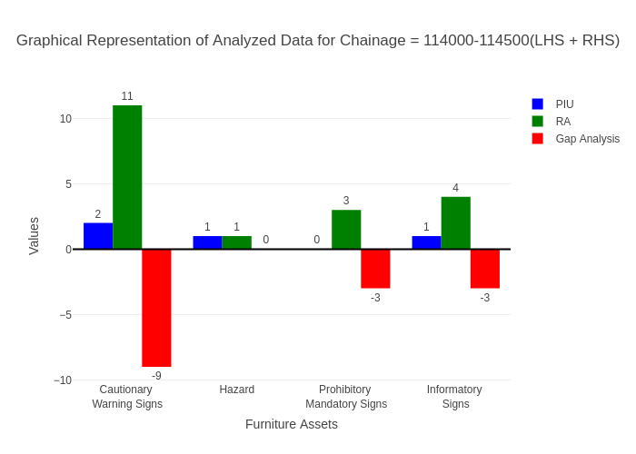

# Chainage: 114500-115000

## PIU Data:

|  |  |  |  |
| --- | --- | --- | --- |
| **Furniture Assets** | **114500-115000** | **115000-114500** | **LHS+RHS** |
| Chevron | 0.0 | 0.0 | 0.0 |
| Cautionary Warning Signs | 0.0 | 0.0 | 0.0 |
| Hazard | 0.0 | 0.0 | 0.0 |
| Prohibitory Mandatory Signs | 0.0 | 0.0 | 0.0 |
| Informatory Signs | 1.0 | 0.0 | 1.0 |

## RA Data:

|  |  |  |  |
| --- | --- | --- | --- |
| **Furniture Assets** | **114500-115000** | **115000-114500** | **LHS+RHS** |
| Chevron | 0.0 | 0.0 | 0.0 |
| Cautionary Warning Signs | 0.0 | 0.0 | 0.0 |
| Hazard | 0.0 | 0.0 | 0.0 |
| Prohibitory Mandatory Signs | 0.0 | 1.0 | 1.0 |
| Informatory Signs | 0.0 | 0.0 | 0.0 |

## Gap Analysis:

|  |  |  |  |
| --- | --- | --- | --- |
| **Furniture Assets** | **114500-115000** | **115000-114500** | **LHS+RHS** |
| Chevron | 0.0 | 0.0 | 0.0 |
| Cautionary Warning Signs | 0.0 | 0.0 | 0.0 |
| Hazard | 0.0 | 0.0 | 0.0 |
| Prohibitory Mandatory Signs | 0.0 | -1.0 | -1.0 |
| Informatory Signs | 1.0 | 0.0 | 1.0 |

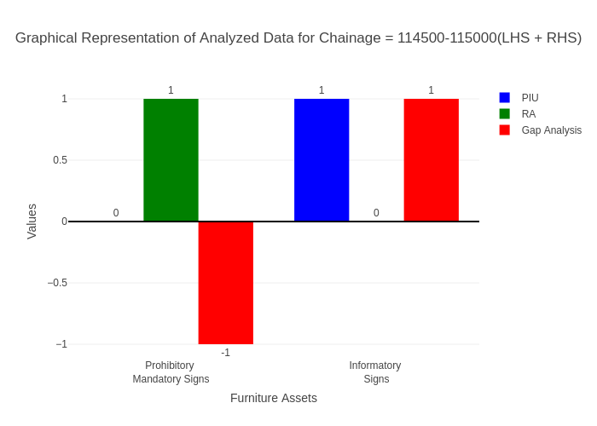

# Chainage: 115000-115500

## PIU Data:

|  |  |  |  |
| --- | --- | --- | --- |
| **Furniture Assets** | **115000-115500** | **115500-115000** | **LHS+RHS** |
| Chevron | 0.0 | 0.0 | 0.0 |
| Cautionary Warning Signs | 1.0 | 0.0 | 1.0 |
| Hazard | 0.0 | 0.0 | 0.0 |
| Prohibitory Mandatory Signs | 0.0 | 0.0 | 0.0 |
| Informatory Signs | 1.0 | 0.0 | 1.0 |

## RA Data:

|  |  |  |  |
| --- | --- | --- | --- |
| **Furniture Assets** | **115000-115500** | **115500-115000** | **LHS+RHS** |
| Chevron | 0.0 | 0.0 | 0.0 |
| Cautionary Warning Signs | 1.0 | 0.0 | 1.0 |
| Hazard | 0.0 | 0.0 | 0.0 |
| Prohibitory Mandatory Signs | 0.0 | 1.0 | 1.0 |
| Informatory Signs | 2.0 | 0.0 | 2.0 |

## Gap Analysis:

|  |  |  |  |
| --- | --- | --- | --- |
| **Furniture Assets** | **115000-115500** | **115500-115000** | **LHS+RHS** |
| Chevron | 0.0 | 0.0 | 0.0 |
| Cautionary Warning Signs | 0.0 | 0.0 | 0.0 |
| Hazard | 0.0 | 0.0 | 0.0 |
| Prohibitory Mandatory Signs | 0.0 | -1.0 | -1.0 |
| Informatory Signs | -1.0 | 0.0 | -1.0 |

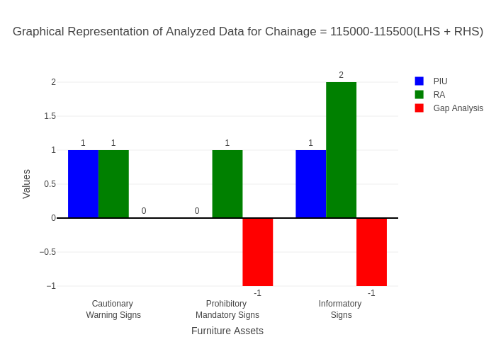

# Chainage: 115500-116000

## PIU Data:

|  |  |  |  |
| --- | --- | --- | --- |
| **Furniture Assets** | **115500-116000** | **116000-115500** | **LHS+RHS** |
| Chevron | 0.0 | 0.0 | 0.0 |
| Cautionary Warning Signs | 1.0 | 0.0 | 1.0 |
| Hazard | 0.0 | 0.0 | 0.0 |
| Prohibitory Mandatory Signs | 0.0 | 0.0 | 0.0 |
| Informatory Signs | 1.0 | 0.0 | 1.0 |

## RA Data:

|  |  |  |  |
| --- | --- | --- | --- |
| **Furniture Assets** | **115500-116000** | **116000-115500** | **LHS+RHS** |
| Chevron | 2.0 | 2.0 | 4.0 |
| Cautionary Warning Signs | 1.0 | 1.0 | 2.0 |
| Hazard | 0.0 | 0.0 | 0.0 |
| Prohibitory Mandatory Signs | 0.0 | 0.0 | 0.0 |
| Informatory Signs | 0.0 | 0.0 | 0.0 |

## Gap Analysis:

|  |  |  |  |
| --- | --- | --- | --- |
| **Furniture Assets** | **115500-116000** | **116000-115500** | **LHS+RHS** |
| Chevron | -2.0 | -2.0 | -4.0 |
| Cautionary Warning Signs | 0.0 | -1.0 | -1.0 |
| Hazard | 0.0 | 0.0 | 0.0 |
| Prohibitory Mandatory Signs | 0.0 | 0.0 | 0.0 |
| Informatory Signs | 1.0 | 0.0 | 1.0 |

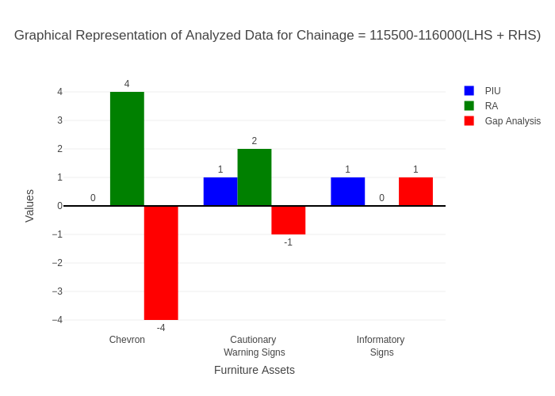

# Chainage: 116000-116500

## PIU Data:

|  |  |  |  |
| --- | --- | --- | --- |
| **Furniture Assets** | **116000-116500** | **116500-116000** | **LHS+RHS** |
| Chevron | 0.0 | 0.0 | 0.0 |
| Cautionary Warning Signs | 1.0 | 0.0 | 1.0 |
| Hazard | 0.0 | 0.0 | 0.0 |
| Prohibitory Mandatory Signs | 0.0 | 0.0 | 0.0 |
| Informatory Signs | 1.0 | 0.0 | 1.0 |

## RA Data:

|  |  |  |  |
| --- | --- | --- | --- |
| **Furniture Assets** | **116000-116500** | **116500-116000** | **LHS+RHS** |
| Chevron | 0.0 | 0.0 | 0.0 |
| Cautionary Warning Signs | 0.0 | 1.0 | 1.0 |
| Hazard | 0.0 | 0.0 | 0.0 |
| Prohibitory Mandatory Signs | 0.0 | 1.0 | 1.0 |
| Informatory Signs | 1.0 | 0.0 | 1.0 |

## Gap Analysis:

|  |  |  |  |
| --- | --- | --- | --- |
| **Furniture Assets** | **116000-116500** | **116500-116000** | **LHS+RHS** |
| Chevron | 0.0 | 0.0 | 0.0 |
| Cautionary Warning Signs | 1.0 | -1.0 | 0.0 |
| Hazard | 0.0 | 0.0 | 0.0 |
| Prohibitory Mandatory Signs | 0.0 | -1.0 | -1.0 |
| Informatory Signs | 0.0 | 0.0 | 0.0 |

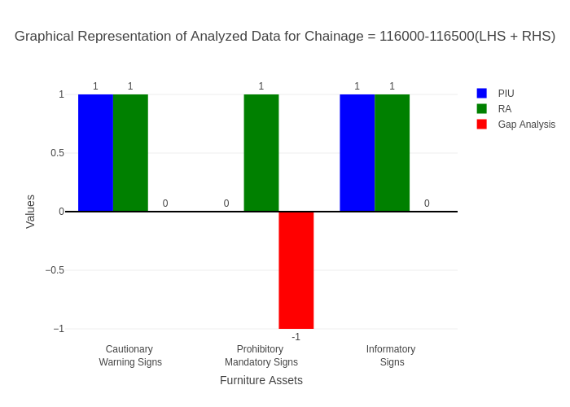

# Chainage: 116500-117000

## PIU Data:

|  |  |  |  |
| --- | --- | --- | --- |
| **Furniture Assets** | **116500-117000** | **117000-116500** | **LHS+RHS** |
| Chevron | 0.0 | 0.0 | 0.0 |
| Cautionary Warning Signs | 2.0 | 0.0 | 2.0 |
| Hazard | 2.0 | 0.0 | 2.0 |
| Prohibitory Mandatory Signs | 0.0 | 0.0 | 0.0 |
| Informatory Signs | 1.0 | 0.0 | 1.0 |

## RA Data:

|  |  |  |  |
| --- | --- | --- | --- |
| **Furniture Assets** | **116500-117000** | **117000-116500** | **LHS+RHS** |
| Chevron | 0.0 | 0.0 | 0.0 |
| Cautionary Warning Signs | 0.0 | 0.0 | 0.0 |
| Hazard | 1.0 | 0.0 | 1.0 |
| Prohibitory Mandatory Signs | 0.0 | 0.0 | 0.0 |
| Informatory Signs | 0.0 | 2.0 | 2.0 |

## Gap Analysis:

|  |  |  |  |
| --- | --- | --- | --- |
| **Furniture Assets** | **116500-117000** | **117000-116500** | **LHS+RHS** |
| Chevron | 0.0 | 0.0 | 0.0 |
| Cautionary Warning Signs | 2.0 | 0.0 | 2.0 |
| Hazard | 1.0 | 0.0 | 1.0 |
| Prohibitory Mandatory Signs | 0.0 | 0.0 | 0.0 |
| Informatory Signs | 1.0 | -2.0 | -1.0 |

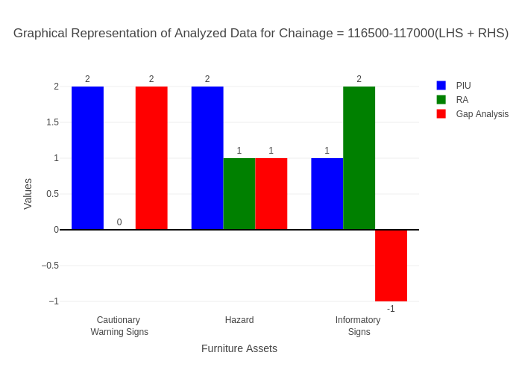

# Chainage: 117000-117500

## PIU Data:

|  |  |  |  |
| --- | --- | --- | --- |
| **Furniture Assets** | **117000-117500** | **117500-117000** | **LHS+RHS** |
| Chevron | 0.0 | 0.0 | 0.0 |
| Cautionary Warning Signs | 0.0 | 0.0 | 0.0 |
| Hazard | 0.0 | 0.0 | 0.0 |
| Prohibitory Mandatory Signs | 0.0 | 0.0 | 0.0 |
| Informatory Signs | 1.0 | 0.0 | 1.0 |

## RA Data:

|  |  |  |  |
| --- | --- | --- | --- |
| **Furniture Assets** | **117000-117500** | **117500-117000** | **LHS+RHS** |
| Chevron | 0.0 | 0.0 | 0.0 |
| Cautionary Warning Signs | 0.0 | 0.0 | 0.0 |
| Hazard | 0.0 | 0.0 | 0.0 |
| Prohibitory Mandatory Signs | 0.0 | 0.0 | 0.0 |
| Informatory Signs | 1.0 | 1.0 | 2.0 |

## Gap Analysis:

|  |  |  |  |
| --- | --- | --- | --- |
| **Furniture Assets** | **117000-117500** | **117500-117000** | **LHS+RHS** |
| Chevron | 0.0 | 0.0 | 0.0 |
| Cautionary Warning Signs | 0.0 | 0.0 | 0.0 |
| Hazard | 0.0 | 0.0 | 0.0 |
| Prohibitory Mandatory Signs | 0.0 | 0.0 | 0.0 |
| Informatory Signs | 0.0 | -1.0 | -1.0 |

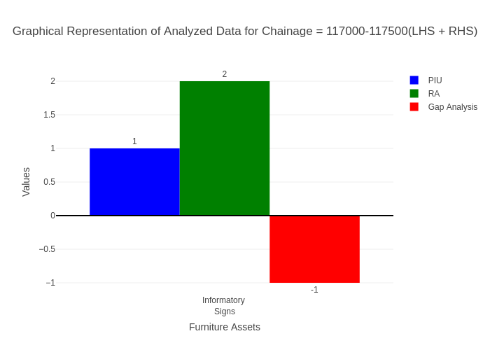

# Chainage: 117500-118000

## PIU Data:

|  |  |  |  |
| --- | --- | --- | --- |
| **Furniture Assets** | **117500-118000** | **118000-117500** | **LHS+RHS** |
| Chevron | 0.0 | 0.0 | 0.0 |
| Cautionary Warning Signs | 1.0 | 0.0 | 1.0 |
| Hazard | 0.0 | 0.0 | 0.0 |
| Prohibitory Mandatory Signs | 0.0 | 0.0 | 0.0 |
| Informatory Signs | 0.0 | 0.0 | 0.0 |

## RA Data:

|  |  |  |  |
| --- | --- | --- | --- |
| **Furniture Assets** | **117500-118000** | **118000-117500** | **LHS+RHS** |
| Chevron | 0.0 | 0.0 | 0.0 |
| Cautionary Warning Signs | 0.0 | 0.0 | 0.0 |
| Hazard | 0.0 | 0.0 | 0.0 |
| Prohibitory Mandatory Signs | 2.0 | 0.0 | 2.0 |
| Informatory Signs | 0.0 | 0.0 | 0.0 |

## Gap Analysis:

|  |  |  |  |
| --- | --- | --- | --- |
| **Furniture Assets** | **117500-118000** | **118000-117500** | **LHS+RHS** |
| Chevron | 0.0 | 0.0 | 0.0 |
| Cautionary Warning Signs | 1.0 | 0.0 | 1.0 |
| Hazard | 0.0 | 0.0 | 0.0 |
| Prohibitory Mandatory Signs | -2.0 | 0.0 | -2.0 |
| Informatory Signs | 0.0 | 0.0 | 0.0 |

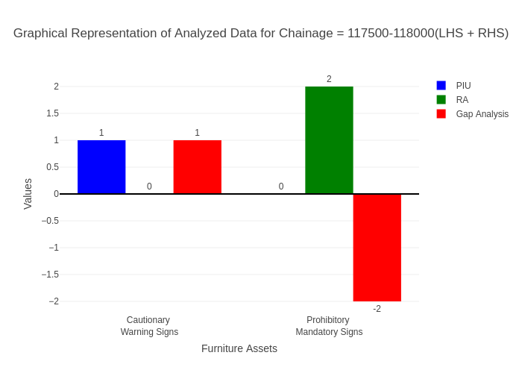

# Chainage: 118000-118500

## PIU Data:

|  |  |  |  |
| --- | --- | --- | --- |
| **Furniture Assets** | **118000-118500** | **118500-118000** | **LHS+RHS** |
| Chevron | 0.0 | 0.0 | 0.0 |
| Cautionary Warning Signs | 0.0 | 0.0 | 0.0 |
| Hazard | 1.0 | 0.0 | 1.0 |
| Prohibitory Mandatory Signs | 0.0 | 0.0 | 0.0 |
| Informatory Signs | 2.0 | 0.0 | 2.0 |

## RA Data:

|  |  |  |  |
| --- | --- | --- | --- |
| **Furniture Assets** | **118000-118500** | **118500-118000** | **LHS+RHS** |
| Chevron | 0.0 | 0.0 | 0.0 |
| Cautionary Warning Signs | 0.0 | 0.0 | 0.0 |
| Hazard | 0.0 | 1.0 | 1.0 |
| Prohibitory Mandatory Signs | 0.0 | 0.0 | 0.0 |
| Informatory Signs | 0.0 | 2.0 | 2.0 |

## Gap Analysis:

|  |  |  |  |
| --- | --- | --- | --- |
| **Furniture Assets** | **118000-118500** | **118500-118000** | **LHS+RHS** |
| Chevron | 0.0 | 0.0 | 0.0 |
| Cautionary Warning Signs | 0.0 | 0.0 | 0.0 |
| Hazard | 1.0 | -1.0 | 0.0 |
| Prohibitory Mandatory Signs | 0.0 | 0.0 | 0.0 |
| Informatory Signs | 2.0 | -2.0 | 0.0 |

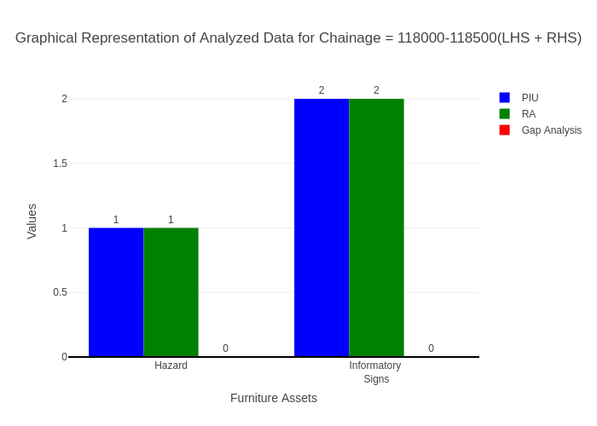

# Chainage: 118500-119000

## PIU Data:

|  |  |  |  |
| --- | --- | --- | --- |
| **Furniture Assets** | **118500-119000** | **119000-118500** | **LHS+RHS** |
| Chevron | 0.0 | 0.0 | 0.0 |
| Cautionary Warning Signs | 1.0 | 0.0 | 1.0 |
| Hazard | 1.0 | 1.0 | 2.0 |
| Prohibitory Mandatory Signs | 0.0 | 0.0 | 0.0 |
| Informatory Signs | 0.0 | 0.0 | 0.0 |

## RA Data:

|  |  |  |  |
| --- | --- | --- | --- |
| **Furniture Assets** | **118500-119000** | **119000-118500** | **LHS+RHS** |
| Chevron | 0.0 | 0.0 | 0.0 |
| Cautionary Warning Signs | 0.0 | 0.0 | 0.0 |
| Hazard | 0.0 | 0.0 | 0.0 |
| Prohibitory Mandatory Signs | 0.0 | 0.0 | 0.0 |
| Informatory Signs | 0.0 | 0.0 | 0.0 |

## Gap Analysis:

|  |  |  |  |
| --- | --- | --- | --- |
| **Furniture Assets** | **118500-119000** | **119000-118500** | **LHS+RHS** |
| Chevron | 0.0 | 0.0 | 0.0 |
| Cautionary Warning Signs | 1.0 | 0.0 | 1.0 |
| Hazard | 1.0 | 1.0 | 2.0 |
| Prohibitory Mandatory Signs | 0.0 | 0.0 | 0.0 |
| Informatory Signs | 0.0 | 0.0 | 0.0 |

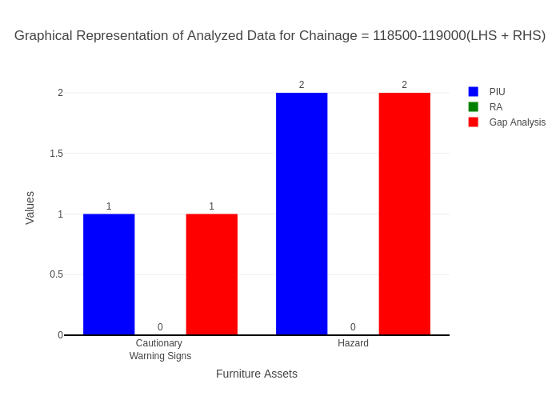

# Chainage: 119000-119500

## PIU Data:

|  |  |  |  |
| --- | --- | --- | --- |
| **Furniture Assets** | **119000-119500** | **119500-119000** | **LHS+RHS** |
| Chevron | 0.0 | 0.0 | 0.0 |
| Cautionary Warning Signs | 1.0 | 0.0 | 1.0 |
| Hazard | 1.0 | 0.0 | 1.0 |
| Prohibitory Mandatory Signs | 0.0 | 0.0 | 0.0 |
| Informatory Signs | 2.0 | 0.0 | 2.0 |

## RA Data:

|  |  |  |  |
| --- | --- | --- | --- |
| **Furniture Assets** | **119000-119500** | **119500-119000** | **LHS+RHS** |
| Chevron | 0.0 | 0.0 | 0.0 |
| Cautionary Warning Signs | 0.0 | 0.0 | 0.0 |
| Hazard | 0.0 | 0.0 | 0.0 |
| Prohibitory Mandatory Signs | 0.0 | 0.0 | 0.0 |
| Informatory Signs | 3.0 | 0.0 | 3.0 |

## Gap Analysis:

|  |  |  |  |
| --- | --- | --- | --- |
| **Furniture Assets** | **119000-119500** | **119500-119000** | **LHS+RHS** |
| Chevron | 0.0 | 0.0 | 0.0 |
| Cautionary Warning Signs | 1.0 | 0.0 | 1.0 |
| Hazard | 1.0 | 0.0 | 1.0 |
| Prohibitory Mandatory Signs | 0.0 | 0.0 | 0.0 |
| Informatory Signs | -1.0 | 0.0 | -1.0 |

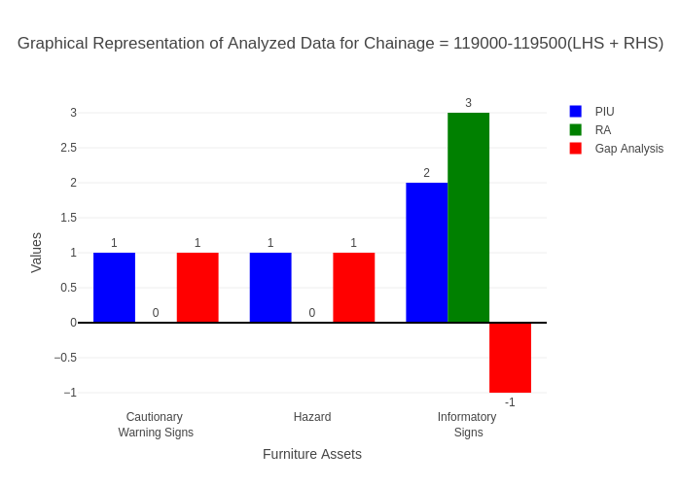

# Chainage: 119500-120000

## PIU Data:

|  |  |  |  |
| --- | --- | --- | --- |
| **Furniture Assets** | **119500-120000** | **120000-119500** | **LHS+RHS** |
| Chevron | 0.0 | 0.0 | 0.0 |
| Cautionary Warning Signs | 0.0 | 0.0 | 0.0 |
| Hazard | 1.0 | 0.0 | 1.0 |
| Prohibitory Mandatory Signs | 0.0 | 0.0 | 0.0 |
| Informatory Signs | 0.0 | 0.0 | 0.0 |

## RA Data:

|  |  |  |  |
| --- | --- | --- | --- |
| **Furniture Assets** | **119500-120000** | **120000-119500** | **LHS+RHS** |
| Chevron | 0.0 | 0.0 | 0.0 |
| Cautionary Warning Signs | 0.0 | 1.0 | 1.0 |
| Hazard | 0.0 | 0.0 | 0.0 |
| Prohibitory Mandatory Signs | 0.0 | 0.0 | 0.0 |
| Informatory Signs | 0.0 | 0.0 | 0.0 |

## Gap Analysis:

|  |  |  |  |
| --- | --- | --- | --- |
| **Furniture Assets** | **119500-120000** | **120000-119500** | **LHS+RHS** |
| Chevron | 0.0 | 0.0 | 0.0 |
| Cautionary Warning Signs | 0.0 | -1.0 | -1.0 |
| Hazard | 1.0 | 0.0 | 1.0 |
| Prohibitory Mandatory Signs | 0.0 | 0.0 | 0.0 |
| Informatory Signs | 0.0 | 0.0 | 0.0 |

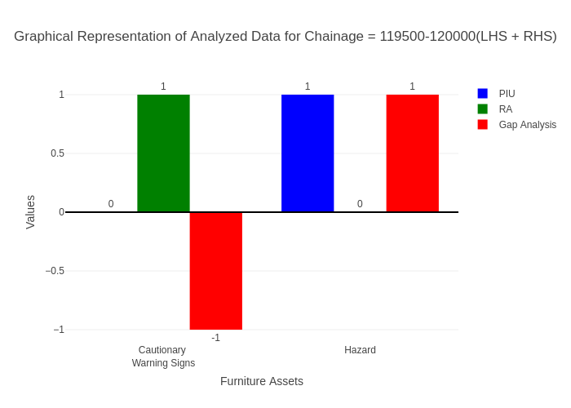

# Chainage: 120000-120500

## PIU Data:

|  |  |  |  |
| --- | --- | --- | --- |
| **Furniture Assets** | **120000-120500** | **120500-120000** | **LHS+RHS** |
| Chevron | 0.0 | 0.0 | 0.0 |
| Cautionary Warning Signs | 2.0 | 0.0 | 2.0 |
| Hazard | 0.0 | 0.0 | 0.0 |
| Prohibitory Mandatory Signs | 0.0 | 0.0 | 0.0 |
| Informatory Signs | 1.0 | 0.0 | 1.0 |

## RA Data:

|  |  |  |  |
| --- | --- | --- | --- |
| **Furniture Assets** | **120000-120500** | **120500-120000** | **LHS+RHS** |
| Chevron | 0.0 | 0.0 | 0.0 |
| Cautionary Warning Signs | 0.0 | 0.0 | 0.0 |
| Hazard | 0.0 | 1.0 | 1.0 |
| Prohibitory Mandatory Signs | 0.0 | 0.0 | 0.0 |
| Informatory Signs | 3.0 | 1.0 | 4.0 |

## Gap Analysis:

|  |  |  |  |
| --- | --- | --- | --- |
| **Furniture Assets** | **120000-120500** | **120500-120000** | **LHS+RHS** |
| Chevron | 0.0 | 0.0 | 0.0 |
| Cautionary Warning Signs | 2.0 | 0.0 | 2.0 |
| Hazard | 0.0 | -1.0 | -1.0 |
| Prohibitory Mandatory Signs | 0.0 | 0.0 | 0.0 |
| Informatory Signs | -2.0 | -1.0 | -3.0 |

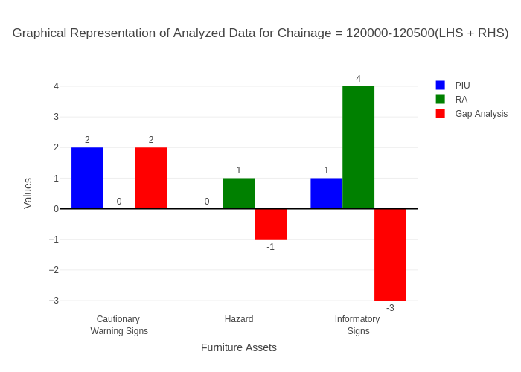

# Chainage: 120500-121000

## PIU Data:

|  |  |  |  |
| --- | --- | --- | --- |
| **Furniture Assets** | **120500-121000** | **121000-120500** | **LHS+RHS** |
| Chevron | 0.0 | 0.0 | 0.0 |
| Cautionary Warning Signs | 0.0 | 0.0 | 0.0 |
| Hazard | 0.0 | 0.0 | 0.0 |
| Prohibitory Mandatory Signs | 0.0 | 0.0 | 0.0 |
| Informatory Signs | 2.0 | 0.0 | 2.0 |

## RA Data:

|  |  |  |  |
| --- | --- | --- | --- |
| **Furniture Assets** | **120500-121000** | **121000-120500** | **LHS+RHS** |
| Chevron | 0.0 | 0.0 | 0.0 |
| Cautionary Warning Signs | 0.0 | 0.0 | 0.0 |
| Hazard | 0.0 | 0.0 | 0.0 |
| Prohibitory Mandatory Signs | 0.0 | 0.0 | 0.0 |
| Informatory Signs | 0.0 | 0.0 | 0.0 |

## Gap Analysis:

|  |  |  |  |
| --- | --- | --- | --- |
| **Furniture Assets** | **120500-121000** | **121000-120500** | **LHS+RHS** |
| Chevron | 0.0 | 0.0 | 0.0 |
| Cautionary Warning Signs | 0.0 | 0.0 | 0.0 |
| Hazard | 0.0 | 0.0 | 0.0 |
| Prohibitory Mandatory Signs | 0.0 | 0.0 | 0.0 |
| Informatory Signs | 2.0 | 0.0 | 2.0 |

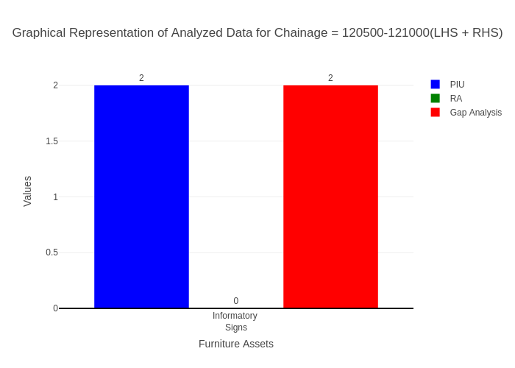

# Chainage: 121000-121500

## PIU Data:

|  |  |  |  |
| --- | --- | --- | --- |
| **Furniture Assets** | **121000-121500** | **121500-121000** | **LHS+RHS** |
| Chevron | 0.0 | 0.0 | 0.0 |
| Cautionary Warning Signs | 0.0 | 0.0 | 0.0 |
| Hazard | 0.0 | 0.0 | 0.0 |
| Prohibitory Mandatory Signs | 0.0 | 0.0 | 0.0 |
| Informatory Signs | 2.0 | 0.0 | 2.0 |

## RA Data:

|  |  |  |  |
| --- | --- | --- | --- |
| **Furniture Assets** | **121000-121500** | **121500-121000** | **LHS+RHS** |
| Chevron | 0.0 | 0.0 | 0.0 |
| Cautionary Warning Signs | 0.0 | 0.0 | 0.0 |
| Hazard | 0.0 | 0.0 | 0.0 |
| Prohibitory Mandatory Signs | 0.0 | 0.0 | 0.0 |
| Informatory Signs | 0.0 | 0.0 | 0.0 |

## Gap Analysis:

|  |  |  |  |
| --- | --- | --- | --- |
| **Furniture Assets** | **121000-121500** | **121500-121000** | **LHS+RHS** |
| Chevron | 0.0 | 0.0 | 0.0 |
| Cautionary Warning Signs | 0.0 | 0.0 | 0.0 |
| Hazard | 0.0 | 0.0 | 0.0 |
| Prohibitory Mandatory Signs | 0.0 | 0.0 | 0.0 |
| Informatory Signs | 2.0 | 0.0 | 2.0 |

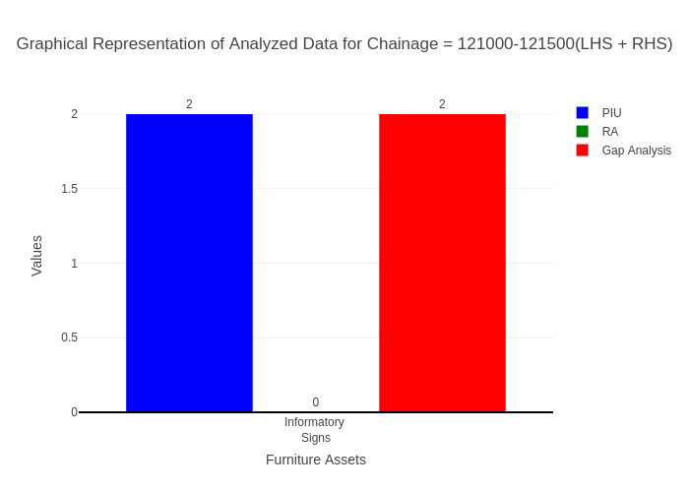

# Chainage: 121500-122000

## PIU Data:

|  |  |  |  |
| --- | --- | --- | --- |
| **Furniture Assets** | **121500-122000** | **122000-121500** | **LHS+RHS** |
| Chevron | 0.0 | 0.0 | 0.0 |
| Cautionary Warning Signs | 0.0 | 0.0 | 0.0 |
| Hazard | 0.0 | 0.0 | 0.0 |
| Prohibitory Mandatory Signs | 0.0 | 0.0 | 0.0 |
| Informatory Signs | 0.0 | 0.0 | 0.0 |

## RA Data:

|  |  |  |  |
| --- | --- | --- | --- |
| **Furniture Assets** | **121500-122000** | **122000-121500** | **LHS+RHS** |
| Chevron | 0.0 | 0.0 | 0.0 |
| Cautionary Warning Signs | 0.0 | 3.0 | 3.0 |
| Hazard | 0.0 | 2.0 | 2.0 |
| Prohibitory Mandatory Signs | 0.0 | 4.0 | 4.0 |
| Informatory Signs | 0.0 | 0.0 | 0.0 |

## Gap Analysis:

|  |  |  |  |
| --- | --- | --- | --- |
| **Furniture Assets** | **121500-122000** | **122000-121500** | **LHS+RHS** |
| Chevron | 0.0 | 0.0 | 0.0 |
| Cautionary Warning Signs | 0.0 | -3.0 | -3.0 |
| Hazard | 0.0 | -2.0 | -2.0 |
| Prohibitory Mandatory Signs | 0.0 | -4.0 | -4.0 |
| Informatory Signs | 0.0 | 0.0 | 0.0 |

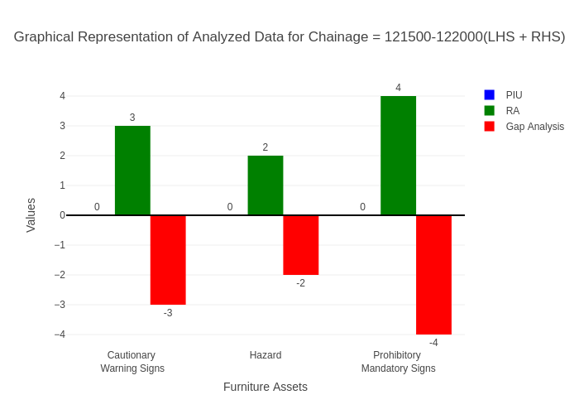

# Chainage: 122000-122420

## PIU Data:

|  |  |  |  |
| --- | --- | --- | --- |
| **Furniture Assets** | **122000-122420** | **122420-122000** | **LHS+RHS** |
| Chevron | 0.0 | 0.0 | 0.0 |
| Cautionary Warning Signs | 0.0 | 0.0 | 0.0 |
| Hazard | 0.0 | 0.0 | 0.0 |
| Prohibitory Mandatory Signs | 0.0 | 0.0 | 0.0 |
| Informatory Signs | 0.0 | 1.0 | 1.0 |

## RA Data:

|  |  |  |  |
| --- | --- | --- | --- |
| **Furniture Assets** | **122000-122420** | **122420-122000** | **LHS+RHS** |
| Chevron | 0.0 | 0.0 | 0.0 |
| Cautionary Warning Signs | 0.0 | 1.0 | 1.0 |
| Hazard | 1.0 | 0.0 | 1.0 |
| Prohibitory Mandatory Signs | 0.0 | 0.0 | 0.0 |
| Informatory Signs | 0.0 | 1.0 | 1.0 |

## Gap Analysis:

|  |  |  |  |
| --- | --- | --- | --- |
| **Furniture Assets** | **122000-122420** | **122420-122000** | **LHS+RHS** |
| Chevron | 0.0 | 0.0 | 0.0 |
| Cautionary Warning Signs | 0.0 | -1.0 | -1.0 |
| Hazard | -1.0 | 0.0 | -1.0 |
| Prohibitory Mandatory Signs | 0.0 | 0.0 | 0.0 |
| Informatory Signs | 0.0 | 0.0 | 0.0 |

